Supplementary Information
Table A1: Correlation matrix of agricultural input for high-income countries
 | Fertilizer N | Fertilizer P2O5 | Fertilizer K2O | Pesticides | Capital Stocks | Irrigation
Fertilizer N | 1
Fertilizer P2O5 | 0.0393 | 1
Fertilizer K2O | 0.6098 | 0.4846 | 1
Pesticides | 0.0913 | 0.4269 | 0.607 | 1
Capital Stocks | 0.0477 | 0.1155 | 0.2074 | 0.2442 | 1
Irrigation | -0.2553 | 0.2587 | 0.1767 | 0.5895 | 0.0967 | 1

Table A2: Correlation matrix of agricultural input for low-income countries
 | Fertilizer N | Fertilizer P2O5 | Fertilizer K2O | Pesticides | Capital Stocks | Irrigation
Fertilizer N | 1
Fertilizer P2O5 | 0.8915 | 1
Fertilizer K2O | 0.2802 | 0.3746 | 1
Pesticides | 0.3528 | 0.3373 | 0.3109 | 1
Capital Stocks | 0.4322 | 0.4378 | 0.0899 | 0.3457 | 1
Irrigation | 0.5456 | 0.5413 | -0.058 | 0.0047 | 0.4567 | 1

Table A3: Principal component analysis results for high-income countries
 | Eigenvalue | Difference | Proportion | Cumulative
PC1 | 2.4469 | 0.977421 | 0.4078 | 0.4078
PC2 | 1.46948 | 0.542185 | 0.2449 | 0.6527
PC3 | 0.927294 | 0.227319 | 0.1545 | 0.8073
PC4 | 0.699974 | 0.398001 | 0.1167 | 0.9239
PC5 | 0.301974 | 0.147594 | 0.0503 | 0.9743
PC6 | 0.15438 |  | 0.0257 | 1

Table A4: Principal component analysis results for low-income countries
 | Eigenvalue | Difference | Proportion | Cumulative
PC1 | 2.94145 | 1.69376 | 0.4902 | 0.4902
PC2 | 1.24768 | 0.419187 | 0.2079 | 0.6982
PC3 | 0.828496 | 0.285746 | 0.1381 | 0.8363
PC4 | 0.54275 | 0.204313 | 0.0905 | 0.9267
PC5 | 0.338437 | 0.237251 | 0.0564 | 0.9831
PC6 | 0.101186 |  | 0.0169 | 1

 | High-income countries | Low-income countries
1 | Luxembourg | Kenya
2 | Singapore | Pakistan
3 | Ireland | Nigeria
4 | Qatar | Congo, Republic of
5 | Norway | Cameroon
6 | Switzerland | Nepal
7 | Brunei Darussalam | Tajikistan
8 | United States | Zimbabwe
9 | Denmark | Senegal
10 | Netherlands | Benin
11 | Iceland | Guinea
12 | United Arab Emirates | Zambia
13 | Taiwan Province of China | Tanzania
14 | Austria | Ethiopia
15 | Hong Kong SAR | Comoros
16 | Belgium | Rwanda
17 | Sweden | Uganda
18 | Germany | Sudan
19 | Malta | Haiti
20 | Australia | Togo
21 | France | Mali
22 | Finland | Chad
23 | Bahrain | Burkina Faso
24 | Canada | Afghanistan
25 | Saudi Arabia | Madagascar
26 | United Kingdom | Niger
27 | Korea, Republic of | Congo, Dem. Rep. of the
28 | Italy | Malawi
29 | Cyprus | Mozambique
30 | Czech Republic | Central African Republic
Table A5. Selected countries

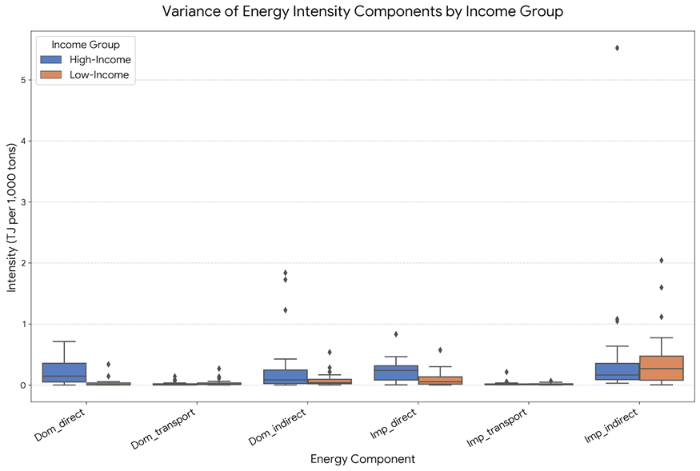
Figure A1. Distribution of Energy Intensity by Income Level

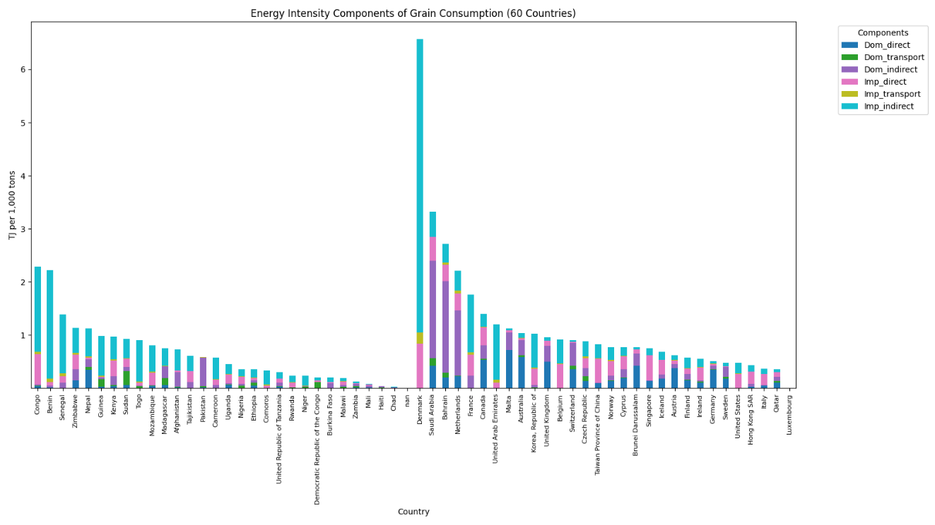
Figure A2. Energy Intensity of Grain Consumption in 60 countries

