Supplementary Data

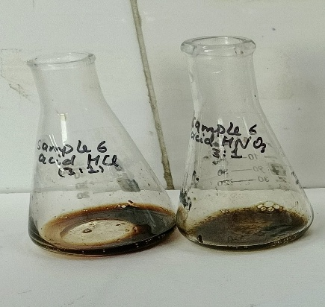
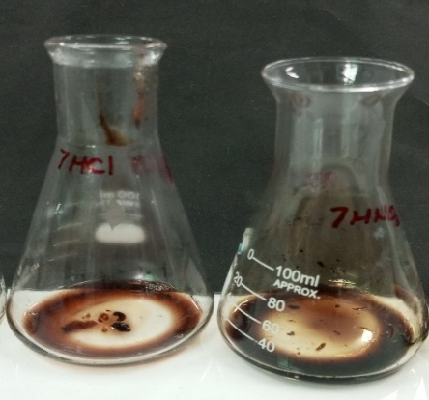
(b)
(a)

Figure 1 : Acidic digestion of blood with acids (HCl and HNO₃) was observed at 0h and 24 h. a) shows the clumping of blood with acids at 0h. b) shows the digestion of blood with acids at 24h.
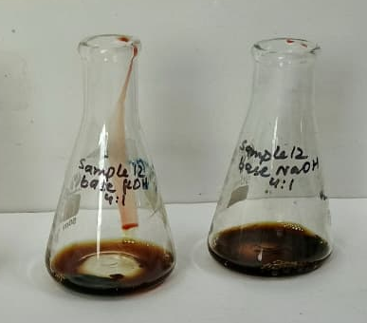
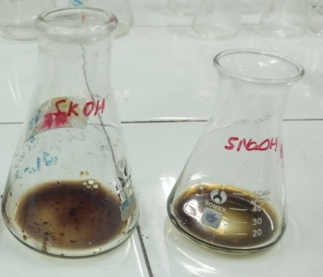
(b)
(a)

Figure 2: Alkaline digestion of blood with bases (NaOH and KOH) was observed at 0h and 24h. a) shows the clumping of blood with bases at 0h. b) shows the complete digestion of blood with bases at 24h.

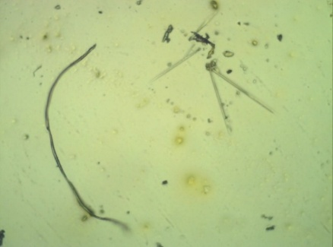
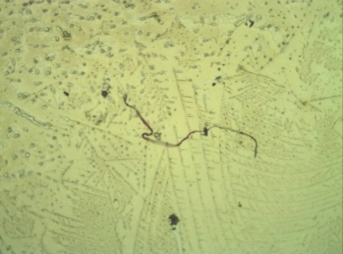
(a)
(b)

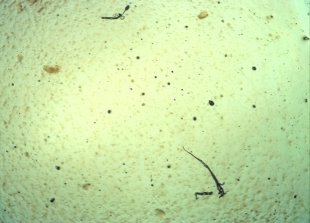
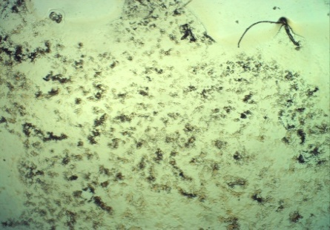
(d)
(c)

Figure 3 : Acid digestion of normal and immunocompromised blood sample using 1M HNO₃ at 4x. (a) No digestion in normal blood sample at 0h of incubation at 37 °C. (b) Partial digestion in normal blood sample at 24h of incubation at 37°C with elongated fibrous microplastic-like fragments. (c) No digestion and clumping found in immunocompromised blood sample at 0h of incubation at 37°C. (d) Partial digestion and small residues in immunocompromised blood sample at 24h of incubation at 37°C. Arrow indicates microplastic fragments.
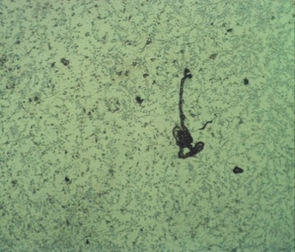
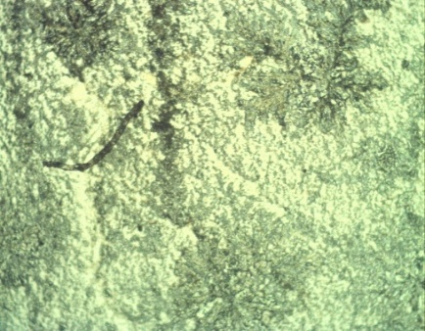
(b)
(a)

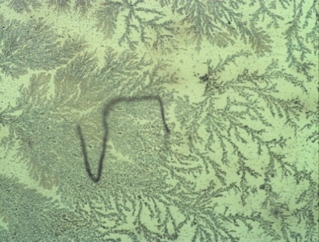
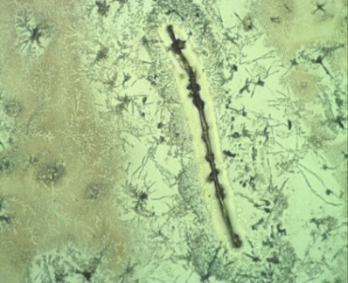
(d)
(c)

Figure 4 : Alkaline digestion of normal and immunocompromised blood sample using 1M sodium hydroxide (NaOH) at 10x by light microscope. (a) Normal blood sample showed thread-like tendencies of branching structures with no digestion (b) This microscopic image shows incomplete digestion of organic matter. (c) At 0h, dense, web-like filamentous structures with early branching patterns observed showing no digestion in immunocompromised blood samples. (d) After 24h, least digestion appears showing coagulated residue and thickened filamentous networks.
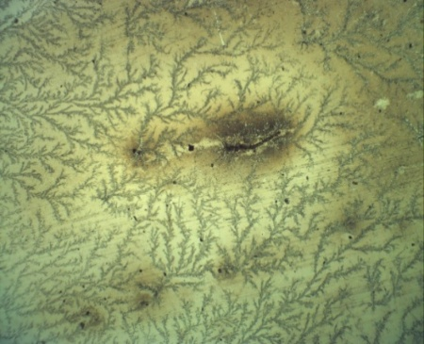
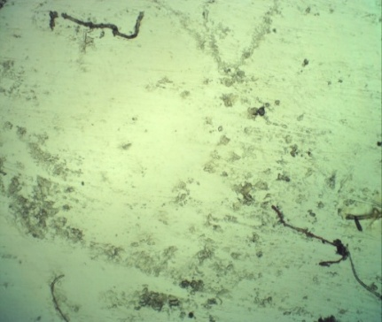
(b)
(a)

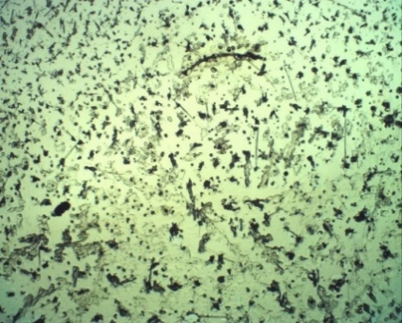
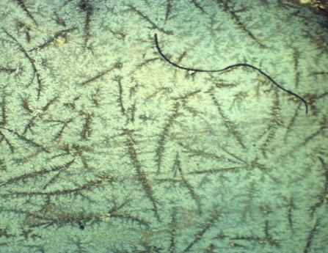
(d)
(c)

Figure 7 : Alkaline digestion of normal and immunocompromised blood sample using 1.8 M Potassium hydroxide (KOH) at 10x. (a) Indigested plasma components forming delicate and dense branching patterns across the slide showing no digestion. (b) The filamentous residues appear thin and discontinuous, indicating no digestion. (c) At 0h, no digestion in immunocompromised blood sample appears. (d) After 24 h of alkaline digestion, least digestion and small residues was observed in immunocompromised blood samples. Arrow indicates microplastic fragments.
Table 1: The table shows FTIR Results of MP polymers that met the LOQ threshold. Additional columns determine the Limit of Quantification and Limit of Detection values.
Polymer and Sample ID | Polymer quantity in 0.5 mL samples (A) | Mean polymer quantity  in  parallel controls  ±SD (B) | Blank Correction (A-B)  (C) | Limit of Detection 4*SD of B  (LoD) | Limit of Quantification 10*SD of B  (LoQ) | LoQ corrected value/10g of blood sample
PAM  3 HNO3  6 HCL  8 KOH  11NaOH  20 HCL  22 HCL  25 NaOH  26 KOH  28 HNO3  30 HCL  32 HCL  33 HCL  33 NaOH  34 NaOH  35 KOH | 67  82  63  78  74  79  73  60  75  76  71  70  77  85  74 | 0.004±0.0015 | 66.996  81.996  62.996  77.996  73.996  78.996  72.996  59.996  74.996  75.996  70.996  69.996  76.996  84.996  73.996 | 0.006 | 0.015 | 66.996  81.996  62.996  77.996  73.996  78.996  72.996  59.996  74.996  75.996  70.996  69.996  76.996  84.996  73.996
PBT  3 HNO3  6 HCL  8 KOH  11NaOH  20 HCL  22 HCL  25 NaOH  26 KOH  28 HNO3  30 HCL  32 HCL  33 HCL  33 NaOH  34 NaOH  35 KOH | 67  65  49  73  57  70  57  67  72  71 | 0.0035±0.0011 | 66.9965  64.9965  47.9965  72.9965  56.9965  69.9965  56.9965  66.9965  71.9965  70.9965 | 0.0044 | 0.011 | 66.9965  64.9965  47.9965  72.9965  56.9965  69.9965  56.9965  66.9965  71.9965  70.9965
PVC  3 HNO3  6 HCL  8 KOH  11NaOH  20 HCL  22 HCL  25 NaOH  26 KOH  28 HNO3  30 HCL  32 HCL  33 HCL  33NaOH  34 NaOH  35 KOH | 61  53  63  59  54  61  62 | 0.0042±0.0015 | 60.9958  52.9958  62.9958  58.9958  53.9958  60.9958  61.9958 | 0.006 | 0.015 | 60.9958  52.9958  62.9958  58.9958  53.9958  60.9958  61.9958
PU  3 HNO3  6 HCL  8 KOH  11NaOH  20 HCL  22 HCL  25 NaOH  26 KOH  28 HNO3  30 HCL  32 HCL  33 HCL  33NaOH  34 NaOH  35 KOH | 57  65  61  61 | 0.003±0.0007 | 56.997  64.997  60.997  60.997 | 0.0028 | 0.007 | 56.997  64.997  60.997  60.997
PE Rubber  3 HNO3  6 HCL  8 KOH  11NaOH  20 HCL  22 HCL  25 NaOH  26 KOH  28 HNO3  30 HCL  32 HCL  33 HCL  33NaOH  34 NaOH  35 KOH | 56 | 0.0042±0.0011 | 55.9958 | 0.0044 | 0.011 | 55.9958
PA  3 HNO3  6 HCL  8 KOH  11NaOH  20 HCL  22 HCL  25 NaOH  26 KOH  28 HNO3  30 HCL  32 HCL  33 HCL  33NaOH  34 NaOH  35 KOH | 55  57  65  61  64 | 0.003±0.001 | 54.997  56.997  64.997  60.997  63.997 | 0.004 | 0.01 | 54.997  56.997  64.997  60.997  63.997
PAr  3 HNO3  6 HCL  8 KOH  11NaOH  20 HCL  22 HCL  25 NaOH  26 KOH  28 HNO3  30 HCL  32 HCL  33 HCL  33NaOH  34 NaOH  35 KOH | 65  67  60  79  57  71  76  69  54  65  74  80  56 | 0.005±0.003 | 64.995  66.995  59.995  78.995  56.995  70.995  75.995  68.995  53.995  64.995  73.995  79.995  55.995 | 0.012 | 0.03 | 64.995  66.995  59.995  78.995  56.995  70.995  75.995  68.995  53.995  64.995  73.995  79.995  55.995
PA6/PCL  3 HNO3  6 HCL  8 KOH  11NaOH  20 HCL  22 HCL  25 NaOH  26 KOH  28 HNO3  30 HCL  32 HCL  33 HCL  33NaOH  34 NaOH  35 KOH | 59  70  55  67  67  65  62  66  67  56 | 0.003±0.0015 | 58.997  69.997  54.997  66.997  66.997  64.997  61.997  65.997  66.997  55.997 | 0.006 | 0.015 | 58.997  69.997  54.997  66.997  66.997  64.997  61.997  65.997  66.997  55.997
PPS  3 HNO3  6 HCL  8 KOH  11NaOH  20 HCL  22 HCL  25 NaOH  26 KOH  28 HNO3  30 HCL  32 HCL  33 HCL  33NaOH  34 NaOH  35 KOH | 50 | 0.0042±0.0008 | 49.9958 | 0.0032 | 0.008 | 49.9958
PIB  3 HNO3  6 HCL  8 KOH  11NaOH  20 HCL  22 HCL  25 NaOH  26 KOH  28 HNO3  30 HCL  32 HCL  33 HCL  33NaOH  34 NaOH  35 KOH | 50 | 0.004±0.0015 | 49.996 | 0.006 | 0.015 | 49.996
PVA  3 HNO3  6 HCL  8 KOH  11NaOH  20 HCL  22 HCL  25 NaOH  26 KOH  28 HNO3  30 HCL  32 HCL  33 HCL  33NaOH  34 NaOH  35 KOH | 54 | 0.006±0.003 | 53.994 | 0.012 | 0.03 | 53.994
Copolymer  3 HNO3  6 HCL  8 KOH  11NaOH  20 HCL  22 HCL  25 NaOH  26 KOH  28 HNO3  30 HCL  32 HCL  33 HCL  33NaOH  34 NaOH  35 KOH | 50  50 | 0.003±0.001 | 49.997  49.997 | 0.004 | 0.01 | 49.997  49.997

Calculation 1: Conventional Pellet Mass–Based Quantification
Table 2: Reporting the number of MPs found in the blood sample of healthy and immune-compromised patients. All Polymer types that met the LOQ criteria are displayed in units of no. of MP/L.
Sample ID | PAM | PBT | PVC | PU | PE | PA | PAr | PA6/  PCL | PPS | PIB | PVA | Copolymer
3 HNO3 | 2680 | 2680 | 2440 | 2280 | 2240 | _ | 2600 | 2360 | _ | _ | _ | _
6HCL | 4920 | 3900 | _ | _ | _ | 3300 | 4020 | 4200 | _ | _ | _ | _
8KOH | 2520 | 1960 | 2120 | _ | _ | _ | 2400 | 2200 | 2000 | 2000 | _ | _
11NaOH | 1560 | 1460 | _ | 1300 | _ | _ | 1580 | 1340 | _ | _ | _ | _
20HCL | 4440 | 3420 | _ | _ | _ | - | 3420 | _ | _ | _ | _ | _
22HCL | 4740 | _ | 3780 | _ | _ | 3420 | 4260 | 4020 | _ | _ | _ | _
25NaOH | 1460 | _ | _ | _ | _ | 1300 | 1520 | _ | _ | _ | _ | _
26KOH | 3600 | _ | _ | _ | _ | _ | _ | _ | _ | _ | _ | _
28HNO3 | 3000 | 2800 | 2360 | 2440 | _ | _ | 2760 | 2600 | _ | _ | _ | _
30HCL | 6080 | 4560 | _ | _ | _ | - | _ | _ | _ | _ | _ | _
32HCL | 4260 |  | 3240 | _ | _ | 3660 | 3240 | _ | _ | _ | 3240
33NaOH | 1540 | 1440 | 1240 | 1220 | _ | 1280 | 1480 | 2680 | _ | _ | _ | _
34NaOH | 3400 | 2840 | _ | _ | _ | _ | 3200 | 2680 | _ | _ | _ | 2000
35KOH | 2960 | _ | _ | _ | _ | _ | 2240 | 2240 | _ | _ | _ | _

Calculation 2 Modified Residue-Corrected Polymer Mass Quantification Approach
Table 3 : Reporting the number of MPs found in the blood sample of healthy and immune-compromised patients by FTIR Spectroscopy. All Polymer types that met the LOQ criteria are displayed in units of MP/L.
Sample ID | PAM | PBT | PVC | PU | PE | PA | PAr | PA6/  PCL | PPS | PIB | PVA | Copolymer
3 HNO3 | 1876 | 1876 | 1708 | 1596 | 1568 | _ | 1820 | 1652 | _ | _ | _ | _
6HCL | 3444 | 2730 | _ | _ | _ | 2310 | 2814 | 2940 | _ | _ | _ | _
8KOH | 252 | 196 | 212 | _ | _ | _ | 240 | 220 | 200 | 200 | _ | _
11NaOH | 156 | 146 | _ | 130 | _ | _ | 158 | 134 | _ | _ | _ | _
20HCL | 3700 | 2850 | _ | _ | _ | - | 2850 | _ | _ | _ | _ | _
22HCL | 2370 | _ | 1890 | _ | _ | 1710 | 2130 | 2010 | _ | _ | _ | _
25NaOH | 1460 | _ | _ | _ | _ | 1300 | 1520 | _ | _ | _ | _ | _
26KOH | 840 | _ | _ | _ | _ | _ | _ | _ | _ | _ | _ | _
28HNO3 | 2100 | 1960 | 1652 | 1708 | _ | _ | 1932 | 1820 | _ | _ | _ | _
30HCL | 5320 | 3990 | _ | _ | _ | - | _ | _ | _ | _ | _ | _
32HCL | 2130 |  | 1620 | _ | _ | 1830 | 1620 | _ | _ | _ | 1620
33NaOH | 1540 | 1440 | 1240 | 1220 | _ | 1280 | 1480 | 2680 | _ | _ | _ | _
34NaOH | 2890 | 2414 | _ | _ | _ | _ | 2720 | 2278 | _ | _ | _ | 1700
35KOH | 2516 | _ | _ | _ | _ | _ | 1904 | 1904 | _ | _ | _ | _

