Table 1. Main and interaction effects of pregnancy trimester, parity, and occupational type sedentary behavior and MVPA (GLMM).
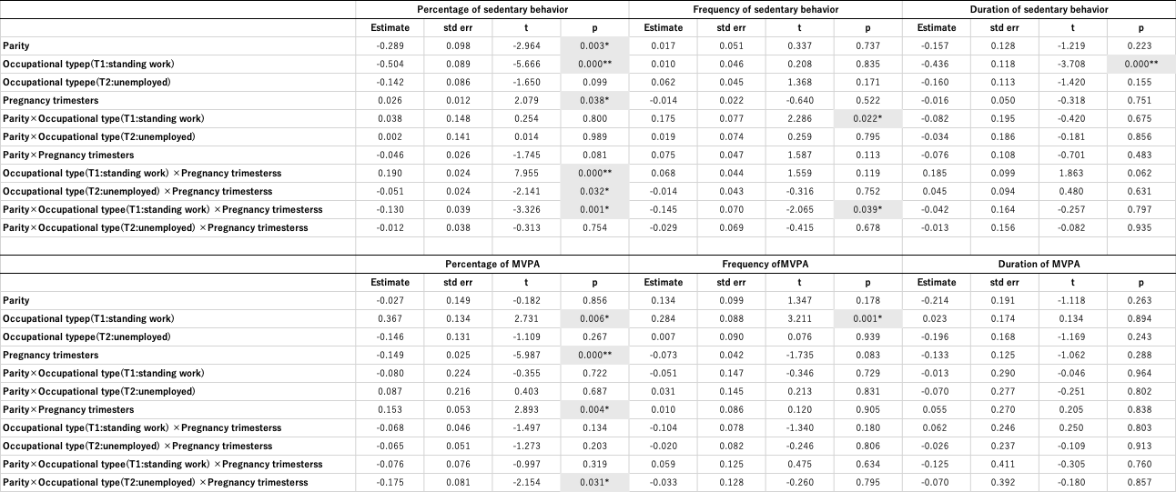
The proportions of sedentary behavior and MVPA were analyzed using a binomial distribution (logit link), the frequency using a Poisson distribution (log link), and the duration using a gamma distribution (log link). Statistical significance: main effect, * p < 0.05; ** p < 0.001. MVPA: moderate-to-vigorous physical activity.

Table 2. Group comparisons for significant interaction effects (Tukey’s post-hoc test). (a) Percentage of sedentary behavior, (b) Frequency of sedentary behavior, (c) Percentage of MVPA.
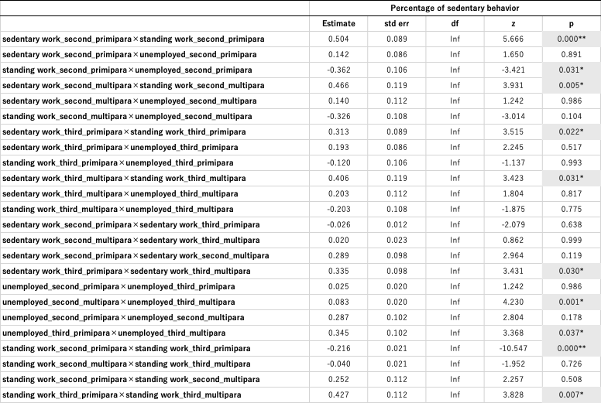
(a)
(b)
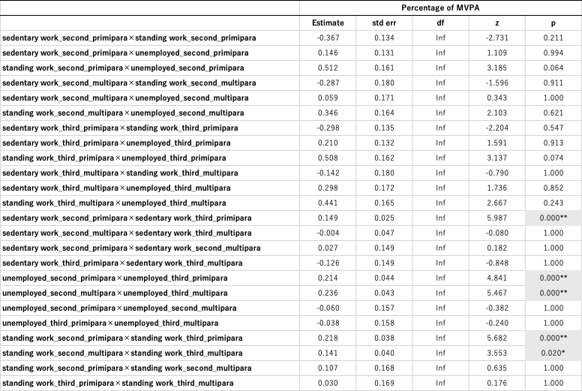
(c)
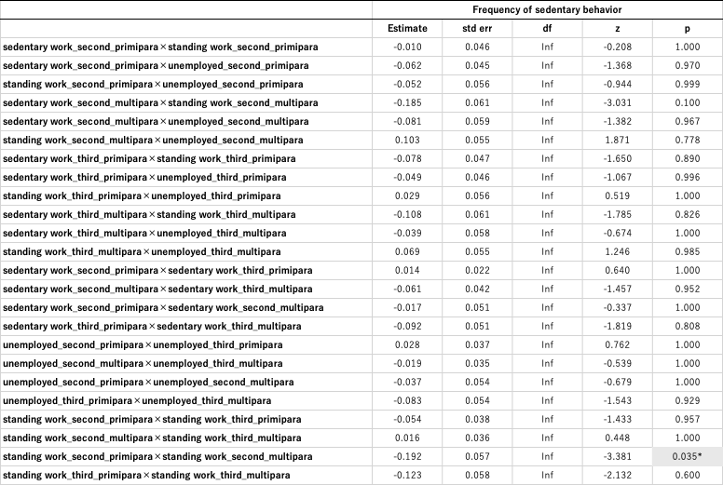
Statistical significance: main effect, * p < 0.05; ** p < 0.001. MVPA: moderate-to-vigorous physical activity.

Table 3. Group comparisons by occupational type (Tukey’s post-hoc test)
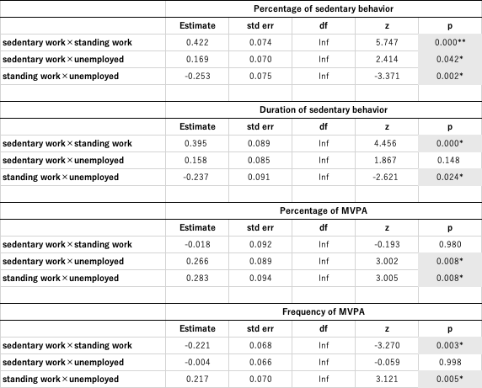
Statistical significance: main effect, * p < 0.05; ** p < 0.001. MVPA: moderate-to-vigorous physical activity.

Table 4. MVPA change rate between the second and third trimesters
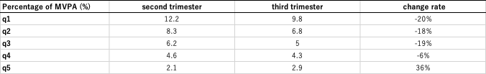
Based on the average values of the percentage of moderate-intensity physical activity during the second trimester, participants were classified into five groups (Q1: highest moderate-intensity physical activity to Q5: lowest moderate-intensity physical activity), and the rate of change in moderate-intensity physical activity from the second to the third trimester was compared across groups. MVPA: moderate-to-vigorous physical activity

