Supplement materials for

Increased CO₂ growth rate following the 2023/24 El Niño in a warming climate

Xiaoyu Sun¹, Sharon Patris², Denghui Ji¹, Darko Dubravica³, Mathias Palm¹, Frank Hase², Justus Notholt^{1 *}
¹ IUP, University of Bremen, Otto-Hahn-Allee 1, Bremen, 28334, Germany
² Coral Reef Research Foundation, Koror, 96940, Palau
³ IMK-ASF, Karlsruher Institut für Technologie, Karlsruhe, Germany
*Corresponding author(s). E-mail(s):
jnotholt@iup.physik.uni-bremen.de

S1. Palau FTIR XCO2 Anomaly Calculation

S1.1 Theoretical basis
As described in the main text, $X_{CO_{2}}$ anomalies for long-term records (GOSAT and MLO) were derived using a second-order polynomial–harmonic regression over the 2009–2025 period. However, the limited two-year span of the Palau FTIR record (2024–2025) precludes a robust independent trend estimation. A standard unconstrained fit would misattribute the prominent 2025 $X_{CO_{2}}$ pulse to the long-term baseline, thereby absorbing the interannual signal of El Niño into the fitted trend.
To maintain consistency with the unified framework while preserving the episodic ENSO signal, we adapted the regression model by constraining the growth rate and aligning the baseline to a pre-pulse reference period.

S1.2. Mathematical Formulation
For the Palau FTIR time series, the fitted ${\overset{^}{X}}_{Palau}$ is defined as:
$${\overset{^}{X}}_{Palau}(t)=β_{0}+γ_{GOSAT}⋅t+\sum_{k=1}^{1}{[b_{k}sin⁡(2πkt)+c_{k}cos⁡(2πkt)]}$$
Where:
t is the time in fractional years.
$γ_{GOSAT}$ is the regional long-term growth rate (approximately 2.5 ppm yr⁻¹), calculated from the linear component of the GOSAT regional trend (2010–2025) as specified in the Methods section.
The harmonic terms (k=1) represent the annual seasonal cycle, consistent with the primary frequency observed in Tropical Western Pacific (TWP) regional averages.
$β_{0}$ is the adjusted intercept, determined via the baseline alignment procedure as followed.

S1.3. Baseline Alignment
The intercept $β_{0}$ was determined by aligning the model to the initial phase of the record (January 2024 to May 2024). This period corresponds to the peak and decay of the 2023/24 El Niño Sea Surface Temperature (SST) anomalies. According to Chatterjee et al. (2017), the early stages of strong El Niño events are often characterized by reduced oceanic CO₂ outgassing in the tropical Pacific, which can temporarily mask or offset the late terrestrial biospheric response. By anchoring our baseline to this window, we ensure that the anomalies calculated for 2025 exclusively represent the subsequent lagged terrestrial biospheric response of the atmosphere. This prevents the "reference zero" from being contaminated by the initial ocean-driven dip or the early-stage ramp-up of biospheric releases, thereby providing a more robust quantification of the net carbon cycle impact observed at the Palau site.

S1.4. Uncertainty
To account for measurement noise and fitting uncertainty, we employed a Bootstrap Resampling technique (1,000 iterations). Residuals from the baseline-aligned fit were resampled to generate a distribution of possible anomaly time series. The reported uncertainty (1-σ) represents the standard deviation of these iterations. This rigorous approach confirms that the positive $X_{CO_{2}}$ anomalies in 2025 are statistically significant and robust against the choice of seasonal fitting parameters.

S2. Comparison of Palau EM27/SUN CO₂ with GOSAT and Mauna Loa
The time series of (X)CO₂ from three distinct platforms, Mauna Loa (MLO) in-situ measurements, Palau EM27/SUN FTIR, and GOSAT satellite products spatial averaged in the WP region (5$​^{∘}$S–5$​^{∘}$N, 120$​^{∘}$E–180$​^{∘}$E), are illustrated in Fig. S1. Overall, the absolute $X_{CO_{2}}$ concentrations from the Palau EM27/SUN show high consistency with the GOSAT CO₂ over the WP region and the MLO reference CO₂ records. All three datasets exhibit a synchronized seasonal cycle, characterized by a peak in late spring (May-June) and a minimum in autumn (September-October), reflecting the biological uptake and release patterns of the Northern Hemisphere. While the seasonal amplitude captured at Palau appears slightly more pronounced with sharper peaks than the GOSAT spatial average, the seasonal transition points and phase alignment between the two remote sensing platforms are remarkably well-synchronized.
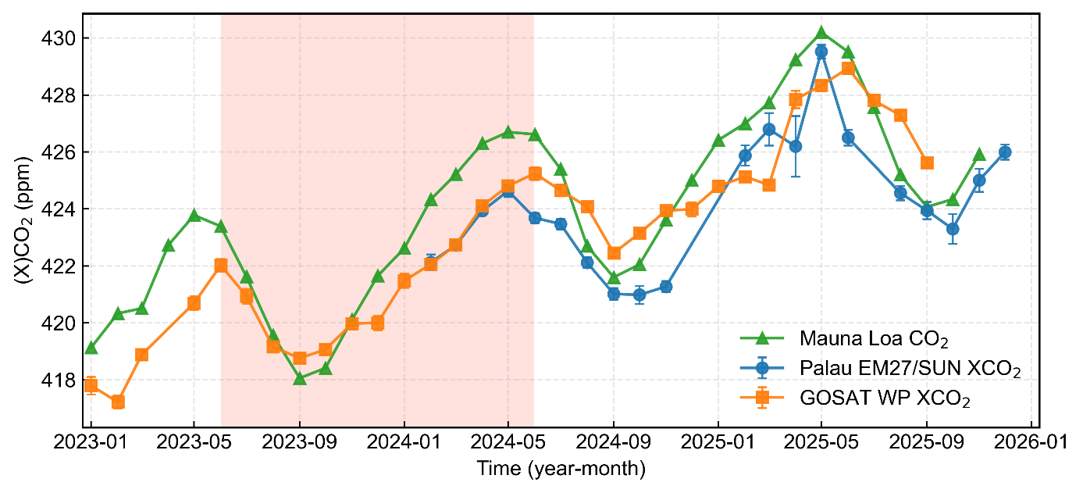Figure S1. Time series of the (X)CO2 by in-situ measurement in Mauna Loa, EM27/SUN FTIR and GOSAT satellite spatial averaged over the Western Pacific (WP) region (5$​^{∘}$S–5$​^{∘}$N, 120$​^{∘}$E–180$​^{∘}$E). The 2023/24 El Niño period is marked in red shadow. Note that the offset in absolute values between EM27/SUN and GOSAT reflects their respective retrieval baselines; however, both datasets exhibit consistent seasonal cycles and inter-annual trends as discussed in the main text.

S3. Single station regression results
We evaluated the robustness of the global CO₂ growth rate estimates and the validity of the statistical model by performing independent regression analyses for each of the 8 sampling stations from Scripps CO₂ records by Scripps Institution of Oceanography (Scripps Institution of Oceanography 2024; Keeling et al. 2005). Following the regression framework of Betts et al. (2016), the annual CO₂ growth rate ($Δ{CO}_{2}$) for each individual station was quantified using an ordinary least squares model expressed as
$$Δ{CO}_{2}=α_{0}+α_{N}N+α_{E}E.$$
Within this framework, N represents the Niño-3.4 SST anomaly averaged from April to March to account for the lagged response of the terrestrial biosphere, while E denotes global anthropogenic CO₂ emissions (Friedlingstein et al., 2024) for the corresponding calendar year. The coefficients $α_{N}$ and $α_{E}$ represent the sensitivity of the CO₂ growth rate to ENSO variability and the anthropogenic emission, respectively.
To ensure the accuracy of the ENSO sensitivity coefficients, years influenced by the cooling effects of the Mt. Pinatubo eruption (1992–1993) were excluded from the regression analysis to prevent non-linear carbon cycle responses to volcanic aerosols from biasing the results. As illustrated in Fig. S2, the CO₂ growth rates across all 8 stations exhibit remarkable phase synchronization despite their vast geographical separation. All stations, ranging from tropical sites such as American Samoa to the polar regions, captured significant growth rate surges during major El Niño events such as 1998, 2016, and the recent 2024 event. The station-level regression results summarized in Fig. S3 and Table. As shown in Figure S1, the sites closer to the equator (e.g., Mauna Loa and American Samoa) exhibit stronger correlations (R² > 0.55) and higher ENSO-induced CO$​_{2}$ sensitivity ($α_{N}$) compared to high-latitude stations like Alert (ALT) and Barrow, Alaska (PTB). This latitudinal decay of ENSO sensitivity confirms that the unexpected CO₂ surge in 2023/24 is primarily driven by enhanced feedback within tropical terrestrial ecosystems, where warming-induced stress is most pronounced. Besides, this cross-latitudinal consistency demonstrates that the inter-annual variability in CO₂ is a well-mixed global signal and confirms that the regression approach is statistically stable across different monitoring locations.
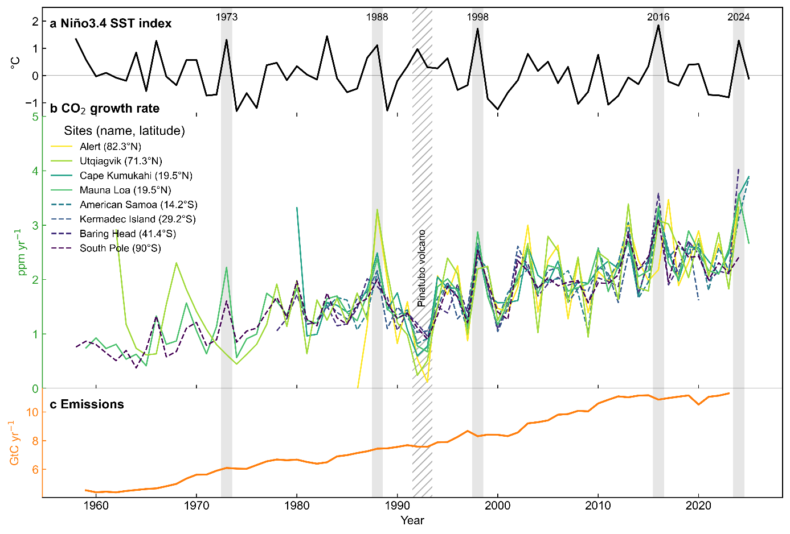 Figure S2. CO$​_{2}$ growth rates at individual Scripps in-situ stations in relation to ENSO and anthropogenic emissions. (a) Annual Niño-3.4 sea-surface temperature (SST) anomalies averaged over April–March, with major El Niño events (1973, 1988, 1998, 2016, 2024) indicated by grey shading. (b) Annual CO$​_{2}$ growth rates (ppm yr$​^{-1}$) derived independently for individual Scripps in-situ stations, spanning polar to tropical latitudes and listed in the legend with station name and latitude. (c) Global anthropogenic CO$​_{2}$ emissions (GtC yr$​^{-1}$). Years influenced by major volcanic eruptions (hatched shading; El Chichón and Mt Pinatubo) are shown for reference and are excluded from the ENSO–emissions regression analysis.
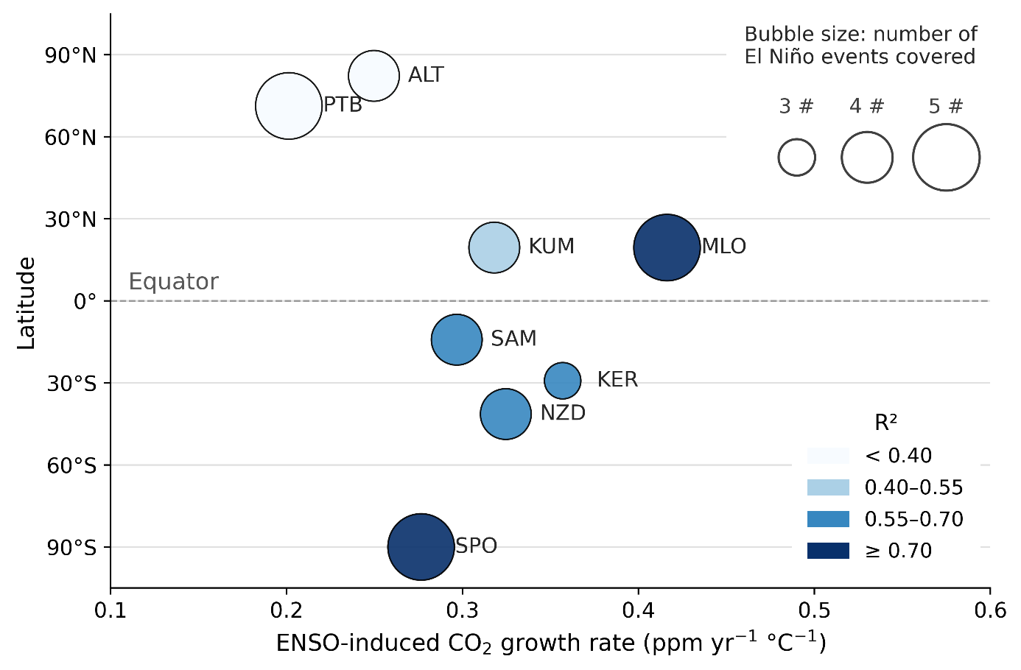
Figure S3. Latitudinal dependence of ENSO-induced CO$​_{2}$ sensitivity across global observation sites. The x-axis represents the sensitivity of the CO$​_{2}$ growth rate to ENSO (ppm yr⁻¹°C⁻¹). Bubble color indicates the coefficient of determination (R²), and bubble size represents the number of El Niño events covered by the record at each site. A clear gradient is observed, with higher sensitivities concentrated in the tropical and subtropical regions.

Table S1. Station-level regression statistic results relating CO$​_{2}$ growth rates to ENSO variability and anthropogenic emissions
Site | Location (lat, lon) | Alt. (m) | $$α_{0}$$ | $$α_{N}$$ | $$α_{E}$$ | $$R^{2}$$ | $$n_{years}$$
ALT | Alert, Nunavut, Canada (82.3$​^{∘}$N, 62.3$​^{∘}$W) | 210 | 0.239 | 0.250 | 0.240 | 0.28 | 36
KER | Kermadec Islands (29.2$​^{∘}$S, 177.9$​^{∘}$W) | 2 | 0.059 | 0.357 | 0.201 | 0.62 | 36
KUM | Cape Kumukahi, Hawaii (19.5$​^{∘}$N, 154.8$​^{∘}$W) | 3 | 0.252 | 0.318 | 0.194 | 0.47 | 42
NZD | Baring Head, New Zealand (41.4$​^{∘}$S, 174.9$​^{∘}$E) | 85 | 0.193 | 0.325 | 0.228 | 0.64 | 44
SAM | American Samoa (14.2$​^{∘}$S, 170.6$​^{∘}$W) | 30 | 0.119 | 0.297 | 0.225 | 0.58 | 40
MLO | Mauna Loa Observatory, Hawaii (19.5$​^{∘}$N, 155.6$​^{∘}$W) | 3397 | 0.307 | 0.416 | 0.251 | 0.86 | 63
PTB | Barrow, Alaska (71.3$​^{∘}$N, 156.6$​^{∘}$W) | 11 | 0.176 | 0.201 | 0.197 | 0.34 | 60
SPO | South Pole Observatory, Antarctica (90.0$​^{∘}$S) | 2810 | 0.319 | 0.276 | 0.244 | 0.84 | 63

Reference
Betts, Richard A., Chris D. Jones, Jeff R. Knight, Ralph F. Keeling, and John J. Kennedy. 2016. “El Niño and a Record CO₂ Rise.” Nature Climate Change 6 (9): 806–10. https://doi.org/10.1038/nclimate3063.
Chatterjee, A., M. M. Gierach, A. J. Sutton, et al. 2017. “Influence of El Niño on Atmospheric CO₂ over the Tropical Pacific Ocean: Findings from NASA’s OCO-2 Mission.” Science 358 (6360): eaam5776. https://doi.org/10.1126/science.aam5776.
Friedlingstein, Pierre, Michael O'Sullivan, Matthew W. Jones, et al. 2025. “Global Carbon Budget 2024.” Earth System Science Data 17 (2): 965–1039. https://doi.org/10.5194/essd-17-965-2025.
Scripps Institution of Oceanography. 2024. The Scripps CO₂ Program. Https://scrippsco2.ucsd.edu.
Keeling, Charles D., Stephen C. Piper, Robert B. Bacastow, et al. 2005. “Atmospheric CO2 and ¹³CO₂ Exchange with the Terrestrial Biosphere and Oceans from 1978 to 2000: Observations and Carbon Cycle Implications.” In A History of Atmospheric CO₂ and Its Effects on Plants, Animals, and Ecosystems, edited by James R. Ehleringer, Thure E. Cerling, and M. Denise Dearing. Springer.

