Supplementary Information
Toxic and useful: Harnessing yeast killer toxins for product recovery
Ankita Suri¹, Michael Norman¹, David Wollborn², Tom Loan³, Jian-Wei Liu⁴, Shoko Okada^{1*}
*Corresponding author: shoko.okada@csiro.au
Affiliations
- CSIRO, Agriculture and Food, Canberra, 2601, Australia
- CSIRO, Agriculture and Food, Werribee, 3030, Australia
- Centre for Future Materials, Research School of Biology, Australian National University, Acton, ACT 2601, Australia
- CSIRO, Environment, Canberra, 2601, Australia

Table S 1 List of plasmids used in this study
Plasmids | Description | Source
pESC-His | HIS3, f1 ori, ADH1 terminator, MCS1/FLAG, P_{GAL10}/P_{GAL1}, MCS2/myc, CYC1 terminator, pUC ori, ampicillin, 2μ ori. | Agilent technologies # 217451
pmCherry | URA3, 2μ ori, AmpR+ColE1, P_{TDH3}-AAACA-mCherry-T_{CY1} | This study
pHM-1 | HIS3, 2μ ori, KanR+ColE1, P_{GAL1}-AAACA-HM-1- T_{CYC1} | This study
pHSK | HIS3, 2μ ori, KanR+ColE1, P_{GAL1}-AAACA-HSK- T_{CYC1} | This study
pTruncatedK2 | HIS3, 2μ ori, KanR+ColE1, P_{GAL1}-AAACA-TruncatedK2 - T_{CYC1} | This study
pZygocin | HIS3, 2μ ori, KanR+ColE1, P_{GAL1}-AAACA-Zygocin- T_{CYC1} | This study
pZymocin | HIS3, 2μ ori, KanR+ColE1, P_{GAL1}-AAACA-Zygocin- T_{CYC1} | This study

Figure S 1 A Serial dilution spot assay of S. cerevisiae BY4741 expressing different yeast killer toxins. Cultures were serially diluted 10-fold (10⁻² to 10⁻⁶) and spotted onto selective SCI agar plates of pH 4.6 or 5.5 and incubated at 30 °C for 72 h .

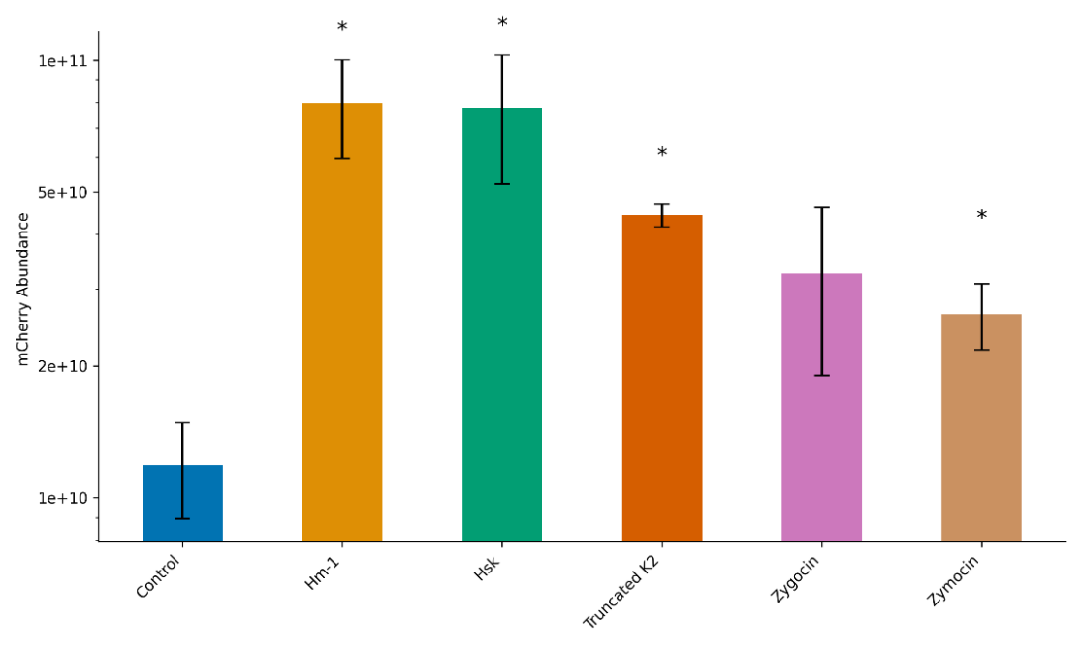
Figure S 2 mCherry abundance quantified by proteomics (LC-MS/MS) in culture supernatant of S. cerevisiae strains expressing different killer toxins. Bar represents the mean mCherry abundance (mean± SD, n=3). * represents significance of each toxin compared to the control strain (Games-Howell test, p value <0.05).

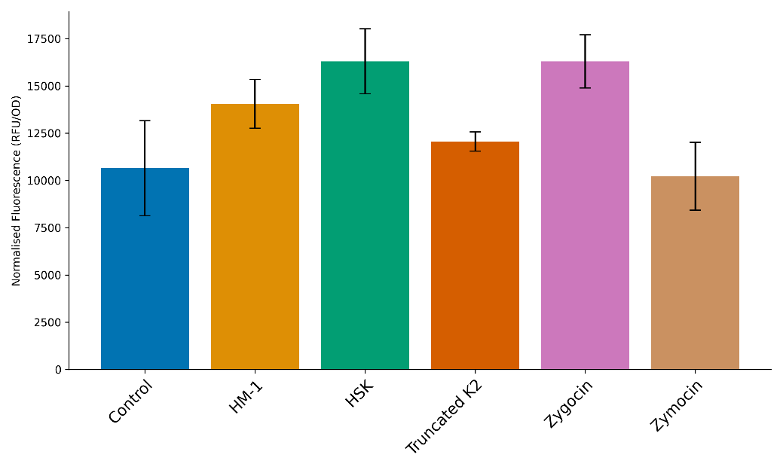
Figure S 3 Intracellular mCherry fluorescence measured in empty vector control and toxin-expressing yeast strains before mechanical disruption. The cultures were adjusted to an O.D._{600nm} of 0.5 and the measured fluorescence was normalised by O.D._{600nm}. Data represent mean ± SD from three biological replicates (n=3). Statistical analysis used Welch’s one way ANOVA followed by Games-Howell comparison against control strain.

