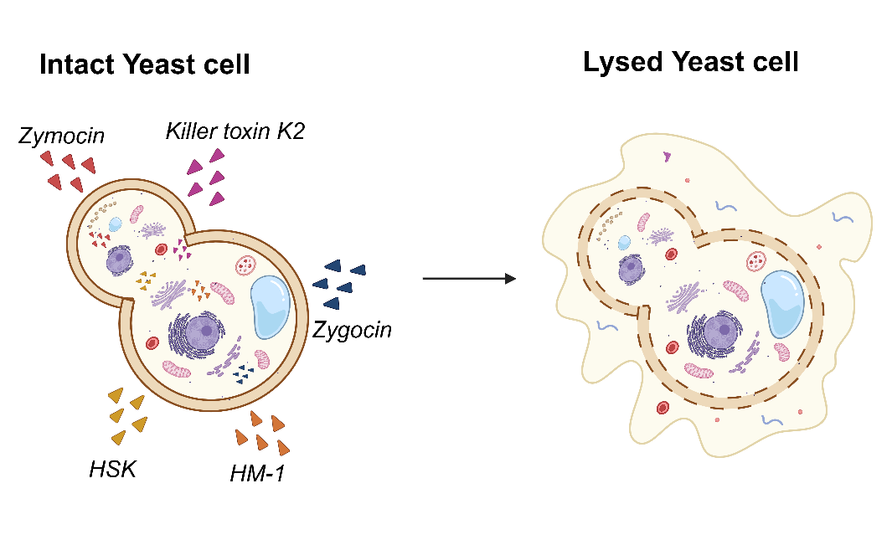
Schematic representation of yeast killer toxin-induced autolysis.

