Supporting Information

Table S1. Primer sequences for PCRs and dsRNA synthesis

Primer/adapter | Sequence 5′ → 3′ (IDT, Germany) | PCR template
dsDcr2* forward | GAATTGTAATACGACTCACTATAGGGAGCTCGATTTCCTAATCACCTGC | P. chrysocephala adult cDNA
dsDcr2* reverse | GAATTGTAATACGACTCACTATAGGGAGACTGTCTAAATACACTGCTCC | P. chrysocephala adult cDNA
dsPc-1* forward | GAATTGTAATACGACTCACTATAGGTGACCTGAAAGCATTGCAGAG | P. chrysocephala adult cDNA  (see Supporting Dataset 1 for the sequence)
dsPc-1* reverse | GAATTGTAATACGACTCACTATAGGAGGTGTAATTCCAACTCTCA | P. chrysocephala adult cDNA  (see Supporting Dataset 1 for the sequence)
dsPc-2* forward | GAATTGTAATACGACTCACTATAGGGAGAGCCAGTTACAGCCCAACCTAC | Synthetic dsDNA template (IDT, Germany)
dsPc-2* reverse | GAATTGTAATACGACTCACTATAGGGAGACGTACGATGTGAAAGTGCTGA | Synthetic dsDNA template (IDT, Germany)
dsmGFP* forward | GAATTGTAATACGACTCACTATAGGACCCTGACCTACGGCCTAT | Synthetic dsDNA template (IDT, Germany)
dsmGFP* reverse | GAATTGTAATACGACTCACTATAGGTGCCGTCCTCGTACTAGTT | Synthetic dsDNA template (IDT, Germany)
Dcr2 RT-qPCR forward | GGCCTGGTGCTCAACCTAAA | P. chrysocephala adult cDNA
Dcr2 RT-qPCR reverse | TCACGGCTAAGAAAGCTGCA | P. chrysocephala adult cDNA
rps4e RT-qPCR reference forward | GGGTCGTGTTGGTACGGTAA | P. chrysocephala adult cDNA
rps4e RT-qPCR reference reverse | AGTAGCAAACACGTGGCCAT | P. chrysocephala adult cDNA
dsNode343 A1 forward | TGGCCAAAGGTAAAGATGTTCG | B. napus leaf cDNA
dsNode343 A1 reverse | CGACTAGGAGTGTTATGCCGA | B. napus leaf cDNA
dsNode343 A2 forward | CCAAGCGATCTTTTCGTCGG | B. napus leaf cDNA
dsNode343 A2 reverse | AAAGTTACTCTATTCACCCGTCT | B. napus leaf cDNA
dsNode343 whole forward | ATCCAAAGGAGGTTTCATGGC | B. napus leaf cDNA
dsNode343 whole reverse | AGGCTAGTAGTTCTAGGGGTCG | B. napus leaf cDNA
B. napus PCR actin-7 (EV116054) forward | TGGGTTTGCTGGTGACGAT | B. napus leaf cDNA
B. napus PCR actin-7 (EV116054) reverse | TGCCTAGGACGACCAACAATACT | B. napus leaf cDNA
dsGFP* PCR forward | TGCCATGCCCGAAGGTTATG | dsGFP (Eupheria Biotech, Germany) cDNA
dsGFP* PCR reverse | TCAGCACGCGTCTTGTAGTT | dsGFP (Eupheria Biotech, Germany) cDNA

* See Supporting Dataset 1 for full dsRNA sequence.
Table S2. Sequences of primers and adapters used for RNA degradome sequencing

Primer/adapter | Sequence 5′ → 3′
5′ RNA adaptor | GUUCAGAGUUCUACAGUCCGACGAUCAGCAG
RT-primer | CGAGCACAGAATTAATACGACTTTTTTTTTTTTTTTTTT
5′ adaptor | GTTCAGAGTTCTACAGTCCGAC
3′ adaptor | CGAGCACAGAATTAATACGACT
dsDNA top | TGGAATTCTCGGGTGCCAAGG
dsDNA bottom | CCTTGGCACCCGAGAATTCCA
Final 5′ PCR primer | AATGATACGGCGACCACCGAGATCTACACGTTCAGAGTTCTACAGTCCGA
Final 3′ PCR primer | CAAGCAGAAGACGGCATACGAGATACATCGGTGACTGGAGTTCAGACGTGTGCTCTTCCGATCT

Table S3. BLAST results showing homologous plastid sequences of dsNode343 from Brassica napus in other plant species based on NCBI reference genomes

Description | Max score | Total score | Query cover | E value | Percent identity | Accession length | NCBI accession
Subject: B. napus dsNode343 | 2809 | 2809 | 100% | 0.0 | 100.00% | 1521 | XM_048772801.1
A. thaliana dsNode343 | 1703 | 1703 | 85% | 0.0 | 90.53% | 1303 | LR881471.1
H. lupulus dsNode343 | 595 | 595 | 52% | 3e-173 | 80.69% | 919 | OY720658.1
S. tuberosum dsNode343 | 427 | 427 | 22% | 1e-122 | 89.88% | 934 | OM638079.1

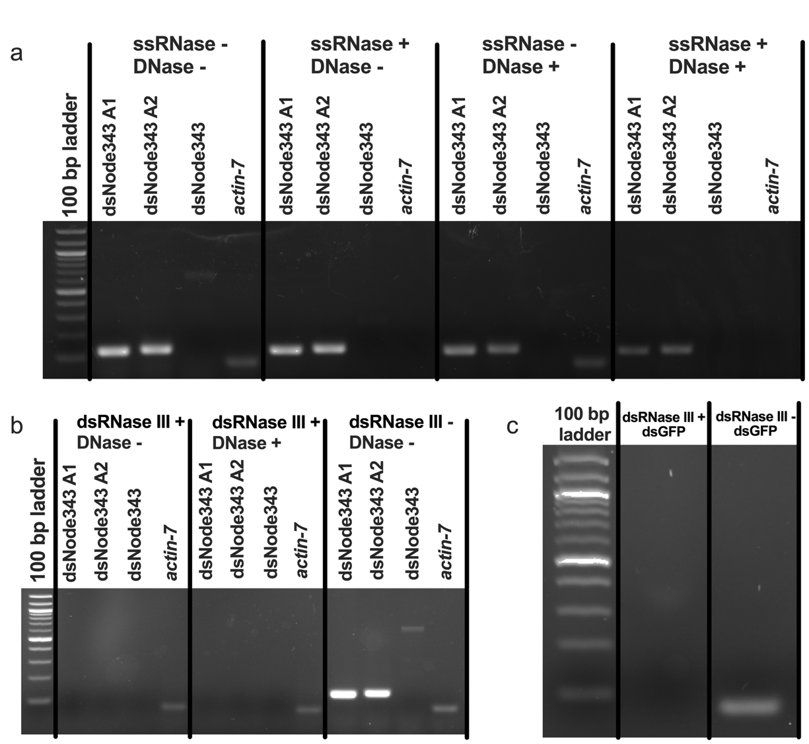

Figure S1. PCR-based confirmation of dsRNA status of dsNode343 fragments in B. napus.
a) Total RNA was extracted from B. napus leaves and incubated with ssRNase (RNase If, NEB) + DNase, only ssRNase, or only DNase, converted to cDNA using RevertAid cDNA Synthesis Kit (Thermo Scientific, Germany) in 50% DMSO and amplified (25 PCR cycles) using primers specific for dsNode343 A1 (133 bp amplicon), dsNode343 A2 (136 bp), the larger dsNode343 (728 bp) region containing both A1 and A2, or reference gene actin-7 (62 bp). The sequences of the dsNode343 A1 and A2 bands were confirmed by Sanger sequencing (Supporting Dataset 4).
b) Total RNA from B. napus leaves was incubated with ShortCut RNase III (dsRNase III), ShortCut RNase III (dsRNase III) + DNase, or mock treatment, converted to cDNA as above, and amplified (25 PCR cycles) using primers specific for dsNode343 A1, dsNode343 A2, the larger dsNode343 region, or actin-7.
c) dsGFP synthesized in vitro (Eupheria Biotech, Germany) was incubated with dsRNase III or mock treatment, converted to cDNA, and amplified (25 PCR cycles) using primers specific for GFP (75 bp) to confirm the dsRNA-specificity of dsRNase III treatment.
The gel images are representative of three independent replicates.

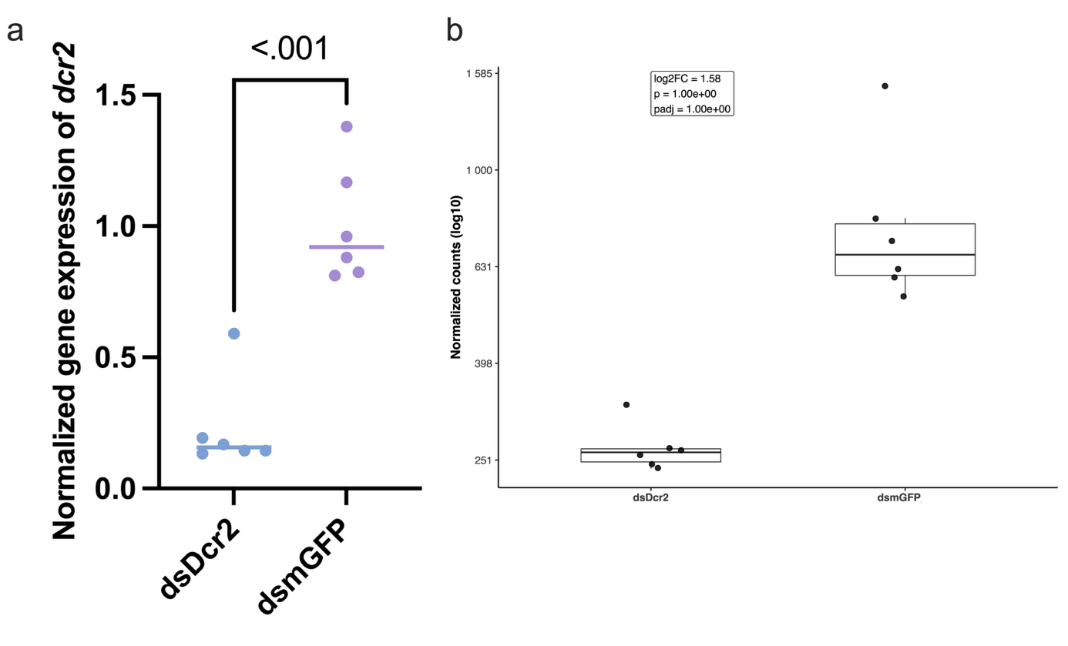
Figure S2. Confirmation that dsDcr2 feeding triggered the knockdown of dicer-2 (DN10673_c0_g1) in P. chrysocephala adults.
a) Confirmation by RT-qPCR using the Luna Universal One-Step RT-qPCR Kit (see Table S1 for primers). P value by t-test (n = 6).
b) Confirmation by RNA-seq (n = 6). P value by DESeq2.

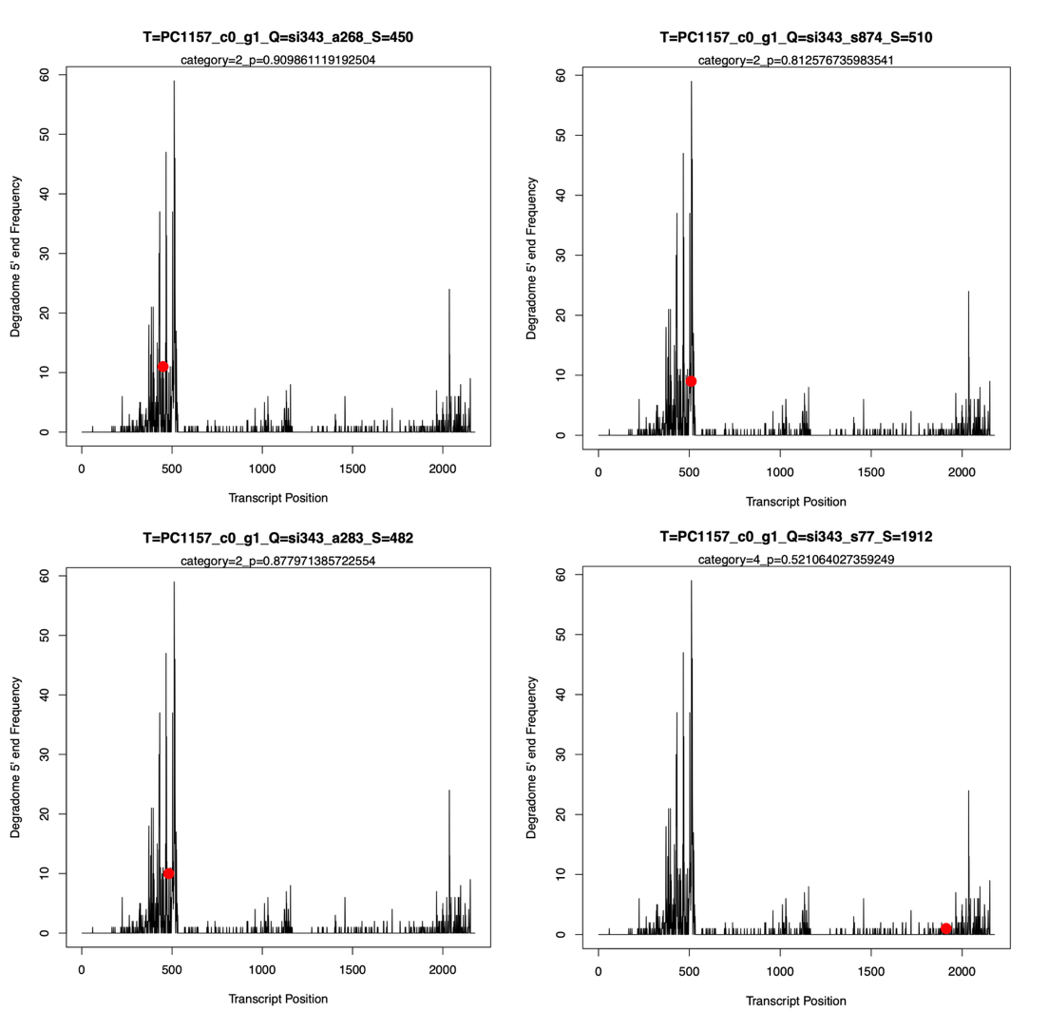
Figure S3. Other dsNode343-derived siRNAs associated with cleavage of the cortactin transcript. CleaveLand4 5′ end degradome frequency plot of the cortactin transcript (same frequency data in all plots) is shown with the red dots indicating different complementary dsNode343-derived siRNAs.

