Supplementary Material
- Supplementary Methods
Bayesian hierarchical beta-binomial regression
Prior Specifications
Weakly informative zero-centered Gaussian priors were used for regression coefficients in the mean model (fixed effects), used as implemented by default in the INLA-R package; while for hierarchical (random-effect) components, we used penalized complexity (PC) priors on precision to favor simpler (lower-variance) models unless the data strongly supported heterogeneity. These choices aimed to estimate data-driven posterior estimates, while also providing principled regularization, improving numerical stability and guarding against overfitting.
Likelihood function (Beta-Binomial for course-level counts)
The primary outcome was modeled as a count conditional on the number tested using a beta-binomial likelihood:
$$yi​∣ni​,pi​∼Beta_Binomial(ni,pi​)$$
This choice directly models the number of proficient examinees (yi) out of the total examinees per course (ni), given the latent course-level proficiency probability (pi); while also allowing extra-binomial variability (overdispersion) across courses, an important feature to partially account for unmeasured course-level differences that can induce more variability than a strict binomial model would detect.
To estimate the probability of graduating proficient students per course (pi​) we fit a Bayesian hierarchical multivariate model using a logit link:
$$logit(pi)=\$β_{0}+\$β^{T}Xi+u_{state\left(i\right)}+v_{city(i)}$$
Where 0 is the intercept, i are regression (fixed-effect) coefficients and Xiis the vector of course-level predictors composed of: (i) institutional administrative category, (ii) authorized yearly enrollment slots (per additional 100 slots, mean-centered), (iii) curricular workload (per 1,000 hours, mean-centered), (iv) Prior Grading by MEC using the Preliminary Course Concept (CPC), capital-city status, and a binary indicator for post More-Doctors program establishment (≥2014). Enrollment increases were expressed per an additional 100 slots to improve interpretability and numerical stability; curricular workload was expressed per 1,000 hours to yield policy-interpretable units.
The terms U_{state(i)} and V_{city(i)} are random intercepts that capture residual geographic clustering at the state level U_{state(i)} and the city-within-state level V_{city(i)}, respectively. Both random effects were specified as independent and identically distributed (IID) Gaussian effects centered at zero.
Estimation and reporting (posterior-based inference using INLA):
Model fitting and inference were conducted in R using Integrated Nested Laplace Approximation (INLA). INLA provides accurate deterministic approximations to posterior distributions for latent Gaussian hierarchical models and is computationally efficient for complex multilevel models, enabling full Bayesian uncertainty quantification without the need for Markov chain Monte-Carlo simulation. All reported results were derived from posterior distributions of model parameters and posterior predictive quantities. We report posterior means and 95% credible intervals (CrI).
A key design decision was to model the full course-level proficiency proportion using
$$pi=\frac{Number of Proficient Medical Graduates (yi)}{Total graduating examinees (ni)}$$
rather than converting outcomes into categories (e.g., ordinal grading groupings) or a binary indicator (≥60% vs <60%). This avoids information loss (e.g., courses substantially different proficiency levels are not treated as identically in the same stratum) and preserves the role of the denominator (courses with fewer examinees appropriately carry more uncertainty).
Of note, it also enables direct translation of model outputs into policy-relevant quantities by allowing us to the posterior probability that a course meets the INEP standard targets and summarized system-level assurance within each institutional category as the expected proportion of courses whose modeled probability exceeds the 60% threshold, conditional on its covariate profile and geographic context.

Sensitivity Analysis and Model Diagnostics
Model adequacy was evaluated using INLA’s leave-one-out predictive diagnostics and calibration checks. We examined conditional predictive ordinates (CPO) and probability integral transform (PIT) summaries to assess predictive consistency, and we assessed calibration by comparing observed course proficiency proportions to model-predicted probabilities across bins of fitted values. These diagnostics were used to confirm that the model was not systematically miscalibrated and that posterior uncertainty appropriately reflected the variability observed in the data.
Furthermore, as the relationship between enrollment slots and course-level ENAMED performance is policy-relevant and not guaranteed to be linear, we evaluated multiple plausible model specifications and selected the best-supported model using information criteria. Specifically, we compared: (i) a model with a linear main effect of +100 enrollment slots; (ii) a model with a slots × institutional category interaction; and (iii) a model allowing a non-linear smooth effect of slots using a second-order random walk (RW2). Models were compared using WAIC and DIC, where lower values indicate better expected out-of-sample predictive performance after accounting for model complexity. The final specification was chosen as the model with the lowest WAIC, assuming a linear main effect of +100 enrollment slots and numerical stability was verified using CPO diagnostics. All diagnostics are present in Supplementary Figure 1 and Supplementary Table 1.
Model comparison results supported a parsimonious linear specification for enrollment slots (Supplementary Table S2). The linear main-effect model achieved the lowest WAIC (2,615.6) and competitive DIC (2,612.2), with no CPO failures. A non-linear RW2 smooth yielded nearly identical fit (WAIC 2,616.7; DIC 2,612.1), indicating limited evidence that a more complex functional form substantially improves predictive performance over the evaluated range. A linear interaction between slots and institutional category performed worse (WAIC 2,619.7; DIC 2,615.9), supporting the use of a single interpretable slot effect for the main analysis.

- Supplementary Tables
Supplementary Table S1: Proficiency by Institutional Category
Institutional category | Mean Grade | Courses with low proficiency | Total courses | % Below proficiency threshold
Public (State) | 70.9 | 1 | 38 | 3%
Public (Federal) | 68.7 | 4 | 78 | 5%
Community/Confessional | 66.9 | 2 | 36 | 6%
Private (Non-profit) | 65.0 | 21 | 63 | 33%
Special Schools | 62.2 | 6 | 11 | 55%
Private (For-profit) | 61.9 | 65 | 112 | 58%
Public (Municipal) | 60.4 | 7 | 8 | 88%

Supplementary Table S2: Model Comparison for Enrollment Effect (WAIC/DIC)
Candidate model | Information criteria |  | CPO failure rate
Candidate model | WAIC | DIC | CPO failure rate
Linear: Slots (main effect) | 2,615.60 | 2,612.20 | 0.00%
Non-linear: RW2 smooth of Slots | 2,616.70 | 2,612.10 | 0.00%
Linear: Slots × Institutional Category | 2,619.70 | 2,615.90 | 0.00%
Supplementary Table 2 Legend:
Supplementary Table S1 represents a comparison of models using WAIC and DIC from INLA fits; while CPO failure rate indicates numerical stability Linear = linear fixed-effect of enrollment slots; RW2 = non-linear effect of enrollment slots modeled with a second-order random walk (RW2); LIN-INT = linear interaction between enrollment slots and institutional category.

Supplementary Table S3: For-Profit Private Fixed Effects (Hierarchical Beta-Binomial)
Institution Characteristics: | Posterior Coefficient  Mean [95CrI] | Odds ratio (OR)  Mean [95 CrI]
Enrollment slots (per +100 slots) | -0.089 [-0.322, 0.141] | 0.915 [0.73, 1.15]
Curricular workload (per 1,000 hours) | -0.233 [-0.444, -0.023] | 0.792 [0.64, 0.98]
Capital city location (yes vs no) | -0.105 [-0.424, 0.218] | 0.9 [0.65, 1.24]
Post–Mais Médicos period (≥2014) | -0.529 [-0.807, -0.251] | 0.589 [0.45, 0.78]
Private conglomerate affiliation (Yes vs No) | -0.139 [-0.390, 0.109] | 0.87 [0.68, 1.12]
Supplementary Table S3 Legend:
Supplementary Table S3 presents adjusted fixed effects from the beta-binomial model fitted only among For-Profit Private courses, with state and city-within-state random intercepts. Enrollment increases are measures as an additional 100 slots within the for-profit subgroup, while Course workload is measured per 1000 hours.

3. Supplementary Figure
Supplementary Figure S1: Diagnostic plots for the Bayesian hierarchical beta-binomial model
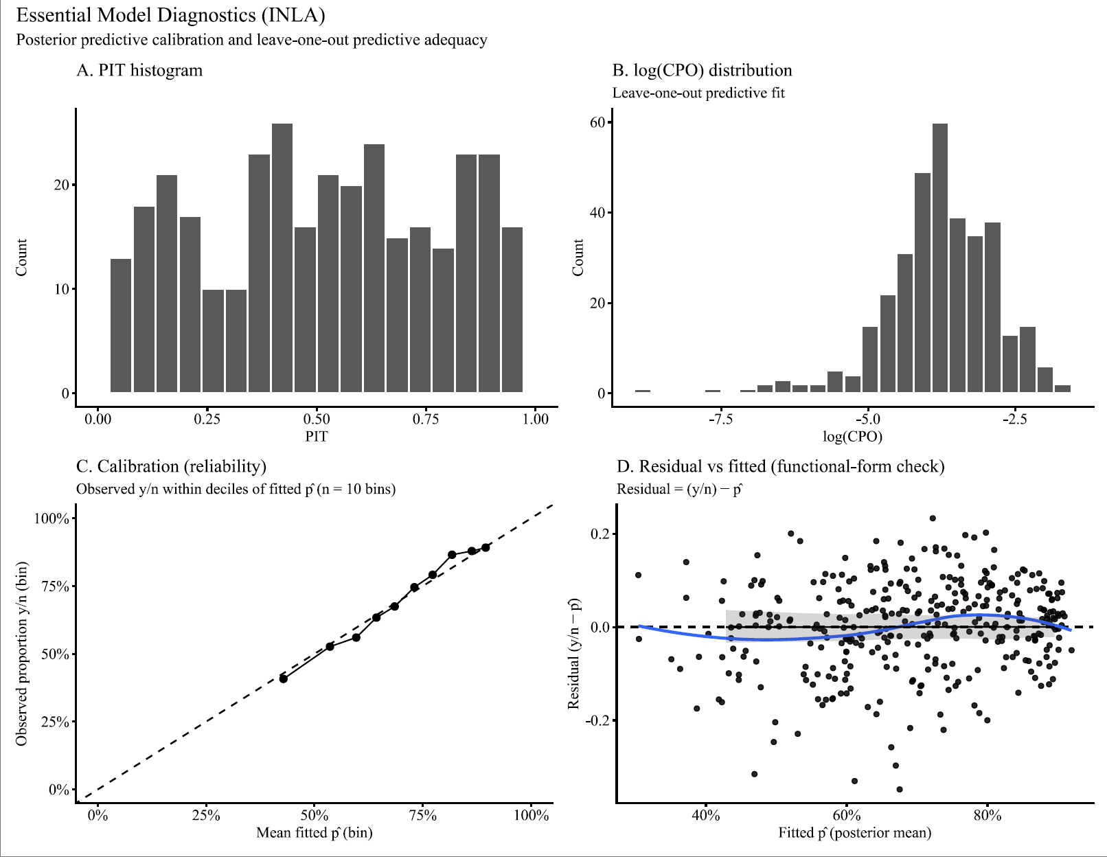

Supplementary Figure S1 Legend: This figure presents posterior predictive and leave-one-out diagnostics for the Bayesian hierarchical beta-binomial model used to estimate the proportion of proficiency in medical graduates, per medical course/program included in the analysis, while accounting for institutional covariates and state and city-within-state random intercepts. (A) The Probability Integral Transform (PIT) histogram assesses predictive calibration; the approximately uniform distribution indicates good calibration. (B) The log (CPO) distribution evaluates leave-one-out predictive fit, with no extreme values suggesting stable prediction and absence of influential observations. (C) The calibration (reliability) plot compares observed and predicted proportions of graduate proficiency across deciles of fitted risk; close agreement with the diagonal indicates accurate calibration across the risk spectrum. (D) Residuals versus fitted values assess functional form and heteroscedasticity; the absence of systematic patterns in the plot suggests no major model misspecification.

