N-doped Activated Carbon-Supported Cu-Fe-Zn-Ni-Co High-Entropy Alloy Electrocatalyst: Improved ORR in Microbial Fuel Cells
Naveen Kumar Verma^{a,b}, Basker Sundararaju^{c}, and Nishith Verma^{a,d,*}
ªDepartment of Chemical Engineering, Indian Institute of Technology Kanpur, Kanpur- 208016, India.
^{b}Department of Chemical Engineering, Rajasthan Technical University, Kota-324010, India.
^{c}Department of Chemistry, Indian Institute of Technology Kanpur, Kanpur-208016, India.
^{d}Center for Environmental Science and Engineering, Indian Institute of Technology Kanpur, Kanpur-208016, India.

*Corresponding author:
Prof. Nishith Verma (Email id: vermanishith@gmail.com)

Materials and methods
List of regents
Phenol (C₆H₅OH), hexamethylene tetraamine ((CH₂)₆N₄, HMTA), formaldehyde (CH₂O), triethylamine (C₂H₅)₃N, TEA), 98-99% hydrolyzed poly vinyl-alcohol([-CH₂CH₂CH(OH)-]_{n}, 95000 g/mol, PVA), urea (NH₂CONH₂), potassium hydroxide (KOH), ethanol (C₂H₅OH), Aquivion® (D72-25BS), potassium ferricyanide (K₃Fe(CN)₆), phosphate buffer saline (pH-7.4, PBS), copper nitrate trihydrate (Cu(NO₃)₂.3H₂O), iron nitrate nonahydrate (Fe(NO₃)₃.9H₂O), zinc nitrate hexahydrate (Zn(NO₃)₂.6H₂O), nickel nitrate hexahydrate (Ni(NO₃)₂.6H₂O), cobalt nitrate hexahydrate (Co(NO₃)₂.6 H₂O), and urea (NH₂CONH₂) were purchased from Merck (Germany). The high purity nitrogen (N₂), hydrogen (H₂), and argon (Ar) gases were supplied by Sigma Gases (Delhi, India).

Physicochemical characterization
Field emission SEM images (FE-SEM, JEOL, JSM-7610F, US) and energy dispersive X-ray spectroscopy (EDS, Oxford instrument, UK) analysis were used to determine the surface texture and chemical compositions of samples, respectively. Prior to imaging, the samples were Au coated using an Au-sputter. The internal structure of CFZNC-HEA/N-ACP was examined by transmission electron microscopic images (TEM, FEI- Tecnai G2 12 Twin, USA, 120 kV). The graphitic characteristics of CFZCN-HEA/N-ACP was analyzed using Raman spectroscopy (Alpha 300 R, Witec, Germany). The pore volume and specific surface area (S_{BET}) of the materials were determined using N₂-adsoption desorption isotherms at 77.35 K (Autosorb-C, Quantachrome, US). X-ray diffraction analysis was performed over the 2θ values ranging 10 - 90º using the X-ray diffractometer (XRD, PAN analytical, PW-3050/60 US,) with Cu Kα radiation. The oxidation states of the elements in the materials were determined using x-ray photoelectron spectroscopy (XPS, K-th PHI 5000 Versa Prob ΙΙ, FEI inc., USA). Inductively coupled plasma mass spectrometry (ICP-MS, Agilent 7900, USA) was used to determine the composition of metals in the synthesized materials. Aqua regia (HNO₃: HCl::3:1 molar ratio) was used to leach out the metals from the synthesized materials. The samples were acid digested at 80 °C for 72 h. The digested liquid samples were then analyzed for ICP-MS.
Electrode preparation
Glassy carbon electrode (GCE) with/without catalyst-coating was used as the working electrode. A catalyst ink was prepared by dispersing catalyst powder (5 mg) in the mixture of ethanol (980 μl) and Aquivion® (20 μl), followed by sonication for 30 min in an ultrasonic bath sonicator. The catalyst ink (10 μL) was coated onto GCE (dia. 2 mm) using drop cast technique and solvents were evaporated at RT.
Electrochemical ORR performance measurements
All electrochemical measurements and characterization were performed on the three- electrode electrochemical workstation (Squidstat Plus, Admiral Instruments, USA) at RT. Glassy carbon electrode coated with the catalyst was used as working electrode. Ag/AgCl (3 M KCl) electrode was used as the reference to apply potentials, while a Pt mesh was used as the auxiliary electrode. Electrolyte solutions were bubbled with Ar/O₂ gas for 30 min before electrochemical tests. Cyclic voltammetry (CV) was carried in a 0.1 M KOH solution at scan rate of 10 mV s⁻¹. The ORR kinetics was studied using rotating disc electrode (RDE) controlled by the connected motor (RDE2, Metrohm, The Netherlands). The RDE linear sweep voltammetry (LSV) was performed, and curves were recorded using different rotations ranging from 400 to 2000 rpm at the linear scan rate of 10 mV/s in the 0.1 M KOH solution. The electrochemical impedance spectroscopy (EIS) was carried out at OCP with the sinusoidal voltage of the amplitude 0.01 V and the frequency range spanning from 10⁵ to 10⁻³ Hz.
MFC set-up and operation
A dual chambered H-type MFC was fabricated using acrylic blocks, with the anode and cathode chamber volume of 100 ml each. Cathodes were fabricated using wet-spray coating of the homogenously mixed catalyst ink on the pretreated activated carbon fabric (ACF, GECIC Ltd., Japan). A catalyst ink was prepared by mixing 1 mg/ml of the as-synthesized catalyst in ethanol with Aquivion® under ultrasonication condition for 30 min. The homogenous catalyst ink was sprayed over the ACF using an airbrush operated under 99.99% pure compressed Ar gas. The ACF was pre-treated with 1M HNO₃ followed by sonication and water washing to remove any organic or inorganic contaminants. The fabricated cathodes were dried at RT. The fabricated cathode and bare ACF anode were mounted in the cathode and anode chambers, respectively. The anodic and cathodic chambers were separated by the Nafion 117 proton exchange membrane. The entire assembly was held together with nut-bolt joint. Gaskets and nylon O-rings were placed at appropriate places to prevent water leakage from the sides. E. coli LB broth (~ 10¹⁰ CFU/ mL) was used for the inoculation of MFC. The glucose-based substrate having 500 mg/L COD in a 10 mM phosphate buffer solution (PBS, pH~7) was used as feed for the microorganisms. Anolyte was purged with Ar gas at least for 30 min to maintain an anaerobic condition in the anode chamber. The MFCs were operated in batch mode with the feed retention time of 48 h (2 days). All experiments were performed three times to check the repeatability.
MFC performance measurements
Generated voltages were measured with 1000 Ω external resistance using a multi-meter. Polarization studies were performed to achieve the maximum power density that can be harvested from the MFCs. Maximum power density (P) normalized to the cathode surface area was calculated: P = I²R/A, where I is the current at external resistance of R, and A is the geometric area of the working cathode.
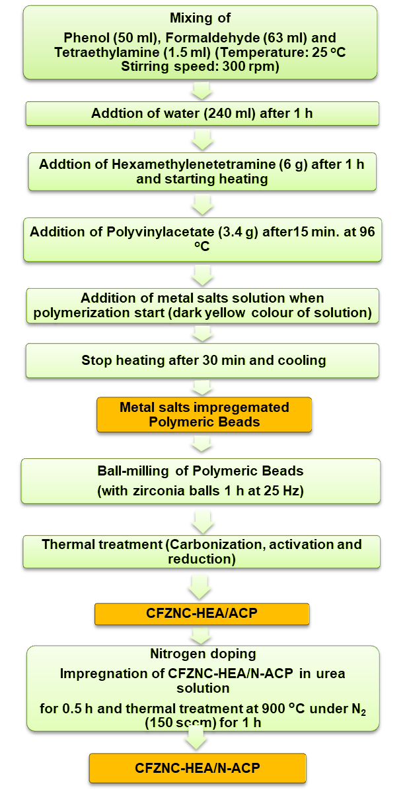
Fig. S1: Process bock diagram for the synthesis of CFZNC-HEA/N-ACP.
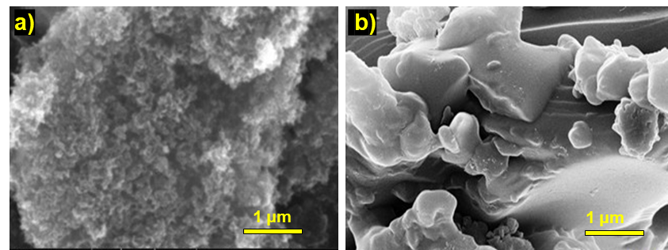
Fig. S2 SEM images of (a) N-ACP and (b) CFZNC.
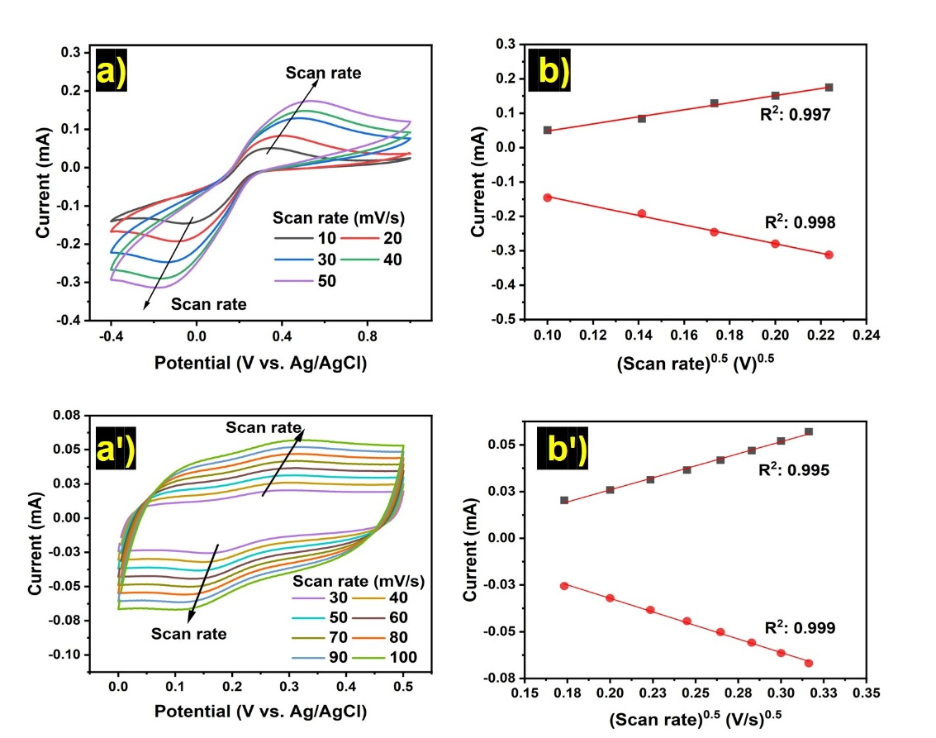
Fig. S3: CVs and linear fitting data for the ECSA estimation for (a-b) CFZNC and (aꞌ-bꞌ) N-ACP.
Metal | Mole% | ∆S/R
Cu | 41.42 | 0.37
Fe | 37.83 | 0.37
Zn | 2.35 | 0.09
Ni | 8.52 | 0.21
Co | 9.88 | 0.23
Total |  | 1.26
Table S1 ICP-MS analysis results and the calculated ∆S/R values of CFZNC.

Table S2 EIS results of N-ACP, CFZNC and CFZNC-HEA/N-ACP.
Working  electrode | Solution resistance  (Rs, Ω) | Charge transfer resistance  (R_{ct}, Ω) | Warburg resistance  (Zw, mMho)
N-ACP | 20.3 | 209 | 21.70
CFZNC | 21.4 | 92 | 48.80
CFZNC-HEA/N-ACP | 20.0 | 64 | 59.30

Table S3 Comparative ORR performance of various electrocatalysts.
S. No. | Catalyst | ORR onset potential (V) | Half wave potential | Electron transfer number | MFC performance | Ref.
1. | CFZNC-HEA/N-ACP | 1.12 V vs RHE | 0.82 vs RHE | 4.1 | OCP: 0.85 V  P_{max}: 0.26 mW cm⁻² | This study
2. | Fe-NPs modified N-doped porous carbon framework | 0.995 V vs. RHE | 0.874 V vs RHE | 3.93 | NA | [27]
3. | Sr/Fe Bimetallic Carbon Composites | 0.197 V vs. Ag/AgCl | −0.157 V vs. Ag/AgCl | 3.96 | OCP: 0.450 V  P_{max}: 398.98 mW m⁻² | [36]
4. | Co-Fe phthalocyanine supported on carbide | NA | NA | 4.1 | OCP: 0.741  P_{max}: 0.157 mW cm⁻² | [46]
5. | CoP NPs supported on rGO | 0.92 V vs RHE | 0.81 V vs RHE | 3.76 | NA | [47]
6. | N-doped mesoporous carbon | 0.975 V vs RHE | 0.86 V vs RHE | 3.5 | NA | [48]
7. | Fe and N co-doped carbon | 0.91 V vs RHE | 0.821 V vs RHE | 3.4 | NA | [49]
8. | N and Co dual-doped porous biocarbon | 0.87 V vs RHE | 0.786 V vs RHE | 3.84 | NA | [50]
rGO: reduced graphene oxide
NPs: Nanoparticles

