Supplementary Information

Ultrarobust, tough and highly stretchable self-healing materials based on cartilage-inspired noncovalent assembly nanostructure
Yuyan Wang¹, Xin Huang¹ & Xinxing Zhang¹

¹ State Key Laboratory of Polymer Materials Engineering, Polymer Research Institute, Sichuan University, Chengdu 610065, China
Correspondence and requests for materials should be addressed to X.Z. (email: xxzwwh@scu.edu.cn)
Supplementary Figures:
Supplementary Figure 1. Particle size distribution of WS₂ nanosheets.

Supplementary Figure 2. UV–vis absorption spectra of the exfoliated WS₂ nanosheets in TA solution after incubated 0 day and 30 days.
Supplementary Figure 3. Zeta potentials of WS₂ nanosheets in TA solution.

Supplementary Figure 4. FTIR spectra of WS₂ nanosheets dispersion after one week of dialysis.

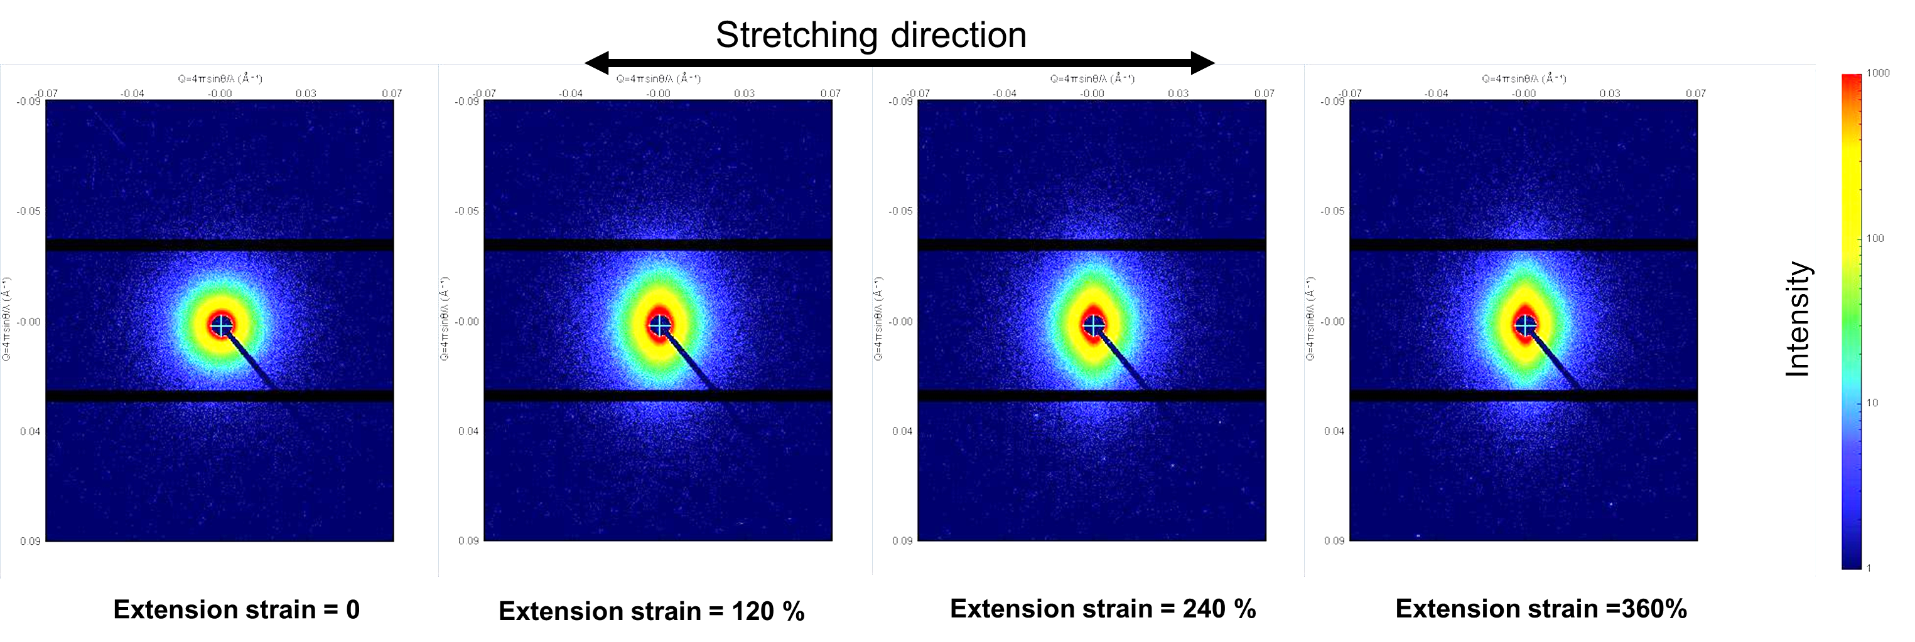
Supplementary Figure 5. 2D SAXS images of the TA-WS2/PU with different extension strain during uniaxial stretching process.
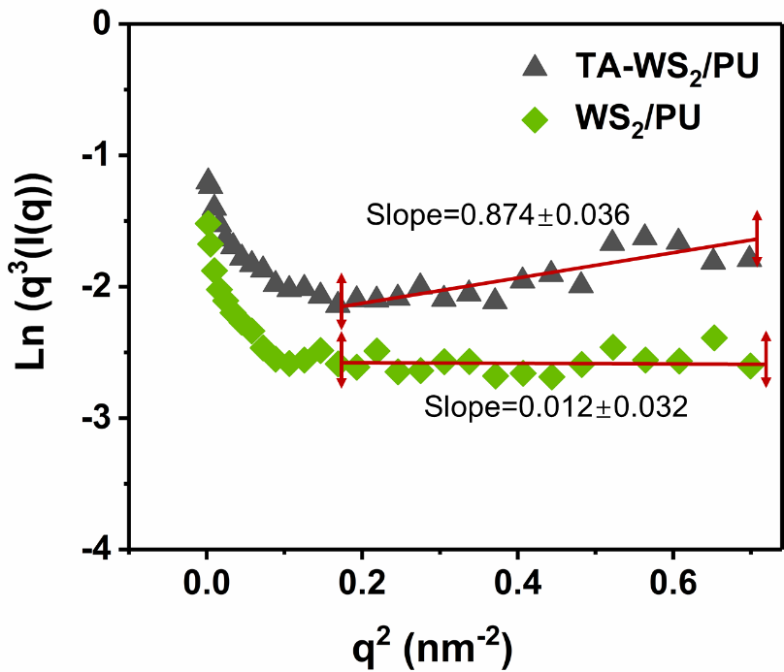
Supplementary Figure 6. SAXS plots of ln(I(q)) versus ln(q); origin data were divided into two parts according to the slope, and those slope values are represented in the graph.
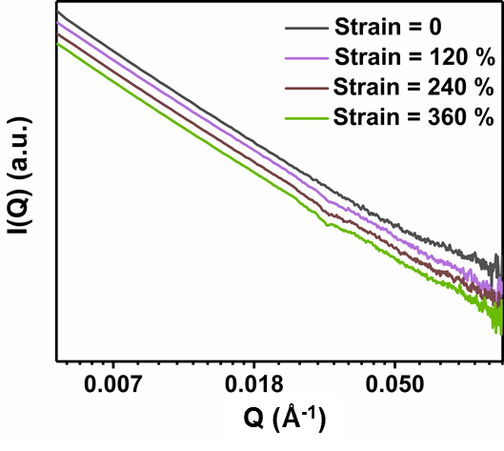
Supplementary Figure 7. 1D scattering profiles of WS₂/PU integrated from 2D SAXS patterns under different strains.
Supplementary Figure 8. Stress-strain curves of PU composites filled with different rigid fillers.

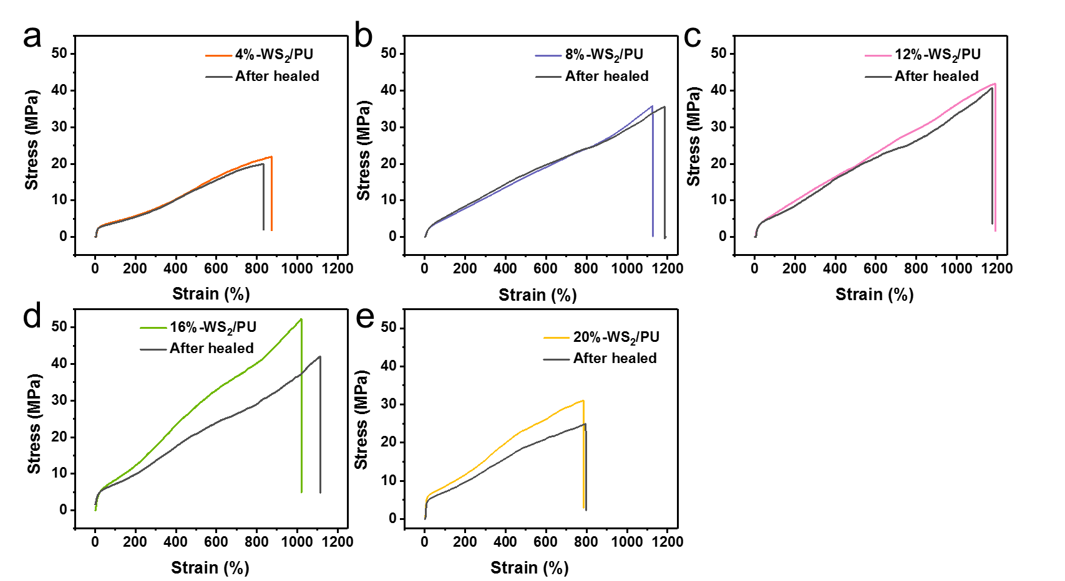
Supplementary Figure 9. Mechanical self-healing performance of PU composites filled with different contents of TA-WS₂.
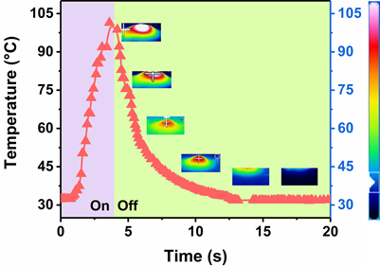
Supplementary Figure 10. NIR light-induced temperature rise of TA-WS₂/PU film, the images inserted in the upper right corner are temperature distribution IR camera images of a sample in the heat transfer process.
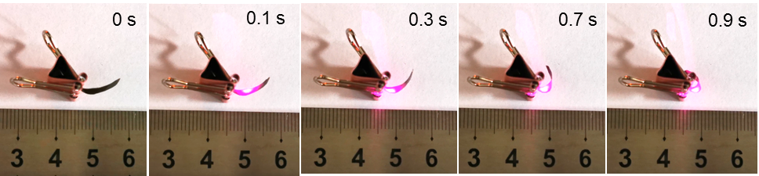
Supplementary Figure 11. Photographs of a film (15 mm × 2 mm × 0.15 mm) bending with NIR light (808 nm) irradiation.
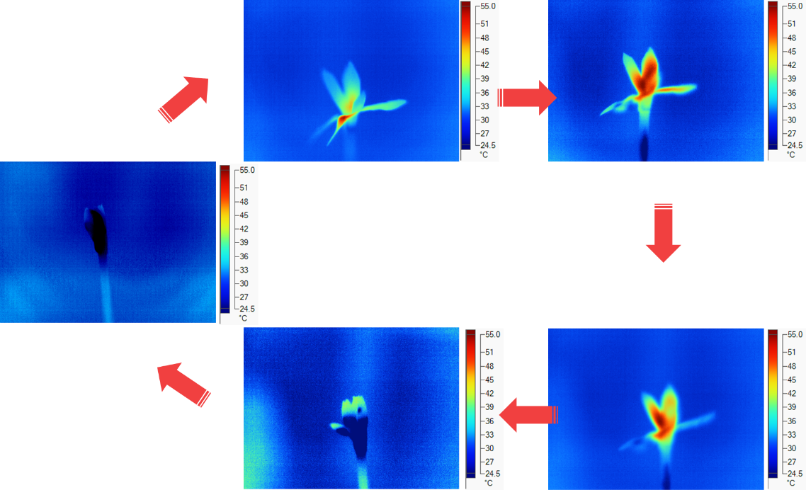
Supplementary Figure 12. Temperature distribution IR camera images of the “flower” in the heat transfer process.
Supplementary Table:
Table 1. Comparison of UTS, elongation at break, toughness, and recovery tests of various self-healing polymers ª.
Ref. | Self-healing motif | Ultimate tensile Strength [MPa] | Elongation at break [%] | Toughness [MJ m⁻³] | Self-healing efficiency [%] | Functional healing | Self-healing conditions
¹ | Disulfides | 6.8 | 923 | 26.9 | 76 | yes | RT. 2 h
² | Metal–ligand | 1.7 | 1700 | 15.3 | 78 | \ | RT. 48 h
³ | Metal–ligand | 1.1 | 310 | 1.35 | 76 | \ | RT. 48 h
⁴ | Ag–S bonds | 0.6 | 1200 | 3.6 | 93 | yes | NIR <1 min
⁵ | Olefin | 17.7 | 1270 | 68.2 | 59 | \ | RT. 120 h
⁶ | Hydrogen bonding | 25 | 1.85 | 0.2 | 95 % | \ | green laser at 80 °C 6 min
⁷ | Disulfides | 10 | 550 | 28.9 | 96 % | \ | Under sunlight in July. 6 h
⁸ | Disulfides | 10 | 550 | 28.9 | 43 % | \ | RT. 6 h
⁸ | Metal–ligand | 10 | 607 | 46.1 | 92 % | yes | RT. 15 s
This work | Hydrogen bonding | 52.3 | 1021 | 282.7 | 80.6 | yes | RT. 12 h
This work | Hydrogen bonding | 35.8 | 1127 | 225.5 | 105.1 | yes | RT. 12 h
ª RT stands for room temperature, self-healing efficiency = σ_{healing}/σ_{original}.
Supplementary Note:
Note 1. The robot first stretches into the plane due to the asymmetrically photothermal expansion. Force analysis reveals that the horizontal traction force of the rear-leg can exceed its maximum static friction resistance to move forward (Fig. 4f, position I). When moving to the position III, the stretched robot begins to bend to its original shape due to the NIR ligh off. According to the force analysis, the horizontal traction force of the front-leg (which is larger than the horizontal force of the rear-leg) will exceed its friction resistance, so the front leg will move forward until a new force balance is reached. As a result, this robot can crawl under periodic NIR light on and off.

Supplementary References
1. Kim, S. M. et al. Superior Toughness and Fast Self-Healing at Room Temperature Engineered by Transparent Elastomers. Adv. Mater. 30, 1705145 (2018).
2. Kang, J. et al. Tough and Water-Insensitive Self-Healing Elastomer for Robust Electronic Skin. Adv. Mater. 30, 1706846 (2018).
3. Rao, Y. L. et al. Stretchable self-healing polymeric dielectrics cross-linked through metal-ligand coordination. J. Am. Chem. Soc. 138, 6020–6027 (2016).
4. Song, P., Qin, H., Gao, H. L., Cong, H. P. & Yu, S. H. Self-healing and superstretchable conductors from hierarchical nanowire assemblies. Nat. Commun. 9, 1–9 (2018).
5. Wang, H. et al. Synthesis of Self-Healing Polymers by Scandium-Catalyzed Copolymerization of Ethylene and Anisylpropylenes. J. Am. Chem. Soc. 141, 3249−3257 (2019).
6. Si, Q. et al. Controllable and Stable Deformation of a Self-Healing Photo-Responsive Supramolecular Assembly for an Optically Actuated Manipulator Arm. ACS Appl. Mater. Interfaces 10, 29909–29917 (2018).
7. Xu, W. M., Rong, M. Z. & Zhang, M. Q. Sunlight driven self-healing, reshaping and recycling of a robust, transparent and yellowing-resistant polymer. J. Mater. Chem. A 4, 10683–10690 (2016).
8. Wang, Y. et al. Hierarchically Structured Self-Healing Actuators with Superfast Light- and Magnetic-Response. Adv. Funct. Mater. 29, 1906198 (2019).

