Table 3. Correct answers distribution according to the type of school of participants:
 | Public |  | Private |  | Total
 | n | % | n | % | n | %
- Inactive carious lesion (no treatment) | 122 | 36,3 | 49 | 33,6 | 171 | 35,5
- Non-cavitated active caries lesion* (non-invasive, microinvasive) | 292 | 86,9 | 106 | 72,6 | 398 | 82,6
- Active cavitated lesion that the patient can clean (non-invasive, micro, and mixed) | 230 | 68,5 | 91 | 62,3 | 321 | 66,6
- Active non-cavitated lesion that the patient cannot clean (invasive and mixed intervention) | 189 | 58,2 | 89 | 61,0 | 278 | 59,0
- Active lesion, cavitated with affected dentin (invasive and mixed) | 293 | 90,2 | 135 | 92,5 | 428 | 90,9
- Active lesion, cavitated without affected dentin (microinvasive and mixed) | 220 | 65,5 | 88 | 60,3 | 308 | 63,9
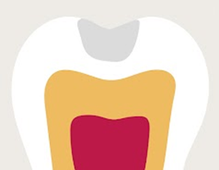  - Active non-cavitated lesion without affected dentin, which radiographically appears as in the following image (non-invasive) | 77 | 22,9 | 41 | 28,1 | 118 | 24,5
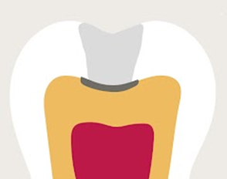  - Active non-cavitated lesion, with affected dentin, which radiographically appears as in the following image (microinvasive) | 113 | 33,6 | 44 | 30,1 | 157 | 32,6
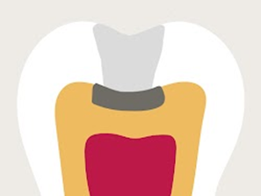  - Active non-cavitated lesion with affected dentin that is observed radiographically appears as in the following image (invasive) | 240 | 71,4 | 100 | 68,5 | 340 | 70,5
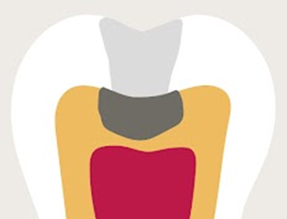  10 Active lesion, non-cavitated, with affected dentin visible radiographically | 262 | 78,0 | 101 | 69,2 | 363 | 75,3
*Chi-square=13.85, p=0.001

