Supplementary Information

Carbon burial outweighs the climate impact of methane emissions across global aquatic ecosystems

Yvonne Y.Y. Yau^{1,2}, Ariane Arias-Ortiz³, Meredith Holgerson⁴, Nicholas Ray⁵, Pierre Taillardat⁶, Linnea Henriksson¹, Mike Peacock^{7,8}, Gerard Rocher Ros⁹, Henrique Sawakuchi¹⁰, Craig Smeaton ¹¹, Stefano Bonaglia¹, Luiz C. Cotovicz Jr.¹², Xiaogang Chen ¹³, Daniela Henry ¹⁴, David Bastviken¹⁰, Hermann Bange¹⁵, Christian Stranne^{2,16}, Isaac R. Santos^{1, 17}

¹ Department of Marine Sciences, University of Gothenburg, Sweden
² Department of Geological Science, Stockholm University, Sweden
³ Department of Physics, Universitat Autonoma de Barcelona, Barcelona, Spain
⁴ Department of Ecology and Evolutionary Biology, Cornell University, Ithaca, New York, United States
⁵ School of Marine Science and Policy, University of Delaware, United States
⁶ Asian School of the Environment, Nanyang Technological University, Singapore
⁷ Department of Geography and Planning, School of Environmental Sciences, University of Liverpool, Liverpool, United Kingdom
⁸ Department of Aquatic Sciences and Assessment, Swedish University of Agricultural Sciences, Uppsala, Sweden
⁹ Integrated Science Lab (IceLab), Department of Ecology and Environmental Science, Umeå University, 901 87 Umeå, Sweden
¹⁰ Department of Thematic Studies – Environmental Change, Linköping University, Linköping, Sweden
¹¹ School of Geography and Sustainable Development, University of St Andrews, United Kingdom
¹² Centro de Estudos do Mar, Universidade Federal do Paraná, Pontal do Paraná, Brazil
¹³ Key Laboratory of Coastal Environment and Resources of Zhejiang Province, School of Engineering, Westlake University, Hangzhou 310024, China
¹⁴ Centre d’Estudis Avançats de Blanes (CEAB-CSIC), Blanes, 17300, Catalonia, Spain
¹⁵ Marine Biogeochemistry Res. Div., GEOMAR Helmholtz Centre for Ocean Research Kiel, Kiel, Germany
¹⁶ Baltic Sea Centre, Stockholm University, Sweden
¹⁷ Faculty of Science and Engineering, Southern Cross University, Australia

Supplementary Text
Text 1. Description of data sources
- CH₄ data

Lakes and Small lakes and Ponds
CH₄ flux of the pond and lake were derived from a) Johnson et al. (2022), b) Kuhn et al. (2021) , c) Taillardat et al. (2024), d) Zheng et al., (2022) and e) Rosentreter et al., (2021).

a) Johnson et al. (2022) reported diffusive and ebullition fluxes (mg CH₄ m⁻² d⁻¹). When fluxes were reported at the same site, we combined them. All the data were included in our analysis. b) Kuhn et al. (2021) (BAWLD-CH₄ aquatic dataset) included CH₄ flux from boreal and Arctic lakes and pond. The fluxes reported as diffusive, ebullition and total CH₄ fluxes (mg CH₄ m⁻² d⁻¹). c) CH₄ data from peatland pools in Taillardat et al. (2024) was treated as pond in this study. Total CH₄ fluxes were reported in mg CH₄ m⁻² d⁻¹. d) Zheng et al 2022 compiled CH₄ fluxes from lakes in mg CH₄ m⁻² hr⁻¹. e) Rosentreter et al., (2021) were also incorporated.
The dataset were check for duplication. If the site only reported ebullition fluxes, we exclude it from our analysis to avoid extrapolation to yearly fluxes.

We converted the daily fluxes to yearly fluxes by summing the daily fluxes for ice-free period and applied 0.3 correction for ice-period (Denfeld et al., 2018). The ice period was estimated from NOAA dataset (Figure S10). We reclassified the pond and lake data using their GPS location and Hydrolakes dataset (Messager et al., 2016). Lakes which were not identified in Hydrolakes dataset were assumed to be smaller than 0.1 km² and classified as small lakes and ponds.

Reservoirs
CH₄ flux of reservoir were derived from Johnson et al., (2021) and Zheng et al., (2022).
a) Johnson et al., (2021) reported diffusive, ebullition and total CH₄ fluxes in unit of mg CH₄ m⁻² d⁻¹. We also added studies from Zheng et al., (2022). Data were checked for duplication with Johnson et al., (2021).
If the site only reported ebullition fluxes, we exclude it from our analysis to avoid extrapolation to yearly fluxes. We converted the daily fluxes to yearly fluxes by summing the daily fluxes for ice-free period and applied 0.3 correction for ice-period (Denfeld et al., 2018). The ice period was estimated from NOAA dataset (Benson et al., 2000) (Figure S11).

Inland wetlands
CH₄ flux of peatland were compiled data from a) Delwiche et al., (2021), b) Kuhn et al., (2021) , c) Treat et al., (2018), d) Evans et al., (2021) and e) Schuster et al., (2024). f) Ma et al., (2024)
a) Delwiche et al., 2021 include global freshwater wetlands from eddy covariance, FLUXNET CH₄ dataset. Annual CH₄ flux (g CH₄ m⁻² yr⁻¹) was extracted and converted to daily CH₄. We excluded uplands (n = 15), rice paddies (n = 7) and drained wetlands (n = 7). Due to duplication of the other dataset, mangrove (n = 1) and saltmarsh (n = 5) were removed from FLUXNET-CH₄ dataset.
b) Kuhn et al., (2021) (BAWLD-CH₄ terrestrial) includes average growing season and annual CH₄ flux from boreal and arctic wetland and non-wetland (Kuhn et al., 2021). We extracted bogs, fens, permafrost bogs, and tundra wetlands and marshes, defined by BAWLD land cover classification (Olefeldt et al., 2021). We exclude “boreal forests” and “upland tundra” from the BAWLD-CH₄ terrestrial dataset.
Annual CH₄ fluxes were used for analysis when reported. If only average growing season CH₄ fluxes were available, we estimated cumulative growing season CH₄ fluxes (g CH₄ m⁻²) by multiplying the reported flux by the number of growing season days. If the growing season was not specified, it was defined as June through mid-September for high latitude (>60°N) and April – October lower latitudes (40°N - 60°N). The cumulative growing season CH₄ flux was modelled to annual CH₄ flux using the relationship from Treat et al., (2018), based on the biomes in wetlands (temperate, boreal and tundra).
c) Treat et al., (2018) reported seasonal fluxes, non-growing season and annual CH₄ fluxes from temperate, boreal and wetland ecosystems. We exclude the wetland class as “upland” and “pond”. We used the annual CH₄ fluxes for our analysis.
d) We also compiled CH₄ data from UK peatlands (Evans et al., 2021), but only included fens (n=14) and raised bogs (n=9) and excluded arable land and grassland, rewetted peatlands from our analysis. CH₄ data were reported as annual CH₄ data (kg CH₄ ha⁻¹ yr⁻¹) and converted to daily fluxes by dividing 365 days.
e) We combined CH₄ data from freshwater wetland (Schuster et al., 2024) and extracted fens (n=1), bogs (n=53) and peat swamps (n=3). We excluded “degraded” and “restored” treatment type, keeping only “natural” wetlands in this analysis. The CH₄ data were reported as annual and daily CH₄ fluxes.
f) Ma et al., (2024) contained CH₄ data from inland marsh and reported annual flux as kg C ha⁻¹ yr⁻¹. The annual fluxes were first converted to kg CH₄ m⁻² y⁻¹ using the molecular ratio and converted to daily fluxes by dividing 365 days. We excluded the data from “restored” and “drained” wetlands from our analysis.

We average the fluxes from the same sites and remove duplicates between datasets.

Rivers
CH₄ fluxes from river and stream were extracted from GRiMeDB dataset Stanley et al., (2023), which included diffusive, ebullition and total fluxes data. We excluded sites that only quantified ebullitive flux (n = 241) for our analysis. We averaged the flux with the same site name. The original data were presented in mmol CH₄ m⁻² d⁻¹ and converted to mg CH₄ m⁻² d⁻¹ using the molecular ratio. The daily fluxes were converted to yearly fluxes by summing the daily fluxes for ice-free period and applied 0.3 correction for ice-period (Denfeld et al., 2018). The ice period was estimated from NOAA dataset (Benson et al., 2000) (Figure S10).

Tidal marshes
Data was extracted from Rosentreter et al., (2023) indicates as saltmarsh and daily CH₄ was reported. The original data were presented in mg CH₄ m⁻² d⁻¹, and converted to annual fluxes by multiplying by 365 days. The data were combined with Arias‐Ortiz et al., (2024) which contains annual CH₄ data from tidal marsh across United States, which included measurements from eddy covariance and chamber measurements.

Mangroves
Data were derived from Rosentreter et al., (2023) where it defined as “mangrove” The original data were presented in mg CH₄ m⁻² d⁻¹. Data were also extracted from Cotovicz et al., (2024). We removed the duplication among dataset. The daily fluxes were converted to annual fluxes by multiplying by 365 days. Recent studies were also included.

Seagrass meadows
Daily CH₄ fluxes were extracted from Eyre et al., (2023), but excluding the sediment-water flux in our analysis. The original data were presented in mg CH₄ m⁻² d⁻¹ and converted to annual fluxes by multiplying by 365 days.

Estuaries
We combined both Rosentreter et al., (2021) and Yeo et al., (2024), with the unit of mg CH₄ m⁻² d⁻¹. We converted to annual fluxes by multiplying by 365 days.

Lagoons
The CH₄ data were derived from Bonaglia et al., (2025), which reported lagoon emissions as mg CH₄ m⁻² d⁻¹. We converted the yearly fluxes by multiplying by 365 days.

Fjords
The CH₄ data were derived from Bonaglia et al., (2022), which presented the data as µmol CH₄ m⁻² d⁻¹. Some of the sites which were classified as fjords in Rosentreter et al., (2023) are defined as estuaries in our study. We converted the yearly fluxes by multiplying by 365 days.

Nearshore Waters and Continental shelves
The CH₄ data were derived from Rosentreter et al., (2021), (2023). Rosentreter et al., (2021) provided total CH₄ flux in the continental shelf (mg CH₄ m⁻² d⁻¹). We excluded the sites only quantified ebullition to avoid bias in our analysis. We converted the yearly fluxes by multiplying by 365 days. The study site was then reclassified as nearshore or continental shelf based on the water depth. Water depth lower than 50 m and 50 – 200 m was classified as nearshore and continental shelf, respectively.

- Carbon burial data
Lakes, Small lakes and Ponds and Reservoirs
Lake and pond carbon burial data were extracted from Amora-Nogueira et al., (2022); Anderson et al., (2020); Mendonça et al., (2017); Ray et al., In review). The data were presented as g C m⁻² yr⁻¹. Same as the CH₄ data, we reclassified the pond and lake data based on the location of lake and Hydrolakes dataset (Messager et al., 2016). Lakes which were not identified in the Hydrolakes dataset were assumed to be smaller than 0.1 km² and classified as small lakes and ponds. Lakes area and water depth were provided in the raw data.

Inland wetlands
Data were extracted from Villa & Bernal, (2018), Amora-Nogueira et al., (2022), Wilkinson et al., (2018), Ray et al., (2024), Henry et al., (2024) and Ma et al., (2024). The data were presented as g C m⁻² yr⁻¹.

River floodplains
Data were extracted from Henry et al., (2024), with sites classified as “floodplain”. The data were presented as g C m⁻² yr⁻¹.

Estuaries
Data were extracted from Tanner & Eyre, (2020) and Tegler et al., (2024). The data were presented as g C m⁻² yr⁻¹.

Lagoons
Data were extracted from Wilkinson et al., (2018) where indicated as lagoon. The data were presented as g C m⁻² yr⁻¹.

Fjords
C burial data of fjord were combining Smith et al., (2015), Cui et al., (2016), Wilkinson et al., (2018) and check for duplication between the datasets. The data were presented as g C m⁻² yr⁻¹.

Tidal marshes
C burial data were compiled from Henry et al., (2024), Wang et al., (2021) and Smeaton et al., (2023) and checked for duplication between the datasets. The data were presented as g C m⁻² yr⁻¹.

Mangroves
C burial data were compiled from Henry et al., (2024), Wang et al., (2021), Breithaupt & Steinmuller, (2022). We checked for duplication between the datasets. The data were presented as g C m⁻² yr⁻¹.

Seagrass meadows
Carbon burial data was derived from Eyre et al., (2023). The data were presented as g C m⁻² yr⁻¹. We only included study sites which are intact or restored and excluded dead seagrass.

Nearshore waters and Continental shelves
Carbon burial data were compiled from Tegler et al., (2024), Wilkinson et al., (2018) and Martens et al., (2021). Data in Wilkinson et al., (2018) were reported as the original C burial unit form the original article and converted to g C m⁻² yr⁻¹.
Same as CH₄ flux data, study site was then reclassified as nearshore or continental shelf based on the water depth. Water depth lower than 50 m and 50 – 200 m was classified as nearshore and continental shelf, respectively.

Figures
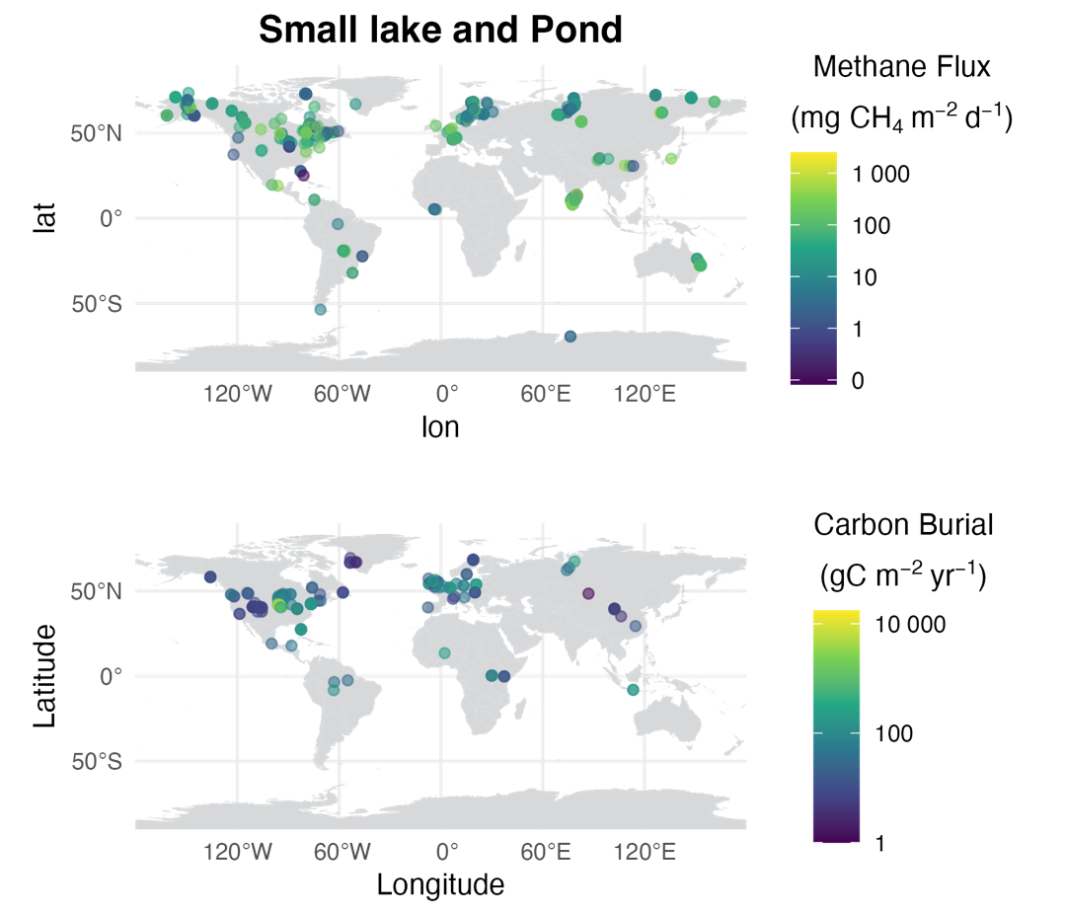
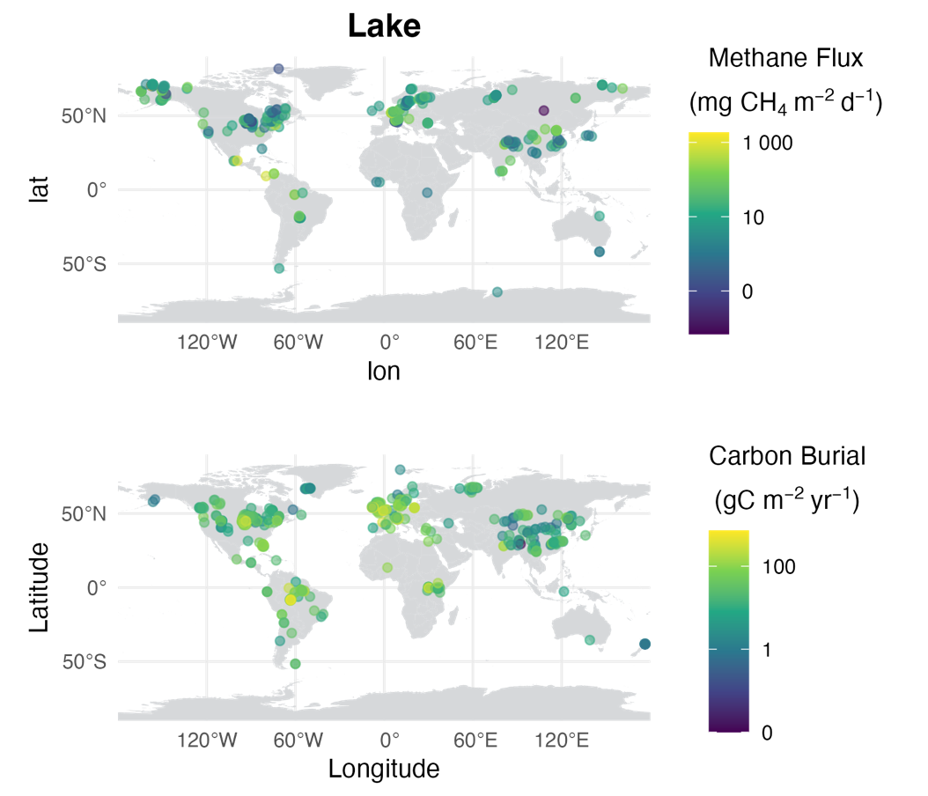
Fig. S1. Global distribution and concentration of methane flux (mg CH₄ m⁻² d⁻¹) and carbon burial rates (g C m⁻² yr⁻¹) in small lakes and ponds and lakes. Point size indicates flux percentile (0.05, 0.25, 0.5, 0.75, 0.95).
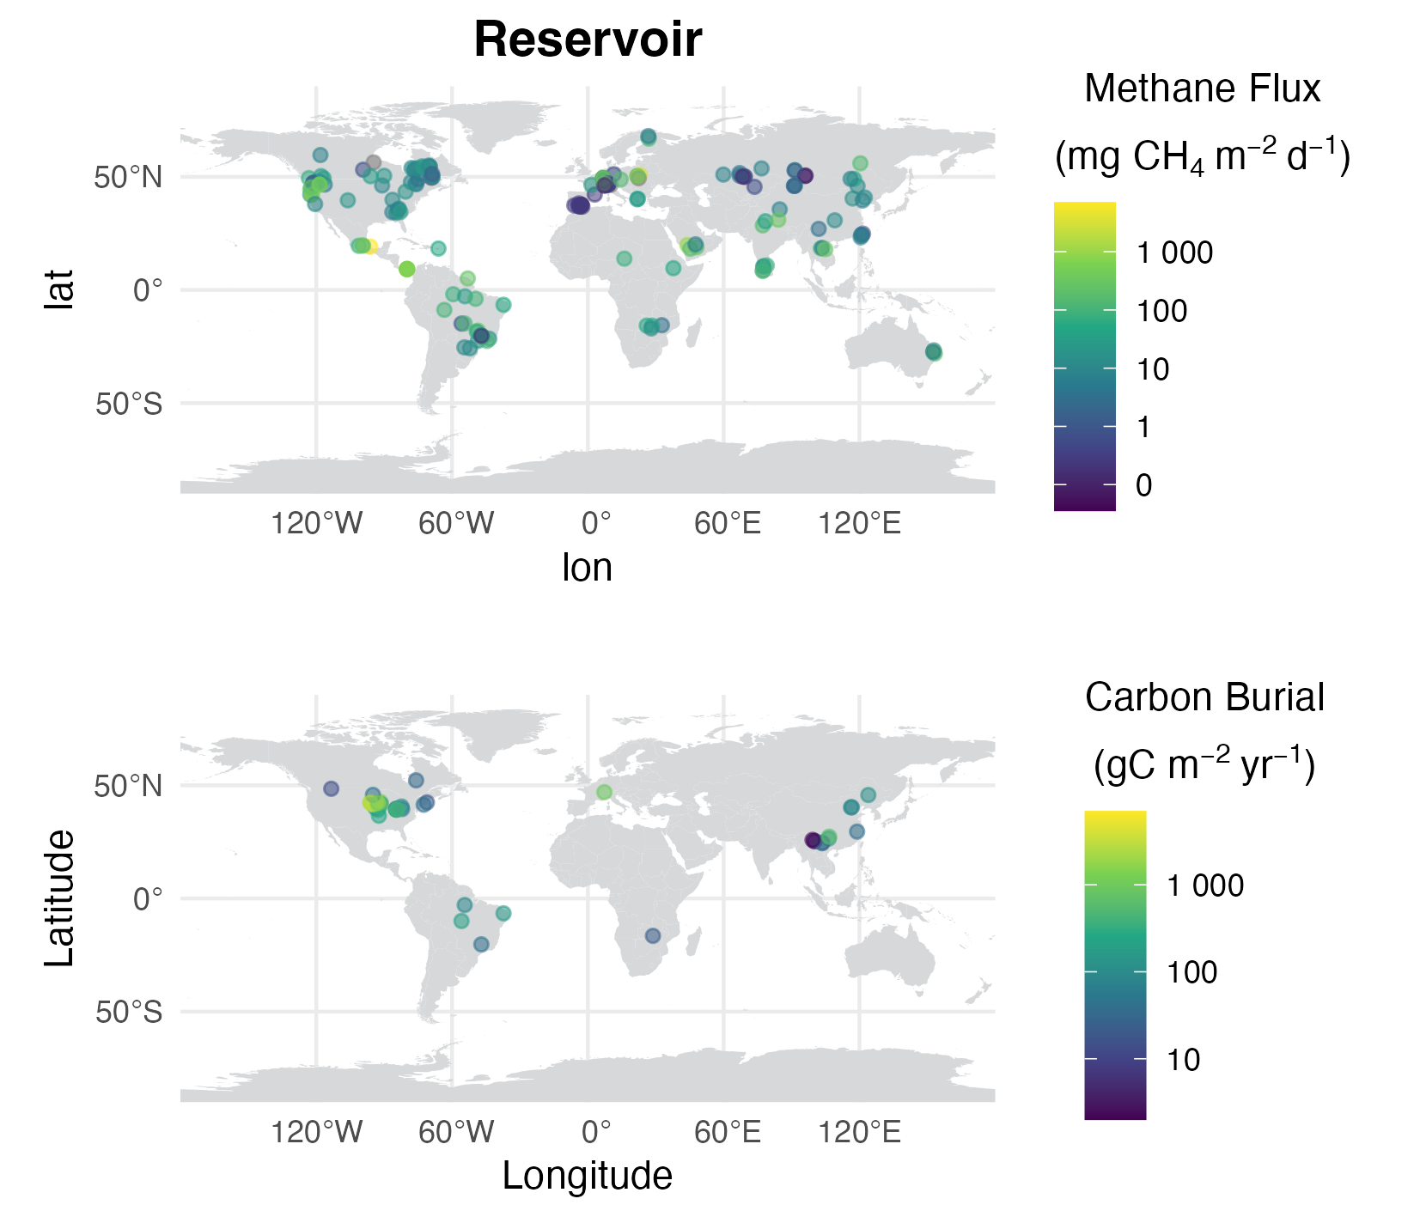

Fig. S2. Global distribution and concentration of methane flux (mg CH₄ m⁻² d⁻¹) and carbon burial rates (g C m⁻² yr⁻¹) in reservoirs. Point size indicates flux percentile (0.05, 0.25, 0.5, 0.75, 0.95). Note that there is no data for carbon burial in rivers.

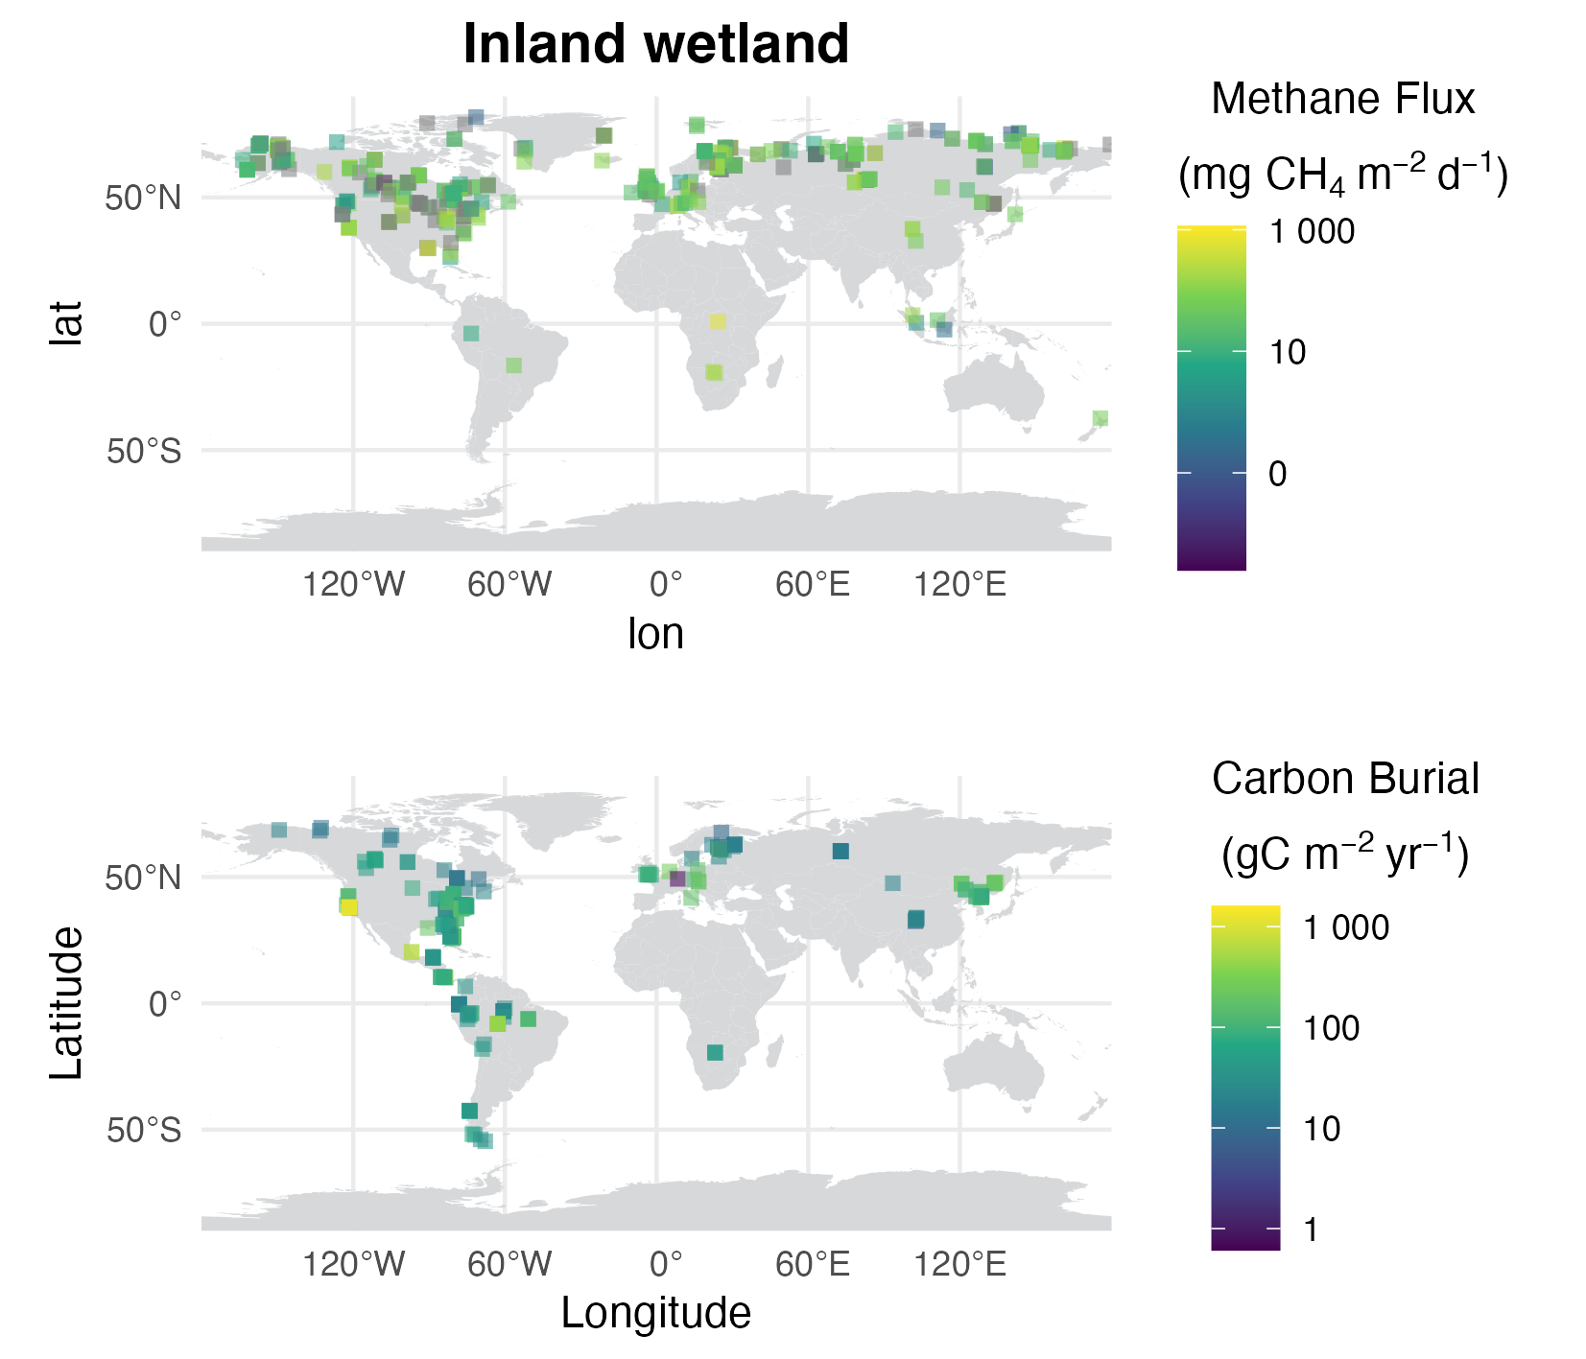
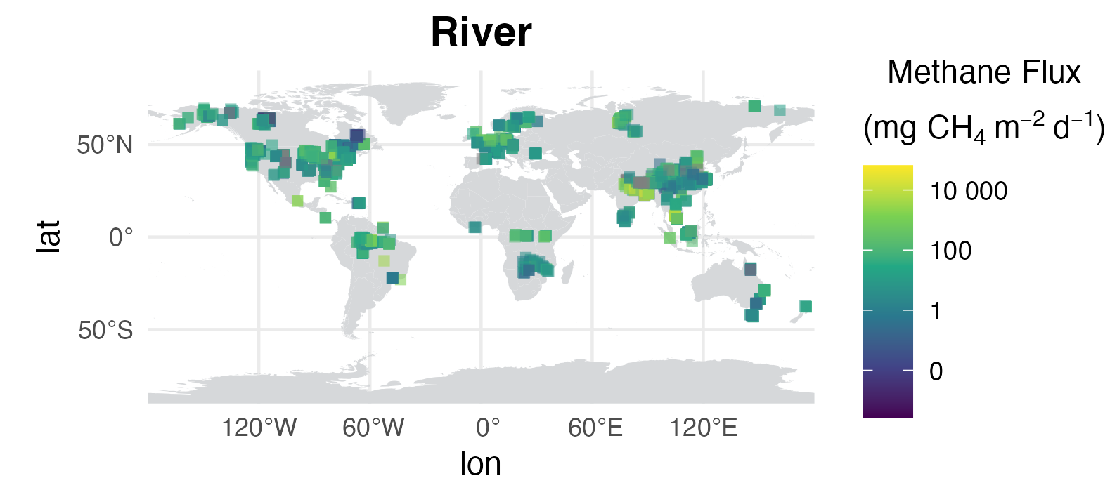
Fig. S3. Global distribution and concentration of methane flux (mg CH₄ m⁻² d⁻¹) and carbon burial rates (g C m⁻² yr⁻¹) in inland wetlands and river. Point size indicates flux percentile (0.05, 0.25, 0.5, 0.75, 0.95).

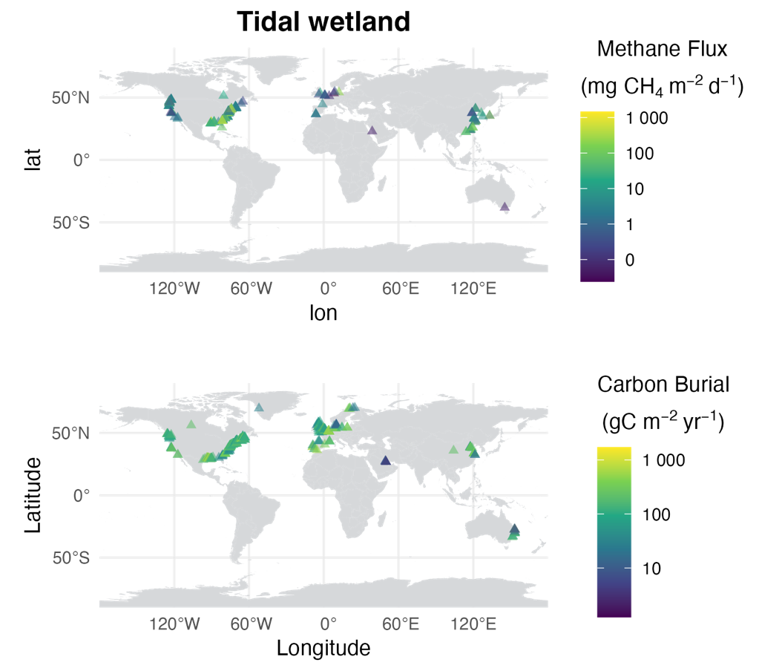
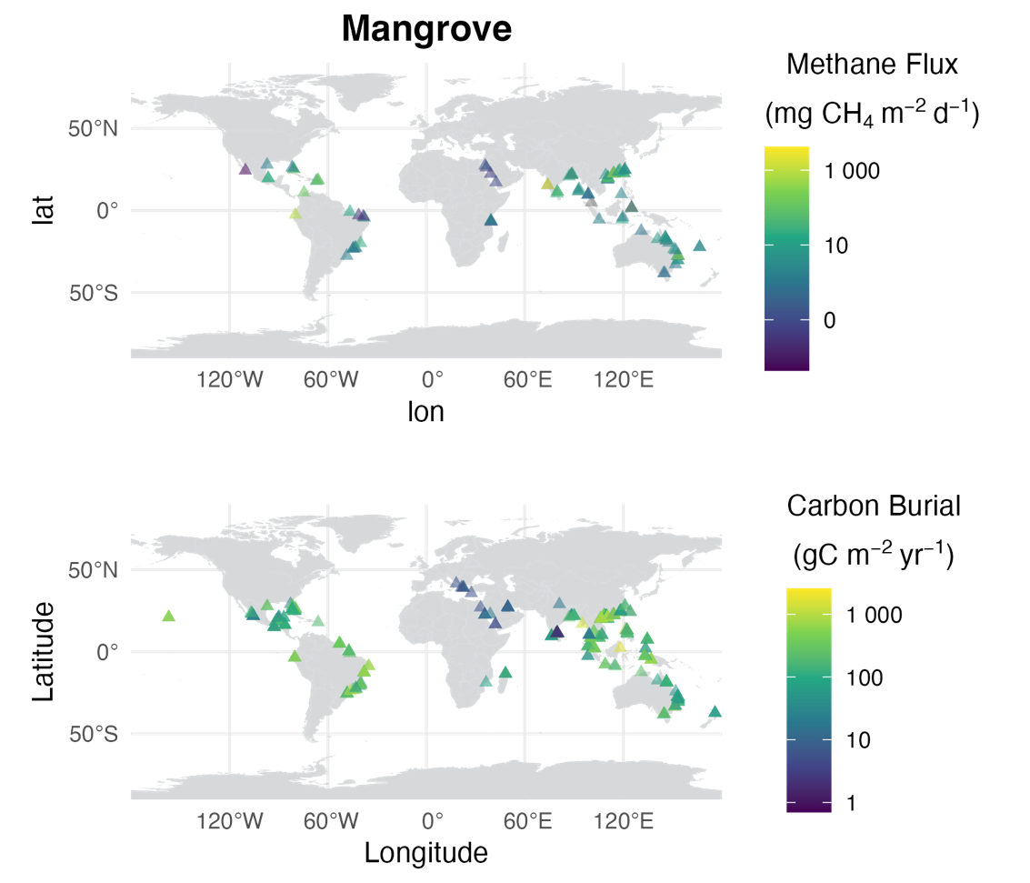
Fig. S4. Global distribution and concentration of methane flux (mg CH₄ m⁻² d⁻¹) and carbon burial rates (g C m⁻² yr⁻¹) in tidal wetlands and mangroves. Point size indicates flux percentile (0.05, 0.25, 0.5, 0.75, 0.95).

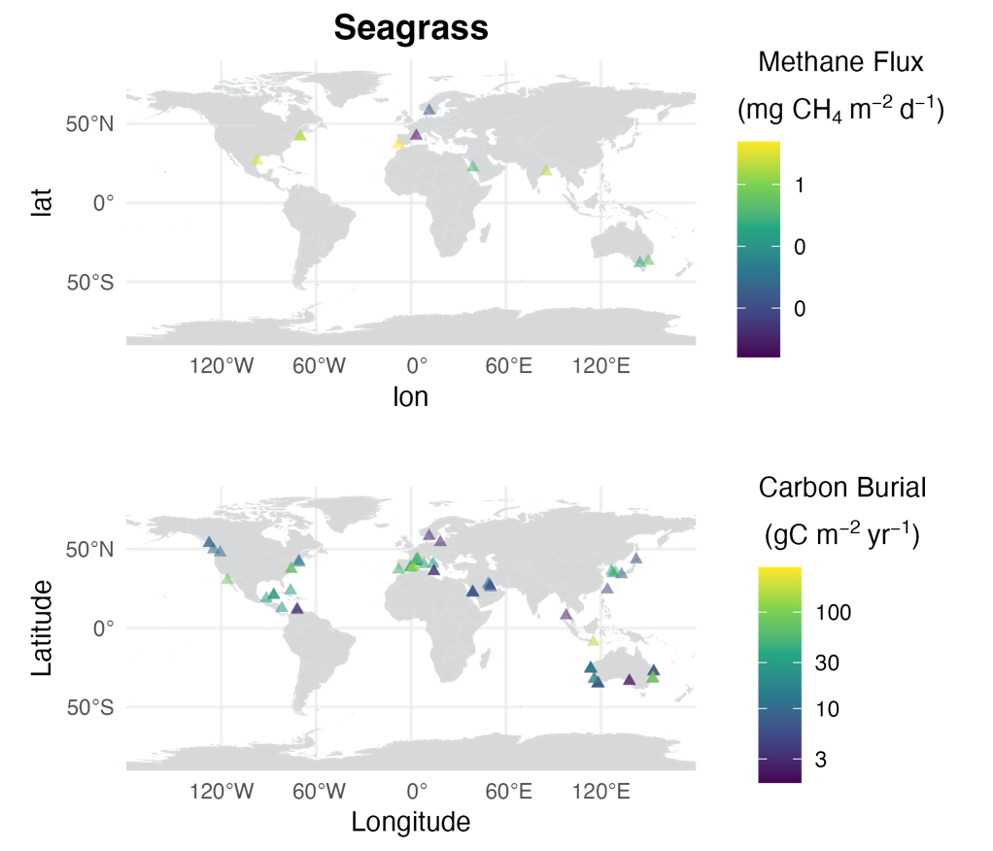
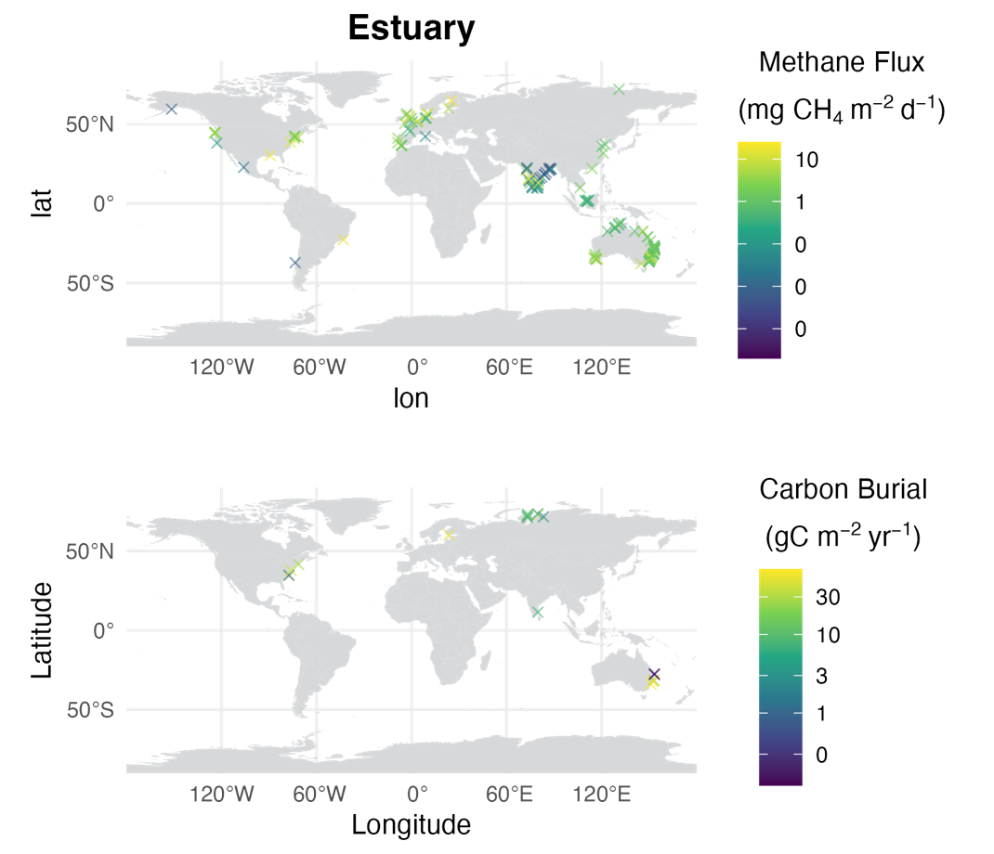
Fig. S5. Global distribution and concentration of methane flux (mg CH₄ m⁻² d⁻¹) and carbon burial rates (g C m⁻² yr⁻¹) in seagrass meadows and estuaries. Point size indicates flux percentile (0.05, 0.25, 0.5, 0.75, 0.95).
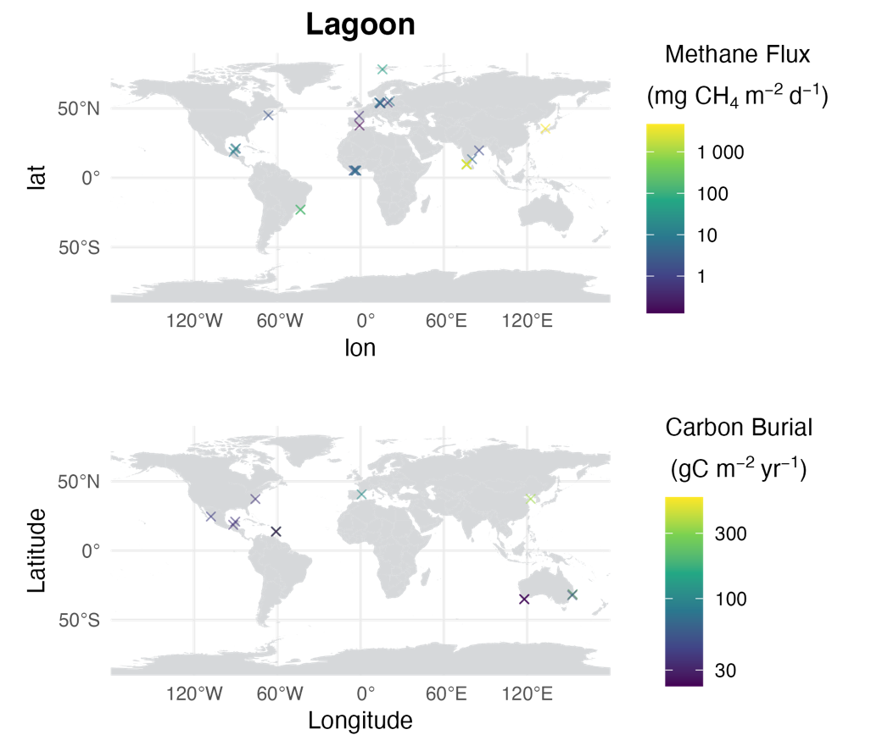

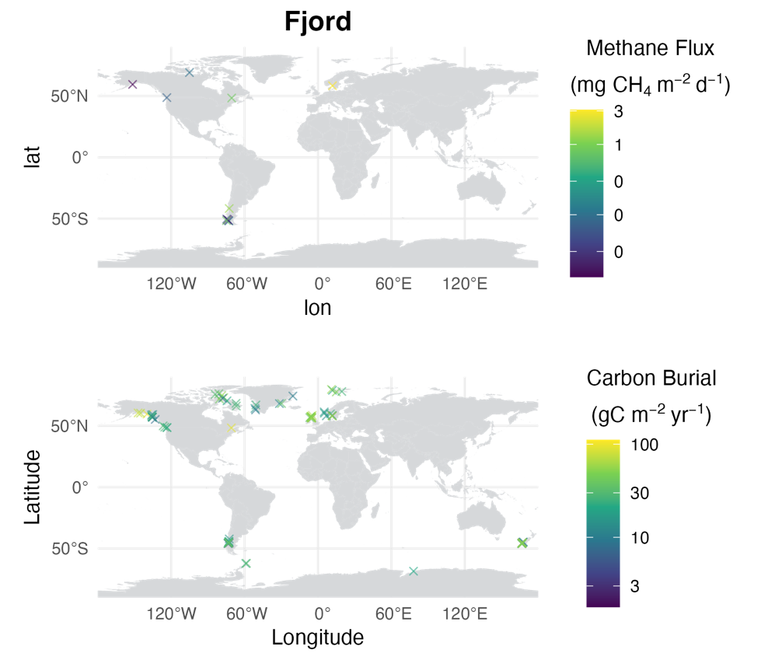

Fig. S6. Global distribution and concentration of methane flux (mg CH₄ m⁻² d⁻¹) and carbon burial rates (g C m⁻² yr⁻¹) in lagoons and fjords. Point size indicates flux percentile (0.05, 0.25, 0.5, 0.75, 0.95).
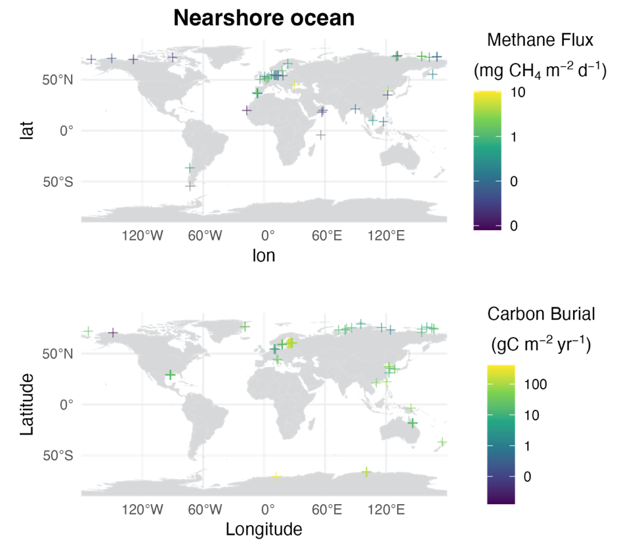

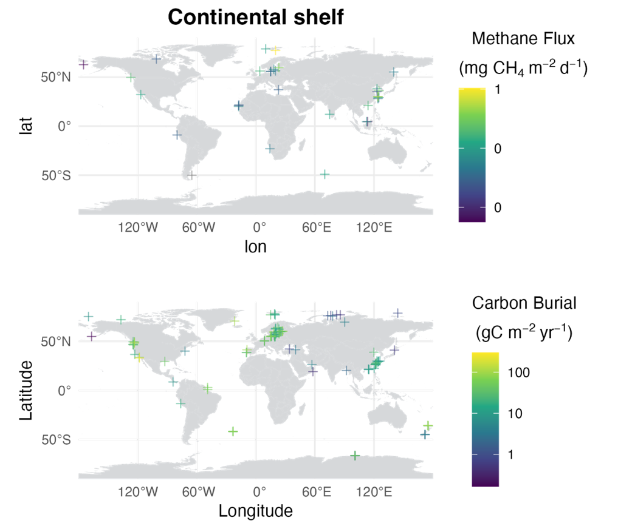
Fig. S7. Global distribution and concentration of methane flux (mg CH₄ m⁻² d⁻¹) and carbon burial rates (g C m⁻² yr⁻¹) in nearshore oceans and continental shelf. Point size indicates flux percentile (0.05, 0.25, 0.5, 0.75, 0.95).

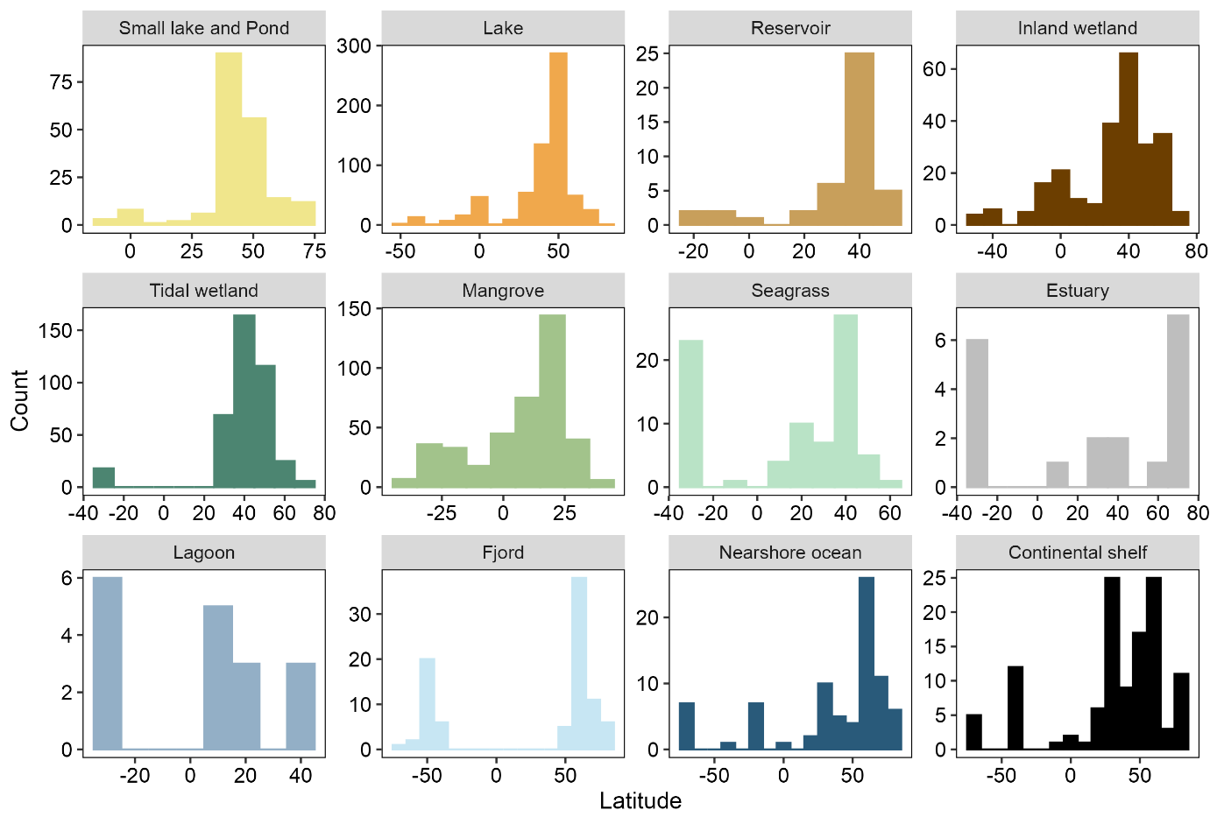
Fig. S8. Distribution of study sites with reported C burial rates across latitude

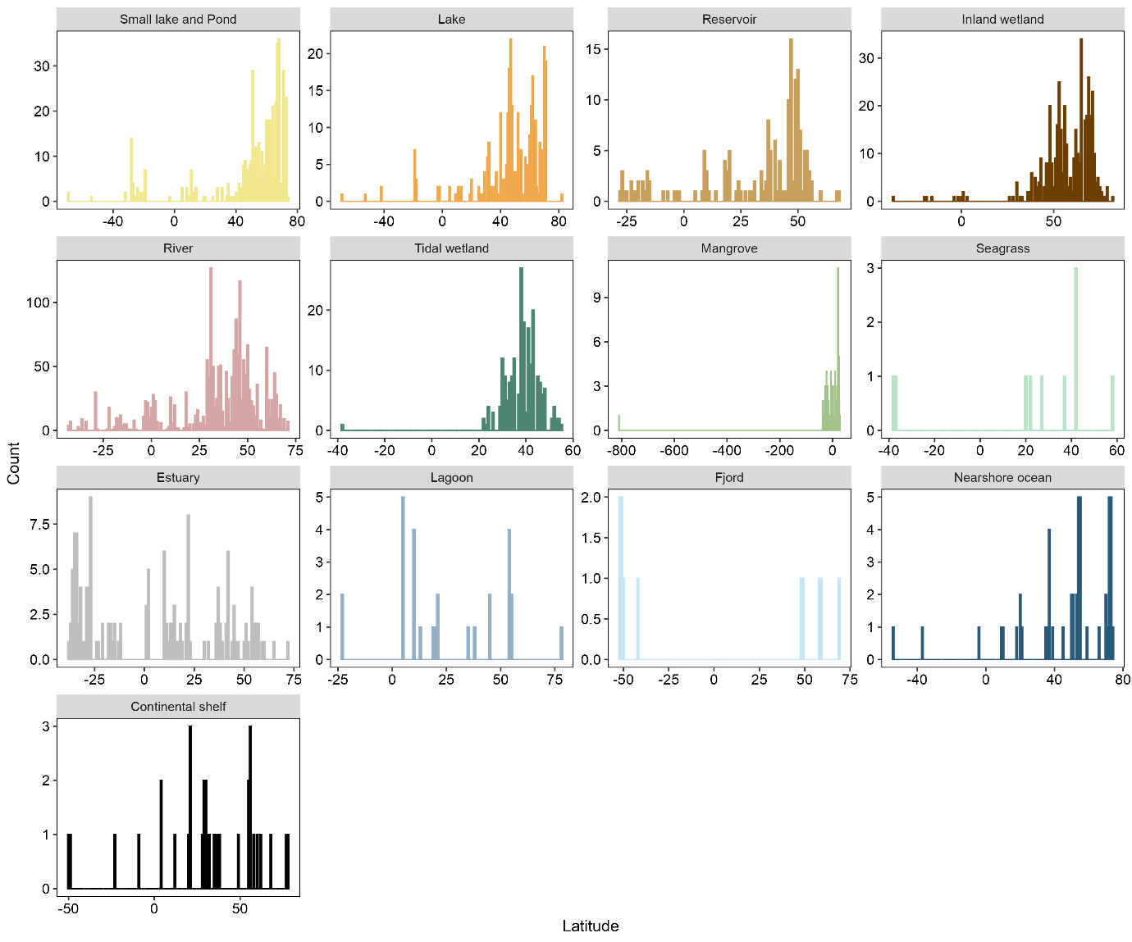
Fig. S9. Distribution of study sites with reported CH₄ fluxes across latitude

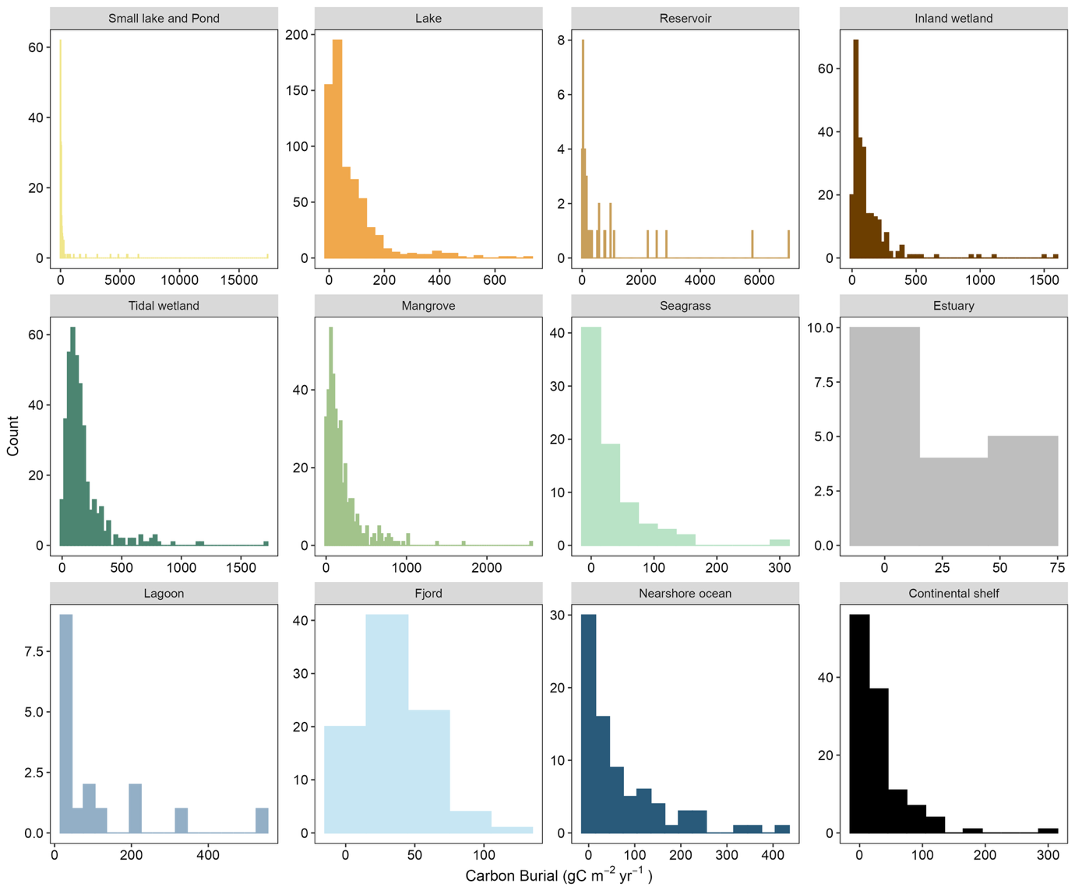
Fig. S10. Distribution of organic carbon burial rates across ecosystems

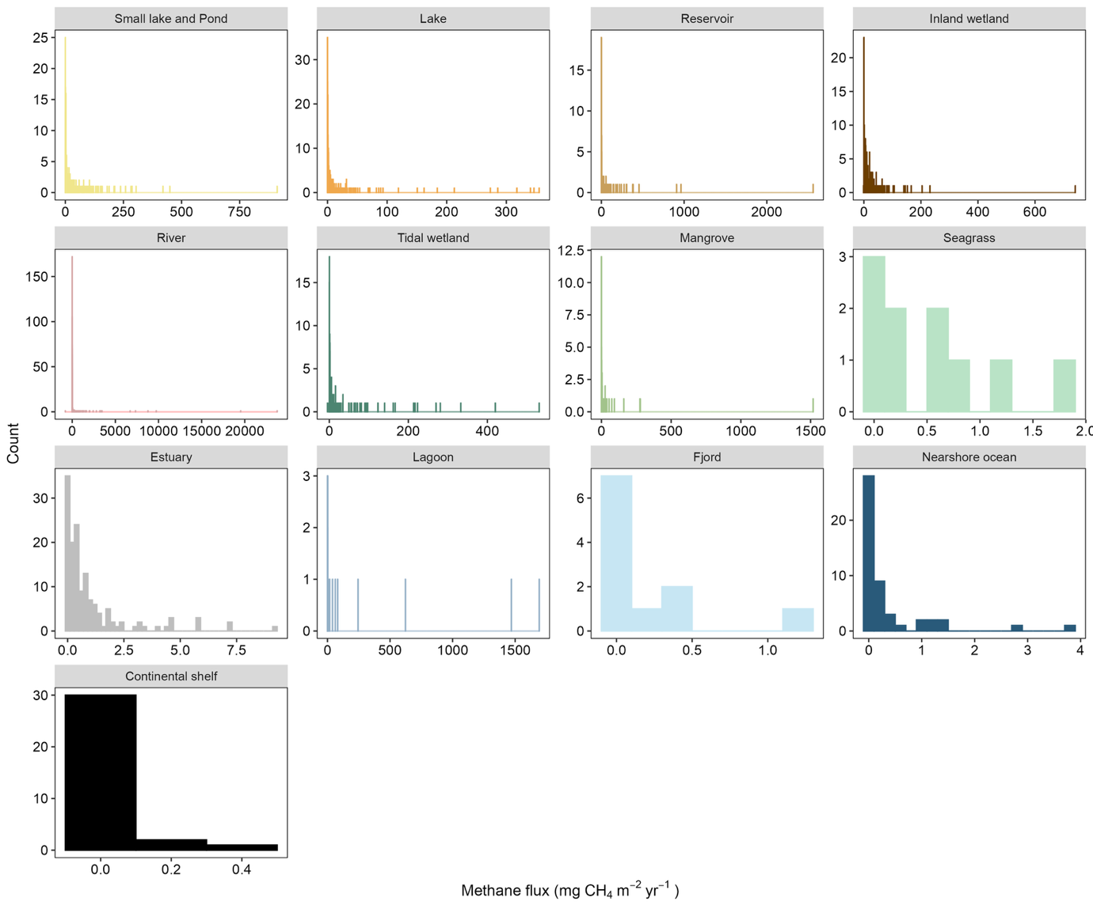

Fig. S11. Distribution of annual CH₄ fluxes across ecosystems

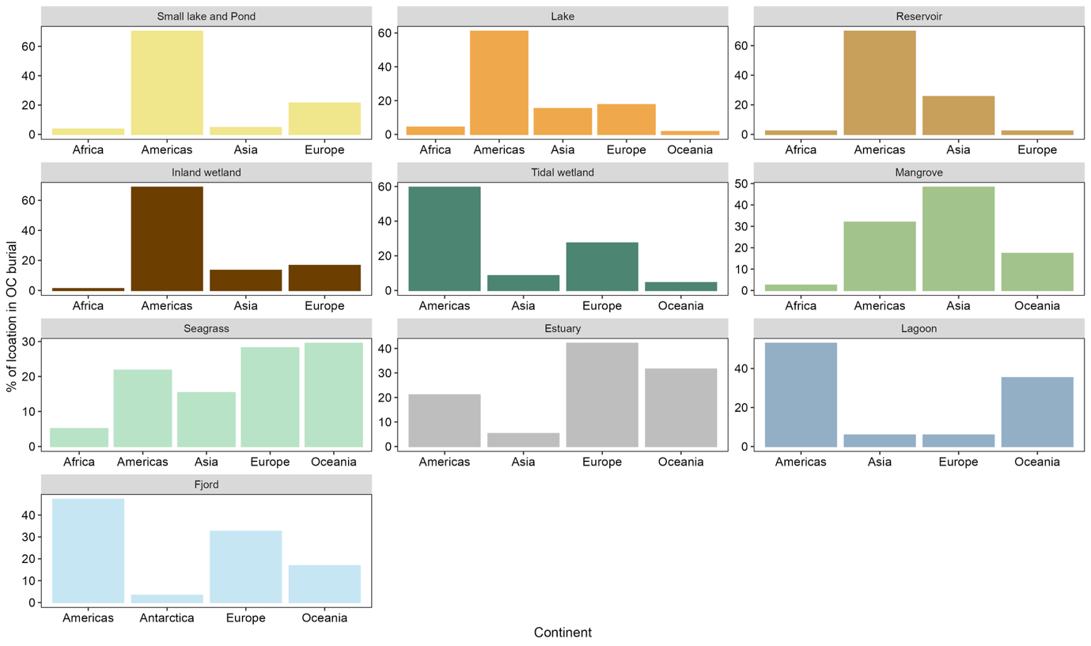

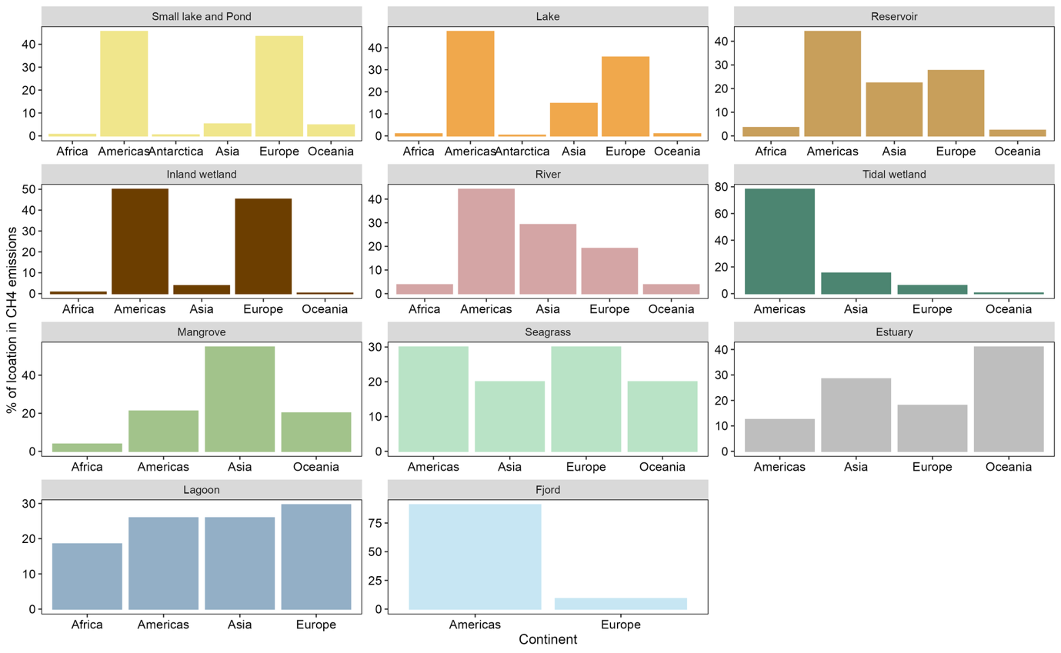
Fig. 12. Distribution of sites across continents in OC burial and CH₄ emissions
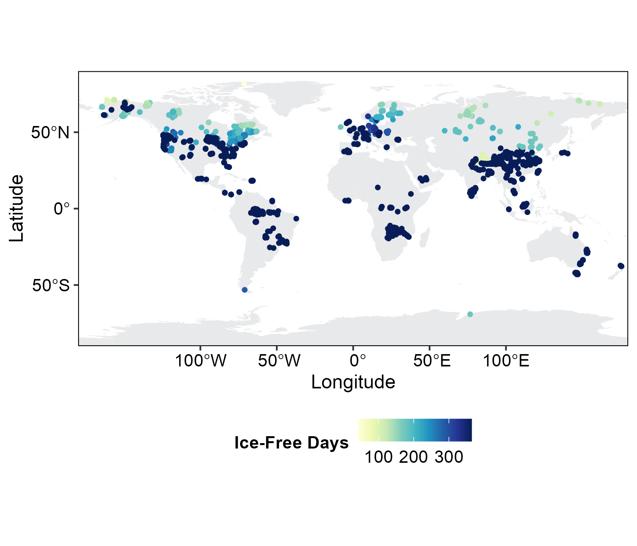
Fig. S13. Number of ice-free days estimated to correct for the annual CH₄ fluxes. The data was source from NOAA (Benson et al., 2000).

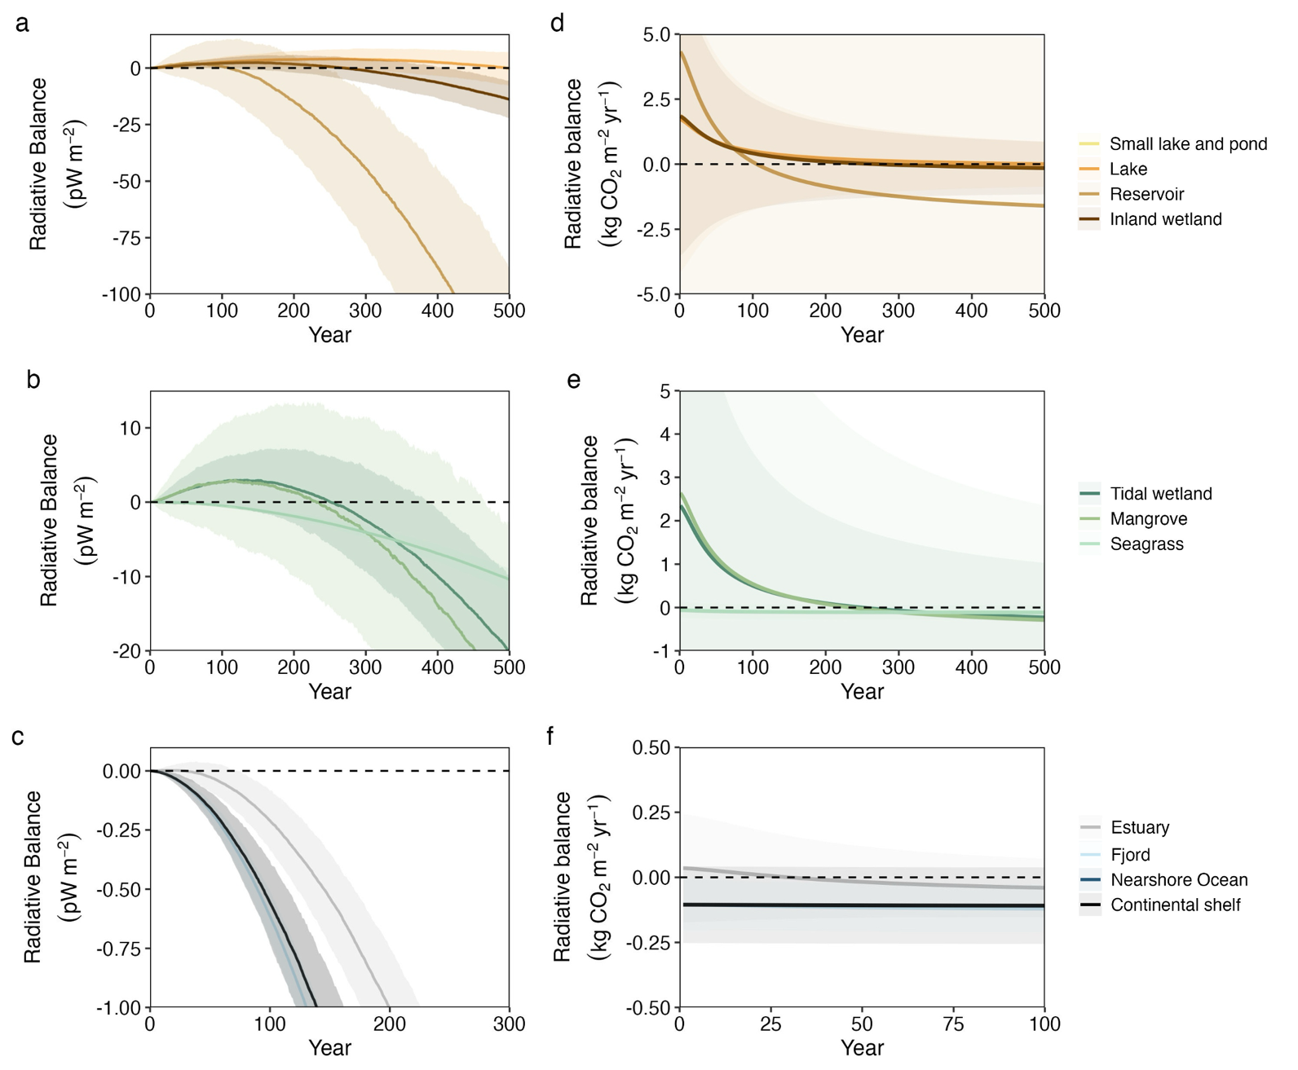

Fig. S14. Modelled net cumulative radiative balance of CH₄ emissions and organic carbon burial over 100 year for each environment using global mean of CH₄ emissions and organic carbon burial rates. Shaded area represents the uncertainty of the radiative balance estimated from Monte Carlo estimation from the standard deviation of CH₄ emissions and organic carbon burial rates.

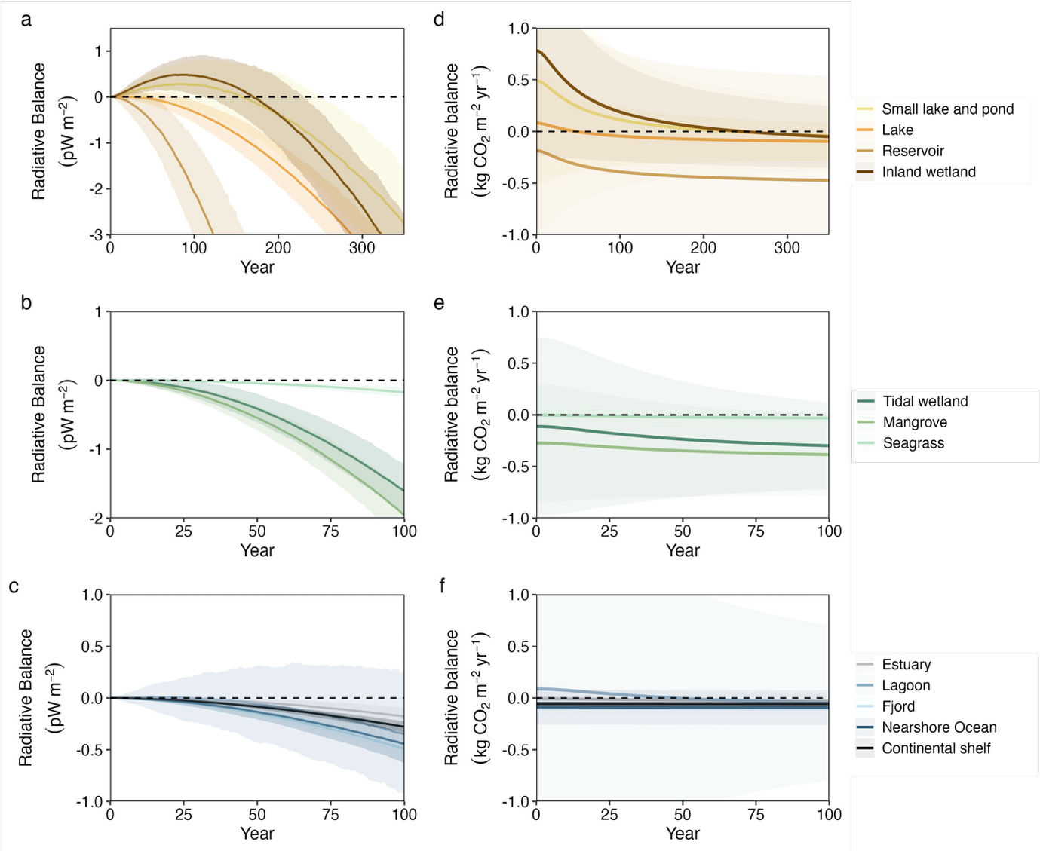

Fig. S15. Modelled net cumulative radiative balance of CH₄ emissions and organic carbon burial over 100 year for each environment using global median of CH₄ emissions and organic carbon burial rates. Shaded area represents the uncertainty of the radiative balance estimated from Monte Carlo estimation from the interquartile range of CH₄ emissions and organic carbon burial rates.

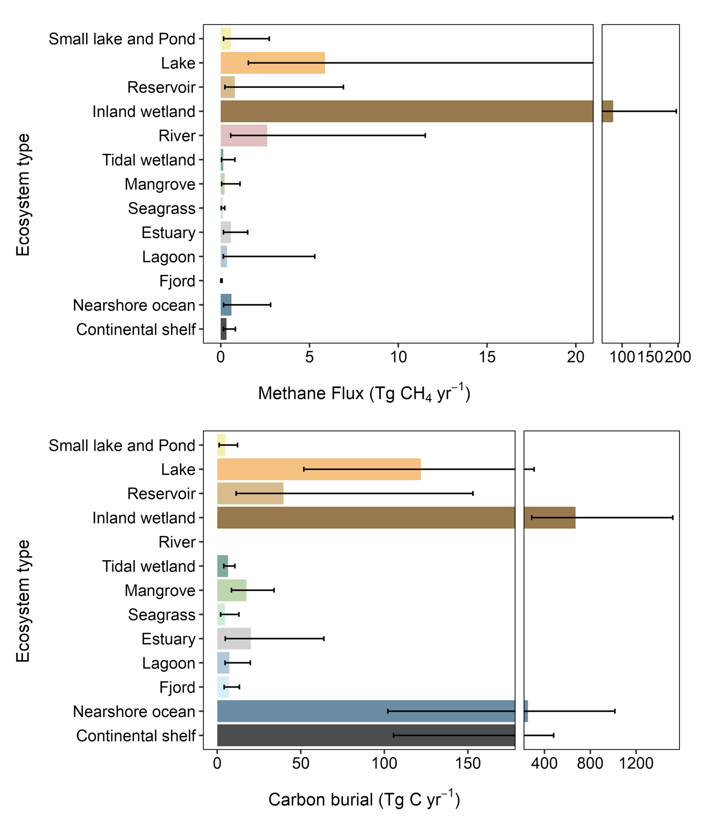
Fig. S16. Extrapolated global CH₄ emissions and carbon burial. Area of each ecosystem are extracted from literature (Table S7). The error bar represents the interquartile ranges.

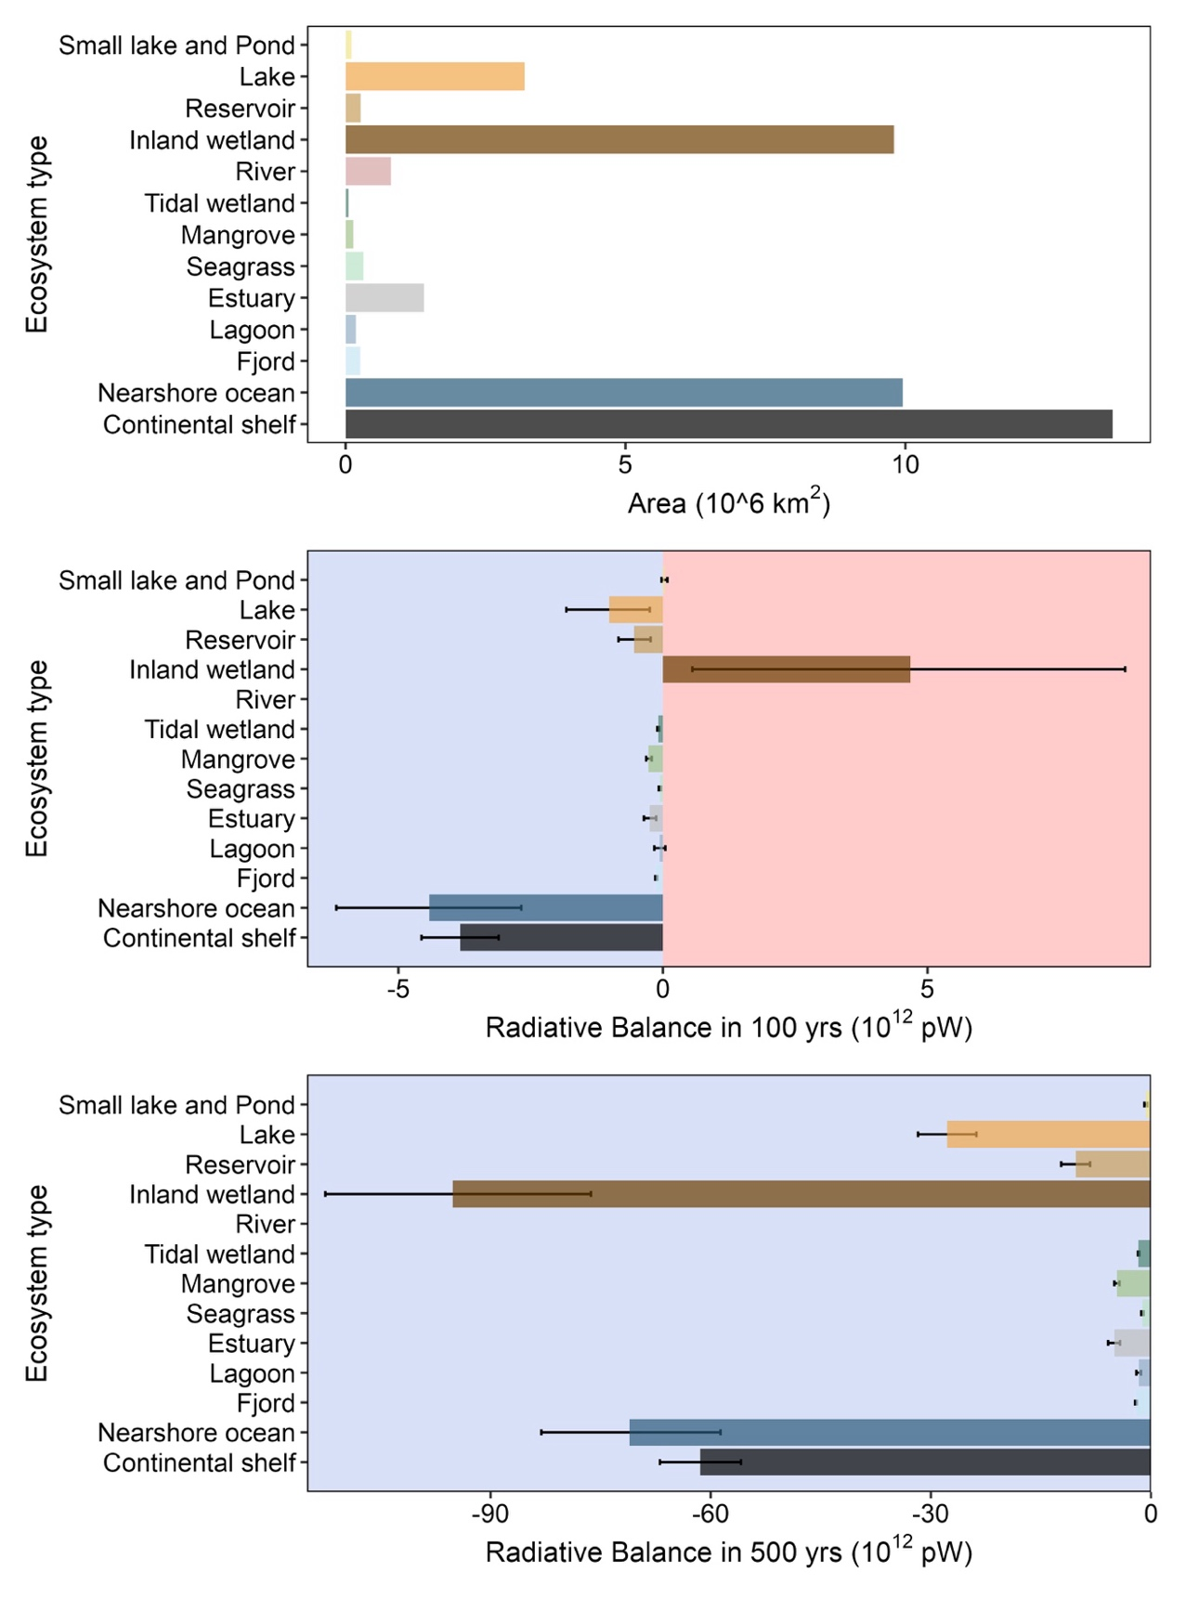
Fig. S17. Global ecosystem area and extrapolated radiative balance in 100 years and 500 years. Blue and red shaded area indicates the negative and positive radiative balance, respectively. The error bar represents the interquartile ranges.

Tables
Table S1 Summary statistics for organic carbon burial (g C m⁻² yr⁻¹). Note that there is no organic carbon burial data for river.
Ecosystem type | n | Mean ± SD | Median | Min | Max | IQR
Small Lake and Pond | 192 | 353 ± 1535 | 46 | 1 | 17392 | 11 − 116
Lake | 647 | 74 ± 96 | 38 | 0 | 720 | 16 − 97
Reservoir | 43 | 689 ± 1438 | 148 | 2 | 6987 | 42 − 571
Inland wetland | 247 | 126 ± 194 | 68 | 1 | 1600 | 29 − 155
River | NA | NA | NA | NA | NA | NA
Tidal marsh | 398 | 172 ± 182 | 120 | 1 | 1713 | 72 − 193
Mangrove | 404 | 203 ± 249 | 129 | 1 | 2560 | 63 − 250
Seagrass | 78 | 34 ± 47 | 15 | 2 | 292 | 6 − 40
Estuary | 19 | 24 ± 23 | 14 | 0 | 67 | 3 − 46
Lagoon | 18 | 111 ± 140 | 40 | 23 | 550 | 28 − 109
Fjord | 89 | 36 ± 24 | 28 | 2 | 111 | 16 − 51
Nearshore Ocean | 94 | 63 ± 82 | 26 | 0 | 406 | 12 − 85
Continental shelf | 122 | 30 ± 39 | 16 | 0 | 298 | 8 − 35
Total | 2351

Table S2. Summary statistics for CH₄ fluxes (mg CH₄ m⁻² d⁻¹)
 | n | Mean ± SD | Median | Min | Max | IQR
Small Lake and Pond | 461 | 92 ± 193 | 25.4 | 0.1 | 2497 | 7 − 98
Lake | 279 | 47 ± 147 | 8.0 | 0.0 | 1833 | 2 − 33
Reservoir | 165 | 134 ± 510 | 8.8 | 0.0 | 5247 | 2 − 53
Inland wetland | 418 | 74 ± 119 | 38.3 | -4 | 1144 | 9 − 86
River | 1893 | 233 ± 2268 | 9.5 | -2185 | 65082 | 2 − 42
Tidal marsh | 214 | 68 ± 182 | 7.4 | -13 | 1455 | 2 − 37
Mangrove | 102 | 78 ± 425 | 4.2 | -1 | 4161 | 1 − 21
Seagrass | 10 | 1 ± 2 | 1.1 | 0.0 | 5 | 0 − 2
Estuary | 144 | 3 ± 4 | 1.1 | 0.0 | 25 | 0 − 3
Lagoon | 27 | 433 ± 1179 | 5.4 | 0.1 | 4637 | 2 − 81
Fjord | 11 | 0.6 ± 0.9 | 0.1 | 0.0 | 3 | 0 − 1
Nearshore Ocean | 49 | 1.01 ± 1.99 | 0.2 | -0.1 | 10 | 0 − 1
Continental shelf | 33 | 0.14 ± 0.2 | 0.1 | 0.0 | 1 | 0 − 0
Total | 3806

Table S3. Summary of statistics for CH₄ fluxes (g CH₄ m⁻² yr⁻¹)
 | Mean ± SD | Median
Small Lake and Pond | 26 ± 65 | 5.5
Lake | 10 ± 30 | 1.8
Reservoir | 49 ± 186 | 3.2
Inland wetland | 19 ± 44 | 8.6
River | 82 ± 826 | 3.2
Tidal marsh | 25 ± 66 | 2.7
Mangrove | 28 ± 154 | 1.6
Seagrass | 0.5 ± 0.6 | 0.4
Estuary | 1.0 ± 1.6 | 0.4
Lagoon | 158 ± 430 | 2.0
Fjord | 0.2 ± 0.3 | 0.04
Nearshore Ocean | 0.4 ± 0.7 | 0.1
Continental shelf | 0.05 ± 0.1 | 0.02

Table S4. Summary of CH₄ fluxes (mg CH₄ m⁻² d⁻¹) in different pathways. “-“ indicates no data available.
 |  | Diffusive | Diffusive + Ebullition | Ebullition | Total flux | % of ebullition measurement
Small Lake and Pond | n | 329 | 130 | 34 | 1 | 33
Small Lake and Pond | Mean | 84 ± 208 | 112 ± 147 | 90 ± 128 | 285 ± 0 | 33
Small Lake and Pond | Median | 19 | 56 | 50 | 285 | 33
Lake | n | 219 | 65 | 33 | 1 | 31
Lake | Mean | 47 ± 135 | 105 ± 265 | 32 ± 57 | 12 ± 0 | 31
Lake | Median | 7 | 31 | 3 | 12 | 31
Reservoir | n | 71 | 56 | 5 | 39 | 36
Reservoir | Mean | 130 ± 842 | 157 ± 228 | 456 ± 341 | 217 ± 684 | 36
Reservoir | Median | 8 | 66 | 602 | 7 | 36
River | n | 6479 | - | 241 | 453 | 3
River | Mean | 123 ± 1428 | - | 58 ± 221 | 150 ± 541 | 3
River | Median | 7 | - | 14 | 9 | 3
Nearshore Ocean | n | 60 | - | 3 | - | 5
Nearshore Ocean | Mean | 2 ± 4 | - | 3 ± 3 | - | 5
Nearshore Ocean | Median | 0.3 | - | 2 | - | 5
Continental shelf | n | 36 | - | 2 | - | 5
Continental shelf | Mean | 1 ± 6 | - | 538 ± 732 | - | 5
Continental shelf | Median | 0.1 | - | 538 | - | 5

Table S5. Summary of different approaches comparing organic carbon burial to CH₄ emissions. 1) Organic carbon burial to CH₄ flux ratio is kg CO₂ to kg CH₄. If the ratio exceeds 120:1 indicates that the ecosystems have a negative radiative balance from the time of establishment. 2) CH₄ flux SWGP₁₀₀ represents CH₄ fluxes normalized to CO₂-equivalent using 100-year sustained global warming potential (SGWP) (Neubauer & Megonigal, 2015) (equation 1). The offset percentage is the ratio of CH₄ flux SWGP₁₀₀ to organic carbon burial rates in each ecosystem (equation 2). 3) Estimate the net radiative balance in 100 and 500 years since establishment using CH₄ emissions and organic carbon burial (as a negative CO₂) (equation 3,4,5).

 | Using global meanª
 | OC: CH₄ ratio | CH₄ flux  SWGP₁₀₀ | offset SWGP₁₀₀ | Net radiative balance in 100 years (pW m⁻²) |  | Net radiative balance in 500 years (pW m⁻²)
 | kg CO₂: kg CH₄ | g CO₂eq m⁻² yr⁻¹ | % | Mean | Q1 – Q3 | Mean | Q1 – Q3
Small Lake and Pond | 49 ± 246 | 689 | 92 ± 459 | -0.3 | -7.5 – 6.9 | -78 | -125.1 – -28.5
Lake | 27 ± 88 | 264 | 168 ± 547 | 2.5 | 0.2 – 4.7 | 0 | -8 – 7
Reservoir | 52 ± 224 | 1280 | 87 ± 378 | 0.7 | -11.5 – 12.3 | -145 | -199.3 – -89.6
Inland wetland | 24 ± 66 | 506 | 188 ± 520 | 2.1 | 0 – 4.4 | -14 | -22.2 – -5.6
River | NaN ± NaN | 2148 | NaN ± NaN | NA | NA | NA | NA
Tidal marsh | 25 ± 73 | 652 | 178 ± 510 | 2.7 | -0.5 – 5.9 | -20 | -31.2 – -9.9
Mangrove | 26 ± 145 | 749 | 173 ± 959 | 2.7 | -4.5 – 10.4 | -26 | -47.3 – -2.6
Seagrass | 232 ± 410 | 14 | 19 ± 34 | -0.5 | -0.7 – -0.3 | -10 | -11.9 – -8.9
Estuary | 85 ± 156 | 27 | 53 ± 97 | -0.2 | -0.3 – -0.1 | -6 | -7.1 – -5.6
Lagoon | 3 ± 8 | 4137 | 1751 ± 5258 | 34.8 | 15.3 – 55.9 | 191 | 135.4 – 246.1
Fjord | 611 ± 1067 | 6 | 7 ± 13 | -0.6 | -0.7 – -0.5 | -11 | -12.2 – -10.6
Nearshore Ocean | 626 ± 1484 | 10 | 7 ± 17 | -1.2 | -1.6 – -0.9 | -22 | -25 – -19.5
Continental shelf | 2192 ± 4344 | 1 | 2 ± 4 | -0.6 | -0.7 – -0.4 | -10 | -11.2 – -8.7
 | Using global median^{b}
Small Lake and Pond | 31 ± 30 | 143 | 147 ± 741 | 0.4 | -0.2 – 1 | -7.1 | -9.5 – -4.8
Lake | 78 ± 100 | 47 | 58 ± 251 | -0.3 | -0.6 – 0 | -10.0 | -11.4 – -8.6
Reservoir | 169 ± 145 | 84 | 27 ± 180 | -2.0 | -3.3 – -0.9 | -44.7 | -52.5 – -35.8
Inland wetland | 29 ± 38 | 225 | 155 ± 412 | 0.7 | 0.2 – 1.2 | -10.1 | -12.5 – -7.7
River | NA ± NA | 84 | NA ± NA | NA | NA | NA | NA
Tidal marsh | 162 ± 141 | 71 | 28 ± 134 | -1.6 | -2 – -1.2 | -35.8 | -37.8 – -33.7
Mangrove | 310 ± 297 | 40 | 14 ± 72 | -2.0 | -2.5 – -1.6 | -40.2 | -43.3 – -37
Seagrass | 129 ± 197 | 11 | 35 ± 97 | -0.2 | -0.2 – -0.1 | -4.2 | -4.7 – -3.7
Estuary | 130 ± 263 | 11 | 35 ± 131 | -0.2 | -0.3 – -0.1 | -4.2 | -4.9 – -3.5
Lagoon | 75 ± 56 | 52 | 60 ± 879 | -0.3 | -1 – 0.4 | -10.6 | -13.1 – -8.5
Fjord | 2813 ± 4575 | 1 | 2 ± 12 | -0.5 | -0.6 – -0.4 | -9.2 | -9.8 – -8.7
Nearshore Ocean | 1543 ± 2110 | 2 | 3 ± 15 | -0.5 | -0.6 – -0.3 | -8.4 | -10 – -7.1
Continental shelf | 2476 ± 3337 | 1 | 2 ± 5 | -0.3 | -0.3 – -0.2 | -5.3 | -5.7 – -4.8

ªAll the calculation was based on global mean CH₄ fluxes and organic carbon burial rates. Uncertainty of the % offset was estimated from error propagation from the standard deviation of CH₄ flux and organic carbon burial.

^{b}All the calculation was based on global median CH₄ fluxes and organic carbon burial rates. Uncertainty was calculated using the interquartile range. Uncertainty of the % offset was estimated from error propagation from the interquartile range of CH₄ flux and organic carbon burial.

Table S6. Radiative forcing switchover time estimated from radiative balance model. Switchover time refers to the time switching from positive to a negative radiative balance, which was determined when the radiative balance reaches zero.

 | Using global meanª |  | Using global median^{b}
 | Mean | Range | Mean | Range
Small lake and Pond | 87 | 5 – 329 | 0 | 0 – 288
Lake | 497 | 82 – 706 | 40 | 2–2
Reservoir | 110 | 5 – 236 | 0 | 0 – 57
Inland wetland | 270 | 103 – 409 | 199 | 7 – 258
River | NA | NA | NA | NA
Tidal wetland | 251 | 0 – 387 | 0 | 0 – 32
Mangrove | 234 | 0 – 465 | 0 | 0 – 14
Seagrass | 0 | 0 – 27 | 0 | 0 – 41
Estuary | 28 | 0 – 73 | 0 | 0 – 51
Lagoon | 0 | 0 – 37 | 0 | 0 – 154
Fjord | NA | NA | NA | NA
Nearshore ocean | 0 | 0 – 12 | 0 | 0 – 18
Continental shelf | 0 | 0 – 9 | 0 | 0 – 4

ª Global mean CH₄ fluxes and organic carbon burial rates were used to calculate the radiative balance. The 95% interval of the switchover time is estimated from a Monte Carlo simulation (n = 1000) using the standard deviation of CH₄ emissions and organic carbon burial rates.

^{b} Global median CH₄ fluxes and organic carbon burial rates were used to calculate the radiative balance. The 95% interval of the switchover time is estimated from a Monte Carlo simulation (n = 1000) using the interquartile range of CH₄ emissions and organic carbon burial rates.

Table S7. Global surface area and global median of organic carbon rates, CH₄ emissions and net radiative balance in 100 and 500 years. The global net radiative balance (pW) is extrapolated from the net radiative balance per area (pW m⁻²) using the global ecosystem area. The numbers represent median (IQR).

Ecosystem type | Area | CH₄ emissions | OC burial | Radiative balance |  | Reference for global area
 |  |  |  | 100 yrs | 500 yrs | Reference for global area
Unit | 10⁴ km² | Tg CH₄ yr⁻¹ | Tg C yr⁻¹ | 10¹² pW | 10¹² pW
Small lake and Pond | 10.5 | 0.6  (0.2 – 2.7) | 5  (1 – 12) | 0  (0 – 0.1) | -0.7 (-1 – -0.5) | (Pi et al., 2022)
Lake | 320 | 5.9  (1.6 – 32.1) | 122 (52 – 310) | -0.9  (-1.9 – -0.1) | -32 (-37 – -28) | (Pi et al., 2022)
Reservoir | 27 | 0.8  (0.2 – 6.9) | 40 (11 – 153) | -0.5  (-0.9 – -0.2) | -12 (-14 – -10) | (Bonnema et al., 2022)
Inland wetland | 980 | 84.2  (36.1 – 196.9) | 666 (286 – 1513) | 7.1 (2.3 – 11.6) | -99 (-122 – -75) | (Lehner et al., 2025)
River | 80 | 2.6  (0.6 – 11.5) | NA | NA | 0 () | (Liu et al., 2022)
Tidal wetland | 5 | 0.1  (0 – 0.8) | 7 (4 – 11) | -0.1 (-0.1 – -0.1) | -2 (-2.1 – -1.8) | (Rosentreter et al., 2023a)
Mangrove | 14 | 0.2  (0.1 – 1.1) | 17 (9 – 34) | -0.3 (-0.3 – -0.2) | -5.5 (-5.9 – -5) | (Rosentreter et al., 2023a)
Seagrass | 32 | 0.1  80 – 0.2) | 5 (2 – 13) | -0.1 (-0.1 – 0) | -1.4 (-1.5 – -1.2) | (Rosentreter et al., 2023a)
Estuary | 140 | 0.6  (0.2 – 1.5) | 20 (5 – 64) | -0.2 (-0.4 – -0.1) | -5.8 (-6.8 – -4.9) | (Laruelle et al., 2025)
Lagoon | 18 | 0.4  (0.1 – 5.3) | 7 (5 – 20) | -0.1 (-0.2 – 0.1) | -1.9 (-2.4 – -1.5) | (Laruelle et al., 2025)
Fjord | 26 | 0.0  (0 – 0.1) | 7 (4 – 13) | -0.1 (-0.2 – -0.1) | -2.4 (-2.5 – -2.2) | (Laruelle et al., 2025)
Nearshore ocean | 995 | 0.6  (0.2 – 2.8) | 257 (117 – 843) | -4.7 (-6.4 – -2.7) | -84 (-99 – -70) | (Weber et al., 2019)
Continental shelf | 1370 | 0.3  (0.2 – 0.8) | 222 (105 – 480) | -4 (-4.7 – -3.3) | -72 (-78 – -66) | (Weber et al., 2019)

References

1. M. S. Johnson, E. Matthews, J. Du, V. Genovese, D. Bastviken, Methane Emission From Global Lakes: New Spatiotemporal Data and Observation‐Driven Modeling of Methane Dynamics Indicates Lower Emissions. JGR Biogeosciences 127, e2022JG006793 (2022).
2. M. A. Kuhn, et al., BAWLD-CH&lt;sub&gt;4&lt;/sub&gt;: a comprehensive dataset of methane fluxes from boreal and arctic ecosystems. Earth Syst. Sci. Data 13, 5151–5189 (2021).
3. P. Taillardat, et al., A Carbon Source in a Carbon Sink: Carbon Dioxide and Methane Dynamics in Open‐Water Peatland Pools. Global Biogeochemical Cycles 38, e2023GB007909 (2024).
4. Y. Zheng, et al., Global methane and nitrous oxide emissions from inland waters and estuaries. Global Change Biology 28, 4713–4725 (2022).
5. J. A. Rosentreter, et al., Half of global methane emissions come from highly variable aquatic ecosystem sources. Nat. Geosci. 14, 225–230 (2021).
6. B. A. Denfeld, H. M. Baulch, P. A. Del Giorgio, S. E. Hampton, J. Karlsson, A synthesis of carbon dioxide and methane dynamics during the ice‐covered period of northern lakes. Limnol Oceanogr Letters 3, 117–131 (2018).
7. M. L. Messager, B. Lehner, G. Grill, I. Nedeva, O. Schmitt, Estimating the volume and age of water stored in global lakes using a geo-statistical approach. Nat Commun 7, 13603 (2016).
8. M. S. Johnson, et al., Spatiotemporal Methane Emission From Global Reservoirs. JGR Biogeosciences 126, e2021JG006305 (2021).
9. B. Benson, J. Magnuson, S. Sharma, Gobal Lake and River Ice Phenology Database. (G01377, Version 1). National Snow and Ice Data Center. https://doi.org/10.7265/N5W66HP8. Deposited 2000.
10. K. B. Delwiche, et al., FLUXNET-CH4: a global, multi-ecosystem dataset and analysis of methane seasonality from freshwater wetlands. Earth Syst. Sci. Data 13, 3607–3689 (2021).
11. C. C. Treat, A. A. Bloom, M. E. Marushchak, Nongrowing season methane emissions–a significant component of annual emissions across northern ecosystems. Global Change Biology 24, 3331–3343 (2018).
12. C. D. Evans, et al., Overriding water table control on managed peatland greenhouse gas emissions. Nature 593, 548–552 (2021).
13. L. Schuster, P. Taillardat, P. I. Macreadie, M. E. Malerba, Freshwater wetland restoration and conservation are long-term natural climate solutions. Science of The Total Environment 922, 171218 (2024).
14. S. Ma, I. F. Creed, P. Badiou, New perspectives on temperate inland wetlands as natural climate solutions under different CO2-equivalent metrics. npj Clim Atmos Sci 7, 222 (2024).
15. D. Olefeldt, et al., The Boreal–Arctic Wetland and Lake Dataset (BAWLD). Earth Syst. Sci. Data 13, 5127–5149 (2021).
16. E. H. Stanley, et al., GRiMeDB: the Global River Methane Database of concentrations and fluxes. Earth Syst. Sci. Data 15, 2879–2926 (2023).
17. J. A. Rosentreter, et al., Coastal vegetation and estuaries are collectively a greenhouse gas sink. Nat. Clim. Chang. 13, 579–587 (2023).
18. A. Arias‐Ortiz, et al., Methane fluxes in tidal marshes of the conterminous United States. Global Change Biology 30, e17462 (2024).
19. L. C. Cotovicz, et al., Methane oxidation minimizes emissions and offsets to carbon burial in mangroves. Nat. Clim. Chang. 14, 275–281 (2024).
20. B. D. Eyre, N. Camillini, R. N. Glud, J. A. Rosentreter, The climate benefit of seagrass blue carbon is reduced by methane fluxes and enhanced by nitrous oxide fluxes. Commun Earth Environ 4, 374 (2023).
21. J. Z.-Q. Yeo, J. A. Rosentreter, J. M. Oakes, B. D. Eyre, Low methane emissions from Australian estuaries influenced by geomorphology and disturbance. Commun Earth Environ 5, 434 (2024).
22. S. Bonaglia, et al., Eutrophication and urbanization enhance methane emissions from coastal lagoons. Limnol Oceanogr Letters 10, 140–150 (2025).
23. S. Bonaglia, et al., High methane emissions from an anoxic fjord driven by mixing and oxygenation. Limnol Oceanogr Letters lol2.10259 (2022). https://doi.org/10.1002/lol2.10259.
24. J. A. Rosentreter, et al., Coastal vegetation and estuaries are collectively a greenhouse gas sink. Nat. Clim. Chang. 13, 579–587 (2023).
25. L. Amora-Nogueira, et al., Tropical forests as drivers of lake carbon burial. Nat Commun 13, 4051 (2022).
26. N. J. Anderson, A. J. Heathcote, D. R. Engstrom, Globocarb data contributors, Anthropogenic alteration of nutrient supply increases the global freshwater carbon sink. Sci. Adv. 6, eaaw2145 (2020).
27. R. Mendonça, et al., Organic carbon burial in global lakes and reservoirs. Nat Commun 8, 1694 (2017).
28. N. Ray, et al., Wetlands dominate the global lentic carbon sink. AGU (2024).
29. J. A. Villa, B. Bernal, Carbon sequestration in wetlands, from science to practice: An overview of the biogeochemical process, measurement methods, and policy framework. Ecological Engineering 114, 115–128 (2018).
30. G. M. Wilkinson, A. Besterman, C. Buelo, J. Gephart, M. L. Pace, A synthesis of modern organic carbon accumulation rates in coastal and aquatic inland ecosystems. Sci Rep 8, 15736 (2018).
31. D. Henry, N. Catalán, B. Obrador, R. Marcé, Modeling carbon burial along the land to ocean aquatic continuum: Current status, challenges and perspectives. Earth-Science Reviews 253, 104791 (2024).
32. D. Henry, N. Catalán, B. Obrador, R. Marcé, Modeling carbon burial along the land to ocean aquatic continuum: Current status, challenges and perspectives. Earth-Science Reviews 253, 104791 (2024).
33. E. L. Tanner, B. D. Eyre, Carbon Budget for a Large Drowned River Valley Estuary Adjacent to an Emerging Megacity (Sydney Harbour). JGR Biogeosciences 125, e2019JG005192 (2020).
34. L. A. Tegler, et al., Distribution and Drivers of Organic Carbon Sedimentation Along the Continental Margins. AGU Advances 5, e2023AV001000 (2024).
35. G. M. Wilkinson, A. Besterman, C. Buelo, J. Gephart, M. L. Pace, A synthesis of modern organic carbon accumulation rates in coastal and aquatic inland ecosystems. Sci Rep 8, 15736 (2018).
36. R. W. Smith, T. S. Bianchi, M. Allison, C. Savage, V. Galy, High rates of organic carbon burial in fjord sediments globally. Nature Geosci 8, 450–453 (2015).
37. X. Cui, T. S. Bianchi, C. Savage, R. W. Smith, Organic carbon burial in fjords: Terrestrial versus marine inputs. Earth and Planetary Science Letters 451, 41–50 (2016).
38. F. Wang, et al., Global blue carbon accumulation in tidal wetlands increases with climate change. National Science Review 8 (2021).
39. C. Smeaton, et al., Organic carbon stocks of Great British saltmarshes. Front. Mar. Sci. 10, 1229486 (2023).
40. J. L. Breithaupt, H. E. Steinmuller, Refining the Global Estimate of Mangrove Carbon Burial Rates Using Sedimentary and Geomorphic Settings. Geophysical Research Letters 49 (2022).
41. S. C. Neubauer, J. P. Megonigal, Correction to: Moving Beyond Global Warming Potentials to Quantify the Climatic Role of Ecosystems. Ecosystems 22, 1931–192 (2015).
42. X. Pi, et al., Mapping global lake dynamics reveals the emerging roles of small lakes. Nat Commun 13, 5777 (2022).
43. M. Bonnema, C. H. David, R. P. D. M. Frasson, C. Oaida, S. Yun, The Global Surface Area Variations of Lakes and Reservoirs as Seen From Satellite Remote Sensing. Geophysical Research Letters 49, e2022GL098987 (2022).
44. B. Lehner, et al., Mapping the world’s inland surface waters: an upgrade to the Global Lakes and Wetlands Database (GLWD v2). Earth Syst. Sci. Data 17, 2277–2329 (2025).
45. S. Liu, et al., The importance of hydrology in routing terrestrial carbon to the atmosphere via global streams and rivers. Proc. Natl. Acad. Sci. U.S.A. 119, e2106322119 (2022).
46. G. G. Laruelle, J. A. Rosentreter, P. Regnier, Extrapolation-Based Regionalized Re-evaluation of the Global Estuarine Surface Area. Estuaries and Coasts 48, 34 (2025).
47. T. Weber, N. A. Wiseman, A. Kock, Global ocean methane emissions dominated by shallow coastal waters. Nat Commun 10, 4584 (2019).

