Polymer Grafting of Graphene Oxide through Esterification of Terephthalic Acid and Allyl Alcohol for Metronidazole Drug Delivery: Central Composite Design Optimization Study

Niloufar Torabi Fard ª, Fariba Tadayon ^{a,*}, Homayon Ahmad Panahi ^{b}, Elham Moniri ^{c}

ª Department of Chemistry, North Tehran Branch, Islamic Azad University, Tehran, Iran

^{b} Department of Chemistry, Central Tehran Branch, Islamic Azad University, Tehran, Iran

^{c} Department of Chemistry, Varamin (Pishva) Branch, Islamic Azad University, Varamin, Iran

*Corresponding author: F_tadayon@iau-tnb.ac.ir

The following is included as additional Supporting Information for this paper:

Figure Captions:
Fig. S1. TGA thermogram of GO/TPAA cl-poly (AA)/TPA.
Fig. S2. XRD pattern of GO/TPAA cl-poly (AA)/TPA.
Fig. S3. FT-IR spectra of GO/TPAA (a) and GO/TPAA cl-poly (AA)/TPA (b).
Fig. S4. N₂ adsorption–desorption isotherm of GO/TPAA cl-poly (AA)/TPA.
Fig. S5. plot of ln (K_{L}) versus 1/T.
Fig. S6. Influence of reusability on MNZ adsorption.

Table captions:

Table S1. Isotherm model parameters for the adsorption of MNZ onto GO/TPAA cl-poly (AA)/TPA.

Table S2. Kinetic model parameters for the adsorption of MNZ onto GO/TPAA cl-poly (AA)/TPA.

Table S3. Thermodynamics parameters for the adsorption of MNZ onto GO/TPAA cl-poly (AA)/TPA.

Table S4. Results of the correlation coefficients and rate constants of different models for release curve of MNZ from GO/TPAA cl-poly (AA)/TPA (pH=1.2 and 7.4).

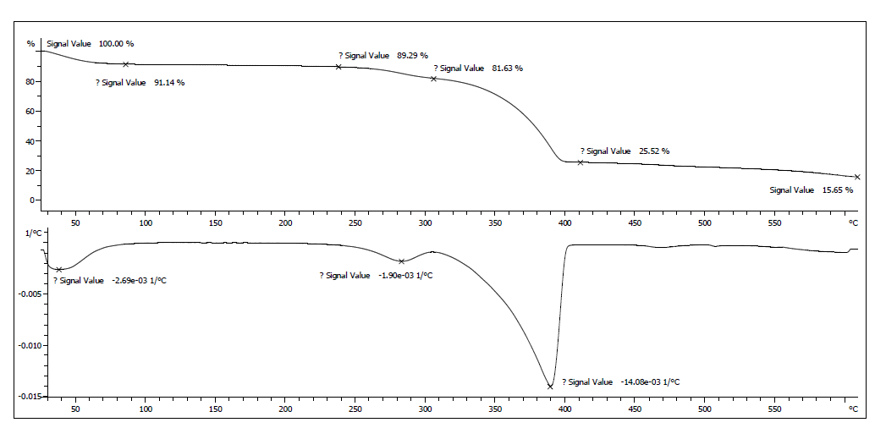
Fig. S1

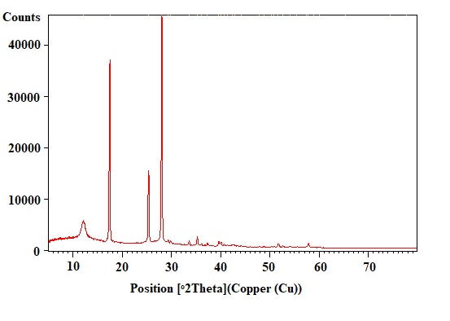
Fig. S2

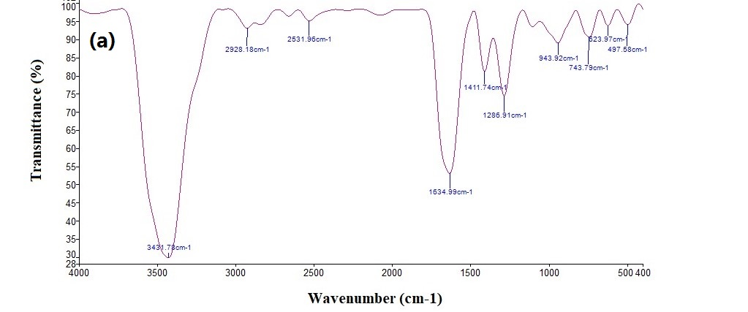

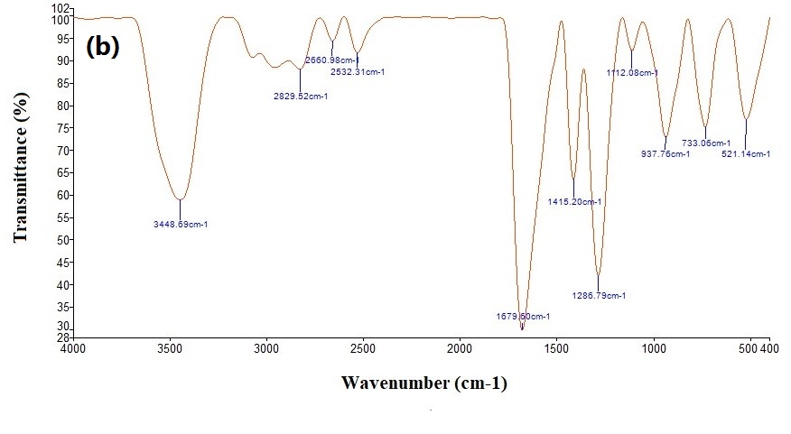
Fig. S3

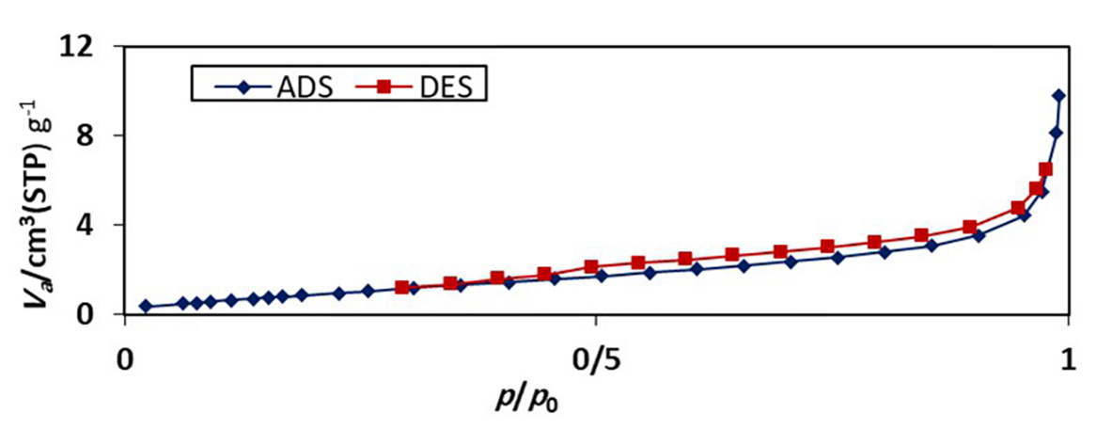

Fig. S4

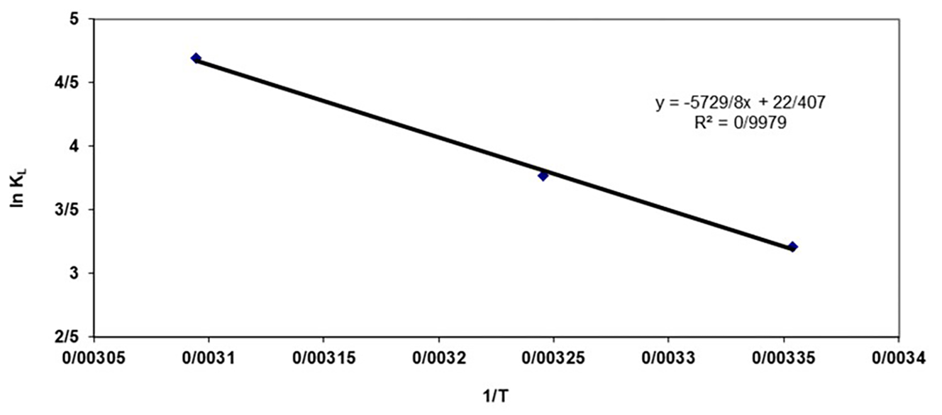

Fig. S5

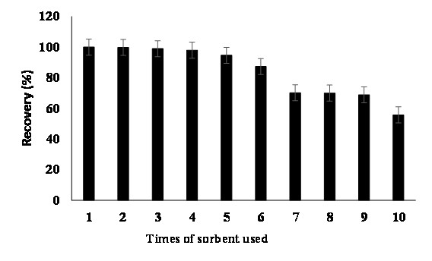
Fig. S6

Table S1

Model | Parameter  T=298.15K |  | Value  T= 308.15 K T= 323.15K
Langmuir | q_{m} (mg g⁻¹)  k_{l} (L mg⁻¹)  R_{l}  R² | 7.776  0.024  0.287  0.9956 | 10.582  0.043  0.186  0.9932 | 11.098  0.109  0.083  0.9913
Ferundlich | n  Ln(k_{f})  k_{f}(mg^{11/n}L^{1/n}g⁻¹)  R² | 1. 508  -1.088  0.336  0.9947 | 1.594  -0.32  0.726  0.9836 | 1.692  0.301  1.351  0.9885
Temkine | B  A_{T} (L mg⁻¹)  R² | 1.295  0.419  0.9515 | 2.227  0.469  0.9945 | 2.433  1.061  0.9828
Dubinin-Radushkevich | K_{ad} (mol² kJ⁻²)  Ln (q_{s})  q_{s} (mg g⁻¹)  R² | 0.00002  1.344  3.834  0.8863 | 0.000007  1.735  5.672  0.9141 | 0.000002  1.901  6.694  0.8406

Table S2
Model | Parameter | Value
Pseudo-first-order model | q_{e} (mg g⁻¹)  K₁ (min⁻¹)  R² | 4.073  0.0039  0.9486
Pseudo-second-order model | q_{e} (mg g⁻¹)  K₂ (g mg⁻¹min⁻¹)  R² | 1.694  1.779  0.9999
Intra-particle diffusion | K_{i} (g mg⁻¹min-^{1/2})  C_{i} (mg g⁻¹)  R² | 0.081  1.365  0.9419

Table S3

Sample | Temperature (K) | ΔHº (J mol⁻¹) | ΔSº (J mol⁻¹ K⁻¹) | ΔGº (J mol⁻¹)
GO/TPAA cl-poly (AA)/TPA | 298.15  308.15  323.15 | 47637.56 | 186.2918 | $-$7.905  $-$9.768  $-$12.562

Table S4
Zero order  pH=1.2 pH=7.4 | First order  pH=1.2 pH=7.4 | Higuchi  pH=1.2 pH=7.4 | Korsmeyer – Peppas  pH=1.2 pH=7.4
K₀ R² K₀ R² | K₁ R² K₁ R² | K_{H} R² K_{H} R² | n K_{KP} R² K_{KP} R²
5.226 0.9919 5.362 0983 | 0.151 0.9562 0.255 0.9863 | 34.579 0.9871 34.03 0.9286 | 0.5 34.077 0.9889 34.03 0.9286  0.6 26.015 0.9937 26.132 0.9441  0.7 20.318 0.9962 20.525 0.9571  0.8 16.118 0.9966 16.37 0.9679  0.9 12.928 0.9951 13.198 0.9765  1 10.454 0.9919 10.724 0.9830

