Table 1. Presents the detailed results of temperature and solar radiation during the sixth month (June), measured at two points on each floor representing the central and perimeter locations

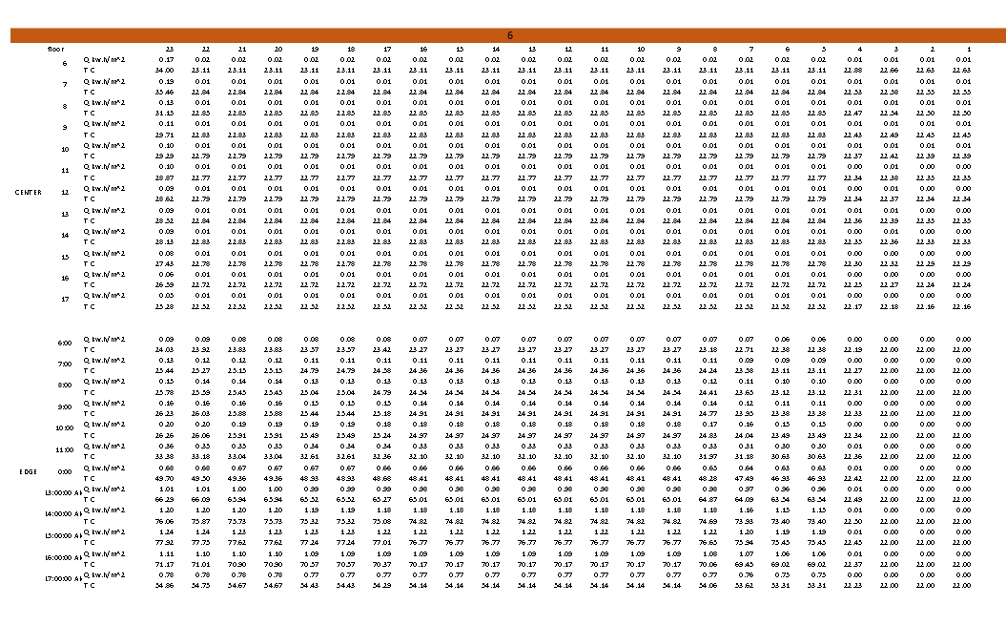

Table 2. Presents the detailed results of temperature and solar radiation during the twelfth month (December), measured at two points on each floor representing the central and perimeter locations.

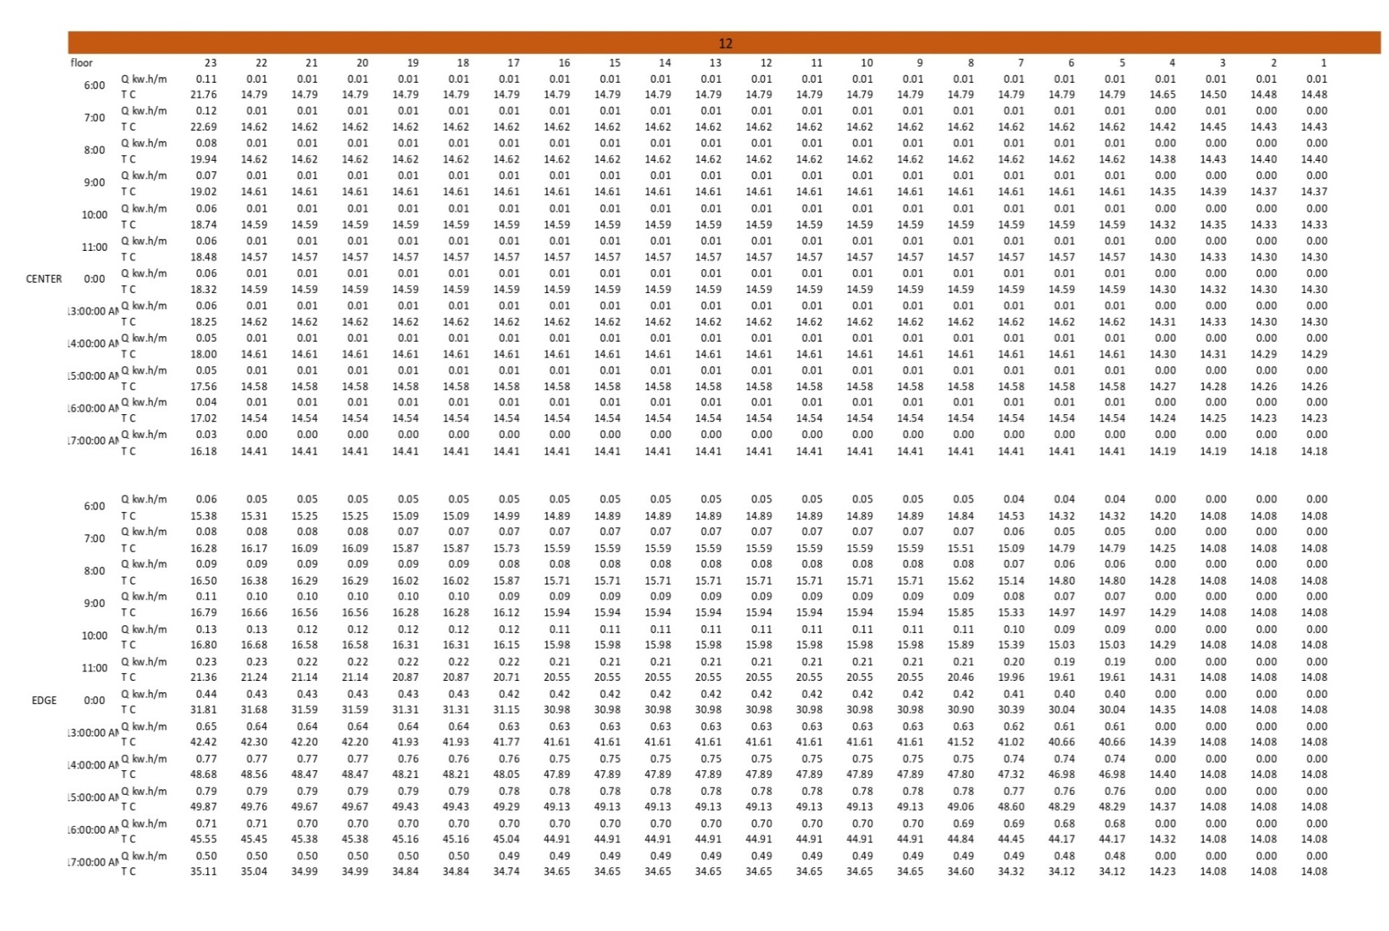

Table 3. Presents the detailed results of temperature and solar radiation during the sixth month (June) after the addition of the smart façade, measured at two points on each floor representing the central and perimeter locations (two authors).
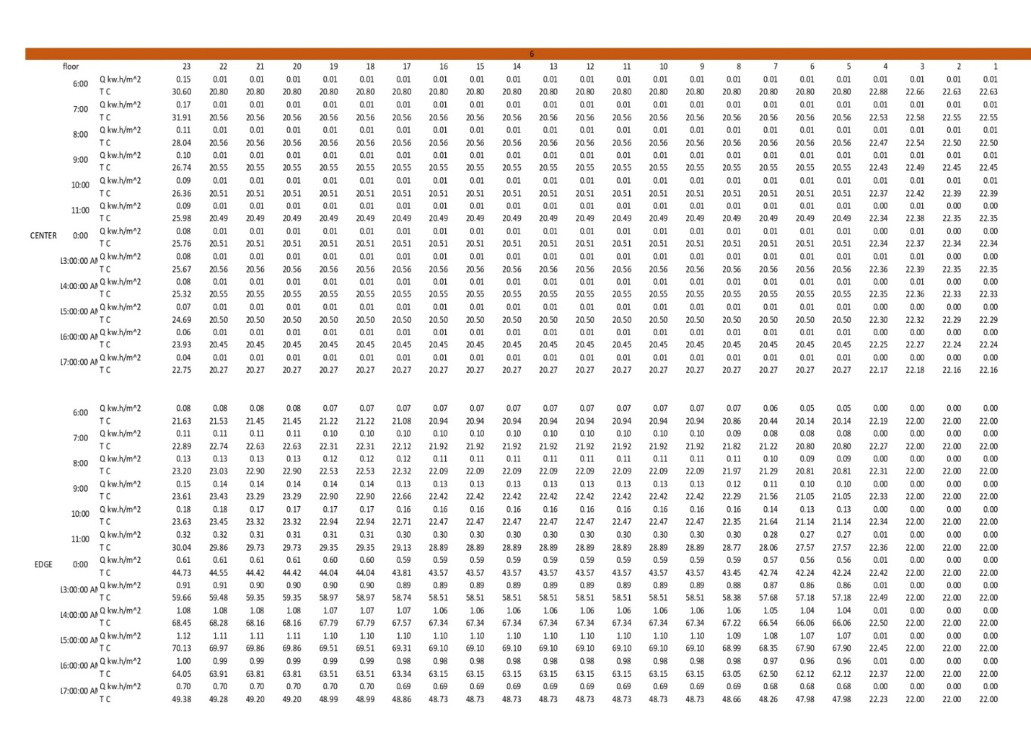

Table 4. Presents the detailed results of temperature and solar radiation during the twelfth month (December) after the addition of the smart façade, measured at two points on each floor representing the central and perimeter locations (two authors).

