Implementation Mapping Data Analysis Protocol
Introduction
The purpose of this protocol is to outline the process of conducting an inductive thematic analysis using the Getting to Equity (GTE) and Exploration, Preparation, Implementation, and Sustainment (EPIS) frameworks and organize the transcribed meeting data into constructs within these frameworks. This protocol will guide the systematic interpretation of meeting data and determine the fidelity of our implementation mapping process and its efficacy within each school setting.
Objectives
- Organize meeting data into constructs of the getting to equity framework and establish connections between constructs.
- Identify key strategies and plans from each role and input them into the EPIS framework to ensure fidelity in our progress.
Preparing Data
- Data Cleaning
  - Remove identifiable information by assigning individuals numeric IDs according to data workbook.
  - Duplicate raw data transcripts and save in Teams
  - Review data for clarity, flow, and misquotes.

Coding Data
Phase 1—Generating Codes for the Exploration, Preparation, Implementation, and Sustainment (EPIS) Framework—this framework will guide the coding of meeting transcripts. Utilizing constructs of the CFIR Model, we will code transcripts line-by-line in order to select quotes that identify

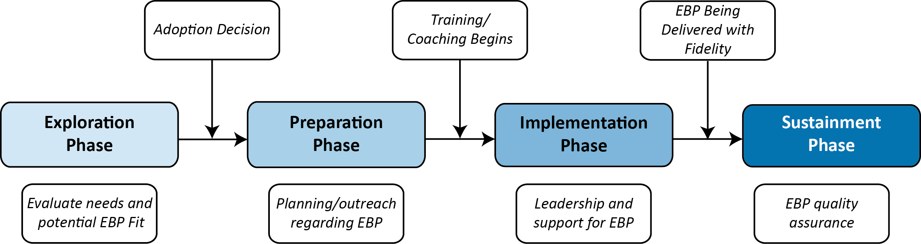
EPIS Constructs – Coding step 1 (assigning data to EPIS constructs)
Domain | Construct | Definition
Outer Context | Service environment – School District & Vendors | District and vendor influence on meal procurement and changes. Issues related to menu changes and follow-through/communication of these changes
 | Service Environment – Policies | State and federal sociopolitical and economic contexts in terms of policies that influence the process of implementation and delivery/use of the innovation  Ex: What money is allocated?
 | Funding | Fiscal support provided by the system in which implementation occurs. Fiscal support can target multiple levels (e.g., staff training, fidelity monitoring, provision of the innovation/EBP) involved in implementation and delivery/use of the innovation.  Ex: How is reimbursement allocated?
 | Leadership | Characteristics and behaviors of key decision-makers pertinent at all levels who are necessary but not sufficient to facilitate or promote the implementation process and delivery/use of the innovation. ￼
 | Inter-organizational networks and partnerships | Relationships of professional organizations through which knowledge of the innovation/EBP is shared and/or goals related to the innovation/EBP implementation are developed/established. i.e., instructions coming from the school district to the school setting/food service. ￼  Excludes the school community and is bi-directional between external partners.
 | Responsiveness to School Community | Support or marketing system change based on consumer needs, priorities and/or demographics. ￼
Inner Context | Organizational Capacity | Three broad areas appear to be especially important in the early stage of implementation: an organization’s absorptive capacity, readiness for change, and receptive context.
 | Individual Adopter Characteristics | Leaders of implementation – could be principals, food staff, classroom teachers. Describe action (or inaction/lack of effort) to demonstrate their leadership within school meals and increase uptake
 | Culture | Demographics and individual characteristics of the students & families  Differences in cultural background within the target population
Bridging Factors |  | Bridging factors are deemed to influence the implementation process as the inner context of organizations is influenced by the outer system in which the organization operates, but those influences are reciprocal (e.g., industry lobbyists impacting pharmacy legislation, direct to consumer marketing, etc.)  Bridging factors may include processes such as interagency collaboration and community-academic partnerships.
Innovation Factors |  | Innovation factors may include characteristics of the innovation or EBP characteristics, and/or the fit of the innovation at system, organization, provider, and patient levels.  Desired changes based on feedback from participants and school representatives

Domains table – Coding step 2: Applying data and codes to specific phases of EPIS
Domain/Phase | Level | Definition
Exploration | Challenges/Barriers | What was not working in their setting, what they felt like needed improvements, and what is already working within the community or school district (i.e. fast food/corner stores nearby, discrepancies in district meal rollout, etc.)
 | Supports/ Facilitators | Include any mentions of what was not working in their setting, what they felt like needed improvements, and what is already working within their school cafeteria culture, administration, and student body.  Responses to the needs assessment report.  Key factors discussed that influence school meal participation.
Preparation | Challenges/Barriers | Main target areas of need within the school are based off of the perception of participants.  Are strategies feasible for the school? What are potential barriers to implementation of strategies?
 | Supports/ Facilitators | External partners and district staff spheres of influence. What programs can be strengthened to support implementation, along with action steps from community organizations and the school district?  Are strategies feasible for partners? What are potential barriers to implementation of strategies?
Implementation | Challenges/ Barriers | Identify key action steps for implementation and how leaders for strategies are identified.
 | Supports/ Facilitators | ..who will be the champion of each strategy, what partners will provide technical assistance
Sustainment | Inner/Outer Setting | Plan for sustainability. What do we expect to do to ensure strategies are long-term

Step 3: Aligning coding for the Getting to Equity Framework
Coding using the GTE Framework will focus on aligning identified overarching barriers and strategy supports within each quadrant of the framework.
- Barriers and strategy supports (or ideas for strategies) within the Getting to Equity framework (link to online toolkit).
Quadrant | Barriers | Strategy Support
Increase Healthy Options | These can include concerns about the healthfulness of the meals, access to food, elements of the policy and how food is prepared and served, built environment of the school, etc. | Facilitators or discussion that relates to building a strategy related to this quadrant. Examples could include changing how food is prepared/served, changes to menu or procurement, etc.
Reduce Deterrents | Concerns related to stigma, discrimination, cultural barriers, competitive foods and beverages, etc. | Ideas to tackle stigma and discrimination around school meals, reducing promotion of unhealthy foods, improving safety
Build on Community Capacity | Communication breakdowns, issues or lack of partnerships, capacity among school and broader community | Ideas to include community voices, integrate local resources and organizations, developing strategic partnerships
Improve Social and Economic Resources | Issues related to student and family finances (i.e., affordability of food, jobs), education and job training for school representatives, housing, and other economic issues | Ideas related to providing job training to food service staff/teachers/students, supporting family finances through improvements to accessing school meals, and support via other federal assistance programming.

Consensus Coding Steps (During Consensus Meetings):
- Coder 1 shares screen and their coded transcript; coder 2 has their coding pulled up on their own computer
- Go through transcript a section at a time and review codes for each reviewer. Where a “disagreement” arises (i.e., different codes applied to the same text), reviewers discuss their reasons for coding this way and discuss how best to code the data based on the protocol and understanding of the data
- Document each section discussed in the Team Coding Consensus Log.docx and what coding decisions were made
- Possible coding decisions include:
  - Removing a code from text segment
  - Adding a code
  - Double or triple coding segments if it’s clear the data fit within more than one construct. This is especially the case with incorporating EPIS constructs.
- Both coders make the changes to their transcripts
- When finished, head to “TeamCloud” and upload revised coding for the team lead with a note telling them which transcripts were edited
Phase 2 – After we have finalized the codes for Steps 1-3 above.
Step 4: Inductive coding – Generating overarching themes from the data to “tell the story”
- Coders may create new, inductive themes that span across all EPIS and GTE domains.
  - Coders can create a short list of codes and assign quotes to them to provide context for the theme
  - Team members meet to review their codes and decide on a semi-final list which makes the best alignment of all their codes
  - Once list is ready, input into MAXQDA TeamCloud and divide up transcripts for team members to code
- Coding in MAXQDA:
  - GM enters coding list into MAXQDA
  - Coders go through one transcript at a time and assign data to coding system
    - Complete Thematic Coding Questions-Reflection.docx
    - Meet weekly between 7/15 and 7/29 to review codes, make decisions (i.e., add, remove, change) on codes, and debrief
    - When coding is complete, team will send to peer debriefers to review

