Implementation Mapping Overview
RISE Lab Project
Conceptual Overview of the 5-year K01 project
Over the 5-year project period, we will complete an implementation mapping process with the School District of Philadelphia which involves development and testing of an implementation strategy to increase the equitable impact of Universal School Meals (USM). The figure below illustrates and describes the 5 components of the implementation mapping process and when they are scheduled to occur across the project lifespan.
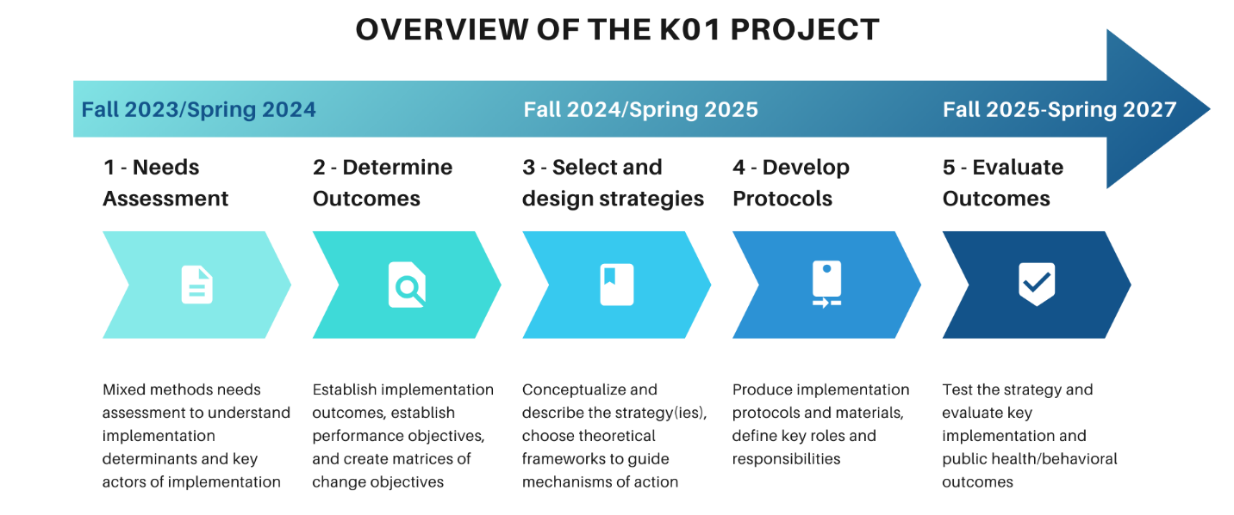
Year 1 Fall 2023-Spring 2024
Step 1: Needs Assessment
A year-long needs assessment took place to understand the key implementation determinants (i.e., challenges, supports) for implementing Universal School Meals (USM). We conducted interviews with key representatives from 8 schools, including students, parents, teachers/staff, food service providers, and administrators. We conducted observations and collected field notes to gain a greater understanding of the school food environment. This provided the research team and the Community Advisory Board (CAB) with an understanding of the key challenges to USM implementation and potential ways to build capacity in schools.
Year 2: Fall 2024-Spring 2025
Randomization into intervention and delayed comparison schools (Fall 2024)
When all schools have been recruited for the sample, they will be matched according to key characteristics (i.e., full service, satellite, community school, non-community school) and randomized into intervention and waitlist comparison schools. We will maintain relationships with the comparison schools by having pre-established check-in meetings with them throughout the spring and fall of 2025 but not engage in any mapping activities. We will take consistent notes of how they are implementing the school meals program, challenges they face over time, and i they are trying out anything new on their own accord. In spring 2026 they will receive the implementation strategy(ies) that will have been tested in the intervention schools and given all resources to implement the strategy.
Step 2: Determine Outcomes (Meeting 1- Fall 2024)
We will work with school administrators to recruit a small group of representatives from each school including school principals/leadership, food service leadership, classroom teachers, climate staff, students, and/or parents (this may vary depending on the school context). In an initial meeting with the school teams, we will 1) recap the data and main findings from the needs assessment, 2) provide an overview of implementation mapping and the intended impact of this process, and 3) establish the high-priority outcomes of USM implementation through collaborative discussions. Meeting 2 will also be scheduled during this time to ensure that everyone can attend.
In-between Meeting 1&2
In-between the first and second meeting, we will begin to chart out performance objectives based on goals established in Meeting 1 so that school teams will have a starting point to work from in Meeting 2. We will send this via email ahead of time in addition to a “menu” of strategies for school teams to review.
Step 3: Select and Design Strategies (Meeting 2 – Winter 2024-25)
Action-oriented performance objectives will be grouped into USM implementation and maintenance categories and the roles for each person responsible will be outlined at each step. Two questions will be assessed during the development of objectives: (1) implementation—what does each role need to promote USM and deliver USM in their school setting? (2) maintenance—What does each role need to maintain USM? We will also identify necessary changes in each setting to carry out performance objectives.
Then the chosen performance objectives will be mapped onto potential implementation strategies for USM (see below) which can be tailored through collaborative discussions. The school teams may wish to adopt one or several implementation strategies and they may be linked to multiple levels (i.e., student, classroom, whole school, outside of school/school community) of the school system such as within the school setting, the cafeteria, or between the school and the community (i.e., students/parents). We will begin to discuss how potential strategies will be translated into practical steps that fit their school context and capacity.
In-between Meeting 2&3
In addition to the Getting to Equity (GTE) framework, we will look to the literature to identify other Theories, Models, and Frameworks from behavioral science that can be used to help us meet performance objectives and help to propose mechanisms of action for the chosen strategies. The team will continue to provide feedback and communication about how strategies will be broken down into tangible steps.
Step 4: Develop Implementation Protocols (Meeting 3 – Winter/Spring 2025)
In the third meeting, the researchers and school teams will work to develop implementation protocols to specify what needs to be done to carry out the implementation strategy and who is responsible for what aspect of the strategy. We will identify criteria necessary for each strategy to be effective in the school based on the necessary changes that were identified in Step 2. This will help the team decide what documents and resources are needed, where they will be stored, and how modifications may occur as we get closer to testing the strategy. We will also decide on a training plan if the chosen strategies are addressing an educational or professional development component. Protocol development will outline the purpose of each strategy, roles responsible for adoption, identified determinants, theoretical frameworks needed, and evaluation questions.
Communication Between Meetings
Communication with the schools between meetings will entail 1) regular emails between the research team and the schools, 2) regular visits to schools to maintain facetime and rapport, 3) asking schools if they want us to be present at events they hold, and 4) as-needed additional meetings to plan and develop materials depending on the chosen implementation strategy(s).
Y3-5: Fall 2025- Spring 2027
Step 5: Rollout and Evaluation of Implementation Strategy
During Y3-5, schools will begin implementation of the strategy and participate in monthly check-in calls/in-person meetings during the first semester of using the implementation strategy to address immediate concerns or challenges, followed by regular touchpoints in the spring. During these calls, we will collect data by taking notes on reported fidelity to the implementation strategy. These calls will focus on real-time pragmatic issues that arise in USM implementation such as staffing, communication, and any unexpected emergencies which severely impact school meals. We will also conduct interviews with school team members to assess perceived acceptability, feasibility, and sustainability of the strategy.
Implementation Strategy Types:
Implementation Strategy Type | Definition
Use and evaluate iterative strategies | Relying on data and feedback regarding barriers and facilitators to guide the development of implementation planning, assessing organizational readiness, and implementation rollout. Strategies can be adapted or changed throughout the process of implementation based on feedback from implementors or consumers (i.e. menu changes based on feedback from the student advisory board).
Provide Interactive Assistance | Enhance delivery of programs through improvements in monitoring and distributing systems, recognizing and developing solutions to specific implementation barriers, and establishing assistance and supervision for implementers.
Adapt and tailor to context | Create new or leverage existing interventions in your school context that can be adapted to several settings (i.e. classroom, cafeteria, etc.), can be tailored based on barriers, and can be tested on a small scale. (i.e. menu testing in the classroom or cafeteria)
Develop implementation partner relationships | Network collaborations with partner organizations, leadership, and consumers (parents, students, teachers) to build support in implementation efforts, train implementers on strategies and behaviors to lead effective implementation, engage groups with diverse perspective to strategize and improve efforts, and identify existing programs that are successful.
Train and educate representatives | Creating targeted educational and training materials for all representatives involved. Training and educational materials can be presented in several formats and catered to different learning styles; Representatives will receive ongoing support from expert team to assist with implementation.
Support educators | Promote adherence and fidelity through resource sharing, direct communication channels, supporting well-being, and fostering motivation.
Engage consumers | Involve staff, students, and families throughout the implementation process by receiving their input communication, strategy development, and encouraging active participation and advocacy for change.
Financial Strategies | Access new funding to support school-level interventions and provide incentives to schools and implementors for engaging and sustaining new implementation practices.
Change Infrastructure | Altering environmental and organizational factors to support implementation. This may consist of developing systems that actively report menu changes, removing competitive foods from the cafeteria, alterations to the cafeteria (layout, health promotion posters, lunch/recess times, etc.), establishing new guidelines for implementation of policies at the school and district level, mandate leadership to prioritize improvement of school meals.

Implementation Strategy Menu
The below table provides a sample of implementation strategies that could be developed/adapted and tested in the project. These are then aligned to address health equity and mapped onto the Getting to Equity (GTE) framework quadrants.
Category | Strategy Name | Description | Integration of Health Equity | GTE Quadrant
Provide interactive assistance | Facilitation | Collaborative problem solving between the project team and the school teams through regular meetings (e.g., monthly) to discuss logistical challenges to USM implementation | Ensure utilization of needs assessment findings to guide this work; make sure representation from school teams is balanced across roles and race/ethnicity
Provide interactive assistance | Provide local technical assistance | Develop and use a system to deliver technical assistance focused on USM implementation issues using local personnel. – this could be in collaboration with SNAP-Ed/Eat Right Philly | Ensure implementers have equitable access to support and information to make informed decisions to the best of their capability | Q4
Develop collaborative relationships | Develop academic partnership | Partner with a university or academic unit to bring training and professional development opportunities to school admin and food service teams for USM | Ensure implementers and recipients hold power over developing goals to avoid academic goals overshadowing the needs of schools. | Q3/Q4
Develop collaborative relationships | Inform local opinion leaders | Inform school personnel identified as leaders or influential about new practices for USM who can socially influence colleagues to adopt it—informing department heads, assistant principals, guidance counselors, etc. | Ensure representation of cultures, languages, race, and ethnicity in the messaging and the people tasked with influencing. | Q4
Train and Educate Representatives | Develop educational materials | Develop training materials for classroom teachers, climate staff, students, and other representatives to address stigma around participation in USM. | Develop educational materials to educate school staff on cultural sensitivity, addressing stigma, and creating a culturally inclusive space. | Q3/Q2
Train and Educate Representatives | Provide ongoing consulting | Support school teams through ongoing check-in meetings to troubleshoot implementation of the education materials for USM | Develop check-in plan with each team to revise implementation methods of the education materials. | Q3
Support Educators | Revise professional roles | Revise roles of food service providers and other staff to accommodate USM implementation plan | Ensure that more work is not added to roles/descriptions of the lowest paid staff | Q3
Engage consumers | Use mass media | Use media (e.g., social media, print signage) to reach large numbers of people to spread the word about school menus, the importance of USM, and other updates be used to reduce stigma | Ensuring information is accessible to hard-to-reach groups such as parents and students | Q4
Engage consumers | Involve students, family, and other staff | Include students, parents, and staff that are affected by USM implementation practices by receiving input and feedback on strategies. | Actively include diverse perspectives of the program recipients (i.e. students, parents) in addition to operational perspectives from mid and high-level leaders and staff to in final decision making. | Q4
Engage consumers | Prepare students and families to be active participants | Empower students and families to advocate for improved USM implementation practices. Ensure families and students are active in providing feedback, asking questions about the rationale for decisions, and suggesting changes. | Intentionally reach and communicate changes to recipients from all backgrounds (i.e. race/ethnicity, socioeconomic status, language). Ensure groups are empowered to share responses and leaders adequately responding to and incorporating feedback ang suggestions for change. | Q4
Financial strategies | Make implementation easier by removing burdensome documentation tasks | Make it easier to implement USM by reducing burdensome tasks or documentation (e.g., completing unnecessary and unused data forms, completing rubrics that are not used to inform decisions, reports, etc.). | Avoid unintentionally burdening other staff who might be lower paid and/or “marginalized” within the school system as a result of streamlining other tasks | Q3/Q2?
Change infrastructure | Change/alter environment | Changing the layout of a classroom/cafeteria, scheduling, repurposing space) to best implement USM. | Collaborate with school faculty to integrate improved schedule and room spacing to best implement school meals. | Q4
Change infrastructure | Mandate for change | School and food service leadership prioritize new practices (i.e., top down) for USM and their determination to have them implemented. | Improve cafeteria culture by embracing diversity of school community and promoting inclusivity through culturally relevant health promotion programming, strengthening staff-student relationships, and fostering school wide cultural consciousness. | Q1/Q2

