Supplementary information
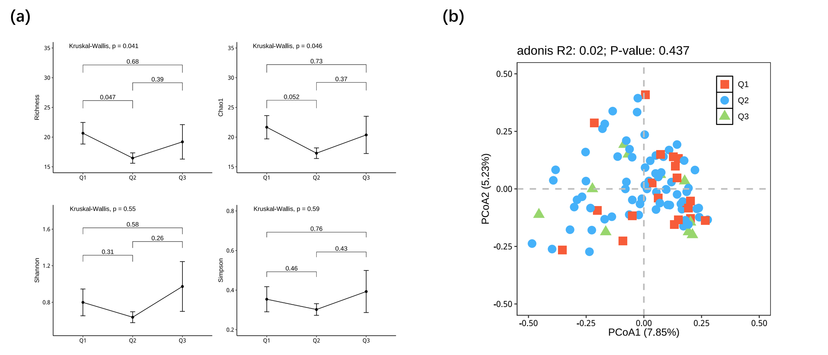
Fig. S1 Population statistics of different groups, including groups Q1 (Gestational age <= 13 weeks), Q2 (Gestational age 14- 27 weeks), Q3 (Gestational age >= 28 weeks).
(a) Alpha diversity analysis of the Q1, Q2, and Q3 groups. Alpha diversity including Richness, Chao1, Shannon, and Simpsom index of different samples in the three groups. The whiskers on each side of the box extend to the minimum or maximum value that is not an outlier. The p value was calculated by the Wilcoxon rank-sum test. (b) Principal coordinate analysis (PCoA) of microbial communities based on Bray–Curtis dissimilarity. Q1, Q2, and Q3 are colored in red, blue, and green, respectively.
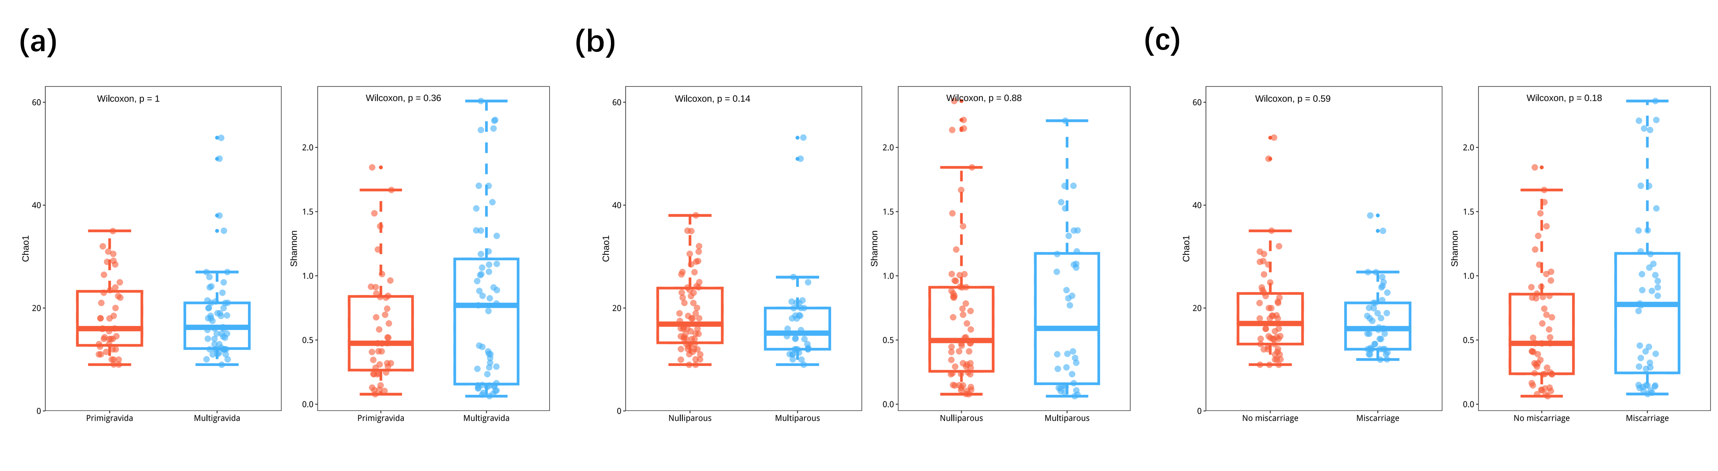
Fig. S2 Alpha diversity analysis of the microbiota in different groups stratified by gravidity, parity, and miscarriage history
Alpha diversity including Chao1, and Shannon index of different samples, stratified by gravidity, parity, and miscarriage history, were shown. The whiskers on each side of the box extend to the minimum or maximum value that is not an outlier. The p value was calculated by the Wilcoxon rank-sum test.

