Supplementary material

Material properties for the numerical modelling

Table S - 1. Properties for the simulated materials. Temperature-dependent materials are expressed as functions of temperature T.
Material | Density  [kg m⁻³] | Electrical conductivity  [S m⁻¹] | Thermal conductivity  [W m⁻¹ ⁰C⁻¹] | Elastic modulus [GPa] | Specific heat  [J kg⁻¹ ⁰C⁻¹] | Poisson’s ratio
PET ^{1,2} | 1300 | $${10}^{-16}$$ | 0.2 | 3 | 1200 | 0.43
Silver^{3–6} | 10500 | $\frac{61.4×{10}^{6}}{1+0.0041×\left(T-20\right)}$* | 429 | 82.7 | $235.3+0.0863×T$ ** | 0.37
Brass^{6–8} | 8450 | 15.9×10⁶ | 120 | 110 | 380 | 0.34
PC ⁶ | 1200 | 10⁻¹² | 0.2 | 2.315-0.00522×T | 1200 | 0.37
PVB⁹ | 1080 | 3.2×10⁻¹² | 0.2 | see Table S - 2 | $1832+2.62×T$ ** | 0.47
*The electrical conductivity is calculated based on $σ=\frac{σ_{0}}{1+α×\left(Τ-Τ_{0}\right)}$, where σ₀ is the resistivity at 20⁰C, α is the temperature coefficient of resistance, and T₀ is the reference temperature.
**The specific heat equation is linearly fitted in the experimental data presented in the referenced publications.
The elastic modulus $E_{\left(t\right)}$ for PVB was modelled using the following equation:
$$E_{\left(t\right)}=E_{∞}+\sum_{i=1}^{n}{E_{i}×e^{-\frac{t}{τ_{i}}}}$$ | (S - 1)
where $E_{∞}$ is the long-term elastic modulus, $E_{i}$ is the elastic modulus associated with the relaxation time, and $τ_{i}$ is the relaxation time. The materials was assessed using DMA and the results were used to calibrate the viscoelastic parameters $E_{i}$ and the relaxation time $τ_{i}$. The values can be found in Table S - 2.
Table S - 2. Viscoelastic parameters and relaxation times for the characterisation of the mechanical properties of PVB. The instantaneous modulus $E_{0}=E_{∞}+\sum{E_{i}}$ and $E_{∞}=0.5MPa.$
 | $$E_{i}/E_{0}$$ | $$τ_{i}$$ |  | $$E_{i}/E_{0}$$ | $$τ_{i}$$
1 | 3.72E-01 | 1.00E-09 | 9 | 6.38E-02 | 1.00E-01
2 | 1.43E-15 | 1.00E-08 | 10 | 4.07E-02 | 1.00E+00
3 | 9.15E-02 | 1.00E-07 | 11 | 1.54E-02 | 1.00E+01
4 | 7.18E-02 | 1.00E-06 | 12 | 5.26E-03 | 1.00E+02
5 | 7.97E-02 | 1.00E-05 | 13 | 6.04E-04 | 1.00E+03
6 | 8.52E-02 | 1.00E-04 | 14 | 3.74E-04 | 1.00E+04
7 | 8.98E-02 | 1.00E-03 | 15 | 1.94E-04 | 1.00E+05
8 | 8.33E-02 | 1.00E-02 | 16 | 2.29E-04 | 1.00E+06

The PET is modelled as linear body without viscoelastic properties due to its glass transition temperature being greater than the attained temperature profiles in the experiments. A comparison of the tan delta between the PVB and PET can be seen in Figure S - 1. The peak of the graphs designate the glass transition area for each material. PVB exhibits a peaks close to 31.6⁰C, and PET close to 104.1⁰C. The high glass transition temperature of PET, combined with the studied temperature range in the experiments (< 70⁰C) signifies that PET is in its glassy state, while PVB experiences glass transition.
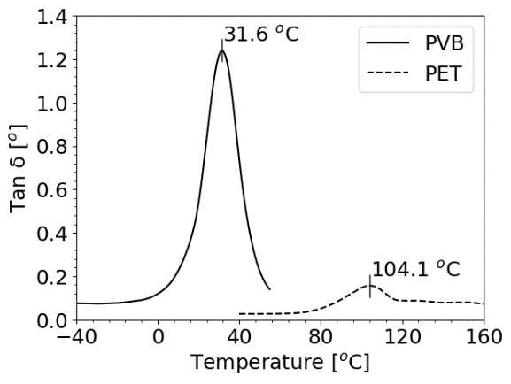
Figure S - 1 Tan delta of PET and PVB with the corresponding glass transition temperature.

Bibliography

1. Sorel, S., Bellet, D. & Coleman, J. N. Relationship between material properties and transparent heater performance for both bulk-like and percolative nanostructured networks. ACS Nano vol. 8 4805–4814 (2014).
2. Ji, S., He, W., Wang, K., Ran, Y. & Ye, C. Thermal response of transparent silver nanowire/PEDOT:PSS film heaters. Small 10, 4951–4960 (2014).
3. Matula, R. A. Electrical Resistivity of Copper, Gold, Palladium and Silver. J. Phys. Chem. 8, 1147–1298 (1979).
4. Cheng, Z., Liu, L., Xu, S., Lu, M. & Wang, X. Temperature dependence of electrical and thermal conduction in single silver nanowire. Sci. Rep. 5, (2015).
5. Furukawa, G., Saba, W. & Reilly, M. Critical Analysis of the Heat-Capacity Data of the Literature and Evaluation of Thermodynamic Properties of Copper, Silver, and Gold from 0 to 300K. (1968) doi:10.7312/schw92626-006.
6. Goodfellow. Material Properties. (2022).
7. Bowler, N. & Huang, Y. Electrical conductivity measurement of metal plates using broadband eddy-current and four-point methods. Meas. Sci. Technol. 16, 2193–2200 (2005).
8. Adineh, M. & Doostmohammadi, H. Microstructure, mechanical properties and machinability of Cu–Zn–Mg and Cu–Zn–Sb brass alloys. Mater. Sci. Technol. (United Kingdom) 35, 1504–1514 (2019).
9. Wilski, V. H. Die spezifische Wärme des Polyvinylbutyrals. Die Angewandte Makromolekulare Chemie vol. 6 101–108 (1969).

