Supplementary information

S1 Reference experiments with NLC core

The fibers with NLC core were spun at 1 kV/cm (10 cm distance between spinneret and collector), at a temperature of 23.3 °C and a relative humidity of 30 %. The PVP solution was pumped at 60 μL/min and the NLC at 2 μL/min. POM images of these fibers are shown in Fig. S1.

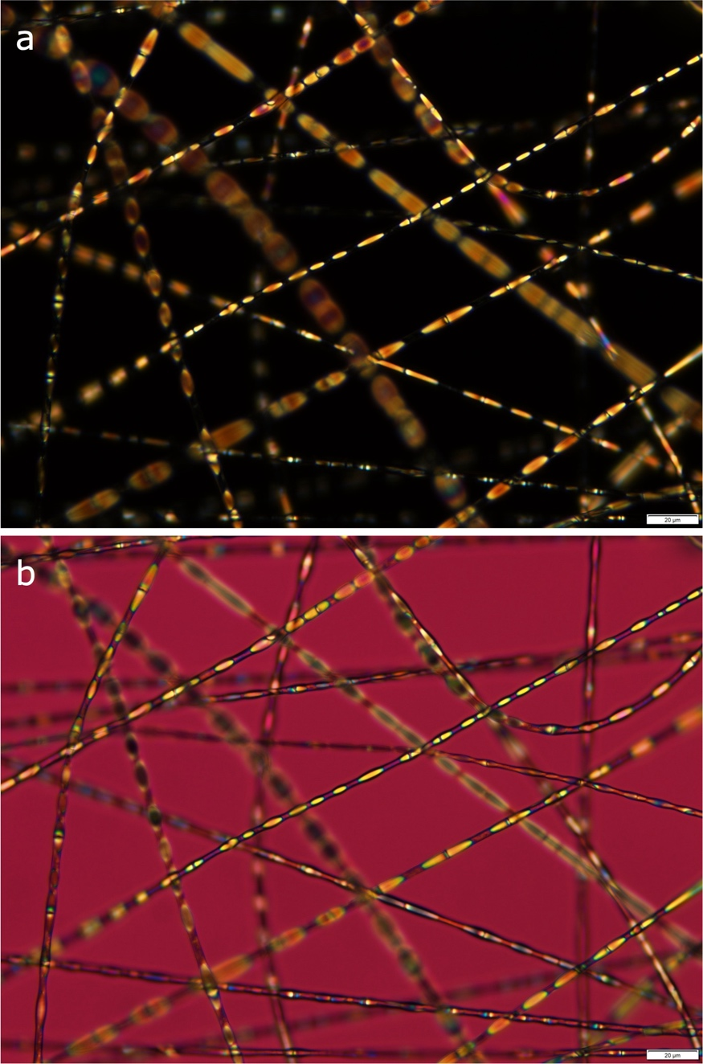

Fig. S1 Fibers spun with the classic nematic LC mixture E55 as core. Regular micrograph between crossed polarizers (a) and with a first-order lambda plate inserted (b). The slow axis of the latter is oriented from bottom left to top right. Scale bar represents 20μm.

S2 Explanation of Supporting Video 1

Supporting Video 1 is a compilation (created using the software OBS) of multiple video feeds. On the left is the video feed from a camera (Pixelink, with a macro lens attached) mounted on top of the spinning chamber and looking down on the spinning experiment. From left to right the video shows the spinneret orifice, the Taylor cone protruding from it, the compound jet ejected from the tip of the Taylor cone, and the plume as the jet instability kicks in. The latter is not seen from the beginning, but at about 1 s in the video an additional torch light is turned on which reveals it clearly. To give a sense of scale, note that the outer diameter of the spinneret is 1.7 mm, hence the video shows approximately the first 2 cm of the jet.

Directly to the right of the camera video feed, at approximately mid height, is a notepad window where we wrote free-text comments about the on-going experiment. Unfortunately, the operators had forgotten to update this when starting this experiment, hence the texts "FNLC no flow" and "PVP disconnected" are incorrect. What is correct in this window is that the voltage was 10 kV, the collector was a grounded metallic ring, and the distance between the spinneret orifice and the ring was 10~cm.

The correct flow rates for the FNLC and PVP solution are shown at the bottom right, in the green-tinted windows from the Fluigent Oxygen software controlling and monitoring the pneumatically activated liquid flow. The actual FNLC flow rate is thus ranging from 5.9–7.4 μL/minute (bottom right) and that of the PVP solution is about 80 μL/minute. The reason for the slightly greater fluctuations in the flow rate of the FNLC than that of the PVP solution is that the former was controlled via constant pressure (second blue panel from the top) while the latter was controlled via constant flow rate.

The white panel in the bottom right corner of the composite video shows the temperature (23.3°C) and relative humidity (30\%) in the spinning chamber.

