- The original SUCRA values (Figure 5A, Figure 5E).
 | PFS | ≥3AE
paclitaxel+cis | 92.74 | 81.7
paclitaxel+car | 89 | 75.9
gem+cis | 72.74 | 83.8
gem+car+PARP | 68.22 | 68.7
paclitaxel+gem | 44.89 | 82.9
SG | 69 | 53
gem+car | 56.92 | 64.9
Dato-Dxd | 58.49 | 54.6
cap+vin+BEV | 96.81 | 2.9
SG+ICIs | 47.79 | 44.3
cap+BEV | 76.98 | 14.5
paclitaxel | 17.76 | 68.5
paclitaxel+ICIs | 30.54 | 47.4
paclitaxel+reparixin | 15.33 | 58
paclitaxel+BEV | 68.63 | 4.3
Ixabepilone | 6.65 | 63.3
paclitaxel+AKT | 37.32 | 27.6
paclitaxel+cobimetnib | 38.86 | 24.8
gem+car+ICIs | 10.83 | 48.5
Ixabepilone+cetuximab | 5.32 | 30.4

- Scenario A (PFS,50% and AE,50%):
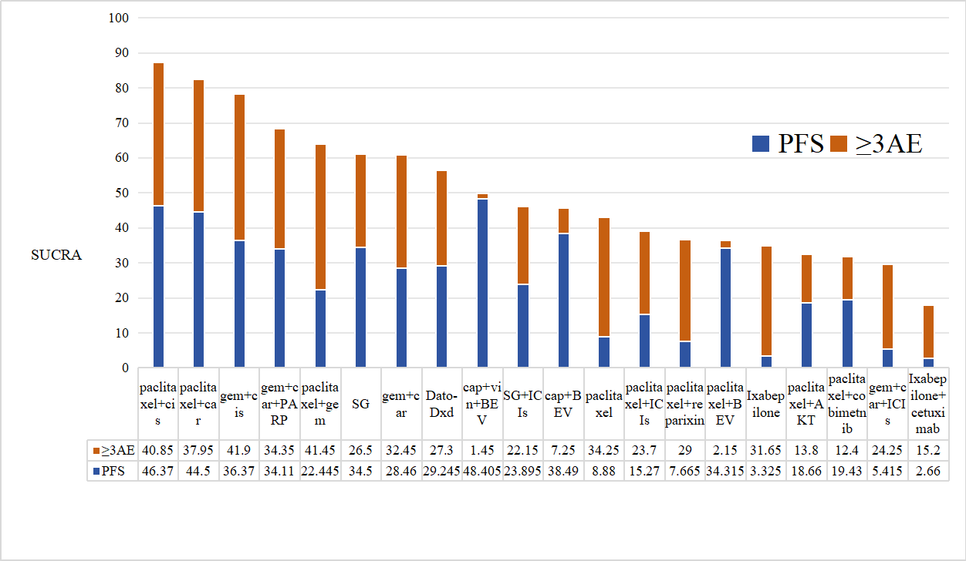
- Scenario B (PFS,30% and AE,70%):
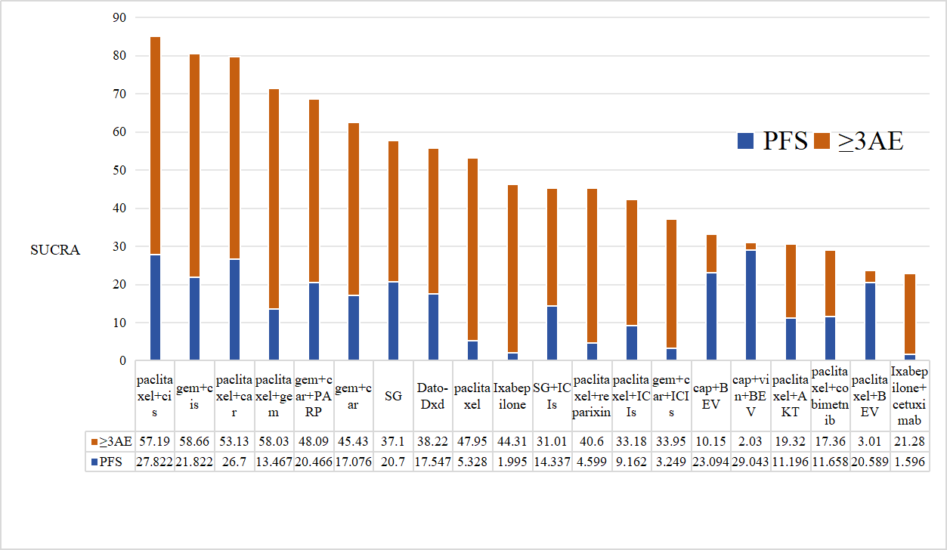
- Scenario C (PFS,70% and AE,30%):
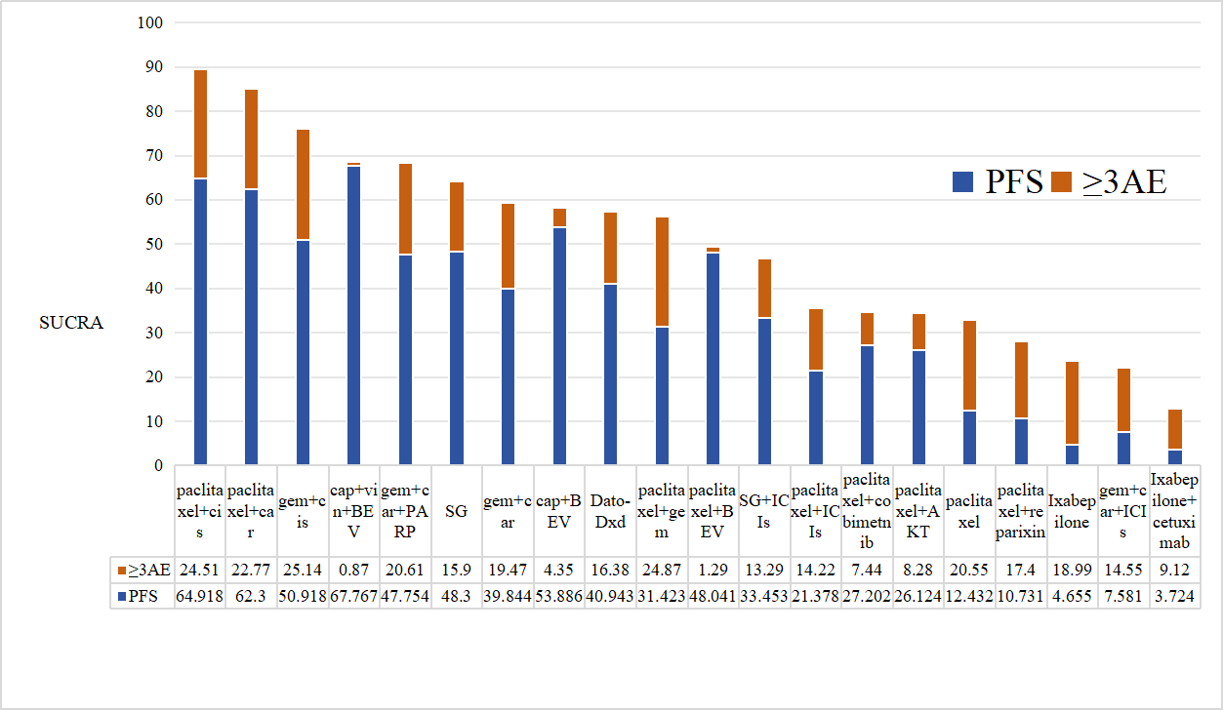

Supplemental File H: Sensitivity analysis of PFS combined with grade ≥3 AEs: A. Original SUCRA values; B. PFS weighted at 50% and grade ≥3 AEs weighted at 50%; C. PFS weighted at 30% and grade ≥3 AEs weighted at 70%; D. PFS weighted at 70% and grade ≥3 AEs weighted at 30%.

