A
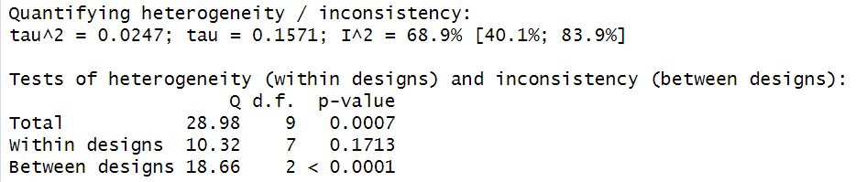

B
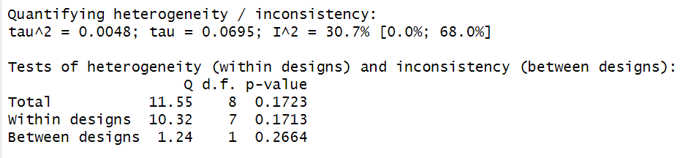

Supplemental File F: Analysis of heterogeneity and inconsistency: A. Analysis results including the IMpassion132 study; B. Analysis results excluding the IMpassion132 study.

