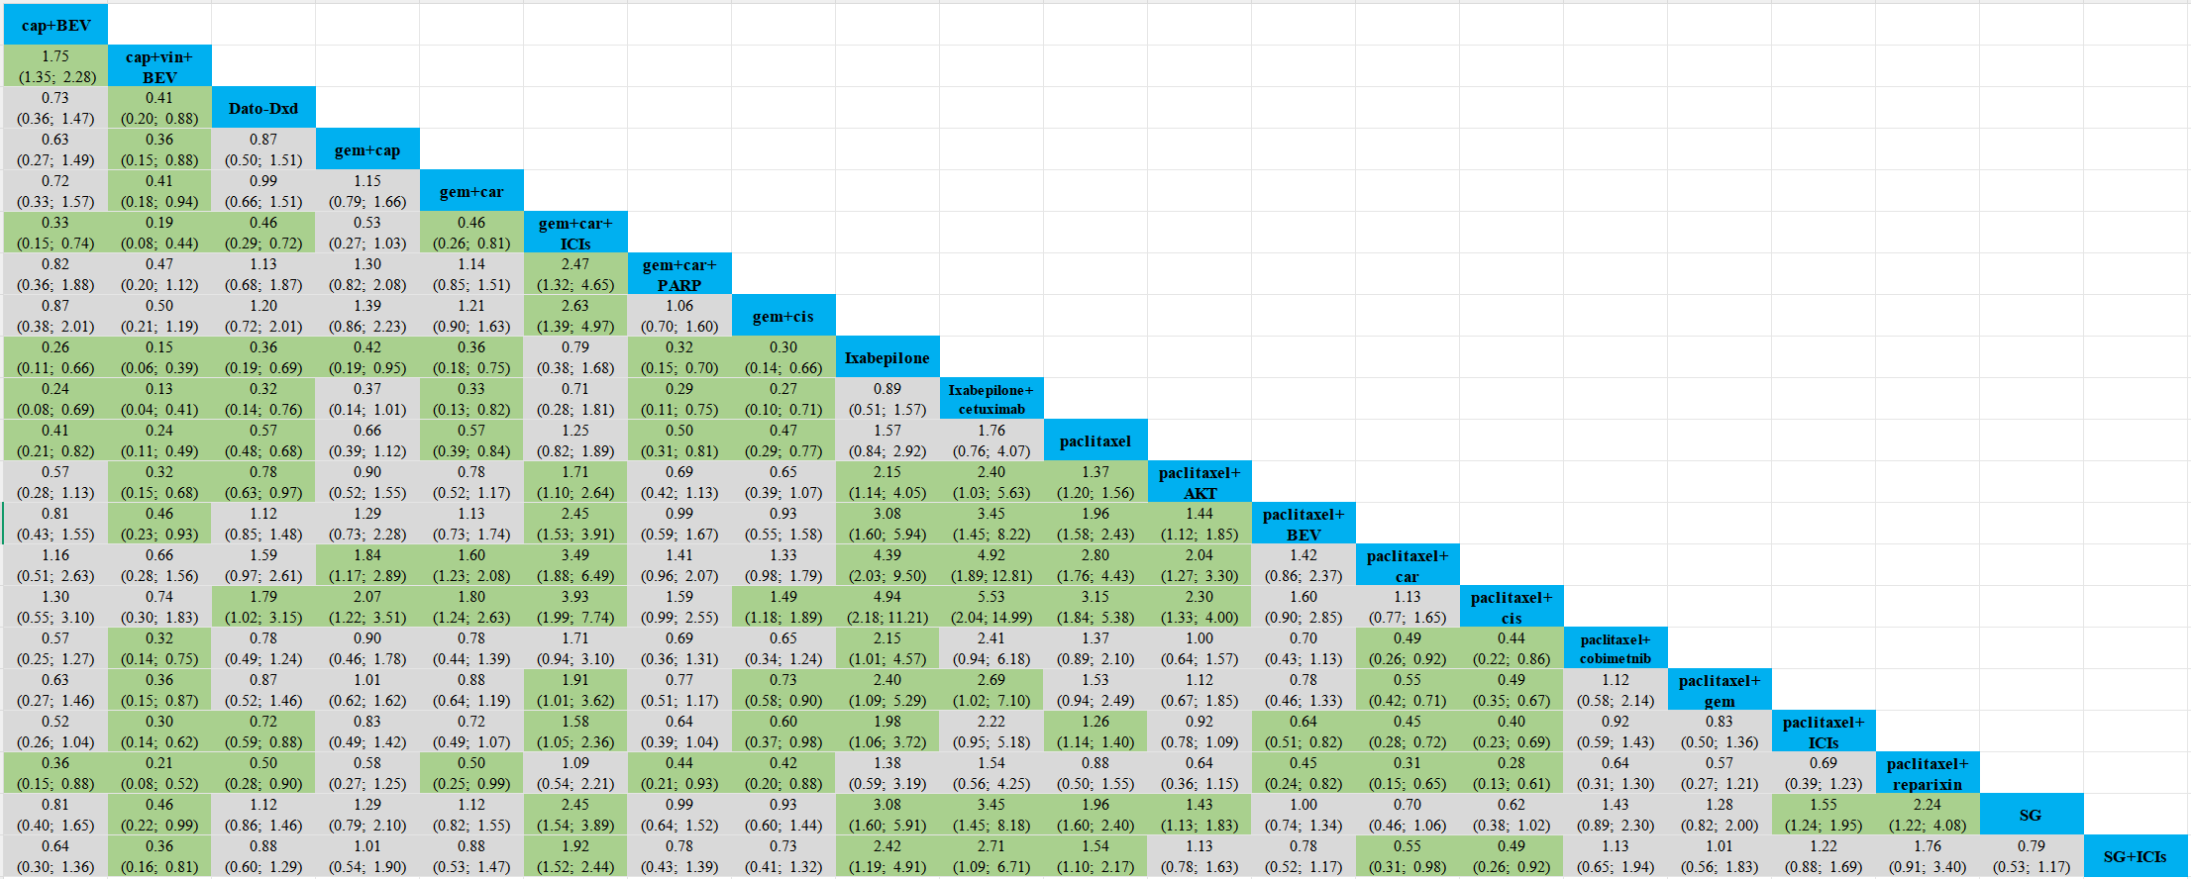

Table 2. Cross-comparison of PFS in populations. The results after making comparisons of the treatment regimens in each row and column are shown as HR and 95% CI results, and results with p < 0.05 are highlighted in light green.

