Supplementary Material
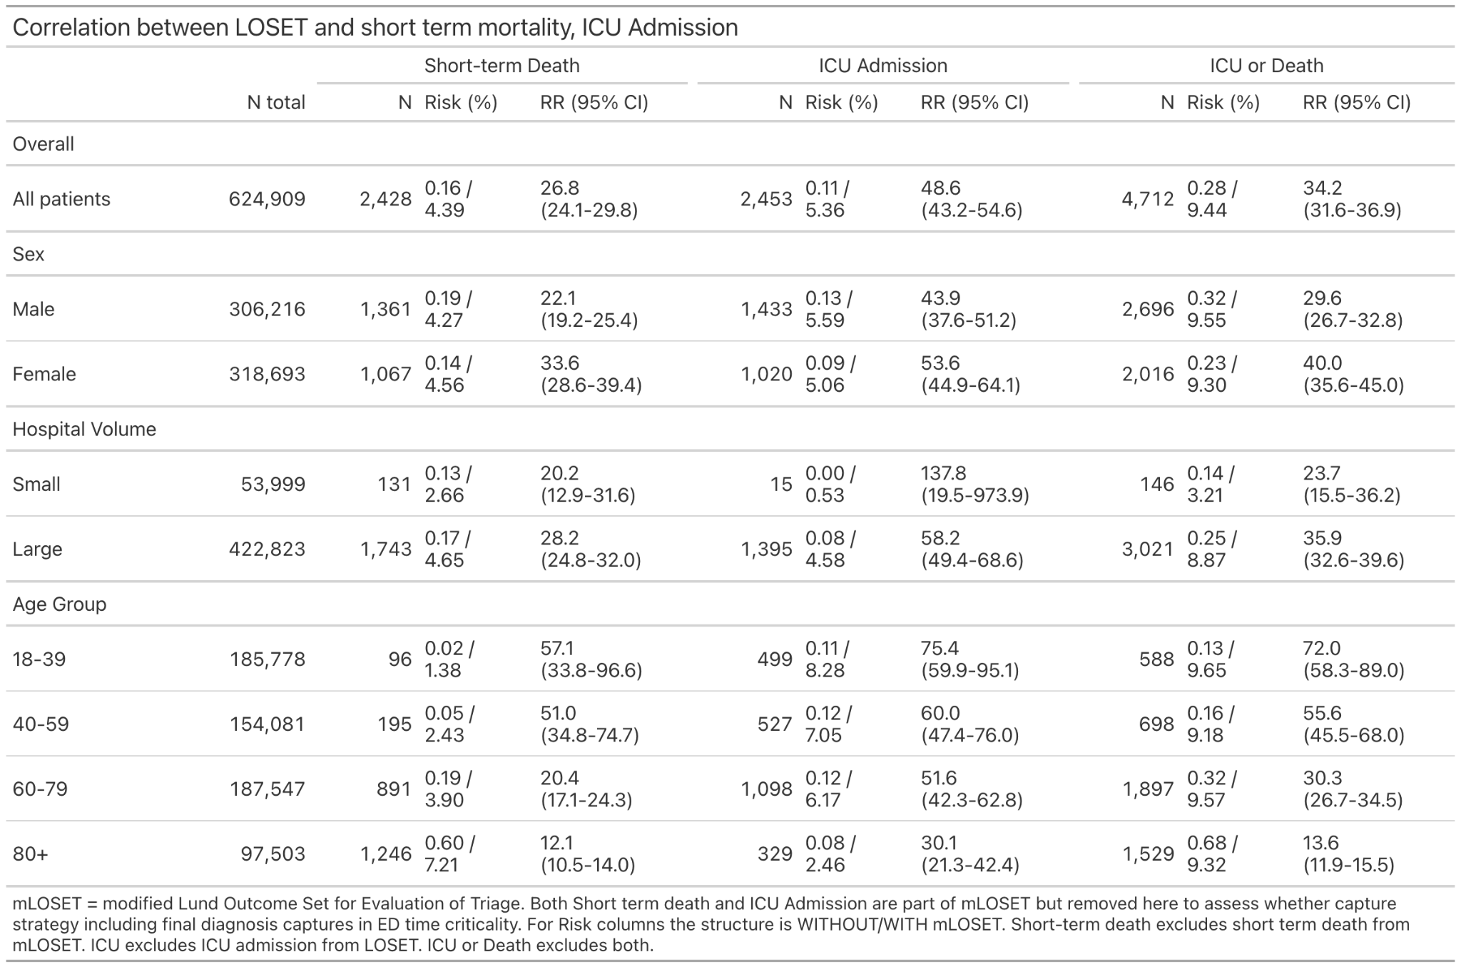
Supplementary Table 1. Relationship between mLOSET and short term death/ICU admission, stratified by sex, hospital volume and age group.
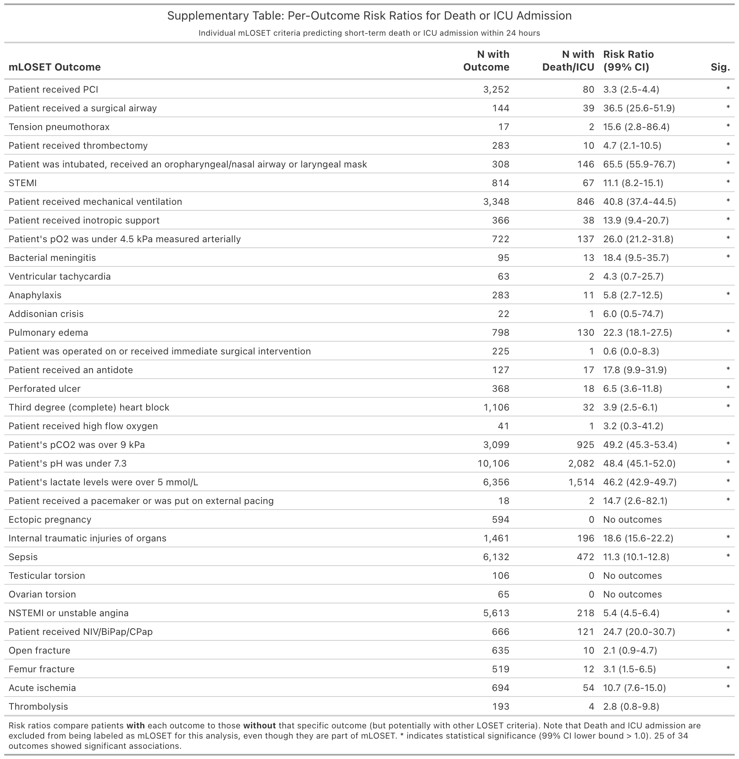
Supplementary Table 2. Risk Ratio for short term death/ICU admission, per outcome in mLOSET.
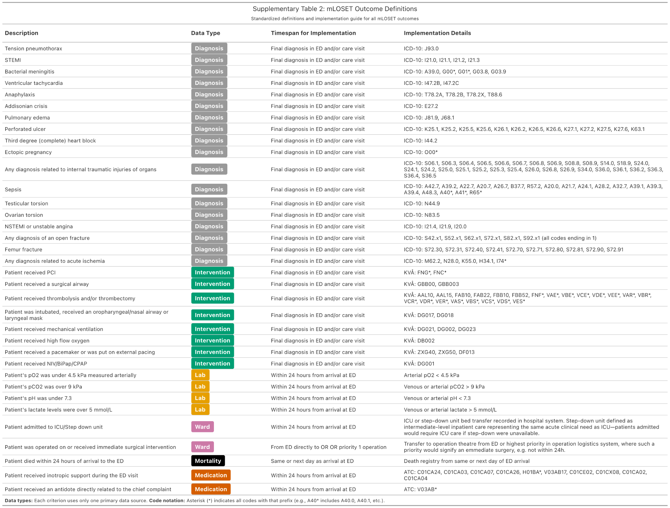
Supplementary Table 3: Definition of each outcome in mLOSET together with type data type required for implementation.

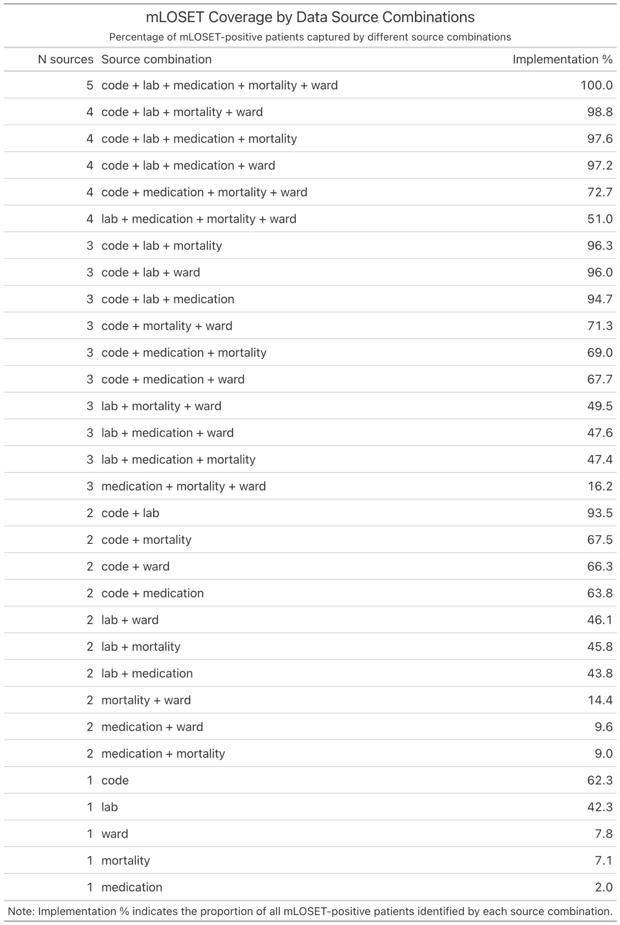
Supplementary Table 4: Percentage of total mLOSET-positive patients identified using different combinations of available data sources.

