Supplementary Information
Extended results 1: Changes in the relative abundance of dominant taxa represents a significant source of taxa turnover in microbial communities. Notably, the phylum-level composition differed significantly across compartments - bulk soil, rhizosphere and roots (Figure 1c and Dataset S8). Among the identified phyla (relative abundance > 0.001%), Ascomycota, Basidiobolomycota, Chytridiomycota, Entomophthoromycota, Rozellomycota and Zoopagomycota presented consistent change (decrease) in the niche direction BS -> RS -> Roots, whereas Basidiomycota, Glomeromycota and Olpidiomycota showed an increasing trend from bulk soil through the rhizosphere to roots. At a finer resolution, bulk soil was enriched in Ascomycota, Mucoromycota and Blastoclasiomycota compared to rhizosphere and roots, whereas the rhizosphere was enriched in Mortierellomycota, Chytridiomycota and Olpidiomycota relative to soil and roots (ALDEx2; Dataset S9). In contrast Basidiomycota and Glomeromycota were largely depleted in bulk soil and rhizosphere relative to roots (Figure 1c) (ALDEx2; Dataset S9). The patterns of depletion in relative abundance of these taxa across compartments align with the overall decrease in fungal diversity along the soil-plant continuum.

To further explore the compartment-specific enrichment, we conducted differential abundance analysis (see methods), using the OTUs from bulk soil as a reference, applying a fold- change threshold of > 1 and an adjusted p value < 0.05 (see methods). This analysis revealed a higher number of enriched or depleted OTUs in roots (2 vs 21) than in rhizosphere (1 vs 10) (Dataset S10). Collectively, these results suggest significant differences in fungal community composition across the compartments, while also revealing a core set of taxa shared between bulk soil, rhizosphere and roots.

Extended Data Figure 1: Fungal and diversity changes across three different compartments- bulk soil (BS), the rhizosphere (RS) and root (RO)
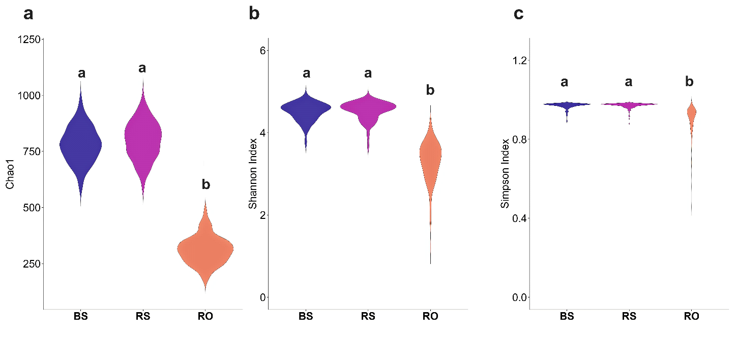

Alpha (within-sample) estimates of fungal communities were assessed across different compartments - bulk soil (BS), rhizosphere (RS) and root (RO). (a) Chao1 (b) Shannon and (c) Simpson diversity. The boxplots displayed represent the distribution of these indices across compartments. One-way ANOVA was used to assess significant differences across compartments, and the means were separated using Tukey’s post-hoc test. Groups with the same letters denote no significant differences (P > 0.05), while groups with different letters indicate statistically significant differences (P < 0.05).

Extended results 2:
Neutral and non-neutral partitions are ecologically different across bulk soil, rhizosphere and root compartments
The Dispersal-Niche Continuum Index (DNCI) further supports the stochastic dispersal-driven assembly of fungal communities with consistently negative DNCI values in pairwise comparisons: BS vs RS (-241.8 ± 3.04), BS vs Roots (-93.04 ± 1.57) and RS vs Roots (DNCI = -138 ± 1.35) (Dataset 12). Within each compartment, several taxa occurred more (above) or less (below) frequently than predicted by the neutral model based on their overall abundance in the metacommunity. These deviations likely reflect differences in dispersal or migratory ability, resulting in significant differences from the neutral prediction. Taxa found more frequently (points above the prediction) than expected, indicate higher migration potential and hence more dispersal, whereas, taxa found less frequently (points below the neutral prediction) than expected, suggests lower migration potential and hence less dispersal (Dataset S13). Alternatively, such deviations may reflect habitat-specific environmental selection, with taxa responding differentially to local conditions in bulk soil, rhizosphere, or root endosphere. To further quantify the relative contribution of dispersal limitations and species sorting in fungal community assembly, we estimated the community-level habitat niche breadths (Bcom). The results revealed that mean niche-breadths values were significantly higher in bulk soil and rhizosphere than in roots (p < 0.001) (Figure S), whereas the differences between bulk soil and rhizosphere were not statistically significant (p > 0.05), indicating broader habitat occupancy in soil-associated compartments relative to roots.

Extended Data Figure 2: Ecological processes of fungal communities across different components- bulk soil, rhizosphere and root.
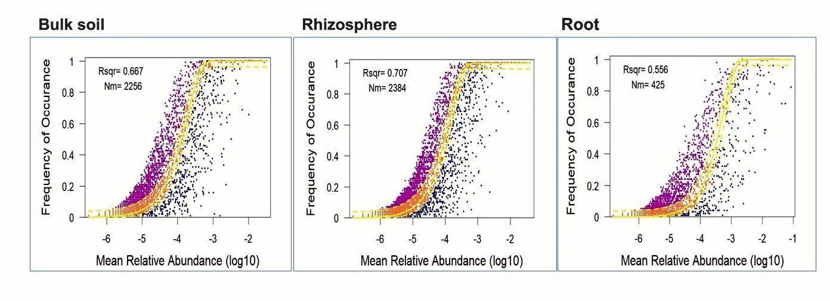
The fit of the neutral community model (NCM) of fungal community assembly, showing the predicted occurrence frequencies for bulk soil, rhizosphere and root, representing the fungal communities from Bulk soil, rhizosphere and root endosphere. The blue solid lines in the plot represent the best fit to NCM as described by Sloan et al., (), while the dashed lines indicate 95% confidence intervals around the model prediction. Taxa that occur more frequently than predicted by NCM are shown in cyan colour, while taxa that occur less frequently than predicted are shown in red colour. The NM and R² values indicate the metacommunity size times the migration rate used for quantifying dispersal between the communities and the model’s fit, respectively.

Extended results 3
For Shannon and Simpson diversity, patterns were generally weaker but consistent with those observed for richness. In the root compartment, both Shannon (F = 8.27, p = 0.01) and Simpson diversity (F = 6.57, p = 0.02) increased significantly with plant species richness, suggesting that root-associated fungal communities are particularly responsive to variation in plant diversity. In contrast, no significant plant richness-related effects were detected for Shannon or Simpson diversity in soil (F = 0.00, p = 0.98 and F = 0.7, p = 0.41) or rhizosphere (F = 3.35, p = 0.08 and F= 0.6, p = 0.46) (Figure 3 and Table 1).

Extended Data Figure 3: Log-linear Relationships between sown plant species richness and fungal diversity and fungal diversity in the compartments bulk soil, rhizosphere, and root. Fungal diversity (a) Shannon and (b) Simpson are plotted against log₂-transformed species richness (x-axis labels back-transformed for clarity) and linear models with 95% confidence intervals are shown, with colours indicating different treatment levels. Asterisks denote significance levels for fixed effects from linear mixed models: p < 0.05 (*), p < 0.01 (**), p < 0.001 (***), and n.s. = not significant. Mixed models include random effects for block and unit. Non- significant (p > 0.05, for all the variables) two-way (SR:SH, SR:PH and SH:PH) and three-way (SR:SH:PH) interactions are not shown.

a
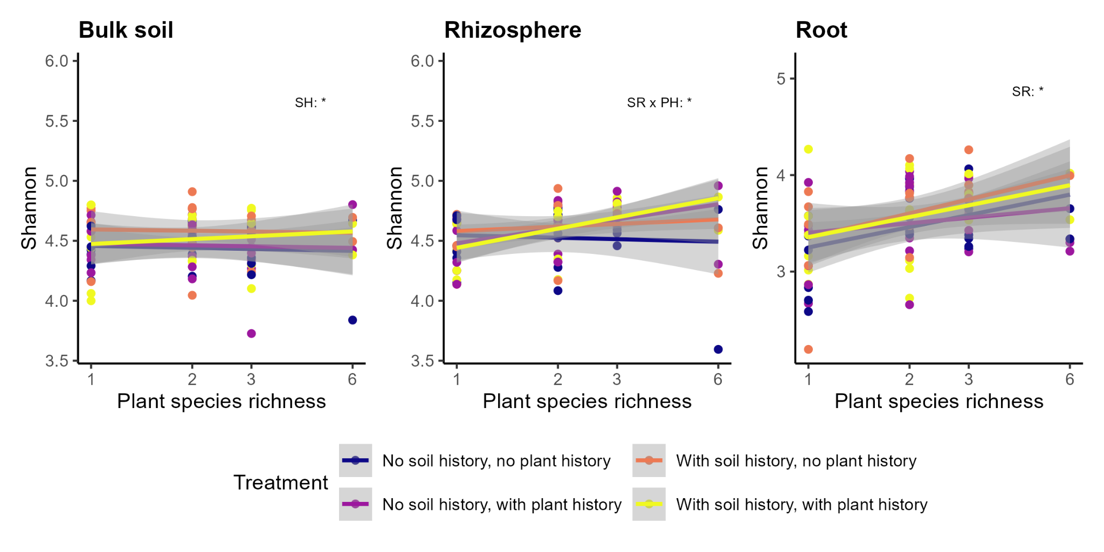
b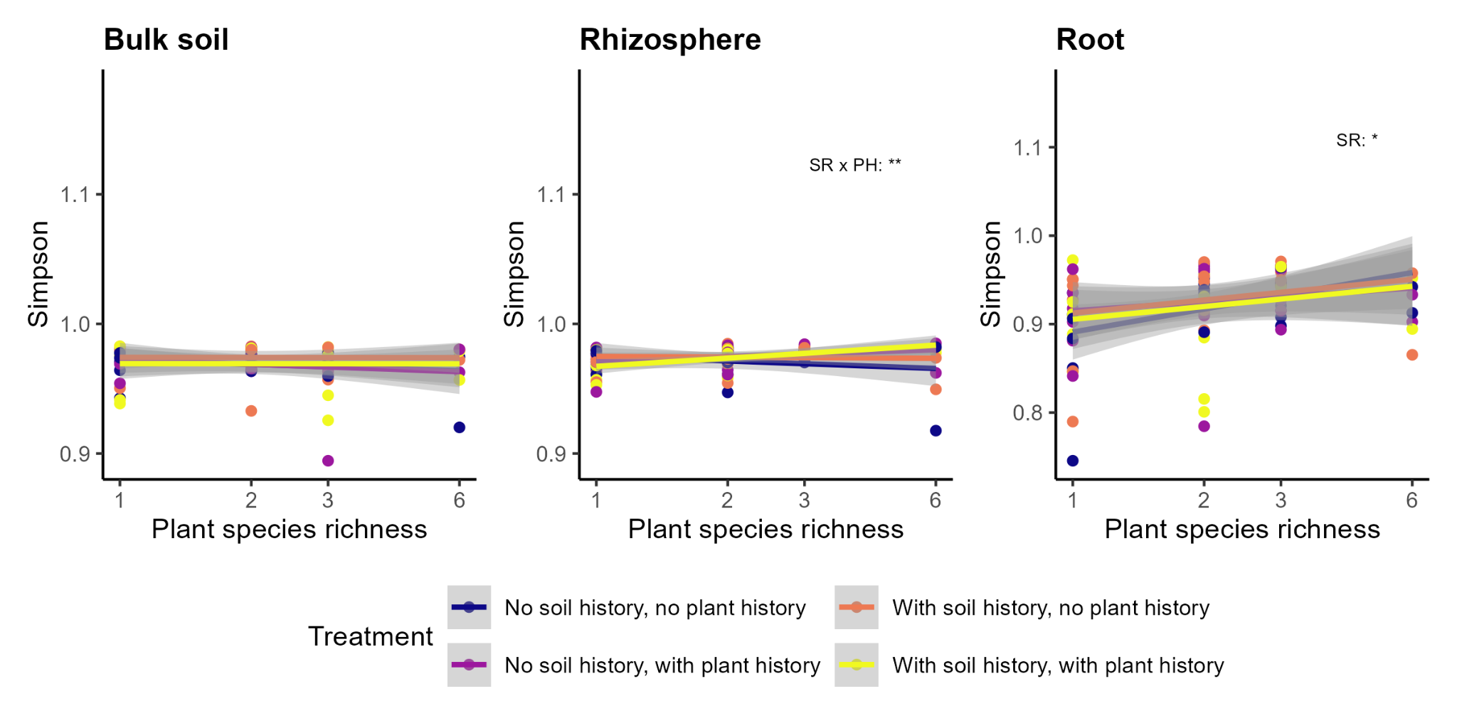

Extended Dataset Table 1. Results of linear mixed-effects models testing the effects of plant species richness, soil- and plant history on fungal alpha-diversity (Shannon and Simpson). The table shows df (degree of freedom), F-values and p-values from linear mixed-effects models for fungal richness (observed OTUs) measured in bulk soil, rhizosphere, and root endosphere compartments. Fixed effects include plant species richness (log₂-transformed: logSR), soil history (SH, with soil legacy vs. without soil legacy), and plant history (PH, with plant legacy vs. without plant legacy), and their two-way and three-way interactions. Models included block and unit as nested random effects. Significant (p < 0.05) results are italicized and highlighted in bold.
 |  | Bulk soil |  | Rhizosphere |  | Root
Shannon | df | F-value | p-value | F-value | p-value | F-value | p-value
Intercept | 1, 66 | 155316.5 | <.0001 | 91120.49 | <.0001 | 12704.61 | <.0001
logSR | 1, 17 | 0.00 | 0.98 | 3.35 | 0.08 | 8.27 | 0.0105
SH | 1, 66 | 4.64 | 0.0349 | 1.44 | 0.23 | 2.17 | 0.14
PH | 1, 66 | 0.27 | 0.601 | 0.94 | 0.33 | 0.003 | 0.95
SH:PH | 1, 66 | 0.92 | 0.34 | 1.51 | 0.22 | 0.25 | 0.6214
logSR:SH | 1, 66 | 0.29 | 0.59 | 0.84 | 0.36 | 0.55 | 0.4622
logSR:PH | 1, 66 | 0.21 | 0.65 | 6.47 | 0.013 | 0.73 | 0.3959
logSR:SH:PH | 1, 66 | 0.16 | 0.69 | 0.08 | 0.78 | 0.14 | 0.7062
Simpson
Intercept | 1, 66 | 1584203 | <.0001 | 2042632 | <.0001 | 65362.14 | <.0001
logSR | 1, 17 | 0.7 | 0.41 | 0.6 | 0.46 | 6.57 | 0.0201
SH | 1, 66 | 1 | 0.3219 | 0.3 | 0.5709 | 0.08 | 0.7747
PH | 1, 66 | 0.6 | 0.4439 | 0.8 | 0.3821 | 0 | 0.9905
SH:PH | 1, 66 | 0.6 | 0.4351 | 1.2 | 0.2768 | 0.79 | 0.3777
logSR:SH | 1, 66 | 0.6 | 0.424 | 1.5 | 0.231 | 0.11 | 0.7446
logSR:PH | 1, 66 | 0 | 0.9501 | 7.5 | 0.0078 | 0.61 | 0.4383
logSR:SH:PH | 1, 66 | 0 | 0.9418 | 0 | 0.978 | 0.53 | 0.4697

Extended Dataset Figure 4: Beta diversity of fungal communities in soil, rhizosphere, and root compartments based on Bray–Curtis dissimilarity. Principal coordinate analysis (PCoA) plots display fungal community composition based on Bray–Curtis distances, with the first two PCoA axes labelled by their percentage of explained variance. Points represent individual samples, coloured by treatment and shaped by plant species richness (SR; 1, 2, 3, or 6 species). Dashed ellipses indicate 95% confidence intervals around treatment centroids. Statistical annotations show R² values (percent variance explained) from PERMANOVA for each fixed effect (SR, SH, PH, and their interactions), along with significance levels: p < 0.05 (*), p < 0.01 (**), n.s. = not significant.
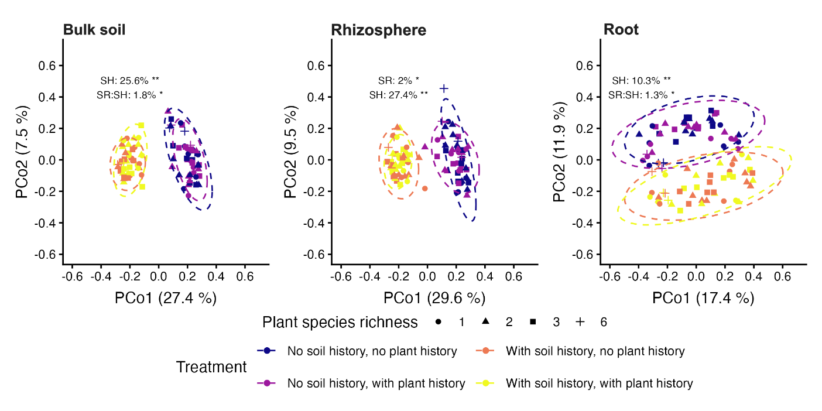

Extended Dataset Table 2: Summary of the compartments PERMANOVA testing, how plant species richness (SR), soil history (SH), plant history (PH), and their two-way species richness: soil history (SR:SH), species richness: plant history (SR:PH), soil history: plant history (SH:PH) and three-way species richness: soil history : plant history (SR:SH:PH) interactions affect fungal beta-diversity (Bray-Curtis dissimilarity) across different compartments-bulk soil (BS), rhizosphere (RS), and root (RO). The table includes dF (degree of freedom), SS (sum of squares), R² (variance explained), F statistics, and p-values for each fixed effect and interaction term in the model. Significant (p < 0.05) results are italicized and highlighted in bold. Non-significant (p ≥ 0.05) interaction terms are not mentioned in the table.
Compartment | Term | df | SS | R² | F-value | p-value
Bulk soil | SR | 1,17 | 0.22 | 0.01 | 0.95 | 0.2
 | SH | 1,66 | 3.94 | 0.26 | 38.8 | 0.001
 | PH | 1,66 | 0.08 | 0.005 | 0.80 | 0.565
 | SR:SH | 1,66 | 0.28 | 0.02 | 2.7 | 0.034
 | SR:PH | 1,66 | 0.08 | 0.005 | 0.77 | 0.559
 | SH:PH | 1,66 | 0.08 | 0.005 | 0.82 | 0.547
 | SR:SH:PH | 1,66 | 0.07 | 0.004 | 0.66 | 0.733
Rhizosphere | SR | 1,17 | 0.27 | 0.02 | 1.26 | 0.036
 | SH | 1,66 | 3.75 | 0.27 | 45.0 | 0.001
 | PH | 1,66 | 0.09 | 0.006 | 1.07 | 0.299
 | SR:SH | 1,66 | 0.17 | 0.013 | 2.06 | 0.094
 | SR:PH | 1,66 | 0.14 | 0.010 | 1.63 | 0.148
 | SH:PH | 1,66 | 0.07 | 0.005 | 0.83 | 0.489
 | SR:SH:PH | 1,66 | 0.05 | 0.003 | 0.57 | 0.838
Root | SR | 1,17 | 0.84 | 0.03 | 1.25 | 0.115
 | SH | 1,66 | 2.90 | 0.10 | 16.0 | 0.001
 | PH | 1,66 | 0.29 | 0.01 | 1.57 | 0.059
 | SR:SH | 1,66 | 0.37 | 0.01 | 2.03 | 0.020
 | SR:PH | 1,66 | 0.12 | 0.004 | 0.67 | 0.924
 | SH:PH | 1,66 | 0.27 | 0.01 | 1.51 | 0.072
 | SR:SH:PH | 1,66 | 0.12 | 0.004 | 0.69 | 0.911

Extended Dataset Table 3: Do covariates (plant biomass) explain the plant diversity and history (plant and soil history) effects on fungal diversity across the compartments. The table includes dF (degree of freedom), F values and P- values. Significant (p < 0.05) results are italicized and highlighted in bold.
 |  | Bulk soil |  | Rhizosphere |  | Root
Observed OTU Richness | df | F-value | P-value | F-value | P-value | F-value | P-value
Intercept | 1, 65 | 15362.94 | <.0001 | 9273.17 | <.0001 | 1816.12 | <.0001
Biomass | 1, 65 | 4.79 | 0.03 | 6.58 | 0.012 | 10.677 | 0.001
logSR | 1,17 | 8.65 | 0.0091 | 15.72 | 0.001 | 9.07 | 0.007
SH | 1, 65 | 34.00 | <.0001 | 28.53 | <.0001 | 31.29 | <.0001
PH | 1, 65 | 0.001 | 0.97 | 4.18 | 0.044 | 0.25 | 0.617
SH:PH | 1, 65 | 0.17 | 0.67 | 1.41 | 0.240 | 0.12 | 0.729
logSR: SH | 1, 65 | 0.45 | 0.50 | 0.78 | 0.378 | 6.22 | 0.015
logSR:PH | 1, 65 | 0.06 | 0.80 | 6.43 | 0.013 | 0.26 | 0.612
logSR:SH:PH | 1, 65 | 0 | 0.993 | 0.18 | 0.669 | 0.18 | 0.671
Shannon
Intercept | 1, 65 | 387155.0 | <.0001 | 518262.5 | <.0001 | 19514.77 | <.0001
Biomass | 1, 65 | 1.1 | 0.30 | 0.3 | 0.605 | 1.79 | 0.184
logSR | 1,17 | 0.7 | 0.41 | 0.6 | 0.463 | 6.37 | 0.021
SH | 1, 65 | 0.4 | 0.52 | 0.1 | 0.756 | 1.08 | 0.301
PH | 1, 65 | 0.7 | 0.39 | 0.9 | 0.341 | 0.01 | 0.941
SH:PH | 1, 65 | 0.6 | 0.46 | 1.3 | 0.252 | 1.17 | 0.282
logSR: SH | 1, 65 | 0.6 | 0.45 | 1.4 | 0.248 | 0.04 | 0.834
logSR:PH | 1, 65 | 0.0 | 0.92 | 7.2 | 0.009 | 0.52 | 0.471
logSR:SH:PH | 1, 65 | 0.0 | 0.96 | 0.0 | 0.932 | 0.46 | 0.501
Simpson
Intercept | 1, 65 | 392339.4 | <.0001 | 635180.9 | <.0001 | 12121.81 | <.0001
Biomass | 1, 65 | 1.1 | 0.30 | 1.0 | 0.323 | 1.16 | 0.284
logSR | 1,17 | 0.6 | 0.43 | 0.5 | 0.508 | 0.82 | 0.377
SH | 1, 65 | 0.4 | 0.52 | 0.7 | 0.404 | 0.32 | 0.571
PH | 1, 65 | 0.7 | 0.42 | 0.2 | 0.636 | 0.01 | 0.978
SH:PH | 1, 65 | 0.5 | 0.48 | 7.2 | 0.009 | 2.56 | 0.114
logSR: SH | 1, 65 | 0.5 | 0.47 | 1.8 | 0.180 | 0.01 | 0.943
logSR:PH | 1, 65 | 0 | 0.90 | 2.4 | 0.130 | 0.24 | 0.627
logSR:SH:PH | 1, 65 | 0 | 0.92 | 1.2 | 0.268 | 0.01 | 0.907

Extended Dataset Table 4: Do covariates (carbon-to-nitrogen ratio: CN) explain the plant diversity and soil- and plant history effects on fungal diversity across the compartments. The table includes dF (degree of freedom), F values and P- values. Significant (p < 0.05) results are italicized and highlighted in bold.
 |  | Bulk soil |  | Rhizosphere |  | Root
Observed OTU Richness | df | F-value | P-value | F-value | P-value | F-value | P-value
Intercept | 1, 64 | 15194.42 | 0.00 | 10080.57 | 0.00 | 1835.66 | 0.00
CN | 1, 64 | 10.238 | 0.002 | 4.254 | 0.043 | 10.110 | 0.002
logSR | 1,17 | 8.243 | 0.010 | 17.872 | < 0.0001 | 10.305 | 0.005
SH | 1, 64 | 29.164 | < 0.0001 | 32.76 | < 0.0001 | 29.550 | < 0.0001
PH | 1, 64 | 0.018 | 0.891 | 5.644 | 0.020 | 0.535 | 0.46
SH:PH | 1, 64 | 0.085 | 0.770 | 1.644 | 0.204 | 0.033 | 0.854
logSR: SH | 1, 64 | 0.201 | 0.654 | 0.304 | 0.582 | 5.431 | 0.022
logSR:PH | 1, 64 | < 0.0001 | 0.996 | 6.194 | 0.015 | 0.278 | 0.599
logSR:SH:PH | 1, 64 | 0.077 | 0.781 | 0.036 | 0.848 | 0.094 | 0.759
Shannon
Intercept | 1, 64 | 383733.14 | 0.00 | 534502.08 | 0.00 | 19056.27 | 0.00
CN | 1, 64 | 0.343 | 0.560 | 4.519 | 0.037 | 0.059 | 0.808
logSR | 1,17 | 0.662 | 0.427 | 0.478 | 0.498 | 8.173 | 0.011
SH | 1, 64 | 2.343 | 0.131 | 4.808 | 0.032 | 0.236 | 0.628
PH | 1, 64 | 0.386 | 0.536 | 2.533 | 0.116 | 0.055 | 0.814
SH:PH | 1, 64 | 0.708 | 0.403 | 1.840 | 0.179 | 1.125 | 0.292
logSR: SH | 1, 64 | 0.388 | 0.535 | 0.543 | 0.464 | 0.502 | 0.481
logSR:PH | 1, 64 | 0.022 | 0.883 | 7.038 | 0.010 | 0.305 | 0.582
logSR:SH:PH | 1, 64 | 0.091 | 0.763 | 0.500 | 0.482 | 0.424 | 0.517
Simpson
Intercept | 1, 64 | 389173.10 | 0.00 | 719907.62 | 0.00 | 12211.04 | 0.00
CN | 1, 64 | 0.341 | 0.562 | 0.291 | 0.592 | 0.375 | 0.542
logSR | 1,17 | 0.607 | 0.446 | 0.084 | 0.774 | 0.978 | 0.336
SH | 1, 64 | 2.371 | 0.128 | 0.272 | 0.603 | 0.262 | 0.610
PH | 1, 64 | 0.332 | 0.566 | 0.0007 | 0.978 | 0.006 | 0.934
SH:PH | 1, 64 | 0.654 | 0.421 | 5.435 | 0.023 | 2.259 | 0.137
logSR: SH | 1, 64 | 0.336 | 0.563 | 0.355 | 0.553 | 0.039 | 0.842
logSR:PH | 1, 64 | 0.033 | 0.855 | 0.442 | 0.508 | 0.336 | 0.563
logSR:SH:PH | 1, 64 | 0.134 | 0.715 | 0.047 | 0.827 | 0.141 | 0.709

