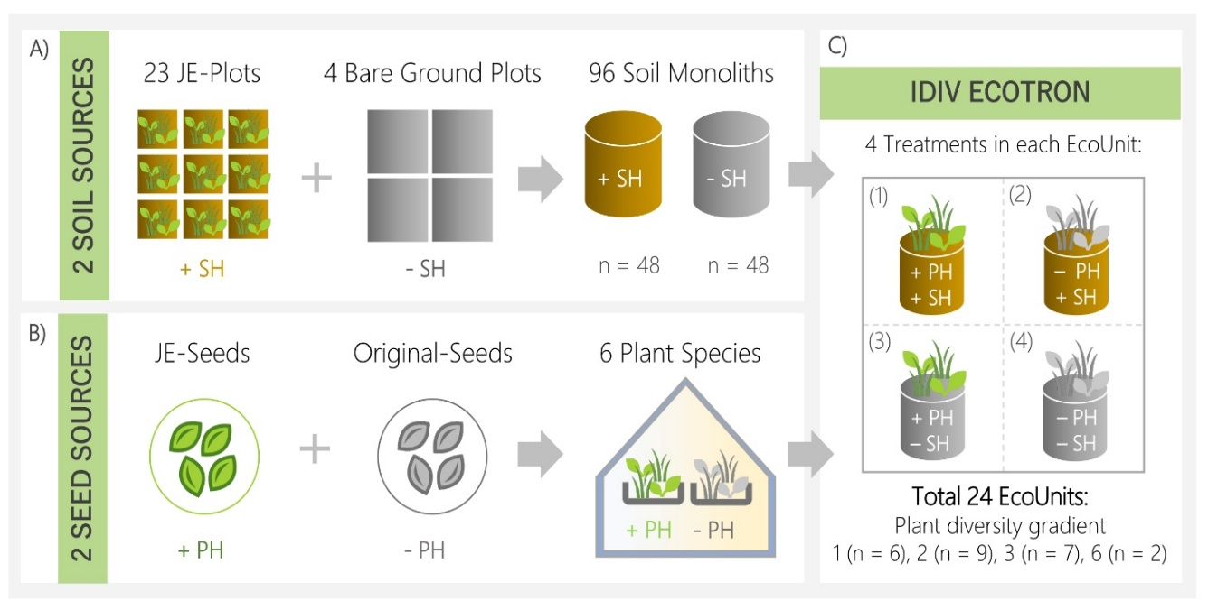
Figure S1: JenaTron experimental Setup. (A) Soil History (SH) and (B) Plant history (PH). (A) Soil history was established by excavating ninety-six (n = 96) intact soil monoliths from the Jena Experiment (JE). Half of the monoliths (n = 48) were collected from (n = 23) plots that sustained a plot-specific community for 12 years (+SH), while the other half (n = 48) came from four bare ground plots, which had remained vegetation-free since the start of the Jena Experiment in 2002 (-SH). (B) Plant history (PH) was established using two seed sources for each of the six plant species: seeds were collected from plants grown since 2010 on the same plots, where the monoliths were excavated in the Jena Experiment (+ PH), and the original seeds used to sow these communities in the field in 2010 (-PH). (C) Soil history and Plant history were independently crossed for each composition at four plant diversity levels (1, 2, 3, and 6 species). This resulted in four treatments in each EcoUnit of the of the Ecotron: (1) with soil history vs with plant history (+SH/+PH), (2) with soil history vs without plant history (+SH/-PH) (3) without soil history vs with plant history (-SH/+PH), and (4) without soil history vs without plant history (-SH/-PH) (adopted from Madaj, Anna-Maria, et al., 2025).

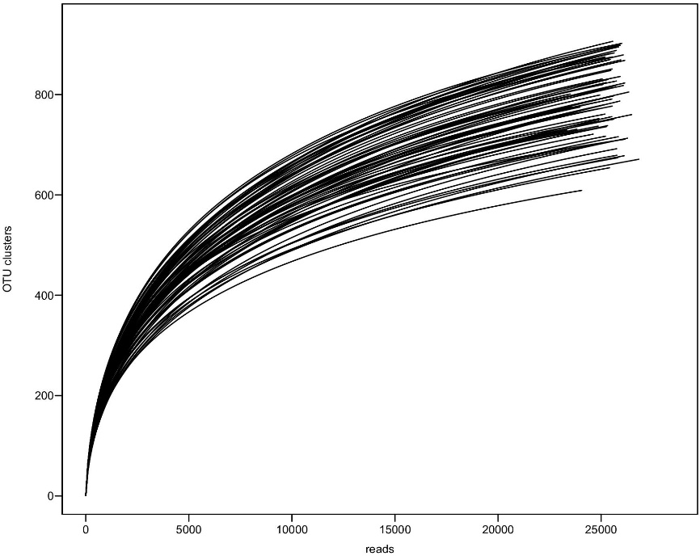
Figure S2: Sequencing depth and rarefaction curve of fungal communities based on ITS gene sequencing of all samples from bulk soil, rhizosphere and root compartments.

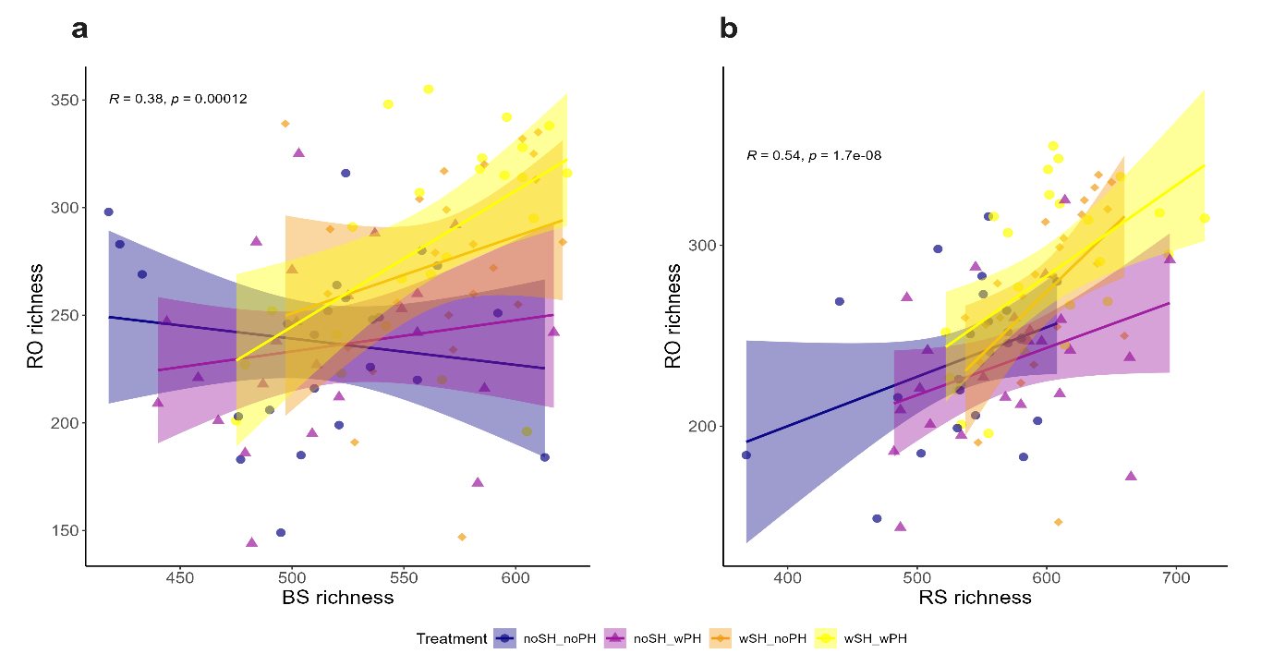
Figure S3: Correlation between fungal OUT richness across compartments a) between bulk soil (BS) and rhizosphere (RS) and b) rhizosphere (RS) and root (RO). Different colors treatments indicate different treatment levels.

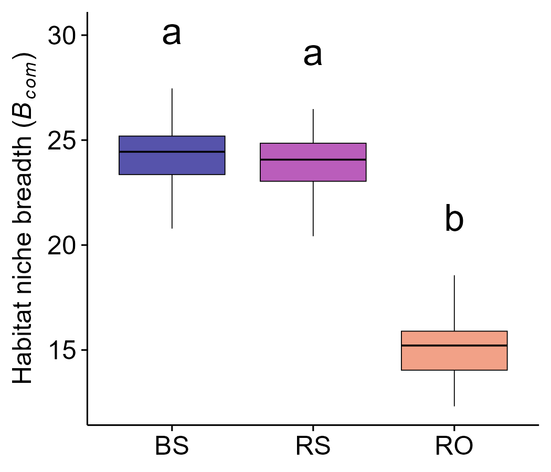
Figure S4: The average habitat niche breadth (B_{com}) of fungal communities across different compartments bulk soil (BS), rhizosphere (RS) and root (RO). Statistical significance was assessed using the Wilcoxon rank-sum test (n.s. = p > 0.05; *** p < 0.001). The average niche breadth between BS and RS were statistically non-significant.

