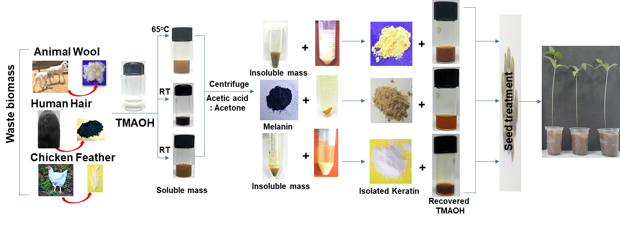
Scheme 1: Processing of waste biomass for the production of keratin.

