Supporting information
Efficient isolation of keratin from protein rich waste biomass : A practical approach to minimize environmental impact and valorize waste biomass
Tapan Kumar Maity ^{a,c}, Nripat Singh ^{a,c}, Pradip Vaghela ^{b,c}, Arup Ghosh ^{b,c}, Sanju Singh ^{a,c}, Pramod B. Shinde ^{a,c}, Rosy Alphons Sequeira ^{a,c}, Kamalesh Prasad* ^{a,c}
ª Natural Products & Green Chemistry Division, CSIR-Central Salt & Marine Chemicals Research Institute, G. B Marg, Bhavnagar-364002 (Gujarat), India. (Tel : +91-278-2567760 ; Fax : +91-278-2567562 ; e-mail : (kamlesh@csmcri.res.in /drkamaleshp@gmail.com).
^{b} Division of Biotechnology and Phycology, CSIR-Central Salt & Marine Chemicals Research Institute, G. B Marg, Bhavnagar-364002 (Gujarat), India
^{c} Academy of Scientific and Innovative Research (AcSIR), Ghaziabad- 201002, India.
Total microbial load count of soil sample and soil microbial toxicity.
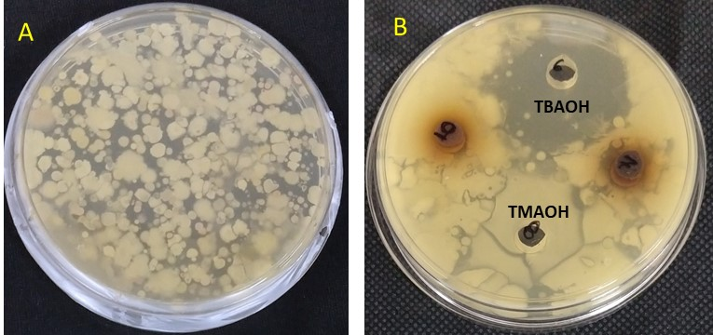

Figure S1: Soil microbial growth (without dilution) (A) Control medium (B) Medium with added samples of the aqueous solution of TBAOH and TMAOH.

Note: No Bacterial colonies were visible around TBAOH indicating its soil microbial toxicity. However, for TMAOH, microbial colonies found to form around the sample indicating non-toxicity of the sample to soil microbes.

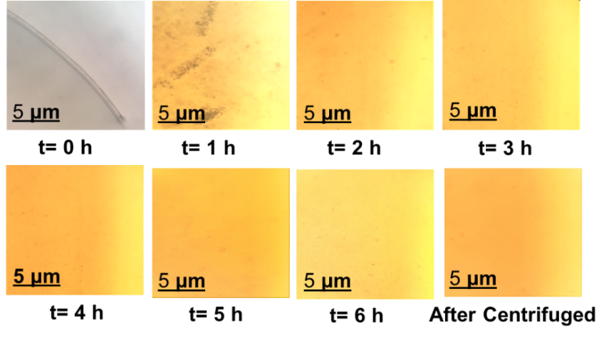
Figure S2: Microscopic images showing the gradual dissolution of animal wool in 25% aqueous solution of TMAOH.

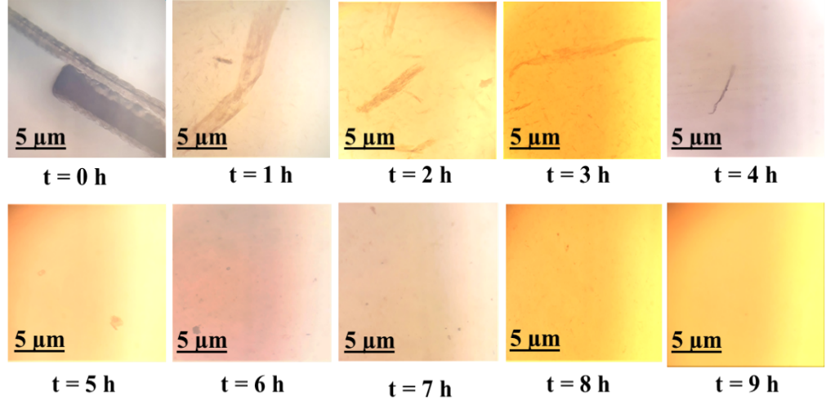
Figure S3: Microscopic images showing the gradual dissolution of human hair in 25% aqueous solution of TMAOH.

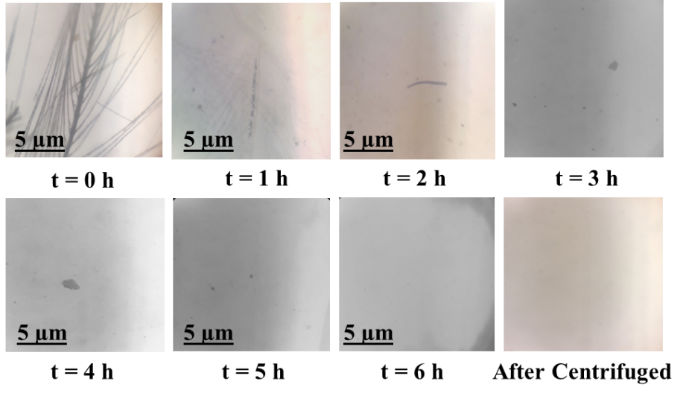
Figure S4: Microscopic images showing the gradual dissolution of the chicken feather in 25% aqueous solution of TMAOH.

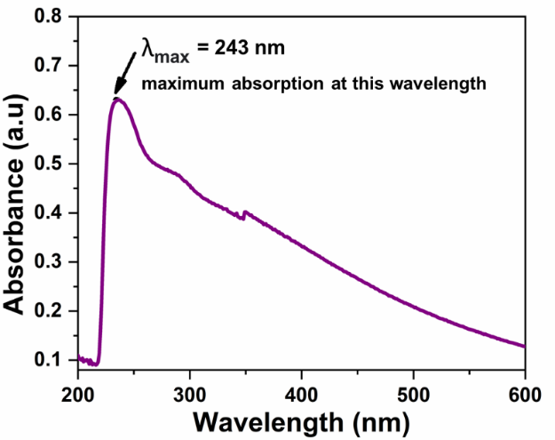
Figure S5: UV-Vis spectra of isolated crude melanin from TMAOH.

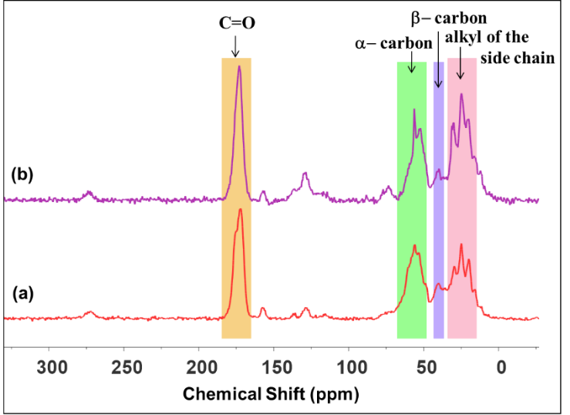
Figure S6: ¹³C CP MAS NMR spectra of the (a) standard melanin and (b) isolated crude melanin.
Note: The UV-Visible absorbance (200-600 nm) of the extracted crude melanin is shown in Figure S5. The absorbance spectrum of the melanin from human hair shows characteristic maximum absorption peak in UV region at 243 nm and progressively less absorbance in visible region which is the characteristic of melanin. This is due to the presence of complex conjugated structures in the melanin molecule (El-Naggar and El-Ewasy, 2017). All the spectra of melanin pigment generally shows strong absorbance in between (200-300 nm) region assigned to the π- π* and n- π* of amino, carboxylic and aromatic moieties (Magarelli et al., 2010).

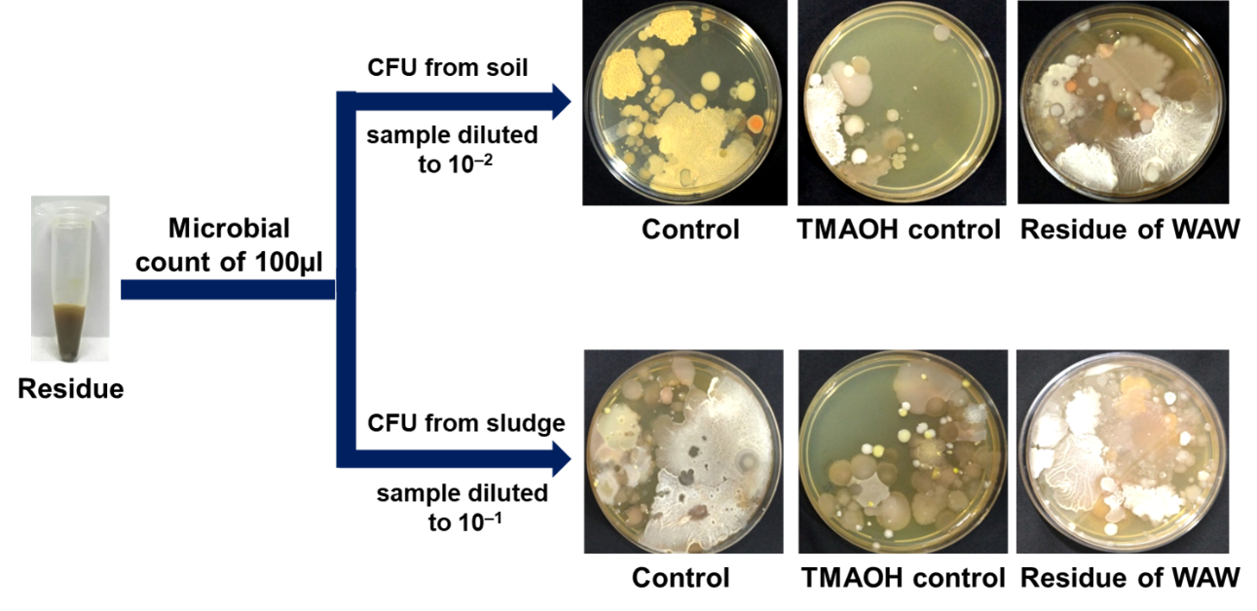
Figure S7: Microbial growth (soil and sludge microbes) in residue obtained during the dissolution of animal wool in TMAOH.
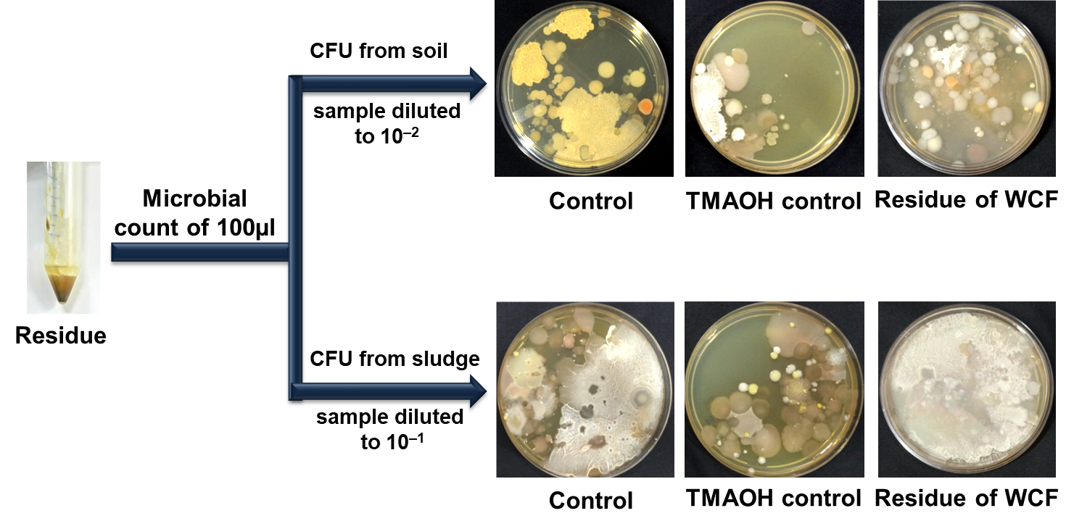
Figure S8: Microbial growth (soil and sludge microbes) in residue obtained during the dissolution of the chicken feather in TMAOH.

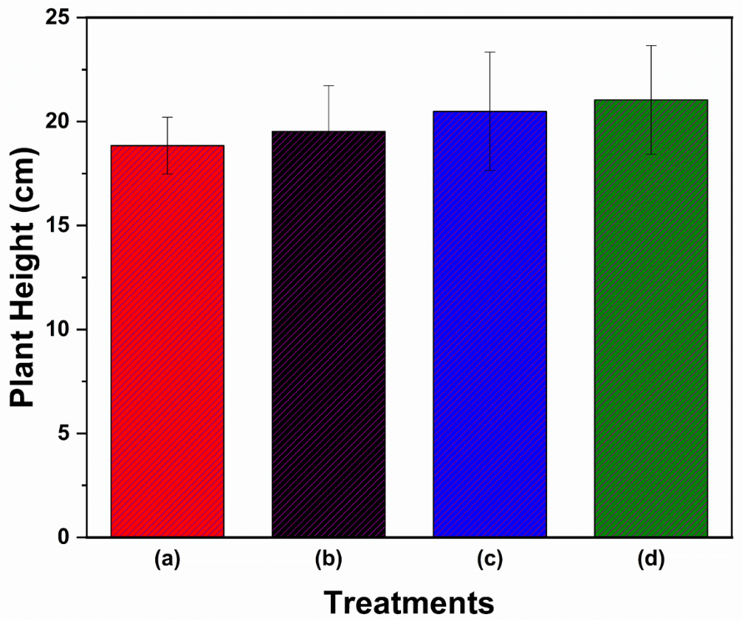
Figure S9: Plant height (cm) of green gram plants (control vs treatments) after 30 days [r-TMAOH obtained from waste (b) animal wool, (c) human hair, and (d) chicken feather processing].

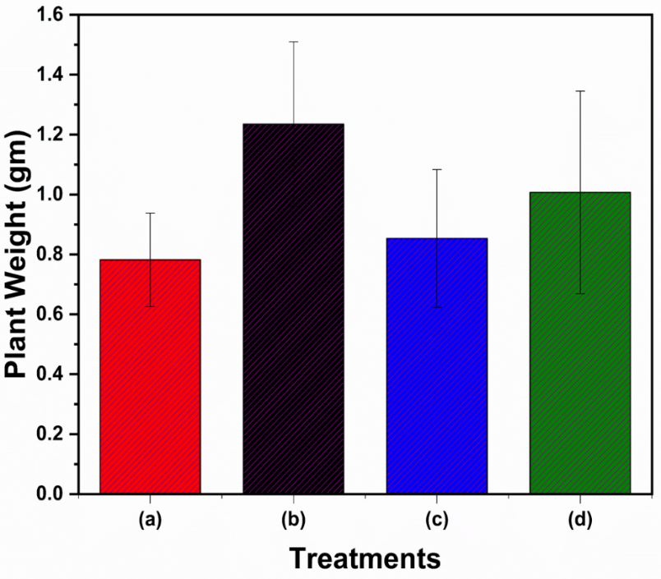
Figure S10: Plant weight (gm) of green gram plants (control vs treatments) after 30 days [r-TMAOH obtained from waste (b) animal wool, (c) human hair, and (d) chicken feather processing].

Reference :

El-Naggar, N.E.A., El-Ewasy, S.M., 2017. Bioproduction, characterization, anticancer and antioxidant activities of extracellular melanin pigment produced by newly isolated micsrobial cell factories Streptomyces glaucescens NEAE-H. Sci. Rep. 7, 1–19. https://doi.org/10.1038/srep42129

Magarelli, M., Passamonti, P., Renieri., C., 2010. Purification , characterization and analysis of sepia melanin from commercial sepia ink ( Sepia Officinalis ). CES Med. Vet. y Zootec. 5, 18–28. https://doi.org/10.21615/1424

