Supporting Information for

Engineering Detachable Hyaluronic Acid Microneedles for Controlled Intradermal Delivery of Particulate and Molecular Colorants: Influence of Matrix Cross-Linking and Particle Size
Kornkamol Obthong,ª Supanan Ampawa ^{b} and Supason Wanichwecharungruang ^{a,}*

ª Center of Excellence in Materials and Bio-Interfaces, Department of Chemistry, Faculty of Science, Chulalongkorn University, Bangkok, 10330, Thailand.
^{b} Mineed Technology, 928 Block 28, Building D, Chulalongkorn 7 Alley, Bangkok, 10330, Thailand.
* Corresponding Author, E-mail: supason.p@chula.ac.th

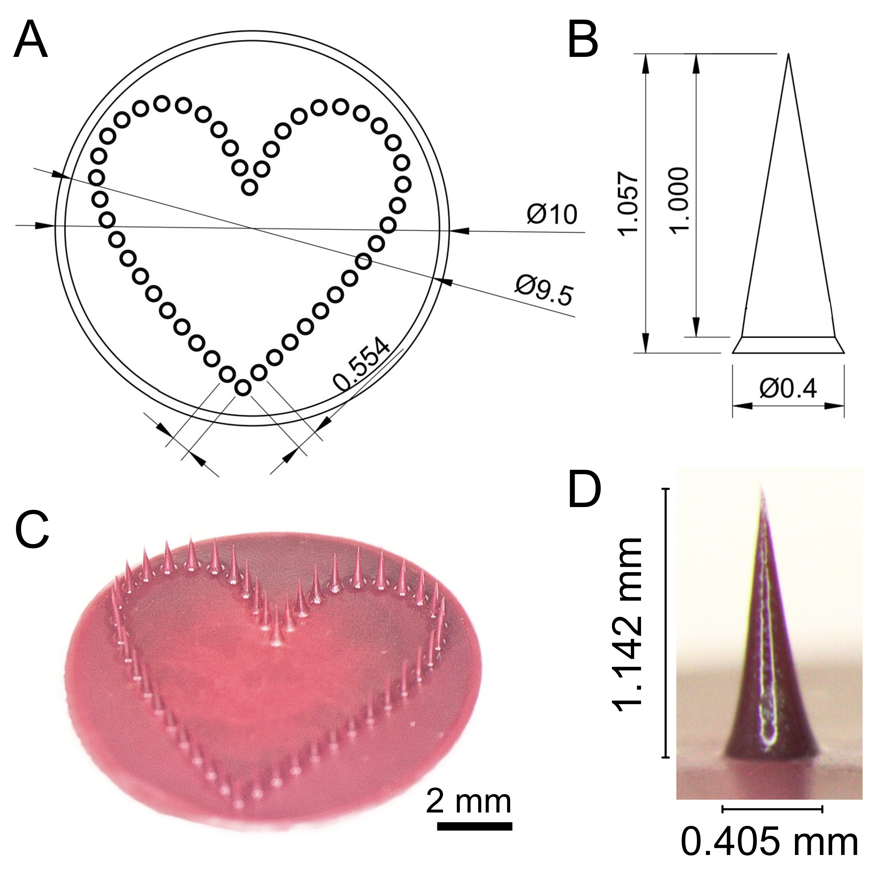
Fig. S1 Microneedle mold design and fabricated tattoo microneedles. (A) Schematic illustration of the heart-shaped microneedle arrangement containing 46 needles within a 10 mm patch, with a center-to-center needle spacing of 0.554 mm. (B) Dimensions of an individual conical microneedle (height: 1,000 µm; base diameter: 400 µm). (C) Stereomicroscopic image of a fabricated tattoo microneedle patch showing 46 needles arranged in a heart-shaped pattern. (D) Stereomicroscopic image of a single fabricated microneedle with a measured height of 1.142 mm and a base diameter of 0.405 mm.
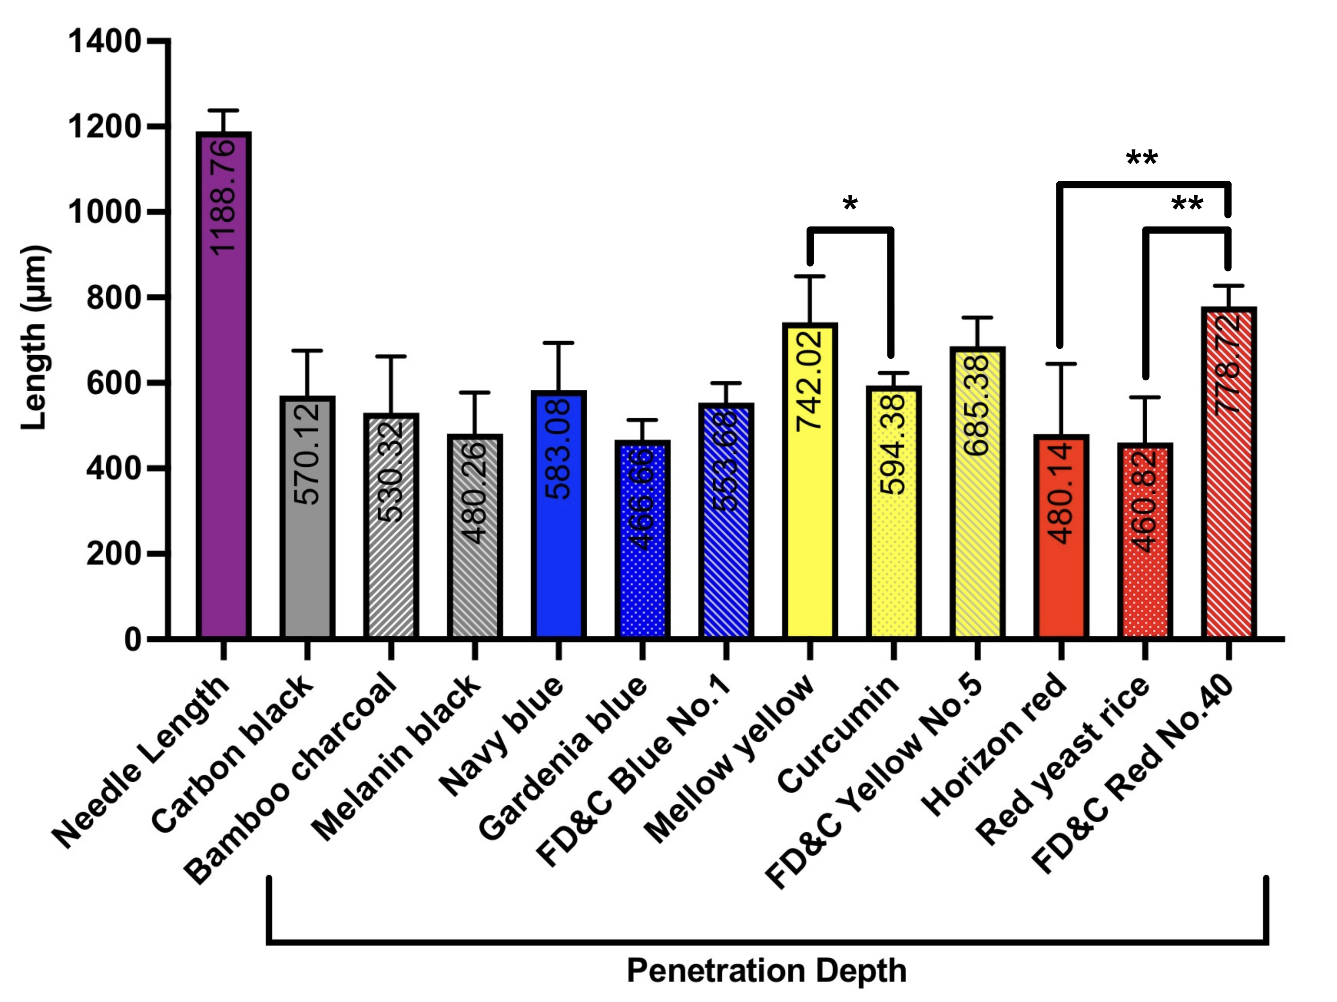
Fig. S2 Needle length and penetration depth of tattoo microneedles in ex vivo porcine skin. Bar graph showing the average penetration depth of color measured in cross-sectioned porcine skin following microneedle application, with error bars representing standard deviation (SD). Needle length is shown for comparison (purple bar, left), indicating that microneedle patches loaded with different colorants possess identical needle lengths. Colorants are grouped by color category (black, blue, yellow, and red). Statistical differences among colorants within the same color category were analyzed using one-way ANOVA. *p < 0.05 and **p < 0.01 (n=5).

