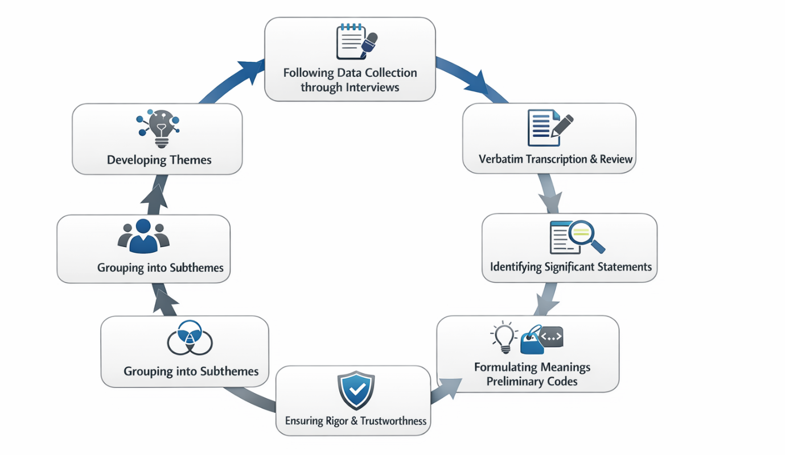
Figure S1. Steps of Data Analysis Using Colaizzi’s Seven-Step Phenomenological Method

Table S1: Participant demographic and contextual characteristics
Id | Age | Sex | Marriage | Type of Participant | Type of interview
1 | 40 | Male | Married | Patient | Face to Face
2 | 28 | Female | Single | Nurse | Face to Face
3 | 61 | Female | Married | Patient | Face to Face
4 | 52 | Male | Married | Patient | virtually
5 | 33 | Male | Married | Nurse | virtually
6 | 38 | Female | Single | Patient | Face to Face
7 | 53 | Male | Married | Patient | virtually
8 | 49 | Male | Married | Nurse | virtually
9 | 39 | Female | Married | Nurse | Face to Face
10 | 26 | Female | Single | Nurse | virtually
11 | 60 | Male | Married | Patient | Face to Face
12 | 35 | Female | Married | Patient | Face to Face
13 | 30 | Male | Single | Nurse | Face to Face
14 | 31 | Female | Married | Patient | Face to Face

Table S2. Themes, Subthemes, and Primary Codes Reflecting Lived Experiences of Racism in Nursing Care
Theme | Subtheme | Primary Codes / Illustrative Examples
Antecedents: Experiencing Care as Unequal, Tense, and Psychologically Eroding | Perceived Poor Quality of Care | - Superficial, rushed care  - Lack of attention and responsiveness  - Feeling invisible in care encounters  “I didn’t feel heard at all… never once asked me what I needed.”
 | Interpersonal Tension | - Stress and fear of misinterpretation  - Emotional withdrawal  - Unsafe relational spaces  “Every time the nurse came, I felt a lot of pressure… stressed that I might be disrespected again.”
 | Psychological Vulnerability | - Feelings of worthlessness  - Self-blame and identity doubt  - Emotional distress  “The indifference and bias that I faced led to self-blame… everything was because of my race or place of birth.”
Consequences: Erosion of Confidence, Satisfaction, and Care Quality | Diminished Self-Confidence | - Feeling devalued  - Hesitancy to express needs  - Reluctance to engage in treatment  “Due to the negligence or bias expressed by nurses, my self-esteem truly suffered.”
 | Reduced Patient Satisfaction | - Distrust in healthcare system  - Feeling unheard or ignored  - Dissatisfaction with care  “The care I received was not satisfying at all… never ask what I needed.”
 | Patient-Related Errors and Safety Risks | - Medication errors  - Miscommunication  - Incorrect diagnoses  “The nurse gave me the wrong medication… really scary.”
 | Reduced Care Productivity | - Delayed interventions  - Poor teamwork  - Lower quality care  “The nurses would pass by me very quickly… care was very poor.”
Mal-Care: Impacts on Trust, Job Satisfaction, and Communication | Reduced Interpersonal Trust | - Distrust between patients and staff  - Feeling unsafe in interactions  “I even felt that my colleagues didn’t believe in me because they often treated me with prejudice.”
 | Decreased Job Satisfaction | - Increased workplace stress  - Reduced motivation  - Burnout  “The fact that patients acted with discrimination made me feel very dissatisfied with my job.”
 | Hindered Effective Communication | - Misunderstandings  - Lack of clarity  - Reduced patient cooperation  “Sometimes, when I tried to connect with patients, I felt like something was blocking that connection.”
Preventive Measures: Strategies to Mitigate Racism in Nursing Care | Ongoing Education | - Continuous professional training  - Cultural competence  - Skill and knowledge enhancement  “Ongoing training helps me build better connections with patients and respond effectively.”
 | Promoting Cultural Awareness | - Inclusive practices  - Respect for diversity  - Strengthened team collaboration  “Promoting cultural awareness helps us pay closer attention to patients from different backgrounds.”
 | Managing Healthcare Conditions | - Fair policies and procedures  - Identification and correction of bias  - Equitable treatment  “Effectively managing patients’ conditions ensures no discrimination.”
 | Enhancing Team Interactions | - Improved communication  - Coordination and empathy  - Collaborative teamwork  “Better team interactions help patients feel more comfortable and enable us to address their needs.”

