Table 6: Output results

Latitude Longitude | Soil & Water Samples Result | Descriptions
(11°06’20.38”N, 77°17’46.97”E)-(11°06’04.81”N, 77°17’52.82”E) | 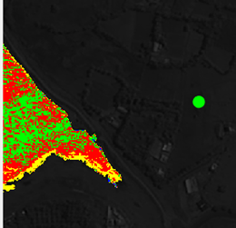 | S17, Kulathupudur, Tirupur This green color dot indicates this location is not polluted.
(11°06’19.91”N,77°17’27.29”E)-(11°06’10.14”N,77°17’32.49”E) | 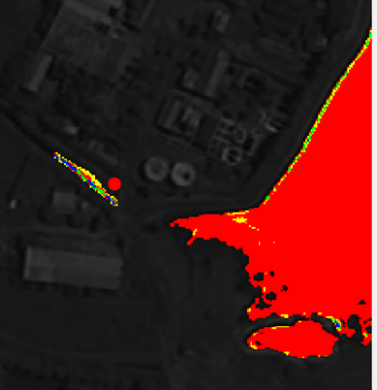 | S8, Chinnandi palayamKulam, Tirupur. This red color dot indicates this location is highly polluted.
(11°06’25.58”N,77°14’49.09”E)-(11°06’21.24”N,77°`14’54.89”E) | 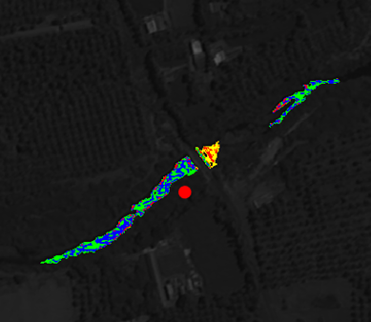 | S4, Noyyal River, Semmandampalayampudur, TirupurDist .This red color dot indicates this location is highly polluted.
(11°06’27.88”N,77°16’01.27”E)-(11°06’20.86”N,77°16’18.73”E) | 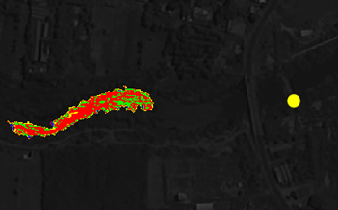 | S10, Noyyal River, Palladam- Avinasi Rd, Tirupur. This yellow color dot indicates this location is moderately polluted.
(11°06’00.92”N,77°18’44.76”E)-(11°05’54.26”N,77°18’49.75”E) | 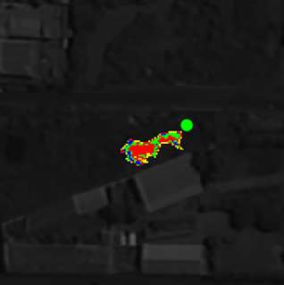 | S16, Kozhipannai, Tirupur. This green color dot indicates that this location is not polluted.
(11°06’48.83”N,77°15’39.03”E)-(11°06’39.34”N,77°15’50.67”E) | 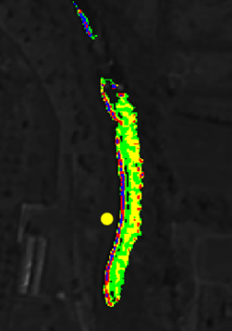 | S7, Kousika, Tiruppur Dist. This yellow color dot indicates that this location is moderately polluted.
(10°59’39.21”N, 77°16’56.94”E)-(10°59’28.69” N, 77°17’15.02”E) | 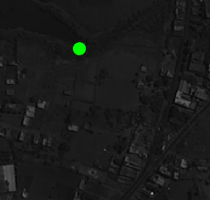 | S3, THIS LOCATION Mullai Nagar, Palladam, Tirupur Dist. This the green color dot indicates that this location is not polluted.
(10°59’54.44”N, 77°17’12.87”E)-(10°59’41.42”N, 77°17’ 29.29”E) | 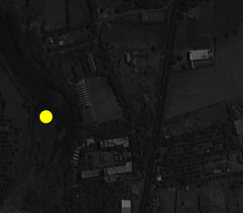 | S2, Palladam, TirupurDist  This yellow color dot indicates that this location is moderately polluted.

