Table 1 : Regions taken for the analysis are given which are represented as region 1,2,.…8 which represent frontal lobe, temporal lobe, lentiform nucleus, insular, thalamus, caudate nucleus, parietal and occipital regions respectively.
  Region 1 frontal lobe |   Region 2 temporal lobe |   Region 3 lentiform nucleus |   Region 4 insular |   Region 5 thalamus | 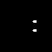  Region 6 caudate nucleus |   Region 7 parietal region |   Region 8 occipital region

Table 2 : Network plot for each region’s activated functional points.
Region 1  frontal lobe | 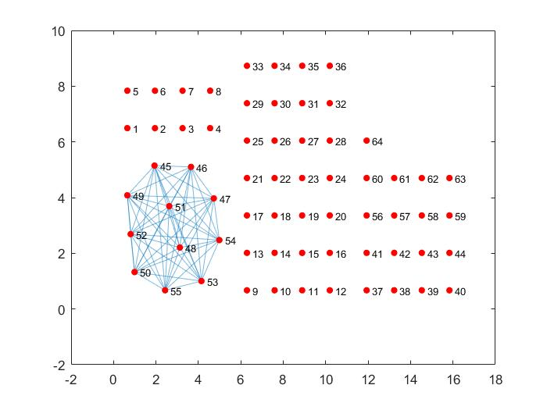
Region 2  temporal lobe | 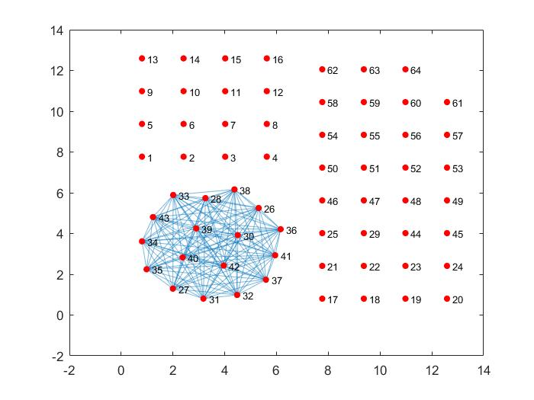
Region 3  lentiform nucleus | 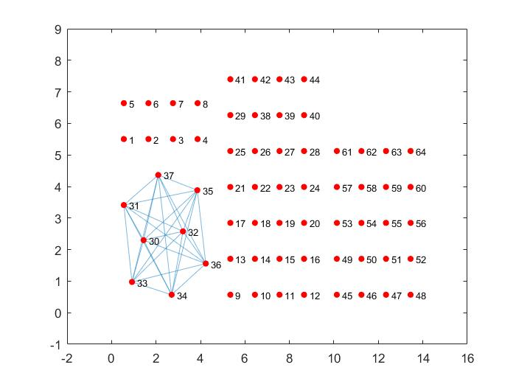
Region 4  insular | 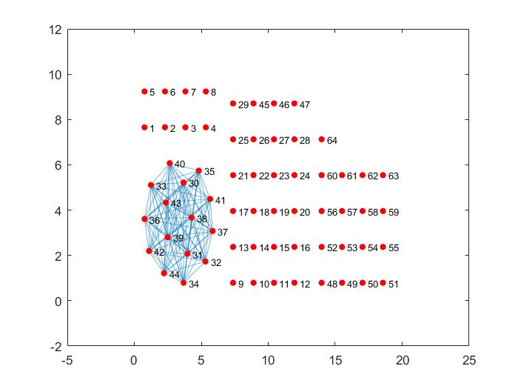
Region 5  thalamus | 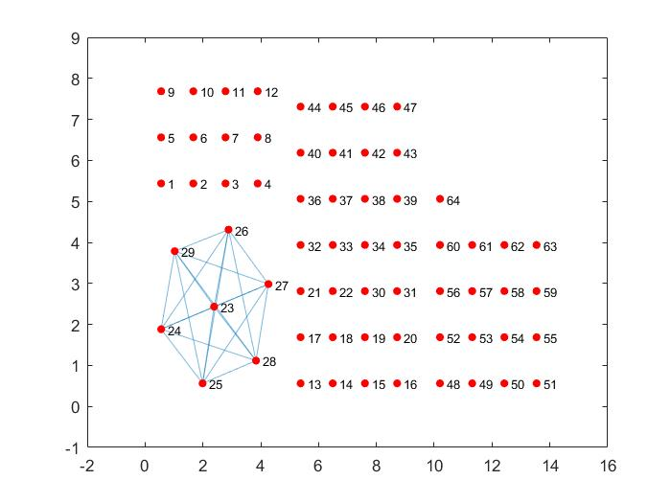
Region 6  caudate nucleus | 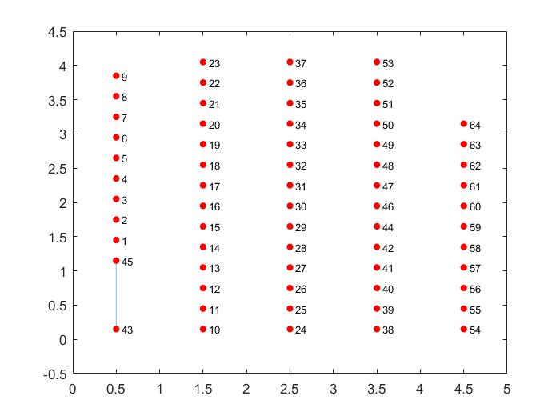
Region 7  parietal regions | 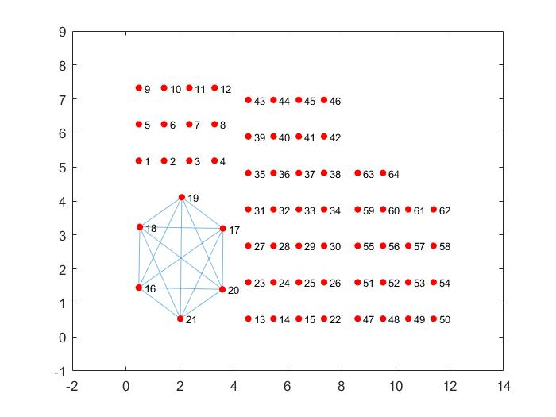
Region 8  occipital regions | 