Table S1 Detailed plot-level information on total basal area, dominant tree species, and ECM tree dominance. Acba, Acer barbinerve; Acmo, Acer mono; Acps, Acer pseudo-sieboldianum; Acte, Acer tegmentosum; Bepl, Betula platyphylla; Coma, Corylus mandshurica; Frma, Fraxinus mandshurica; Maam, Maackia amurensis; Maba, Malus baccata; Piko, Pinus koraiensis; Pous, Populus ussuriensis; Prpa, Prunus padus; Qumo, Quercus mongolica; Syre, Syringa reticulata; Tiam, Tilia amurensis; Ulda, Ulmus davidiana.
Mycorrhizal type | Plot | Total basal area (m² ha⁻¹) | Dominant tree species (percentage of total basal area) | ECM tree dominance (%)
AM-dominated | AM plot 1 | 28.5 | Tiam (23.1), Ulda (22.9), Acmo (14.5), Frma (13.6), Acps (10.2) | 27.2
AM-dominated | AM plot 2 | 42.1 | Frma (34.9), Ulda (23.7), Acmo (13.3), Prpa (10.7), Piko (6.0) | 10.8
AM-dominated | AM plot 3 | 42.4 | Frma (21.5), Ulda (17.9), Syre (15.5), Piko (14.9), Acmo (13.4) | 28.0
AM-dominated | AM plot 4 | 43.3 | Frma (33.7), Acmo (14.7), Tiam (12.6), Ulda (8.0), Prpa (6.5) | 22.0
AM-dominated | AM plot 5 | 51.2 | Frma (34.7), Acmo (22.0), Ulda (15.9), Piko (12.5), Tiam (6.5) | 22.3
AM-dominated | AM plot 6 | 34.6 | Acmo (35.7), Frma (23.4), Tiam (17.0), Qumo (8.1), Ulda (7.7) | 25.9
AM-dominated | AM plot 7 | 54.9 | Ulda (27.8), Prpa (22.1), Frma (15.8), Tiam (15.6), Acmo (5.5) | 16.8
AM-dominated | AM plot 8 | 33.9 | Acmo (33.3), Tiam (21.4), Frma (15.2), Ulda (13.0), Bepl (5.3) | 28.0
AM-dominated | AM plot 9 | 43.2 | Acmo (21.4), Maba (18.5), Frma (13.9), Maam (9.8), Tiam (9.3) | 23.6
AM-dominated | AM plot 10 | 43.8 | Frma (30.3), Acmo (22.7), Tiam (11.9), Ulda (8.5), Piko (5.8) | 27.0
Mixed | Mixed plot 1 | 40.0 | Frma (23.8), Acmo (23.5), Tiam (16.6), Piko (13.1), Acba (6.2) | 34.0
Mixed | Mixed plot 2 | 39.8 | Acmo (27.8), Piko (21.8), Qumo (21.0), Acps (13.1), Frma (8.5) | 45.9
Mixed | Mixed plot 3 | 47.6 | Frma (29.2), Piko (22.6), Acmo (12.3), Syre (11.1), Tiam (7.7) | 34.7
Mixed | Mixed plot 4 | 54.8 | Frma (23.7), Piko (15.7), Ulda (12.6), Acmo (10.5), Tiam (9.6) | 30.6
Mixed | Mixed plot 5 | 36.4 | Tiam (34.0), Frma (21.3), Acps (12.4), Acmo (11.7), Piko (11.2) | 49.0
Mixed | Mixed plot 6 | 32.2 | Frma (27.3), Tiam (24.3), Acmo (13.0), Ulda (9.7), Qumo (8.7) | 42.7
Mixed | Mixed plot 7 | 41.6 | Tiam (21.6), Qumo (20.0), Frma (16.4), Acps (16.0), Acmo (15.5) | 44.4
Mixed | Mixed plot 8 | 31.1 | Acmo (36.2), Piko (17.5), Frma (13.6), Coma (8.8), Acps (6.1) | 31.8
Mixed | Mixed plot 9 | 39.9 | Frma (19.9), Syre (14.3), Bepl (11.3), Qumo (11.0), Tiam (10.1) | 35.0
Mixed | Mixed plot 10 | 43.8 | Piko (25.0), Frma (15.6), Maam (13.6), Ulda (10.6), Tiam (9.2) | 47.0
Mixed | Mixed plot 11 | 41.0 | Piko (22.5), Tiam (21.5), Frma (12.0), Ulda (11.5), Acba (9.0) | 53.2
Mixed | Mixed plot 12 | 40.9 | Qumo (33.3), Tiam (25.4), Acps (15.3), Acmo (9.6), Piko (8.7) | 68.9
Mixed | Mixed plot 13 | 42.4 | Tiam (31.2), Piko (25.8), Frma (21.9), Acmo (13.2), Acba (2.6) | 59.0
Mixed | Mixed plot 14 | 40.2 | Qumo (28.7), Acps (20.4), Piko (17.8), Tiam (17.1), Acmo (15.0) | 64.3
Mixed | Mixed plot 15 | 42.0 | Piko (34.2), Qumo (18.9), Frma (10.5), Tiam (9.5), Acte (9.4) | 65.3
Mixed | Mixed plot 16 | 45.1 | Tiam (25.8), Piko (22.0), Acmo (13.4), Qumo (12.1), Frma (8.9) | 66.4
Mixed | Mixed plot 17 | 43.2 | Tiam (26.1), Frma (8.9), Piko (19.4), Acmo (11.6), Qumo (7.6) | 55.1
Mixed | Mixed plot 18 | 37.4 | Piko (30.8), Acps (29.5), Tiam (17.8), Acmo (11.0), Qumo (9.4) | 58.2
Mixed | Mixed plot 19 | 39.8 | Acmo (33.7), Piko (15.2), Coma (9.5), Tiam (8.7), Qumo (7.8) | 50.2
Mixed | Mixed plot 20 | 43.0 | Tiam (40.6), Piko (17.5), Acmo (13.4), Ulda (11.2), Acps (9.8) | 61.0
ECM-dominated | ECM plot 1 | 28.0 | Tiam (36.2), Piko (32.2), Acmo (10.7), Qumo (6.2), Acps (5.3) | 78.7
ECM-dominated | ECM plot 2 | 38.1 | Piko (46.8), Tiam (18.4), Acps (10.4), Qumo (9.0), Acmo (6.9) | 78.7
ECM-dominated | ECM plot 3 | 38.4 | Tiam (42.6), Piko (24.3), Acps (11.4), Qumo (9.6), Acmo (6.3) | 80.3
ECM-dominated | ECM plot 4 | 50.2 | Piko (40.1), Tiam (25.4), Pous (17.0), Acmo (8.0), Acba (5.4) | 84.3
ECM-dominated | ECM plot 5 | 55.0 | Tiam (42.9), Piko (31.7), Acmo (8.8), Qumo (6.6), Acps (5.5) | 83.2
ECM-dominated | ECM plot 6 | 45.0 | Tiam (46.0), Piko (28.8), Acmo (11.6), Acps (3.5), Syre (2.9) | 77.7
ECM-dominated | ECM plot 7 | 41.2 | Piko (33.6), Qumo (29.5), Tiam (16.3), Acps (11.4), Acba (5.8) | 80.7
ECM-dominated | ECM plot 8 | 32.2 | Tiam (28.7), Qumo (23.1), Piko (21.1), Acmo (8.1), Acba (5.7) | 77.7
ECM-dominated | ECM plot 9 | 50.9 | Tiam (39.3), Piko (28.2), Qumo (9.1), Acmo (8.0), Acps (7.2) | 80.6

Table S2 Results of generalized least-squares models with (spatial) and without (non-spatial) a spherical autocorrelation structure analyzing how soil N cycling, acid-base chemistry, N- hydrolyzing enzyme activities, and amoA gene abundances and diversity of ammonia-oxidizing archaea (AOA) and bacteria (AOB) changed with increasing ECM tree dominance (i.e. the independent variable). Better models shown in bold texts are those with lower Akaike Information Criterion (AIC) values.
Dependent variable | Model | Coefficient | P-value | AIC
Soil C:N ratio | Non-spatial | 0.013 | 0.04 | 116.90
Soil C:N ratio | Spatial | 0.013 | 0.04 | 112.90
Soil N concentration | Non-spatial | -0.03 | 0.01 | 148.88
Soil N concentration | Spatial | -0.03 | 0.01 | 152.88
Soil δ¹⁵N | Non-spatial | -0.016 | <0.01 | 47.24
Soil δ¹⁵N | Spatial | -0.016 | <0.01 | 50.59
Dissolved organic N concentration | Non-spatial | -0.05 | 0.28 | 259.78
Dissolved organic N concentration | Spatial | -0.05 | 0.28 | 263.78
NH₄⁺-N concentration | Non-spatial | -0.093 | 0.01 | 239.57
NH₄⁺-N concentration | Spatial | -0.093 | 0.01 | 243.57
NH₃ concentration | Non-spatial | -0.004 | <0.01 | -30.80
NH₃ concentration | Spatial | -0.004 | <0.01 | -26.80
NO₃–-N concentration | Non-spatial | -0.110 | <0.01 | 226.80
NO₃–-N concentration | Spatial | -0.110 | <0.01 | 230.77
Net N mineralization rate | Non-spatial | -0.007 | 0.02 | 56.20
Net N mineralization rate | Spatial | -0.007 | 0.02 | 60.13
Net nitrification rate | Non-spatial | -0.008 | 0.03 | 68.38
Net nitrification rate | Spatial | -0.008 | 0.03 | 72.38
Soil pH | Non-spatial | -0.004 | <0.01 | -40.29
Soil pH | Spatial | -0.004 | <0.01 | -42.29
Exchangeable bases | Non-spatial | -0.061 | <0.01 | 183.16
Exchangeable bases | Spatial | -0.061 | <0.01 | 187.16
Exchangeable Ca²⁺ concentration | Non-spatial | -0.049 | <0.01 | 170.77
Exchangeable Ca²⁺ concentration | Spatial | -0.049 | <0.01 | 174.77
Exchangeable Mg²⁺ concentration | Non-spatial | -0.010 | <0.01 | 44.44
Exchangeable Mg²⁺ concentration | Spatial | -0.010 | <0.01 | 48.44
Exchangeable K⁺ concentration | Non-spatial | -0.001 | 0.19 | -30.08
Exchangeable K⁺ concentration | Spatial | -0.001 | 0.19 | -26.08
Exchangeable Na⁺ concentration | Non-spatial | -0.001 | 0.09 | -61.30
Exchangeable Na⁺ concentration | Spatial | -0.001 | 0.14 | -58.73
Bacterial 16S rRNA gene abundance (log₁₀-transformed) | Non-spatial | -0.004 | 0.02 | 11.44
Bacterial 16S rRNA gene abundance (log₁₀-transformed) | Spatial | -0.004 | 0.02 | 15.43
Fungal ITS gene abundance (log₁₀-transformed) | Non-spatial | 0.004 | <0.01 | -5.27
Fungal ITS gene abundance (log₁₀-transformed) | Spatial | 0.004 | <0.01 | -1.32
Fungal:bacterial ratio | Non-spatial | 0.001 | <0.01 | -167.47
Fungal:bacterial ratio | Spatial | 0.001 | <0.01 | -163.47
β-N-acetylglucosaminidase activity | Non-spatial | 0.538 | 0.03 | 380.82
β-N-acetylglucosaminidase activity | Spatial | 0.537 | 0.03 | 384.52
Leucine aminopeptidase activity | Non-spatial | 0.212 | 0.06 | 324.60
Leucine aminopeptidase activity | Spatial | 0.215 | 0.06 | 328.58
AOA amoA gene abundance (log₁₀-transformed) | Non-spatial | -0.007 | <0.01 | 36.59
AOA amoA gene abundance (log₁₀-transformed) | Spatial | -0.007 | <0.01 | 40.59
AOB amoA gene abundance (log₁₀-transformed) | Non-spatial | 0.002 | 0.57 | 61.40
AOB amoA gene abundance (log₁₀-transformed) | Spatial | 0.001 | 0.66 | 63.45
AOA:AOB ratio | Non-spatial | -0.009 | <0.01 | 62.19
AOA:AOB ratio | Spatial | -0.009 | <0.01 | 66.13
AOA Chao1 index | Non-spatial | -0.071 | 0.02 | 226.00
AOA Chao1 index | Spatial | -0.071 | 0.02 | 230.00
AOB Chao1 index | Non-spatial | -0.002 | 0.95 | 215.11
AOB Chao1 index | Spatial | -0.002 | 0.95 | 219.01
AOA Shannon index | Non-spatial | -0.002 | 0.04 | -23.59
AOA Shannon index | Spatial | -0.003 | 0.02 | -24.76
AOB Shannon index | Non-spatial | 0.003 | 0.20 | 24.49
AOB Shannon index | Spatial | 0.003 | 0.22 | 28.33

Table S3 Results of multiple linear regression analyzing effects of soil chemical variables on bacterial and fungal abundances, N-hydrolyzing enzyme activities, and amoA gene abundances of ammonia-oxidizing archaea (AOA) and bacteria (AOB). Statistical results are obtained from model averaging across submodels with ΔAIC_{C} <2.0. Statistically significant predictors and P-values are shown in bold texts.
 | Predictor | Estimate | Z-value | P-value
Bacterial 16S rRNA gene abundance (log₁₀-transformed) | Soil pH | 0.36 | 2.10 | 0.04
Bacterial 16S rRNA gene abundance (log₁₀-transformed) | Exchangeable Na⁺ | 0.31 | 1.95 | 0.06
Bacterial 16S rRNA gene abundance (log₁₀-transformed) | NH₄⁺-N concentration | -0.23 | 1.36 | 0.18
Bacterial 16S rRNA gene abundance (log₁₀-transformed) | Exchangeable Ca²⁺ | 0.23 | 1.21 | 0.23
Fungal ITS gene abundance (log₁₀-transformed) | Soil pH | -0.39 | 2.21 | 0.03
Fungal ITS gene abundance (log₁₀-transformed) | NH₄⁺-N concentration | -0.29 | 1.71 | 0.09
Fungal ITS gene abundance (log₁₀-transformed) | Exchangeable Na⁺ | 0.26 | 1.57 | 0.12
Fungal ITS gene abundance (log₁₀-transformed) | Exchangeable Ca²⁺ | -0.29 | 1.50 | 0.14
Fungal ITS gene abundance (log₁₀-transformed) | Exchangeable K⁺ | 0.22 | 1.23 | 0.22
 | Soil C:N ratio | -0.14 | 0.88 | 0.38
β-N-acetylglucosaminidase | Soil pH | -0.52 | 3.39 | <0.01
β-N-acetylglucosaminidase | Exchangeable K⁺ | -0.25 | 1.67 | 0.09
β-N-acetylglucosaminidase | Exchangeable Ca²⁺ | -0.22 | 1.34 | 0.18
β-N-acetylglucosaminidase | NH₄⁺-N concentration | 0.15 | 1.00 | 0.32
β-N-acetylglucosaminidase | Exchangeable Mg²⁺ | -0.15 | 0.99 | 0.32
β-N-acetylglucosaminidase | Exchangeable Na⁺ | 0.13 | 0.80 | 0.43
β-N-acetylglucosaminidase | Soil C:N ratio | -0.12 | 0.80 | 0.43
Leucine aminopeptidase | Soil C:N ratio | 0.44 | 3.10 | <0.01
Leucine aminopeptidase | Exchangeable Na⁺ | -0.46 | 3.01 | <0.01
Leucine aminopeptidase | Exchangeable Ca²⁺ | 0.33 | 1.98 | 0.04
Leucine aminopeptidase | Exchangeable Mg²⁺ | 0.25 | 1.57 | 0.12
Leucine aminopeptidase | NH₄⁺-N concentration | -0.23 | 1.50 | 0.13
Leucine aminopeptidase | Soil pH | -0.19 | 1.15 | 0.25
AOA amoA gene abundance (log₁₀-transformed) | Exchangeable Ca²⁺ | 0.67 | 3.07 | <0.01
AOA amoA gene abundance (log₁₀-transformed) | Exchangeable K⁺ | -0.46 | 2.20 | 0.03
AOA amoA gene abundance (log₁₀-transformed) | NO₃⁻-N concentration | 0.27 | 1.75 | 0.08
AOA amoA gene abundance (log₁₀-transformed) | Soil pH | 0.21 | 1.26 | 0.21
AOB amoA gene abundance (log₁₀-transformed) | NH₄⁺-N concentration | 0.38 | 2.31 | 0.02
AOB amoA gene abundance (log₁₀-transformed) | Exchangeable K+ | 0.09 | 0.53 | 0.60
AOB amoA gene abundance (log₁₀-transformed) | Exchangeable Na⁺ | -0.08 | 0.48 | 0.63

Fig. S1 Distribution of the 39 plots in the broad-leaved Korean pine mixed forest.

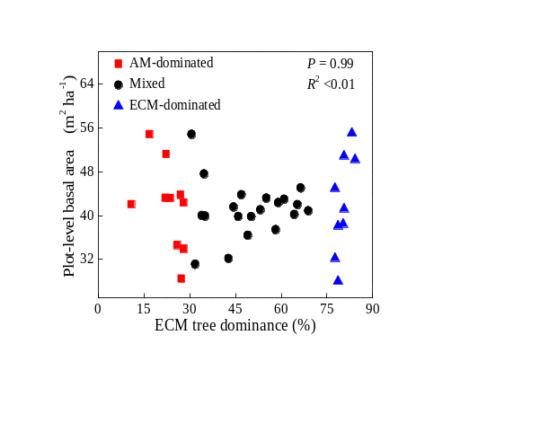
Fig. S2 Changes in plot-level total basal area with increasing ECM tree dominance (n = 39).

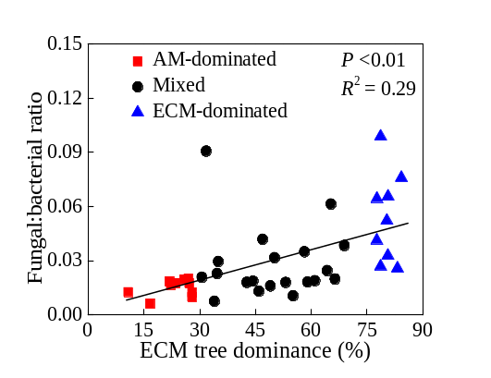
Fig. S3 Changes in the fungal:bacterial ratio with increasing ECM tree dominance (n = 39). Statistical results are obtained from generalized least-squares models (Table S2). Fungal:bacterial ratio is calculated as the ratio of fungal ITS to bacterial 16S rRNA gene abundances.
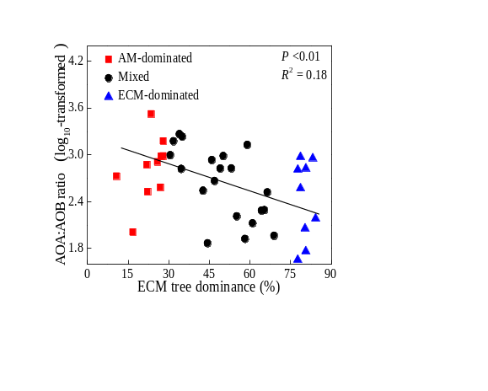
Fig. S4 Changes in the ratio of AOA to AOB amoA gene abundances with increasing ECM tree dominance (n = 39). Statistical results are obtained from generalized least-squares models (Table S2). AOA, ammonia-oxidizing archaea; AOB, ammonia-oxidizing bacteria.

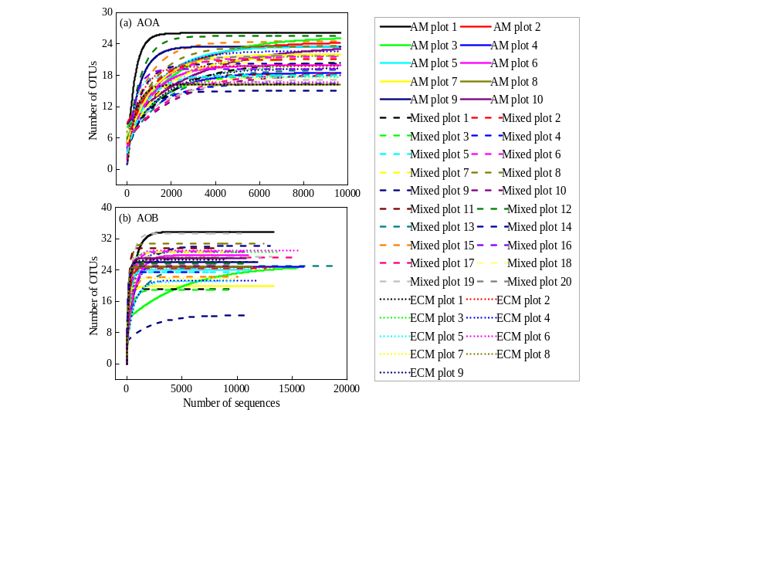
Fig. S5 Rarefaction curves of ammonia-oxidizing archaea (AOA) and bacteria (AOB) for the 39 plots.

Fig. S6 Neighbor-joining phylogenetic tree based on amoA sequences of ammonia-oxidizing archaea. Bootstrap values >70% based on 1000 replicates are shown at nodes. Names starting with OTU indicate sequences obtained in this study and relative abundances of these OTUs are shown in brackets. Reference sequences are downloaded from the NCBI database and their accession numbers are shown in brackets.

Fig. S7 Neighbor-joining phylogenetic tree based on amoA sequences of ammonia-oxidizing bacteria. Bootstrap values >70% based on 1000 replicates are shown at nodes. Names starting with OTU indicate sequences obtained in this study and relative abundances of these OTUs are shown in brackets. Reference sequences are downloaded from the NCBI database and their accession numbers are shown in brackets.

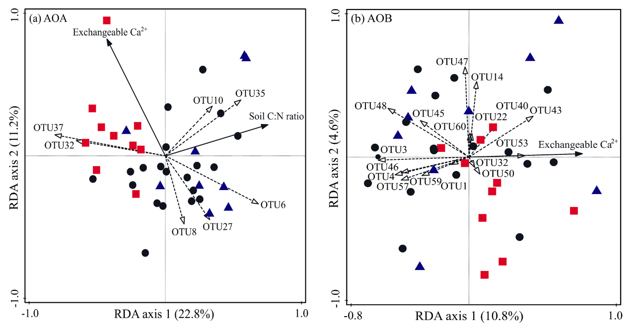
Fig. S8 Triplots of partial redundancy analyses (RDA) to identify soil chemical variables significantly influencing community composition of ammonia-oxidizing archaea (AOA) and bacteria (AOB). Red squares, black circles and blue triangles represent AM-dominated plots, mixed plots and ECM-dominated plots, respectively. Dashed lines represent OTUs with relative abundance larger than 1%. Solid lines represent statistically significant soil chemical variables identified by the forward selection with 999 permutations.

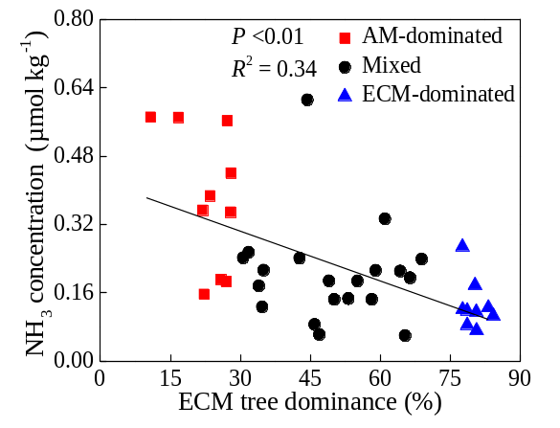
Fig. S9 Changes in NH₃ concentration with increasing ECM tree dominance (n = 39). NH₃ concentration was calculated based on the Henderson-Hasselbalch equation assuming a pK_{a} value of 9.25 (NH₃ = NH₄⁺-N × 10^{(pH–9.25)}).

