Supplementary Material

Synthesis and Structure of the Dimethyl Sulfide Complexes [OsX₄(dms)₂]
(Х = Cl, Br) and [Os₂OCl₆(dms)₄]

Olga V. Rudnitskaya^{a*}, Ekaterina V. Dobrokhotovaª, Tatiana A. Tereshinaª, Ekaterina K. Kultyshkinaª, Daniil S. Pshenichnyyª, Elena A. Fortalnovaª, Ivan V. Anan'ev^{b,c}, Ilya A. Yakushev^{b}, Victor N.Khrustalev^{a,d*}

ª Peoples’ Friendship University of Russia (RUDN University),6 Miklukho-Maklay St, 117198 Moscow, Russian Federation;
^{b} N.S. Kurnakov Institute of General and Inorganic Chemistry RAS, Leninsky prospect, 31, 119991 Moscow, Russian Federation;
^{c} A. N. Nesmeyanov Institute of Organoelement compounds RAS, Vavilova St., 28, bld. 1., 119334, Moscow, Russian Federation;
^{d} Zelinsky Institute of Organic Chemistry RAS,Leninsky prospect, 47, 119991 Moscow, Russian Federation
* Corresponding authors,: E-mail: orudnitskaya@rambler.ru; vnkhrustalev@gmail.com

Figure Captions

Fig. S1. UV-Vis absorption spectra of chromatographic fractions of thermolysis products of complexes 1 at 140 °C, τ = 1 h (a), 3 at 140 °C, τ = 4 h (b), 4 at 100 °C, τ = 4 h (c).
Fig. S2. DTA/TG results of [H(dmso)₂]₂[OsХ₆], where Х = Cl, Br: DTA and Temperature curves vs. time (a); temperature dependences of TG curves (b).
Fig. S3. DTA/TG results of [H(dmso)₂][OsХ₅(dmso)], where Х = Cl, Br: time dependences of DTA and Temperature curves (a); TG curves vs. time (b).
Fig. S4. X-ray diffraction patterns of [OsCl₄(dms)₂]: experimental diffraction pattern of [OsCl₄(dms)₂] powder (1); simulated for a single crystal with space group Pbca (2) and space group P2₁/n (3).
Fig. S5. The staggered and eclipsed conformers of molecules 5 and 6 according to DFT calculations. The relative energies of the conformers (kJ/mol) are given in brackets.

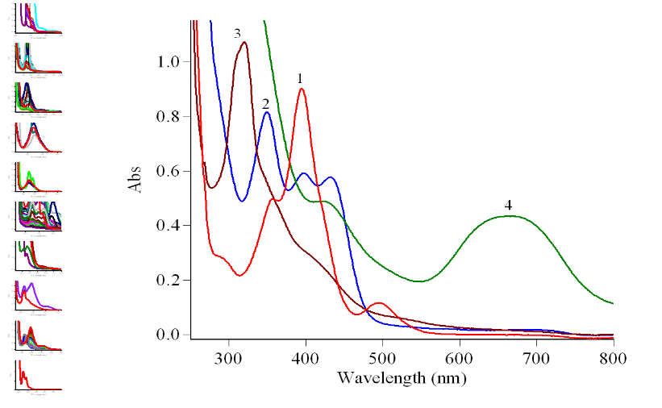
А
λ, nm

a

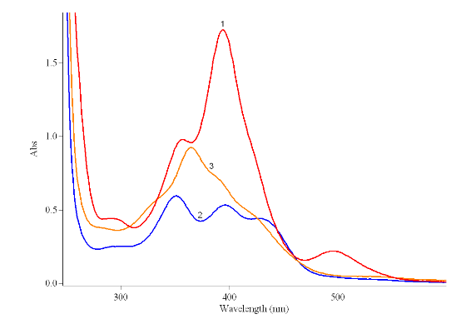
b
λ, nm

А

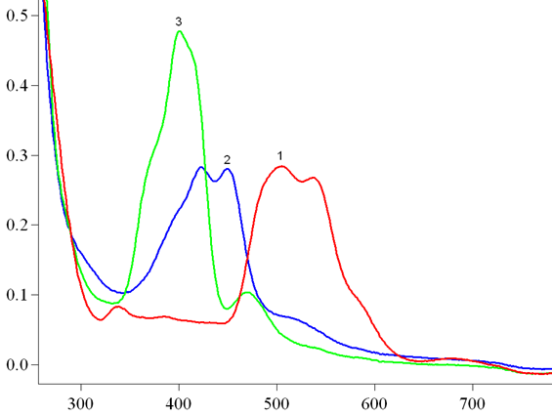
c
λ, nm

А

Fig. S1. UV-vis absorption spectra of chromatographic fractions of thermolysis products of complexes 1 at 140 °C, τ = 1 h (a), 3 at 140 °C, τ = 4 h (b), 4 at 100 °C, τ = 4 h (c).

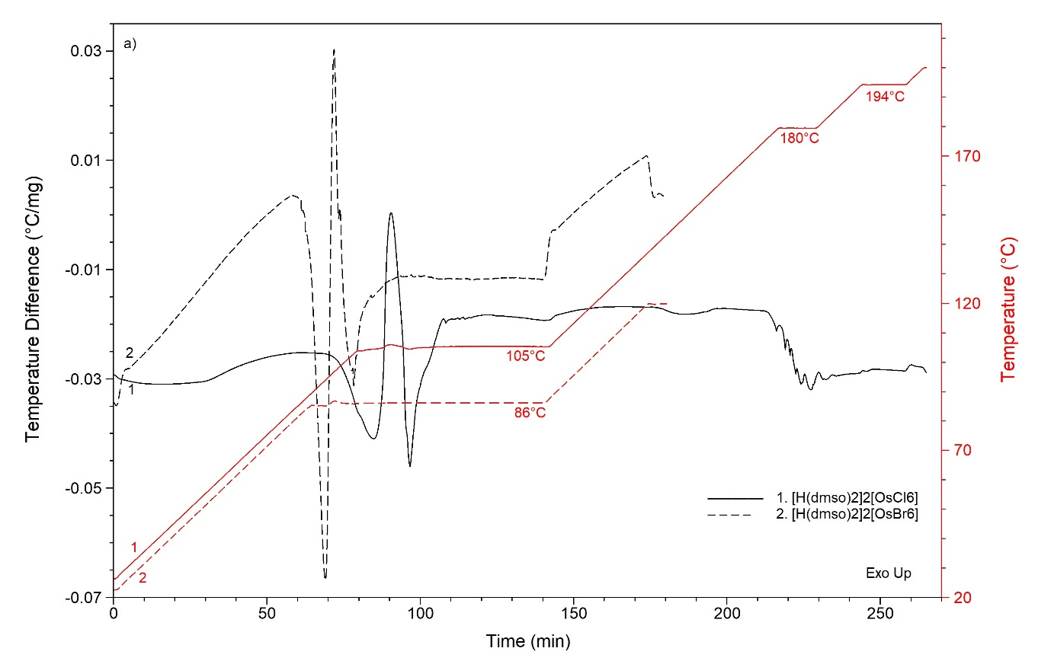
a
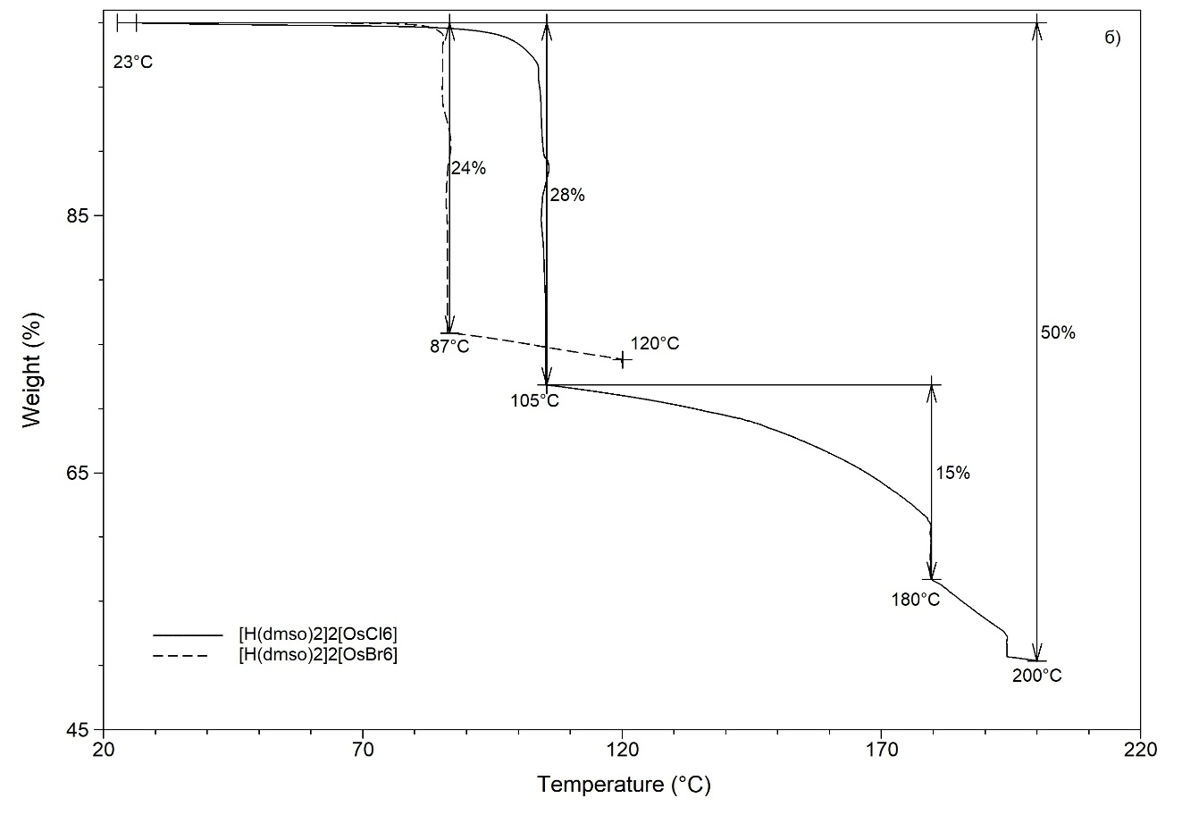
b
Fig. S2. DTA/TG results of [H(dmso)₂]₂[OsХ₆], where Х = Cl, Br: DTA and Temperature curves vs. time (a); temperature dependences of TG curves (b).

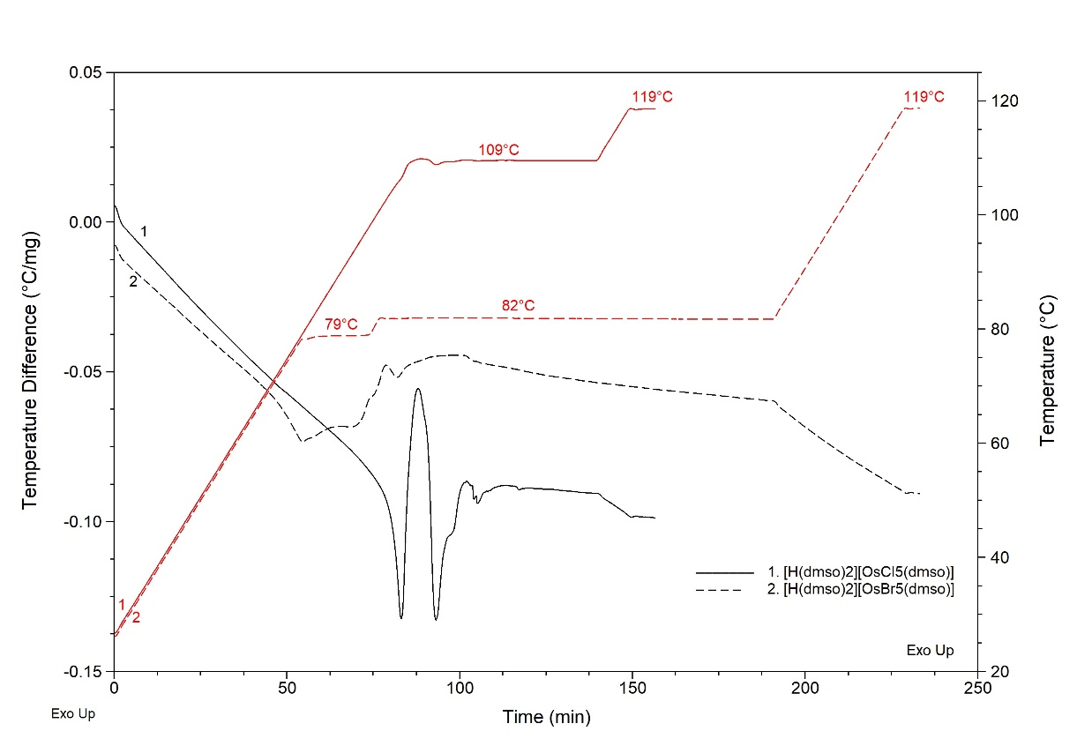

a

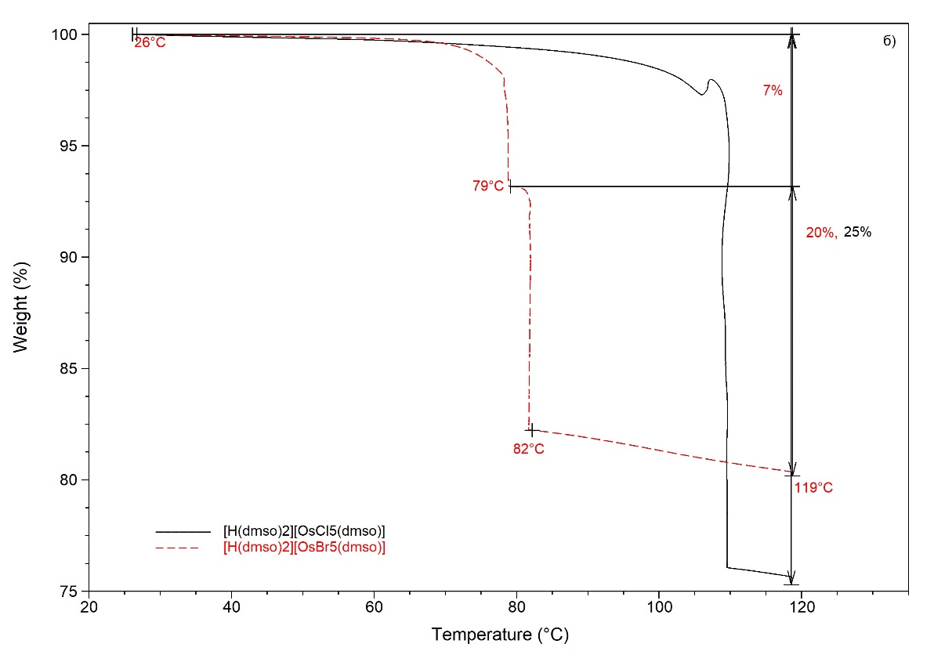
b

Fig. S3. DTA/TG results of [H(dmso)₂][OsХ₅(dmso)], where Х = Cl, Br: time dependences of DTA and Temperature curves (a); TG curves vs. time (b).

I
2θ, deg.
1
3
2

Fig. S4. X-ray diffraction patterns of [OsCl₄(dms)₂]: experimental diffraction pattern of [OsCl₄(dms)₂] powder (1); simulated for a single crystal with space group Pbca (2) and space group P2₁/n (3).

Quantum-chemical calculations

The electronic structure of the molecules was calculated by the density functional theory (DFT) method using the hybrid functional B3LYP and the basis set def2-SV(P). Full optimization of the geometry of the calculated molecules was carried out. All calculations were performed using the Firefly 8.20 software package.
[A. A. Granovsky, Firefly version 8.20. http://classic.chem.msu.su/gran/firefly/index.html]

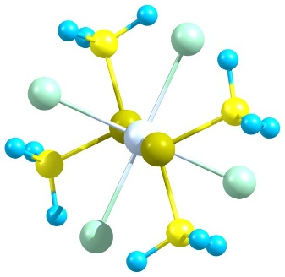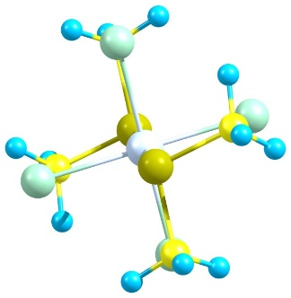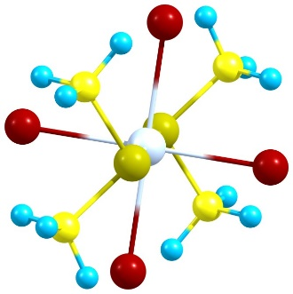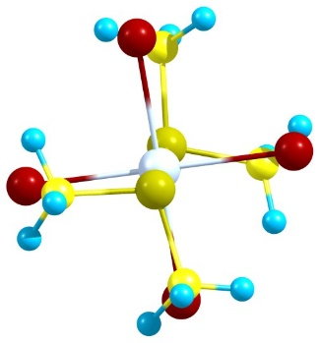
5 staggered (0) 5 eclipsed (+11.4) 6 staggered (0) 6 eclipsed (+5.6)

Fig. S5. The staggered and eclipsed conformers of molecules 5 and 6 according to DFT calculations. The relative energies of the conformers (kJ/mol) are given in brackets.

