Supplemental Fig. 1
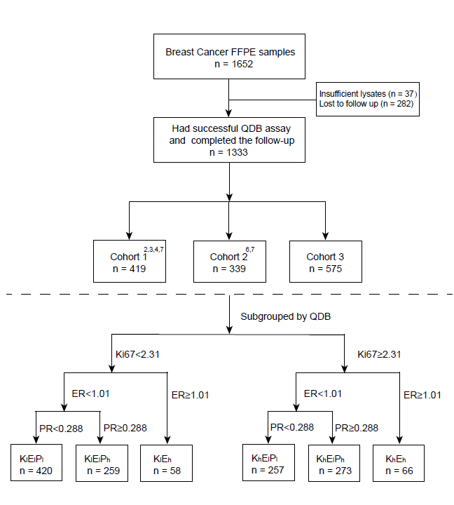
Supplemental Fig. 1: The flow chart of case selection for the study. Cohort 1 and 2 have been reported previously in other studies as indicated in the figure.

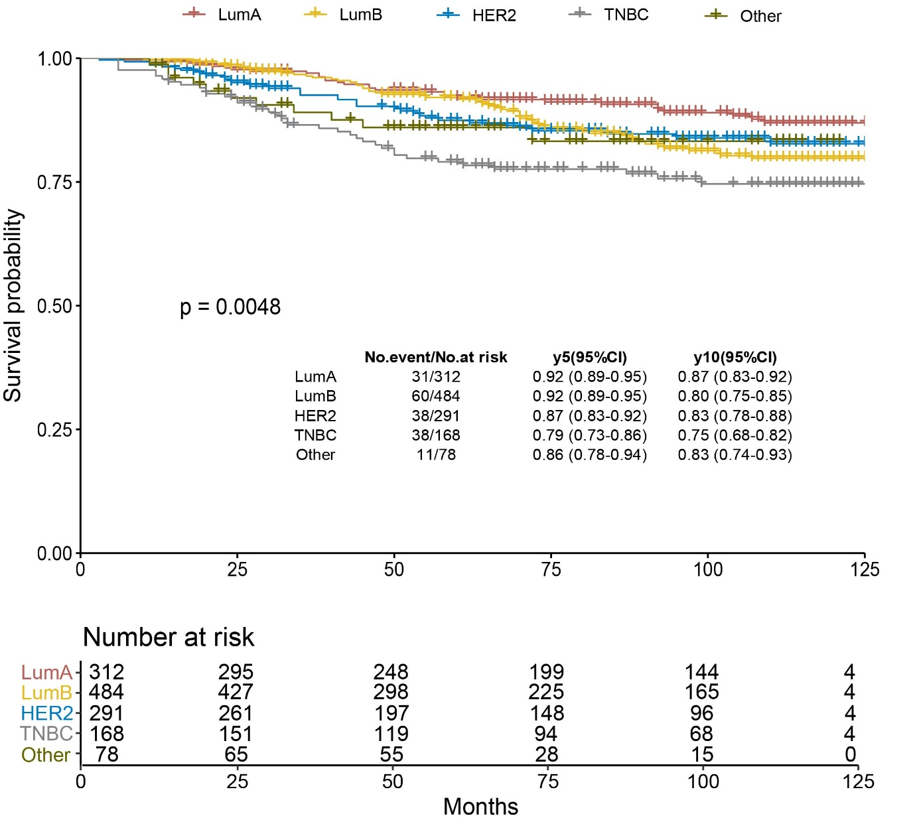
Supplemental Fig. 2: Kaplan-Meier analysis of overall survival (OS) of all cases stratified by clinical subtype based on the definition of 2013 St. Gallen consensus.¹² In brief, Luminal A-like (LumA) is defined as ER and PR positive (ER+ & PR+), PR≥20%, Her2 negative (Her2-) and Ki67<20%; Luminal B (LumB) is defined as ER+, Her2-, PR<20% and/or Ki67≥20%; Her2-like (Her2) is defined as Her2+, and Triple Negative Breast Cancer (TNBC) is defined as ER-, PR- & Her2-. Cases not included in LumA, LumB, Her2 and TNBC, or cases with insufficient IHC information, were included in the Other category. For cases of Her2 2+, if there was no FISH result, we defined them as Her2+ or Her2- based on absolute Her2 protein levels using 0.26 nmol/g as cutoff defined in previous studies^{6,7}.

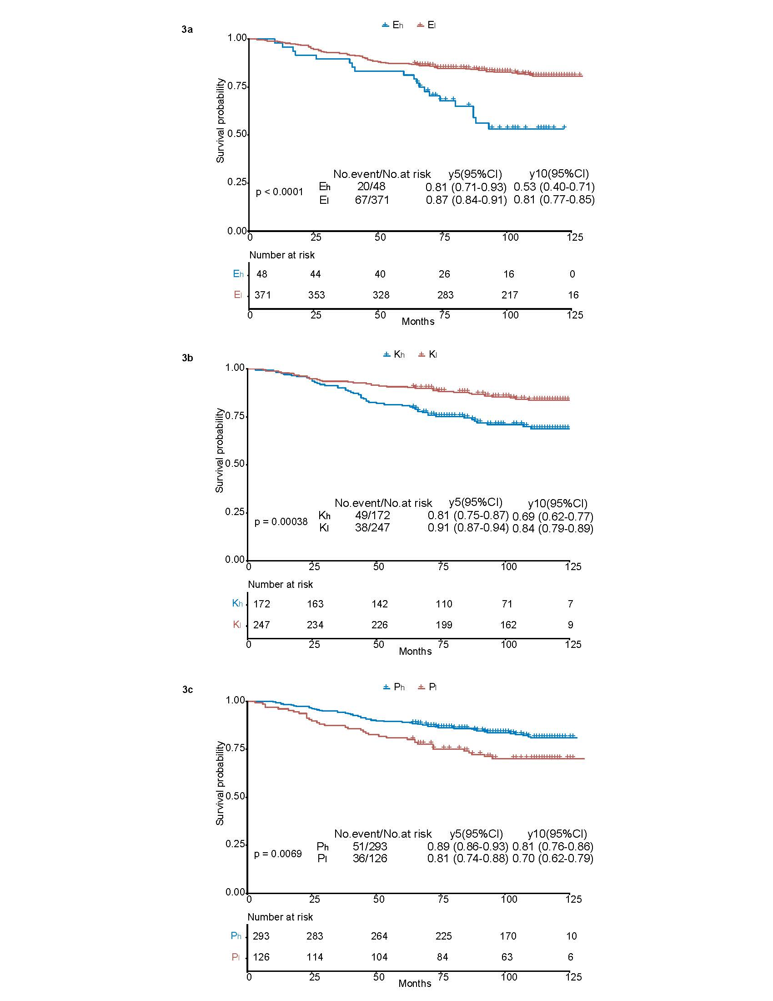
Supplemental Fig. 3: Developing optimized cutoffs of ER, PR, and Ki67 in cohort 1 (n=419) as training cohort 1. The optimized cutoff was identified using “surv_cutpoint” function of the “surviminer” R package based on absolutely quantitated protein biomarker levels and overall survival (OS). 3a, Optimized cutoff of 1.01 nmol/g was used to stratify patients into the E_{h} group for those with ER levels ≥1.01 nmol/g while those <1.01 nmol/g as E_{l} group, with p<0.0001; 3b, optimized cutoff of 2.31 nmol/g was used to stratify patients into K_{h} group with Ki67 levels ≥2.31 nmol/g while those <2.31 nmol/g as K_{l} group with p=0.00038; 3c, Optimized cutoff of 0.17 nmol/g was used to stratify patients into P_{h} group for those with PR levels ≥0.17 nmol/g while those <0.17 nmol/g as P_{l} group, with p=0.0069. For technical considerations, this cutoff was adjusted from 0.17 to 0.288 nmol/g, the lower limit of quantitation (LLOQ). LLOQ was defined as the lowest concentration level with both a CV < 25% and a relative error within ±25%, based on 40 calibration curves analyzed in triplicate.

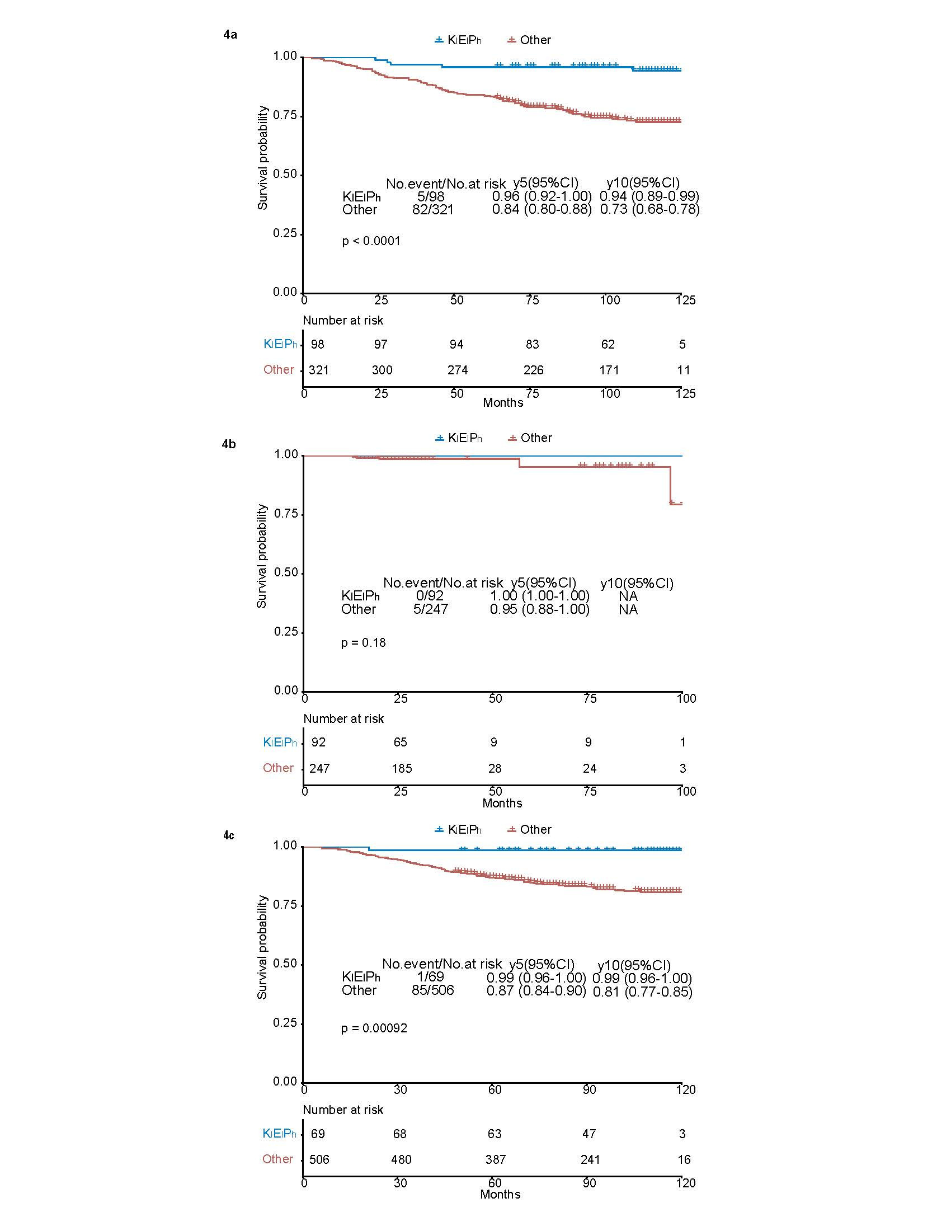
Supplemental Fig. 4: The Kaplan-Meier overall survival analysis of K_{l}E_{l}P_{h} subgroup in cohort 1, 2 and 3 respectively. The K_{l}E_{l}P_{h} subgroup was identified as cases with Ki67<2.31 nmol/g, ER<1.01 nmol/g, and PR≥0.288 nmol/g, and their overall survival (OS) was analyzed using Kaplan-Meier overall survival analysis vs the remaining cases in the same cohort. 4a, the Kaplan-Meier overall analysis of K_{l}E_{l}P_{h} vs the remaining cases in cohort 1 (n=419), with p<0.0001 using Log-rank test; 4b, the Kaplan-Meier overall analysis of K_{l}E_{l}P_{h} vs the remaining cases in cohort 2 (n=339), with p=0.18 using Log-rank test; 4c, the Kaplan-Meier overall analysis of K_{l}E_{l}P_{h} vs the remaining cases in cohort 3 (n=575), with p<0.00092 using Log-rank test;

Supplemental Table 1: Univariate and multivariate Cox proportional hazards overall survival regression analysis of cohort 1 (n=419) using absolutely quantitated ER, PR, Her2 and Ki67 protein levels as continuous variables with death as endpoint.

Variables | Univariate |  |  |  |  | Multivariate
Variables | HR | 95%CI | p-value |  | HR | 95%CI | p-value
ER (nmol/g) | 1.61 | 1.24-2.10 | 0.0004 |  | 1.79 | 1.36-2.36 | 0
Her2 (10 nmol/g) | 1.43 | 0.77-2.68 | 0.2582 |  | 1.5 | 0.80-2.81 | 0.2033
Ki67 (10 nmol/g) | 1.68 | 1.05-2.67 | 0.0302 |  | 1.76 | 1.08-2.87 | 0.0245
PR (nmol/g) | 0.9 | 0.70-1.16 | 0.4189 |  | 0.82 | 0.62-1.08 | 0.1562

Supplemental Table 2: Patient characteristics by subgroup defined by absolutely quantitated ER, PR, Her2 and Ki67 protein levels.

Characteristic | K_{l}E_{l}P_{h} | K_{l}E_{l}P_{l} | K_{h}E_{l}P_{h} | K_{h}E_{l}P_{l} | E_{h}K_{h} | E_{h}K_{l}
 | (n = 259),  No. (%) | (n = 420),  No. (%) | (n = 273)  No. (%) | (n = 257),  No. (%) | (n = 66),  No. (%) | (n = 58),  No. (%)
Age
<50 | 143 (55.2) | 152 (36.2) | 139 (50.9) | 99 (38.5) | 7 (10.6) | 1 (1.7)
≥50 | 115 (44.4) | 268 (63.8) | 134 (49.1) | 157 (61.1) | 59 (89.4) | 57 (98.3)
Unknown | 1 (0.4) | 0 (0.0) | 0 (0.0) | 1 (0.4) | 0 (0.0) | 0 (0.0)
Pathological tumor size, pT
pT1 | 143 (55.2) | 189 (45.0) | 137 (50.2) | 104 (40.5) | 21 (31.8) | 26 (44.8)
pT2 | 101 (39.0) | 194 (46.2) | 129 (47.3) | 127 (49.4) | 41 (62.1) | 27 (46.6)
pT3 | 11 (4.2) | 16 (3.8) | 5 (1.8) | 18 (7.0) | 2 (3.0) | 3 (5.2)
Unknown | 4 (1.5) | 21 (5.0) | 2 (0.7) | 8 (3.1) | 2 (3.0) | 2 (3.4)
Pathological lymph node status, pN
pN0 | 147 (56.8) | 236 (56.2) | 138 (50.5) | 141 (54.9) | 31 (47.0) | 31 (53.4)
pN1 | 80 (30.9) | 101 (24.0) | 90 (33.0) | 61 (23.7) | 24 (36.4) | 18 (31.0)
pN2 | 24 (9.3) | 43 (10.2) | 27 (9.9) | 24 (9.3) | 4 (6.1) | 4 (6.9)
pN3 | 4 (1.5) | 32 (7.6) | 15 (5.5) | 24 (9.3) | 5 (7.6) | 1 (1.7)
Unknown | 4 (1.5) | 8 (1.9) | 3 (1.1) | 7 (2.7) | 2 (3.0) | 4 (6.9)
Tumor type
Ductal | 231 (89.2) | 360 (85.7) | 258 (94.5) | 234 (91.1) | 58 (87.9) | 51 (87.9)
Lobular | 9 (3.5) | 7 (1.7) | 3 (1.1) | 12 (4.7) | 2 (3.0) | 1 (1.7)
Mixed | 2 (0.8) | 6 (1.4) | 2 (0.7) | 3 (1.2) | 0 (0.0) | 4 (6.9)
other | 17 (6.6) | 47 (11.2) | 10 (3.7) | 8 (3.1) | 6 (9.1) | 2 (3.4)
Grade
1 | 51 (19.7) | 42 (10.0) | 22 (8.1) | 2 (0.8) | 3 (4.5) | 9 (15.5)
2 | 154 (59.5) | 197 (46.9) | 119 (43.6) | 94 (36.6) | 37 (56.1) | 38 (65.5)
3 | 23 (8.9) | 77 (18.3) | 120 (44.0) | 129 (50.2) | 20 (30.3) | 5 (8.6)
Unknown | 31 (12.0) | 104 (24.8) | 12 (4.4) | 32 (12.5) | 6 (9.1) | 6 (10.3)
Subtype ª
Luminal-A | 135 (52.1) | 90 (21.4) | 34 (12.5) | 4 (1.6) | 14 (21.2) | 35 (60.3)
Luminal-B | 85 (32.8) | 131 (31.2) | 145 (53.1) | 62 (24.1) | 42 (63.6) | 19 (32.8)
Her2 | 22 (8.5) | 108 (25.7) | 65 (23.8) | 89 (34.6) | 6 (9.1) | 1 (1.7)
TNBC | 4 (1.5) | 50 (11.9) | 16 (5.9) | 95 (37.0) | 2 (3.0) | 1 (1.7)
other | 13 (5.0) | 41 (9.8) | 13 (4.8) | 7 (2.7) | 2 (3.0) | 2 (3.4)
ET
Yes | 59 (22.8) | 105 (25.0) | 28 (10.3) | 30 (11.7) | 8 (12.1) | 8 (13.8)
No | 34 (13.1) | 74 (17.6) | 22 (8.1) | 56 (21.8) | 17 (25.8) | 5 (8.6)
Unknown | 166 (64.1) | 241 (57.4) | 223 (81.7) | 171 (66.5) | 41 (62.1) | 45 (77.6)
CT
Yes | 93 (35.9) | 175 (41.7) | 50 (18.3) | 84 (32.7) | 23 (34.8) | 11 (19.0)
No | 7 (2.7) | 16 (3.8) | 2 (0.7) | 4 (1.6) | 3 (4.5) | 3 (5.2)
Unknown | 159 (61.4) | 229 (54.5) | 221 (81.0) | 169 (65.8) | 40 (60.6) | 44 (75.9)
Trastuzumab
Yes | 1 (0.4) | 24 (5.7) | 0 (0.0) | 5 (1.9) | 0 (0.0) | 0 (0.0)
No | 99 (38.2) | 168 (40.0) | 52 (19.0) | 83 (32.3) | 26 (39.4) | 14 (24.1)
Unknown | 159 (61.4) | 228 (54.3) | 221 (81.0) | 169 (65.8) | 40 (60.6) | 44 (75.9)
Adjuvant therapy received
ET only | 7 (2.7) | 16 (3.8) | 2 (0.7) | 4 (1.6) | 3 (4.5) | 3 (5.2)
CT only | 34（13.1） | 61（14.5） | 22（8.1） | 52（20.2） | 17（25.8） | 5（8.6）
CT+ET | 51（19.7） | 77（18.3） | 26（9.5） | 25（9.7） | 5（7.6） | 5（8.6）
CT+Herceptin | 0（0.0） | 12（2.9） | 0（0.0） | 4（1.6） | 0（0.0） | 0（0.0）
CT+ET+Herceptin | 1（0.4） | 12（2.9） | 0（0.0） | 1（0.4） | 0（0.0） | 0（0.0）
Unknown | 166（64.1） | 242（57.6） | 223（81.7） | 171（66.5） | 41（62.1） | 45（77.6）
AET: adjuvant systemic treatment；CT: chemotherapy；ET: endocrine therapy.

Supplemental table 3: Summary of treatments received by individual subtype in K_{l}E_{l}P_{h} (3a) and K_{l}E_{l}P_{l} (3b) subgroup. ET: Endocrine therapy, CT: Chemotherapy. The number in () indicates number of deaths
3a
 | K_{l}E_{l}P_{h}
 | LumA | LumB | Her2 | TNBC | other
ET only | 4(1) | 3 | 0 | 0 | 0
CT only | 23 | 6 | 1 | 1 | 3(1)
CT+ET | 26(2) | 18(1) | 4 | 1 | 2(1)
CT+Herceptin | 0 | 0 | 0 | 0 | 0
CT+ET+Herceptin | 1 | 0 | 0 | 0 | 0
Unknown | 81 | 58 | 17 | 2 | 8

3b
 | K_{l}E_{l}P_{l}
 | LumA | LumB | Her2 | TNBC | other
ET only | 7(2) | 7 | 2 | 0 | 0
CT only | 3 | 7 | 23(10) | 18(5) | 10(2)
CT+ET | 21(2) | 39(5) | 11(2) | 3(1) | 3
CT+Herceptin | 0 | 0 | 6 | 2 | 4
CT+ET+Herceptin | 0 | 2 | 6(1) | 0 | 4
Unknown | 59(8) | 76(12) | 60(3) | 27(4) | 20(4)

