Appendix A. Sensitivity Analysis with 1/3-Mile Buffer to be consistent with HTRZ Policy
Table A1: Year-wise Adjusted Household Income and Racial Composition of Households Moving into and out of LRT Station Areas (Sensitivity Test).
Analysis Year | Moving out of Station Areas |  |  | Moving into Station Areas
Analysis Year | Number of Households (% of County) | Households' Income-Mean (SD) | % Non-white Households | Number of Households (% of County) | Households' Income-Mean (SD) | % Non-white Households
2012-2013 | 518 (1.53%) | $15431.24 ($15447.21) | 22 | 353 (1.05%) | $25130.17 ($20163.02) | 21
2013-2014 | 671 (1.57%) | $16352.85 ($15401.74) | 25 | 425 (0.99%) | $20954.54 ($15913.13) | 26
2014-2015 | 650 (1.82%) | $22528.71 ($17258.84) | 20 | 417 (1.17%) | $31995.01 ($23477.14) | 25
2015-2016 | 700 (2.13%) | $18765.37 ($14738.98) | 24 | 363 (1.10%) | $27246.67 ($21691.67) | 26
2016-2017 | 563 (1.48%) | $27619.18 ($19048.26) | 30 | 300 (0.79%) | $40884.00 ($28357.43) | 24
2017-2018 | 1050 (2.56%) | $28807.73 ($20833.99) | 23 | 619 (1.51%) | $39035.32 ($29519.93) | 25
2018-2019 | 839 (1.78%) | $32158.88 ($27559.91) | 26 | 759 (1.61%) | $37568.18 ($26493.38) | 25
2019-2020 | 901 (1.57%) | $36938.83 ($26142.43) | 23 | 705 (1.23%) | $41348.38 ($26578.02) | 25
2020-2021 | 1067 (1.88%) | $32206.04 ($25628.86) | 27 | 768 (1.35%) | $45984.17 ($39598.38) | 27
2021-2022 | 1332 (2.66%) | $35114.80 ($22505.38) | 26 | 502 (1.00%) | $39225.52 ($32482.04) | 29

Table A2: Number of low, very low, and extremely low-income households moved in and out of Station Areas (2012 to 2022)(Sensitivity Test)
Analysis Year | Moved out |  |  | Moved in
Analysis Year | Low Income | Very Low Income | Extremely Low Income | Low Income | Very Low Income | Extremely Low Income
2012-2013 | 25 | 74 | 400 | 64 | 85 | 176
2013-2014 | 52 | 81 | 498 | 67 | 109 | 225
2014-2015 | 100 | 178 | 334 | 92 | 101 | 145
2015-2016 | 53 | 157 | 452 | 60 | 107 | 153
2016-2017 | 132 | 140 | 232 | 71 | 63 | 76
2017-2018 | 216 | 267 | 415 | 162 | 115 | 184
2018-2019 | 198 | 227 | 294 | 186 | 150 | 229
2019-2020 | 229 | 208 | 263 | 194 | 161 | 154
2020-2021 | 249 | 265 | 379 | 251 | 161 | 140
2021-2022 | 378 | 318 | 376 | 131 | 109 | 151

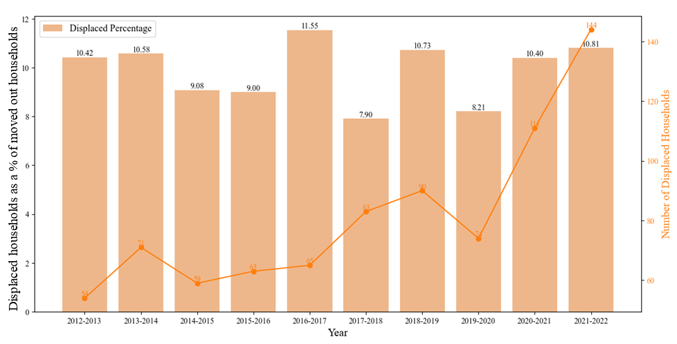
Figure A1:Year-wise number and percentage of displaced from station areas (Sensitivity Test)

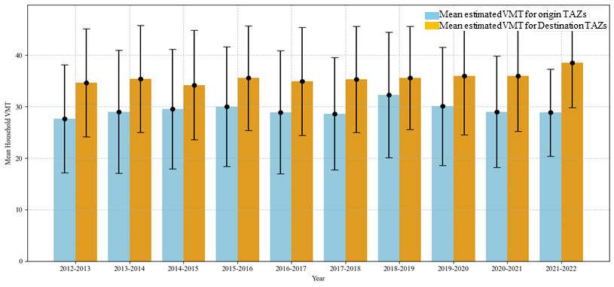
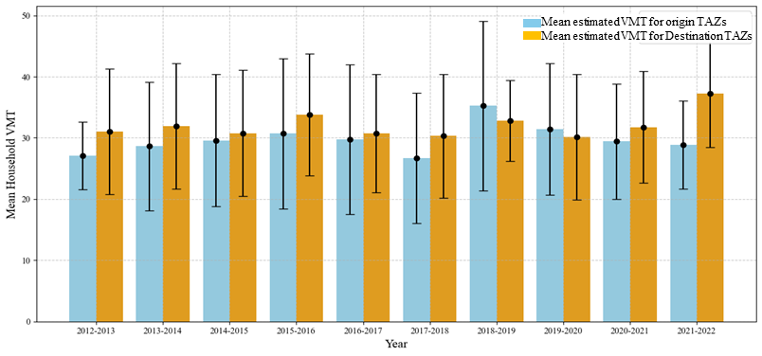
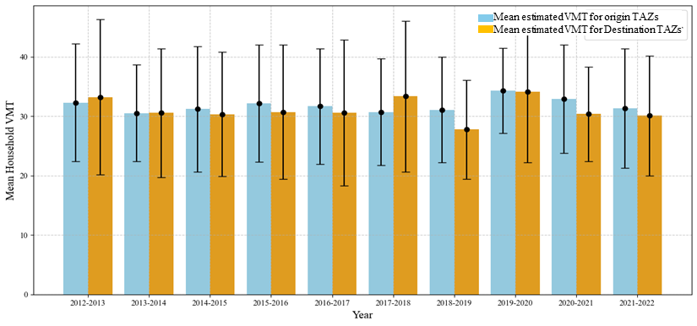
b. Moving out of station areas- displaced renter households
c. Moving into station areas- (all renter households)
a. Moving-out of station areas- (all renter households)
Figure A2:Year-wise pre- and post-move mean VMT for (a) all renter-households moving out; (b) displaced renter-households moving out; and (c) all renter-households moving into station areas (Sensitivity Test)

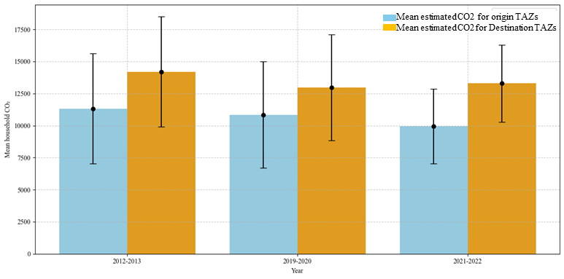
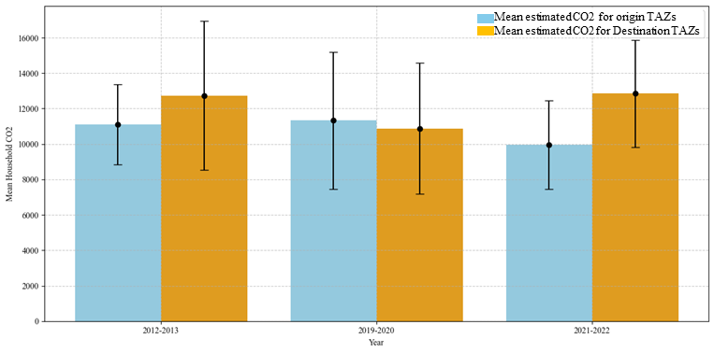
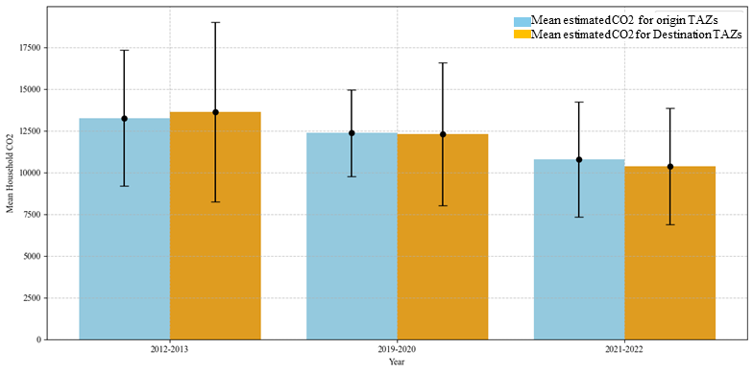
b. Moving out of station areas- displaced renter households
c. Moving into station areas- (all renter households)
a. Moving-out of station areas- (all renter households)
Figure A3: Year-wise pre-move and post-move mean household CO₂ for different residential movement groups (Sensitivity Test)

Appendix B: Validation of VMT Model Estimates Using Household Travel Survey Data from 2012 and 2023
Table B1: Validation of the modeled VMT estimates based on actual travel survey data for 2012
Residential movement pattern |  | Modeled VMT (mean) for 2023 |  |  | Actual VMT (mean) from 2023 UHTS
Residential movement pattern |  | Pre | Post | Δ | Pre | Post | Δ
Moving out of the station areas | Displaced households | 23.74 | 36.47 | 12.73 | 39.13 | 43.71 | 4.58
Moving into station areas | All households | 36.2 | 26.56 | (-9.64) | 49.37 | 47.15 | (-2.22)

Table B2 : Validation of the modeled VMT estimates based on actual travel survey data for 2023
 | Residential movement pattern |  |  | Modeled VMT (mean) for 2023 |  |  |  |  | Actual VMT (mean) from 2012 UHTS
 |  |  |  | Pre | Post |  | Δ |  | Pre |  | Post |  |  | Δ
Moving out of the station areas |  | Displaced households |  | 23.74 |  | 36.47 |  | 12.73 |  | 46.8 |  | 66.39 | 19.59
 | Moving into  station area |  | All households | 36.2 | 26.56 |  | (-9.64) |  | 58.97 |  | 49.28 |  |  | (-9.69)

Appendix C. Selection of VMT model and it’s relative variable influences
Table C1: Comparing model performance with 5-fold cross-validation
Regression Model | R² Value | RMSE | MAE
Log-Log regression | 0.15 | 0.82 | 0.66
Log-linear regression | 0.14 | 0.83 | 0.66
XGBoost regressor | 0.20 | 0.86 | 0.67
Random Forest regressor | 0.19 | 0.87 | 0.68
AdaBoost regressor | 0.18 | 0.87 | 0.69

Table B2: relative importance of variables used in the XGBoost regressor
Categories | Variables | Relative Influence (%) | Total (%)
Socio-economic | Household size | 18.10 | 51.17
Socio-economic | % household with 2 or more vehicles | 8.41 | 51.17
Socio-economic | % household with no vehicle | 5.00 | 51.17
Socio-economic | % renter households | 7.39 | 51.17
Socio-economic | % owner households | 5.84 | 51.17
Socio-economic | Median household income | 6.43 | 51.17
Built environment | Access to jobs by transit | 17.95 | 48.83
Built environment | % 4-way intersection | 9.26 | 48.83
Built environment | Distance to downtown | 8.67 | 48.83
Built environment | Access to jobs by auto | 6.89 | 48.83
Built environment | Distance to nearest rail stop | 6.05 | 48.83

Appendix D: Changes in Household Proximity to Transit and City Centers Following Relocation (2012–2022)
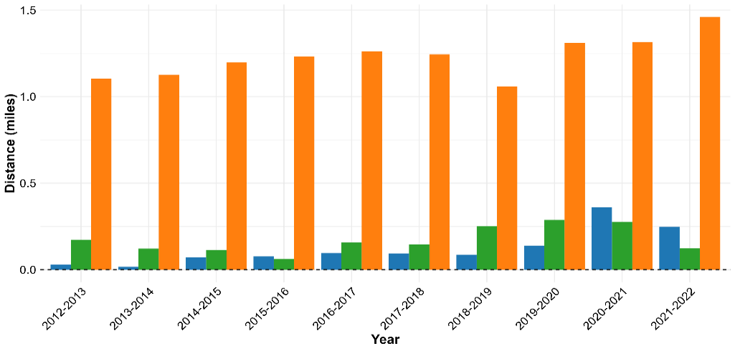
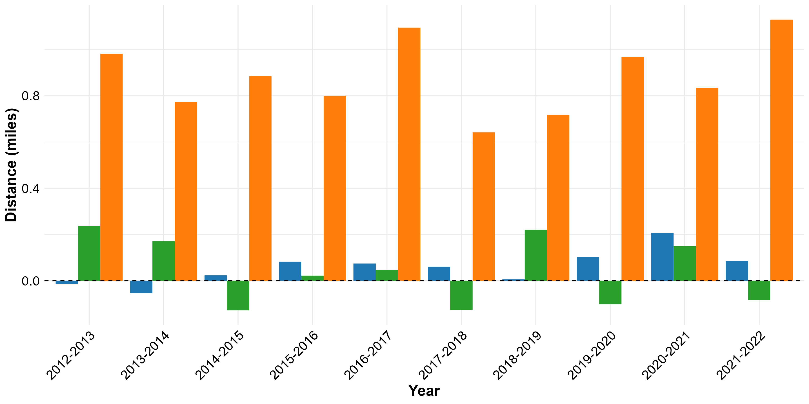
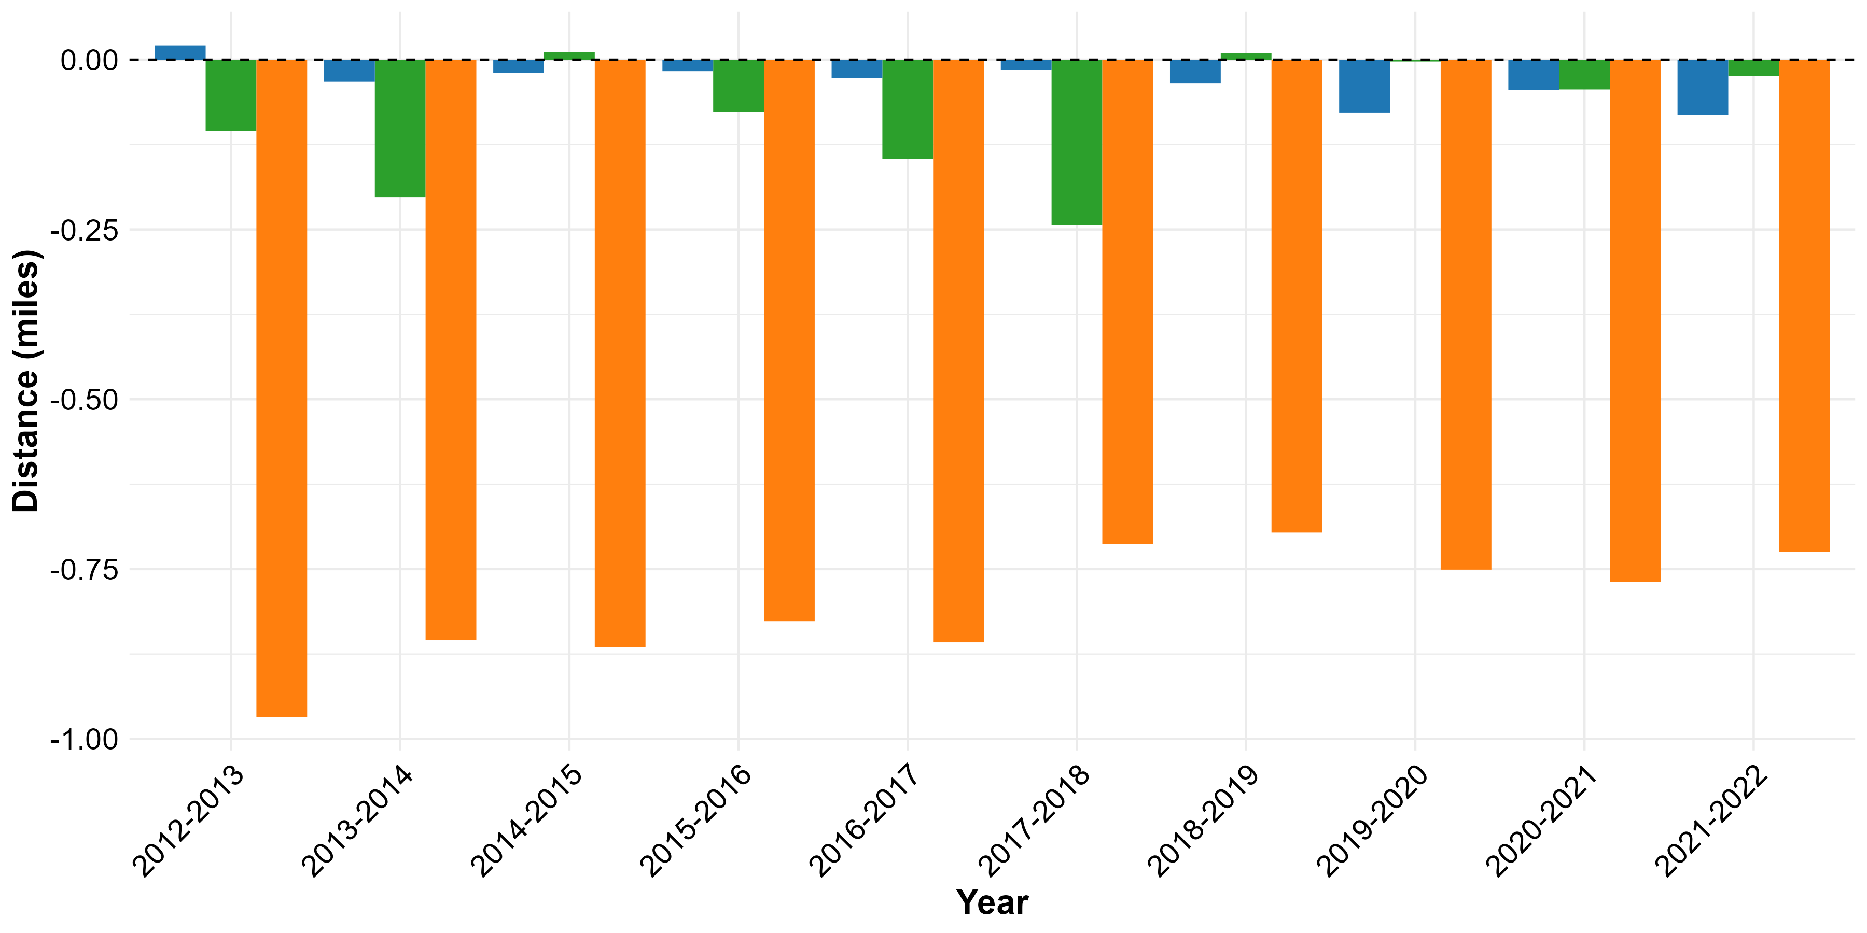
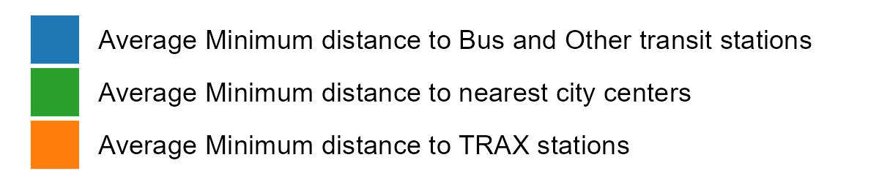
b. Moving out of station areas- displaced households
c. Moving into station areas- (all households)
b. Moving-out of station areas- (all households)

Figure C1: Year-wise mean difference in the distance to transit stops and city centers for different residential movement groups

