Supplementary Material
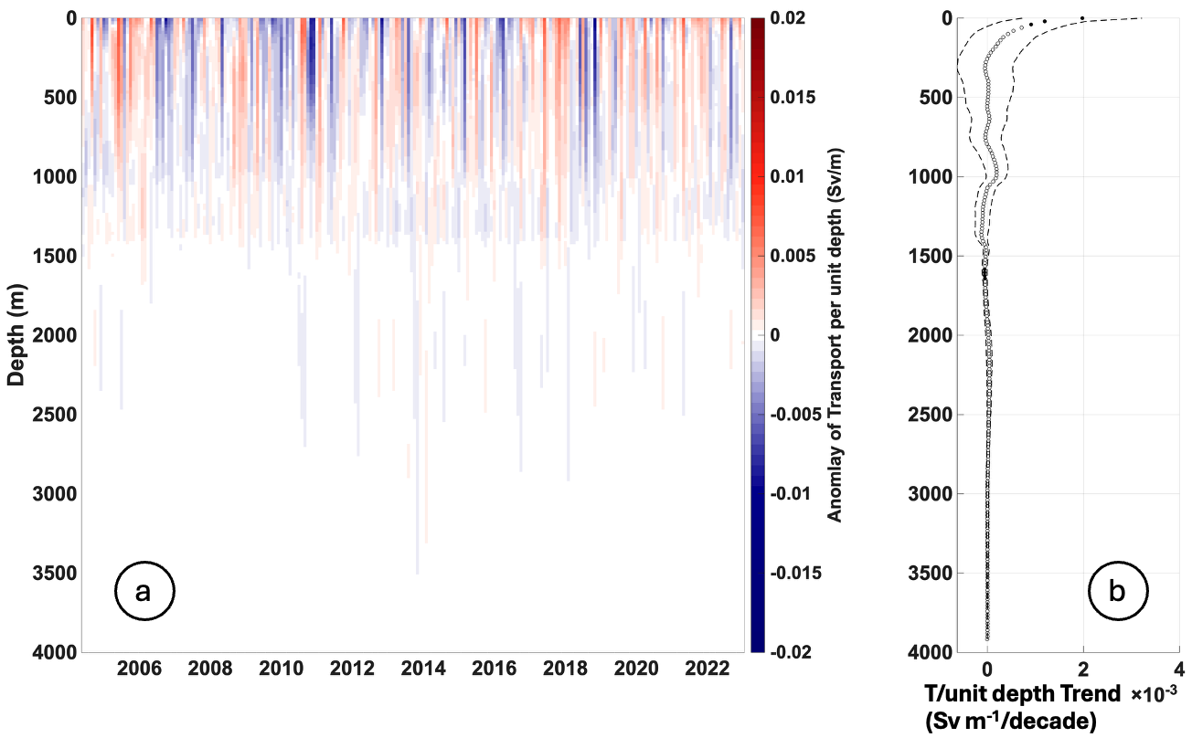
Figure S1: Description of western boundary wedge transport per unit depth profiles. (a) Hovmöller diagram showing transport per unit depth in the western boundary wedge from 2004 to 2024. Colorbar represents anomaly of transport per unit depth (Sv/m). (b) respective trend is indicated by black circles. Solid black circles indicate statistically significant trends. The dashed curves illustrate the 95% confidence intervals.
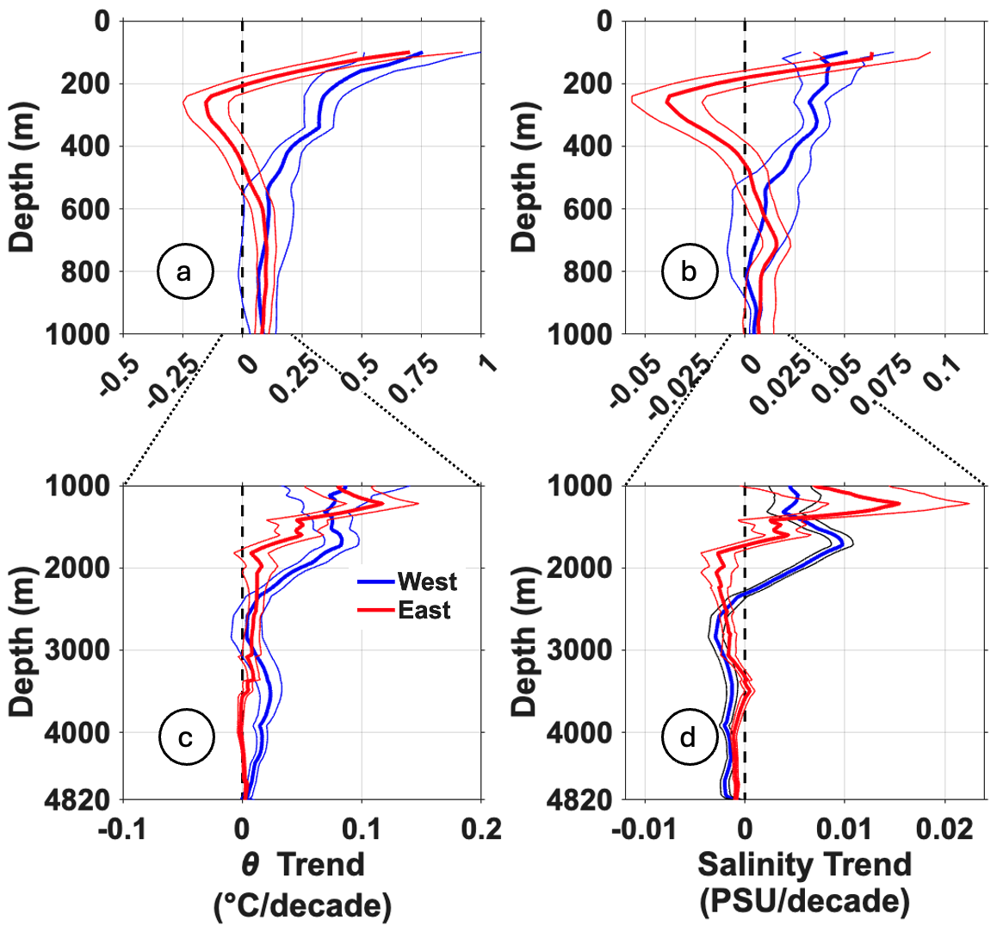
Figure S2: Vertical profiles of long-term temperature and salinity trends at the 26.5°N section. (a) Temperature trend profiles for the upper 1000 m at the western (thick blue curve) and eastern (thick red curve) boundaries. (b) Salinity trend profiles for the upper 1000 m at the western (thick blue curve) and eastern (thick red curve) boundaries. (c) Same as panel (a), but for the 1000–4820 m depth range, showing deep ocean temperature trend profiles for both boundaries. (d) Same as panel (b), but for the 1000–4820 m depth range, showing deep ocean salinity trend profiles for both boundaries. Thin curves of the same color denote the 95% confidence intervals. Dashed vertical lines indicate zero trend for reference. Note the difference in x-axis scale between upper and lower panels, reflecting the larger trend magnitudes in the upper ocean. Dotted lines mark the x-axis limits of the lower panels (c) and (d), for direct visual comparison.
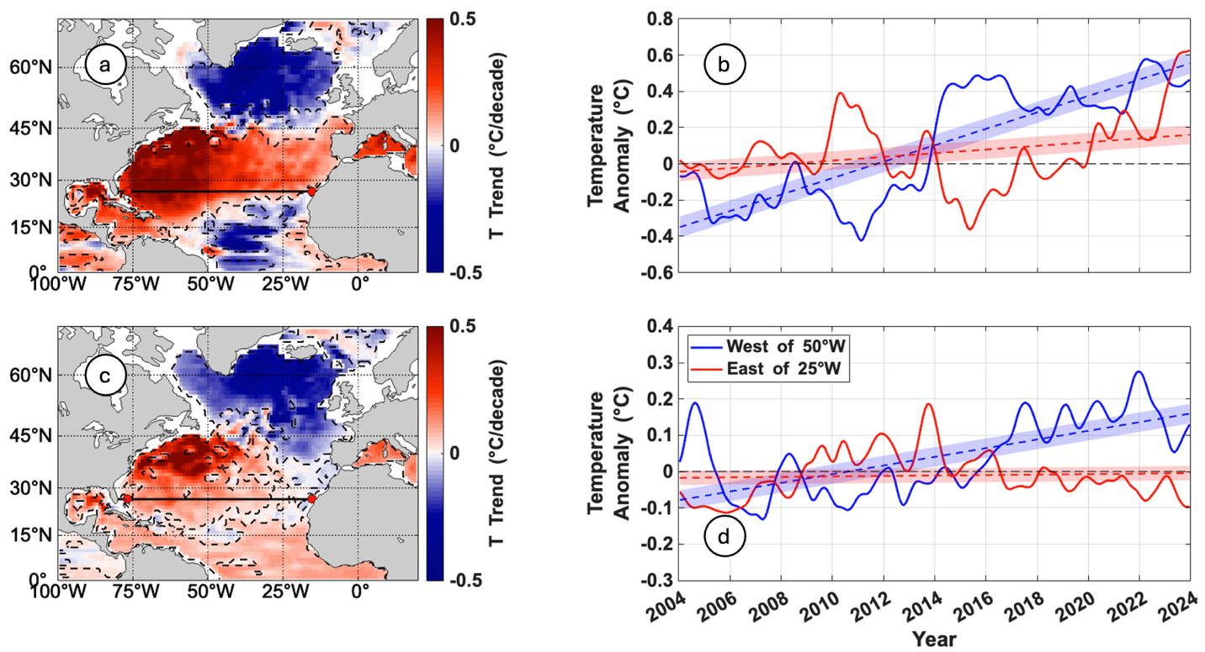
Figure S3: Upper ocean temperature trends for the North Atlantic (0–70°N) from 2004 to 2023 based on Argo RG data (see methods). (a) Spatial distribution of temperature trends in the upper 200 m, with red tones indicating positive trends (warming) and blue tones indicating negative trends (cooling). The solid black line marks the location of the RAPID array at 26.5°N, and red dots indicate the approximate positions of the eastern and western boundary moorings (see Figure 1 for details). (b) Time series of 13-month low-pass filtered density anomalies averaged over the upper 200 m west of 50°W (blue curve) and east of 25°W (red curve) along 26.5°N. (c) Same as panel (a), but for the 200-940 m layer. (d) Same as panel (b), but for the 200-940 m layer.
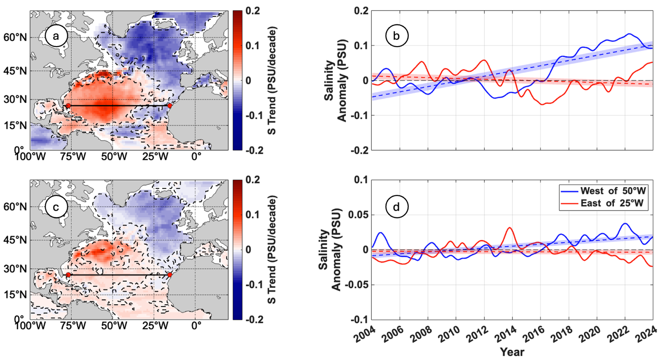
Figure S4: Same as Figure S3, but for salinity.

