JOINPOINT ANALYSIS:

Supplementary Figure 1 : Overall mortality trends in Ischemic heart diseases and new infectious triggers (Influenza & Pneumonia). from 1999 to 2020
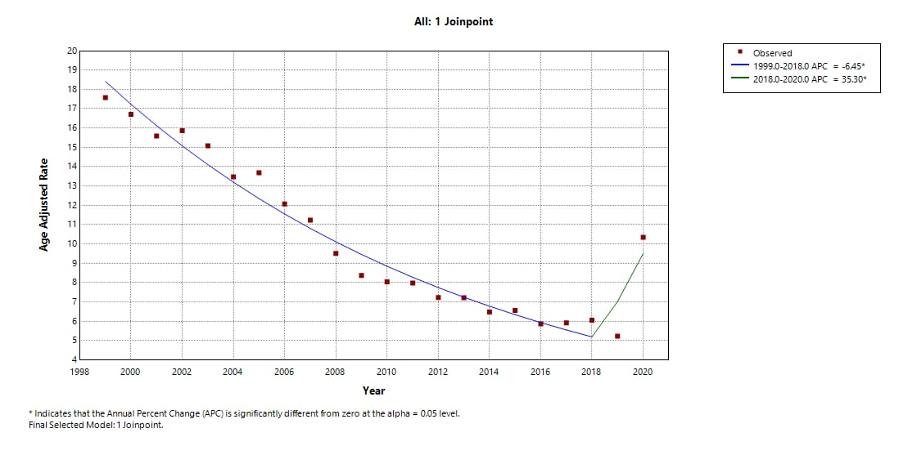
Supplementary Figure 2: Overall mortality trends by sex in Ischemic heart diseases and new infectious triggers (Influenza & Pneumonia) 1999 to 2020.
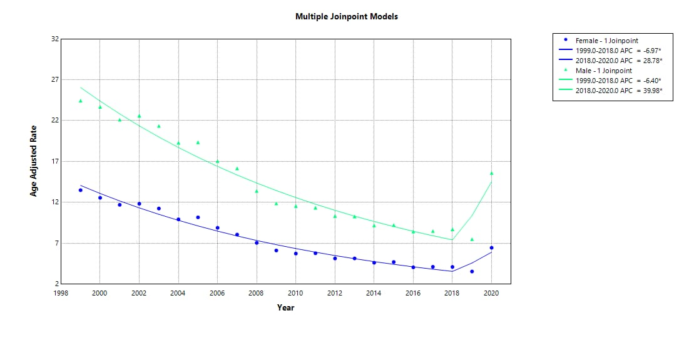
Supplementary Figure 3: Overall mortality trends by race in Ischemic heart diseases and new infectious triggers (Influenza & Pneumonia) 1999-2020
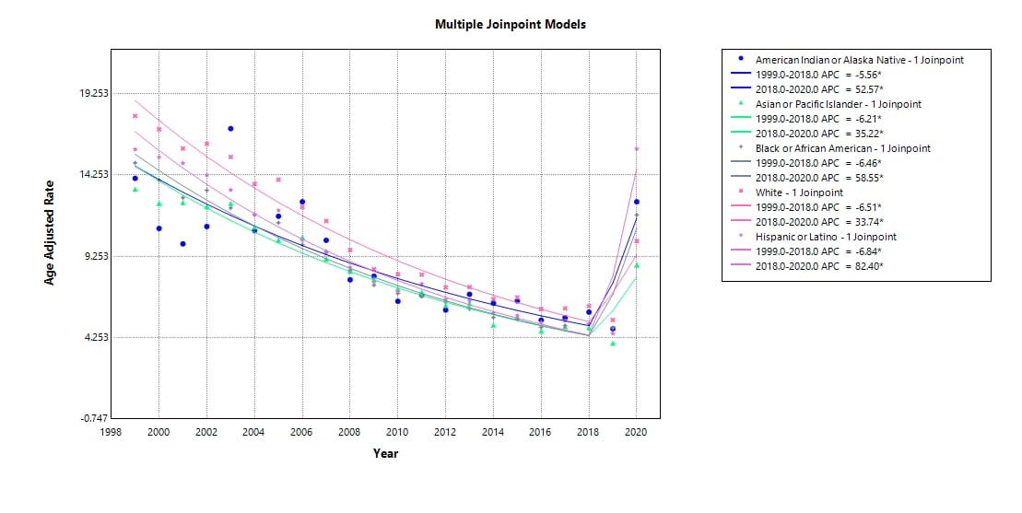
Supplementary Figure 4: Overall mortality trends in Ischemic heart diseases and new infectious triggers (Influenza & Pneumonia) by urbanization 1999-2020.
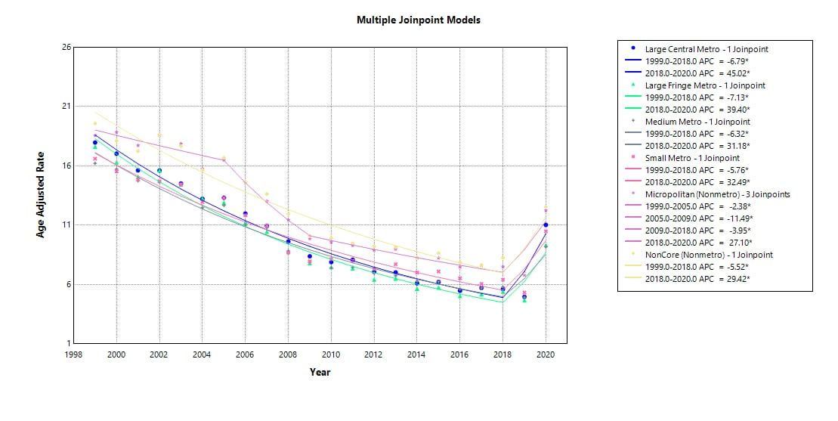

Supplementary Figure 5: Overall mortality trends in Ischemic heart diseases and new infectious triggers (Influenza & Pneumonia) by census region from 1999 to 2020
