Supplementary Information
Transmissible plasma-evolved suspended graphene near room temperature
Kamal Prasad Sharma^{1,2*}, Aliza Khaniya Sharma¹, Toru Asaka^{3,4}, Takahiro Maruyama^{1,2*}
¹Department of Applied Chemistry, ²Nanomaterial Research Center,
Meijo University, Tempaku-ku, Nagoya 468-8502, Japan
³Department of Life Science and Applied Chemistry, ⁴Frontier Research Institute for
Materials Science,
Nagoya Institute of Technology, Showa-ku, Nagoya 466-8555, Japan
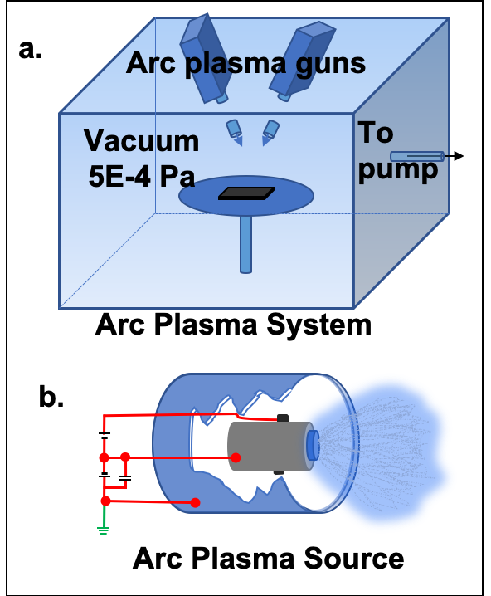
Supplementary Fig. 1 Schematic of a) dual arc plasma system (APS), and b) negatively biased target used in APS source.
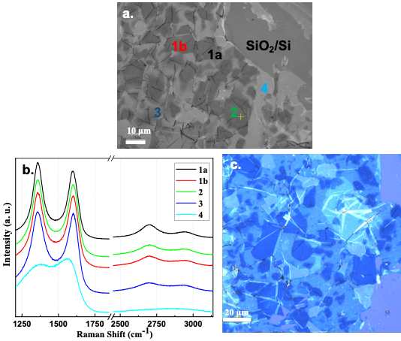
Supplementary Fig. 2 TPEG utilizing PMMA support. a) OM image of graphene produced with Protocol P4'_Ir on SiO₂/Si (PMMA was removed after transfer onto SiO₂/Si using acetone), b) Raman spectra observed at various points (coloured spectra are assigned to their respective points in Fig. 2 (a)). c) OM image (coloured) of graphene after transfer onto SiO₂/Si.
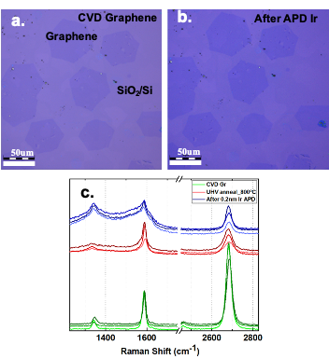
Supplementary Fig. 3 a) OM image of CVD graphene crystals transferred onto SiO₂/Si (using the method reported elsewhere ³⁴). b) OM image of Fig. 3a after Protocol P2_Ir plasma. c) Typical Raman spectra of CVD graphene transferred onto SiO₂/Si with different treatments, as indicated by their respective colours.
Supplementary Table S1 Table showing the details of the protocols employed in this research. Raman analysis was performed after pulsed APD of each protocol (see physical state of a-C mesh on TEM grids in Extended Data Fig. 10), graphene (Gr), Partial Gr, and No Gr were defined based on the frequency of observable 2D band in Raman spectra.
S. N. | Protocol | Element | Carbon source | APD conditions |  |  | Raman analysis
 |  |  |  | Voltage | Pulses | Frequency | Raman analysis
1 | P1_Co | Co | a-C mesh of TEM grid | 70 | 3 | 3 | No Gr
2 | P2_Co | Co | a-C mesh of TEM grid | 100 | 3 | 3 | Partial Gr
3 | P2'_Co | Co | a-C mesh of TEM grid | 100 | 10 | 3 | Gr
4 | P3_Co | Co | a-C mesh of TEM grid | 140 | 3 | 3 | Gr
5 | P4_Co | Co | a-C mesh of TEM grid | 170 | 3 | 3 | Gr
6 | P5_Co | Co | a-C mesh of TEM grid | 210 | 3 | 3 | Gr
7 | P6_Co | Co | a-C mesh of TEM grid | 250 | 3 | 3 | Gr
8 | P1_Co+W | W (+P1_Co) | a-C mesh of TEM grid | 100 | 3 | 3 | No Gr
9 | P1'_Co+W | W (+P1_Co) | a-C mesh of TEM grid | 100 | 10 | 3 | Gr
10 | P2_Co+W | W (+P1_Co) | a-C mesh of TEM grid | 140 | 3 | 3 | Gr
11 | P3_Co+W | W (+P1_Co) | a-C mesh of TEM grid | 180 | 3 | 3 | Gr
12 | P4_Co+W | W (+P1_Co) | a-C mesh of TEM grid | 210 | 3 | 3 | Gr
13 | P3'_Co+W_500ºC | W (+P1_Co) | a-C mesh of TEM grid | 180 | 3 | 3 | Gr
14 | P1_Ir | Ir | a-C mesh of TEM grid | 70 | 3 | 3 | No Gr
15 | P2_Ir | Ir | a-C mesh of TEM grid | 100 | 3 | 3 | Partial Gr
16 | P2'_Ir | Ir | a-C mesh of TEM grid | 100 | 10 | 3 | Gr
17 | P3_Ir | Ir | a-C mesh of TEM grid | 140 | 3 | 3 | Gr
18 | P4_Ir | Ir | a-C mesh of TEM grid | 170 | 3 | 3 | Gr
19 | P1_Pt | Pt | a-C mesh of TEM grid | 70 | 3 | 3 | No Gr
20 | P2_Pt | Pt | a-C mesh of TEM grid | 100 | 3 | 3 | Partial Gr
21 | P2'_Pt | Pt | a-C mesh of TEM grid | 100 | 10 | 3 | Gr
22 | P3_Pt | Pt | a-C mesh of TEM grid | 140 | 3 | 3 | Gr
23 | P4_Pt | Pt | a-C mesh of TEM grid | 170 | 3 | 3 | Gr
24 | P1_W | W | a-C mesh of TEM grid | 100 | 3 | 3 | No Gr
25 | P2_W | W | a-C mesh of TEM grid | 180 | 3 | 3 | Partial Gr
26 | P3_W | W | a-C mesh of TEM grid | 210 | 3 | 3 | Gr
27 | P4_W | W | a-C mesh of TEM grid | 250 | 3 | 3 | Gr
28 | P4'_Ir | Ir | a-C on PMMA | 170 | 10 | 3 | Gr
29 | P4''_Ir | Ir | a-C on PMMA | 170 | 5 | 3 | Gr

