Supplementary Fig. 1: Invasive carcinoma with lobular features identified in a sample collected near the gross tumor margin in both a PDD- and grossly negative area (H&E staining, original magnification x10)
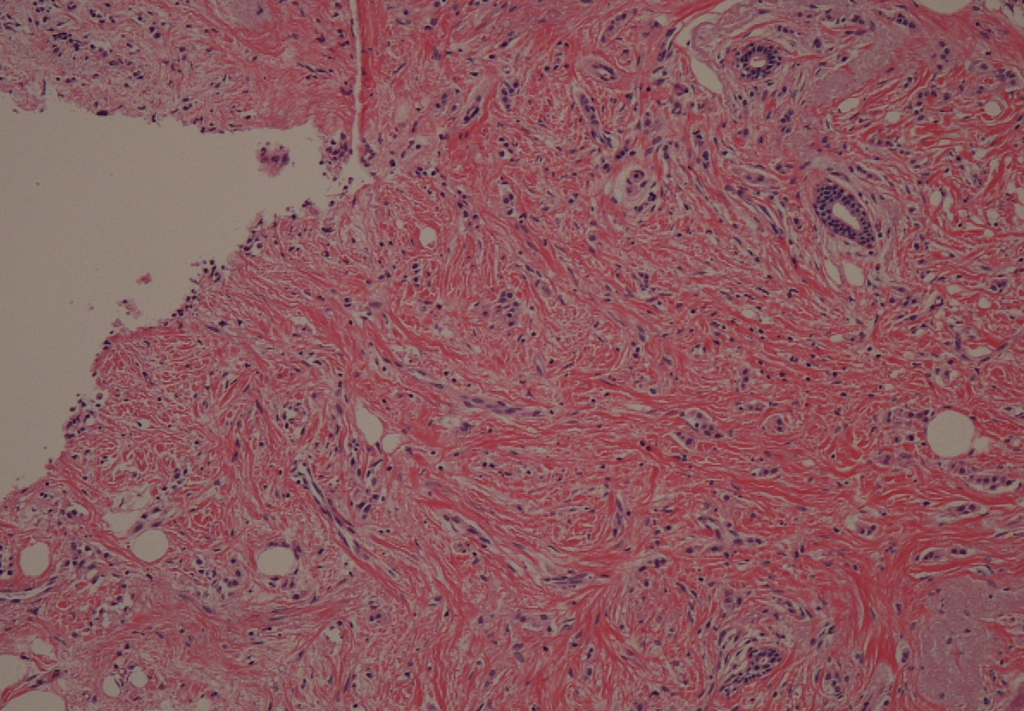

Supplementary Fig. 2: Representative pathological findings of PDD-positive but grossly negative areas
A) Case 4: Histopathological diagnosis revealed inflammation.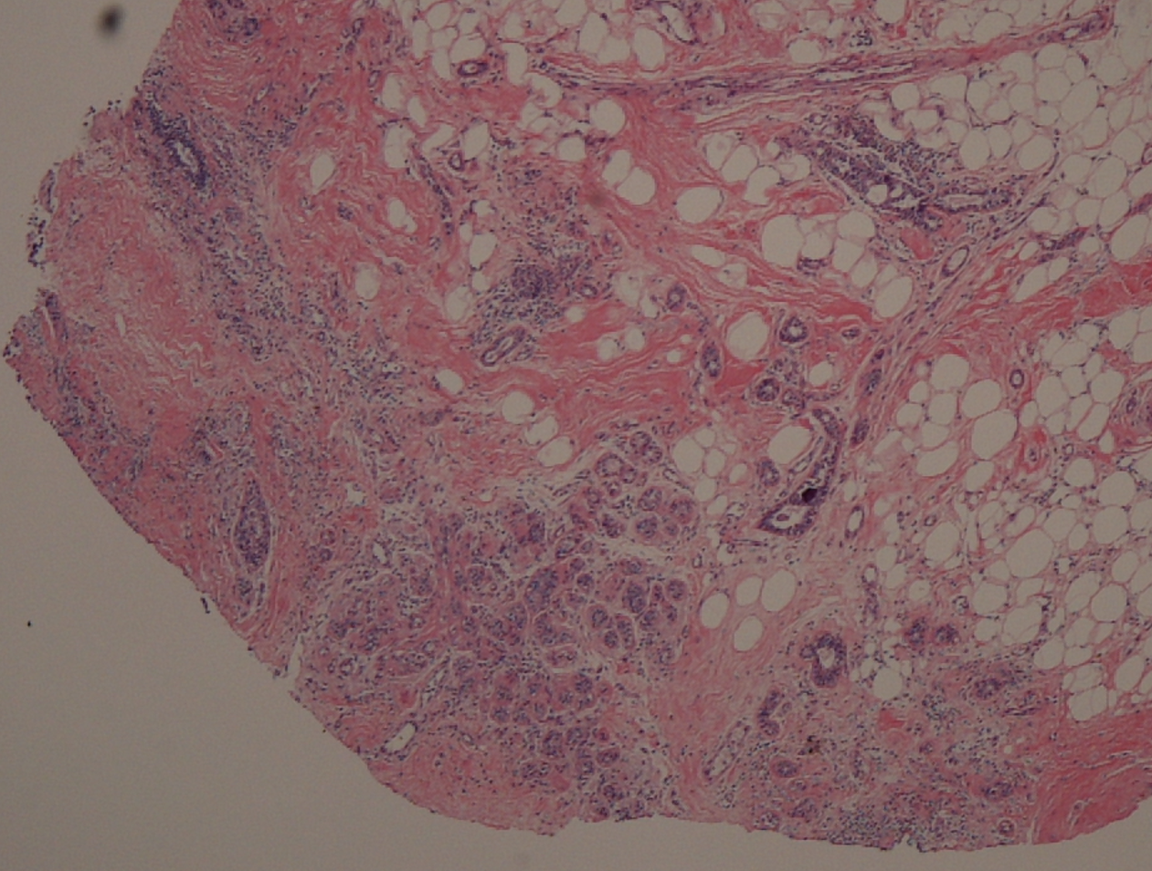
B) Case 6: Histopathological diagnosis revealed mastopathy with ductal dilatation.
