Supporting Information for
Water-Level Rise and Nonmonotonic Salinity Change Across Louisiana Coastal Wetlands over Fifteen Years

Jin Ikeda¹†, Peter Bacopoulos², Linoj Vijayan², Shu Gao², and Christopher E. Kees^{2,3,4}
Corresponding author: Jin Ikeda (E-mail: jin.ikeda0401@gmail.com, ORCID: 0000-0002-9364-0888)

(1) College of Marine Science, University of South Florida, Saint Petersburg, U.S.A.
(2) Coastal Ecosystem Design Studio, Louisiana State University, Baton Rouge, U.S.A.
(3) Department of Civil and Environmental Engineering, Louisiana State University, Baton Rouge, U.S.A
(4) Center for Computation and Technology, Louisiana State University, Baton Rouge, U.S.A

Contents of this file

Figures S1 to S4
Introduction
Figures S3 and S4 display the rest of the subbasin output, which cannot be displayed in Figures 5 and 6, respectively.
- Figure S1 provides supplementary data, displaying a correlation coefficient plot on vegetation types, corresponding to Figure 4.
- Figure S2 provides supplementary data, displaying additional sub-basin results corresponding to Figure 4.
- Figure S3 provides supplementary data, displaying additional sub-basin results corresponding to Figure 5.
- Figure S4 provides supplementary data, displaying additional sub-basin results corresponding to Figure 6.

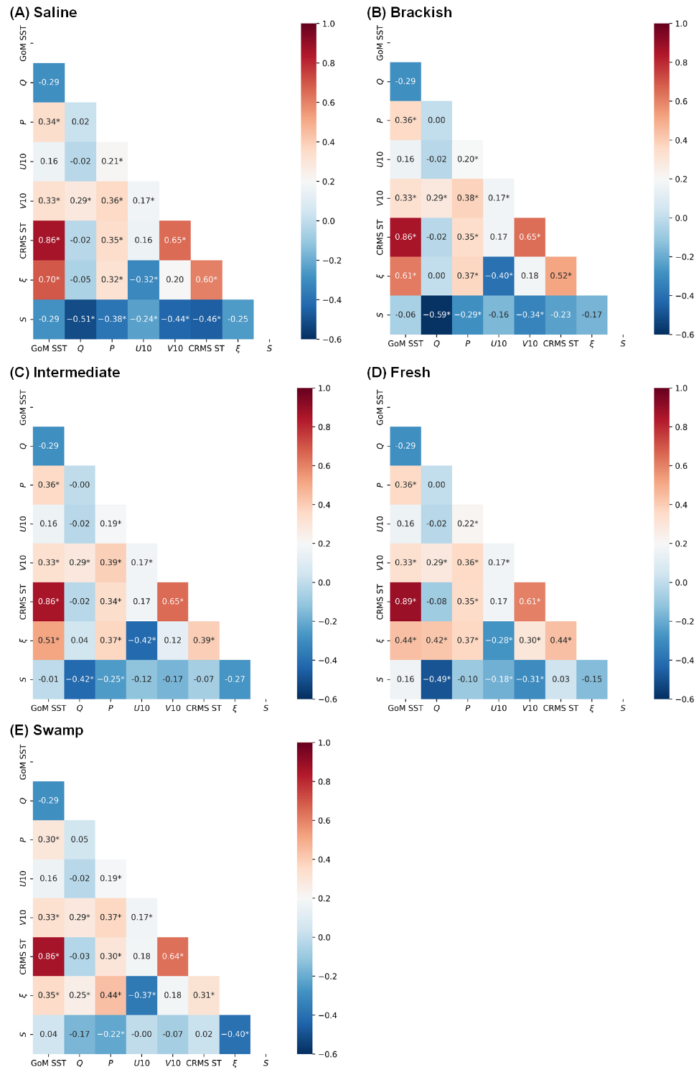
Fig S1 Correlation coefficients among climatic drivers and CRMS data in saline (a), brackish (b), Intermediate (c), freshwater (d) marshes, and swamp (e)

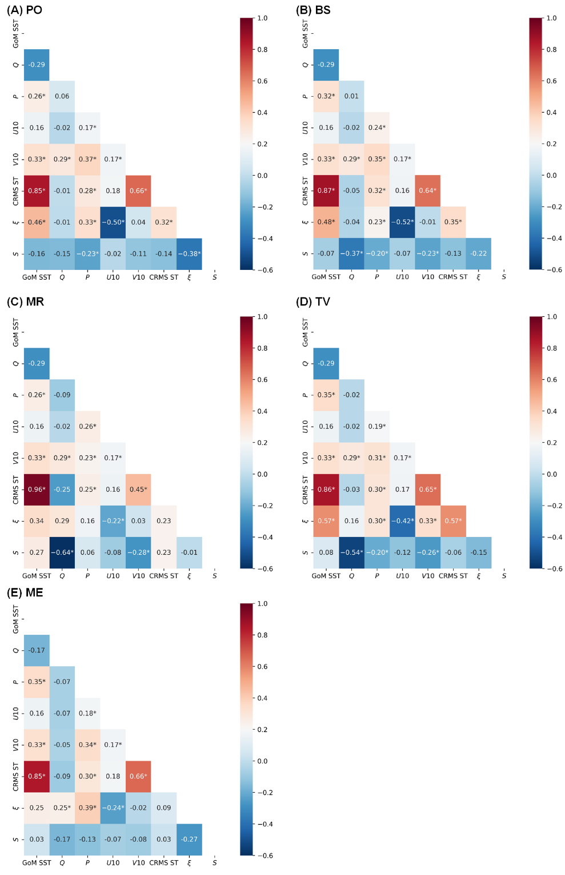
Fig. S2 Correlation coefficients among climatic drivers and CRMS data in Pontchartrain: PO (a), Breton Sound: BS (b), MS River Delta: MR (c), Teche/Vermilion: TV (d), and Mermentau: ME (e) basins

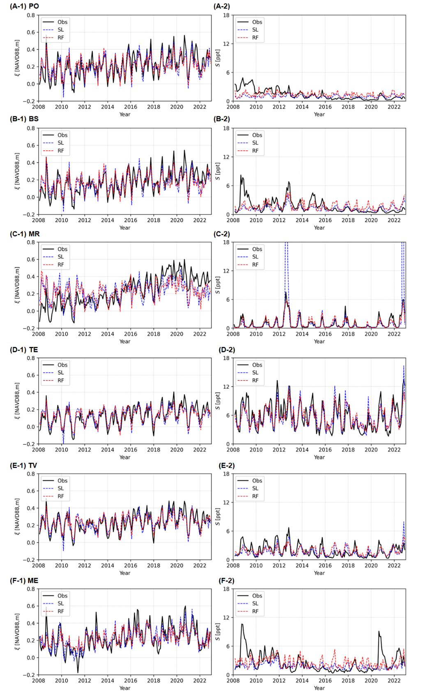
Fig. S3 The estimated median values of water levels (left) and salinity (right) were obtained from multiple regression models in Pontchartrain: PO (a), Breton Sound: BS (b), MS River Delta: MR (c), Terrebonne: TE (d), Teche/Vermilion: TV (e), and Mermentau: ME (f) basins
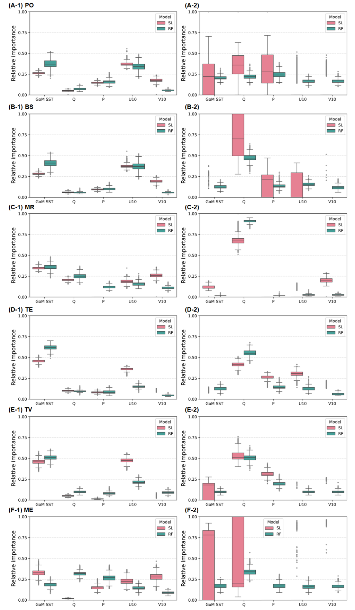
Fig. S4 The relative importance of climate drivers for water level (left) and salinity (right) in Pontchartrain: PO (a), Breton Sound: BS (b), MS River Delta: MR (c), Terrebonne: TE (d), Teche/Vermilion: TV (e), and Mermentau: ME (f) basins.

