Supplementary material for

Energetic Basis for the Host-Guest Complexation Between Alendronate and β-Cyclodextrin

David O. Tovar-Anaya¹ · Lauro Bucio² · Rafael A. Zubillaga³ · Kevin Lopez-Barrios¹ · Jesus A. Arenas-Alatorre⁴ · Angel Jose-Hernandez¹ · Silvia Maldonado-Frías¹ · Marco A. Alvarez-Perez¹ · Francisco J. Marichi-Rodríguez⁵ · Eduardo Villarreal-Ramirez¹*

1. Laboratorio de Bioingeniería de Tejidos, División de Estudios de Posgrado e Investigación, Facultad de Odontología, Universidad Nacional Autónoma de México, 04510 CDMX, Mexico
2. Laboratorio de Cristalofísica y Materiales Naturales, Departamento de Materia Condensada, Instituto de Física, Universidad Nacional Autónoma de México, AP 20-364, 04510 CDMX, Mexico
3. Departamento de Química, Área de Biofisoquímica, División de Ciencias Básicas e Ingeniería, Universidad Autónoma Metropolitana-Iztapalapa, San Rafael Atlixco 186, Col. Vicentina, Iztapalapa 09340, Ciudad de México, Mexico.
4. Laboratorio 113 Síntesis de Nanomateriales Magnéticos, Departamento de Materia Condensada, Instituto de Física, Universidad Nacional Autónoma de México, Ciudad de México, Mexico.
5. Departamento de Ortodoncia, División de Estudios de Posgrado e Investigación, Facultad de Odontología, Universidad Nacional Autónoma de México, 04510 CDMX, Mexico
Keywords: Cyclodextrin, Bisphosphonates, Alendronate, Inclusion complex.

E-mail: villarrealer@fo.odonto.unam.mx

Materials and Methods

Attenuated Total Reflectance-Fourier Transform Infrared Spectroscopy (ATR-FTIR). The ALEN, β-CD, MIXT, and IC samples were analyzed using Fourier transform infrared (ATR-FTIR) spectroscopy. ATR-FTIR spectra were obtained using a Thermo Scientific Nicolet iS50 ATR-FTIR spectrometer in transmission mode with a wavenumber range of 4000 – 600 cm⁻¹ with 16 scans. Results and discussion
ATR-FTIR technique is widely employed to characterize materials, offering insights into the chemical composition and molecular structure of a sample. The characteristic bands of each compound were observed during the ATR-FTIR characterization of the ALEN and β-CD samples. In the ALEN spectrogram, stretching bands corresponding to the phosphate groups PO and P=O became evident within the range of 1250 cm⁻¹ 800 cm⁻¹. Additionally, the vibrations and stretching associated with the amine group appeared at 3476 cm⁻¹ and 1543 cm⁻¹,[1], [2], [3] respectively (Fig S1). Visual inspection of the β-CD spectrogram showed a prominent broad band at 3294 cm⁻¹, attributed to the stretching of the O-H group, along with a bending-twisting band at 1641 cm¹ (related to O-H bond bending)[4], [5]. Furthermore, stretching bands corresponding to the C-H groups of βCD were visible at 2922 cm⁻¹. In the range of 1152–854 cm⁻¹, stretching bands were associated with C-O-C, C-C, C-O, C-H, and C–H groups[4], [6], [7], [8], [9], [10], [11], [12], [13], [14], [15], [16]. The frequencies and band assignments are listed in Table 3[1], [2], [3], [4], [5], [6], [7], [8], [9].
The ATR-FTIR spectra of IC and MIXT were significantly similar to the β-CD spectrum, as the β-CD bands overlapped with the ALEN signal. However, minor differences were observed. For example, in the band corresponding to the O-H group at 3290 cm⁻¹, a shift of 4 cm⁻¹ is observed compared to the β-CD spectrum. The IC complex and MIXT also showed a band at 1543 cm⁻¹, corresponding to N-H stretching of the ALEN amine group (see Fig S1) [1].
The ATR-FTIR spectra of IC and MIXT showed a strong similarity to the β-CD spectrum because the β-CD bands overlapped with the ALEN bands. However, slight differences suggest the formation of a complex. For example, the O-H band at 3290 cm⁻¹ from IC, which is shifted by 4 cm⁻¹ compared to the β-CD spectrum, could indicate changes in the hydrogen bonding interactions between β-CD and ALEN, which is also reflected in the increased E_{a} of IC Studies, suggesting that this band is related to the formation of inclusion complexes.[4], [5], [6] ALEN, IC, and MIXT share a band at 1543 cm⁻¹, associated with the N-H stretching of the ALEN amine group. The changes in band 5 ( Fig S1) could be attributed to specific interactions between β-CD and ALEN.[1], [15]

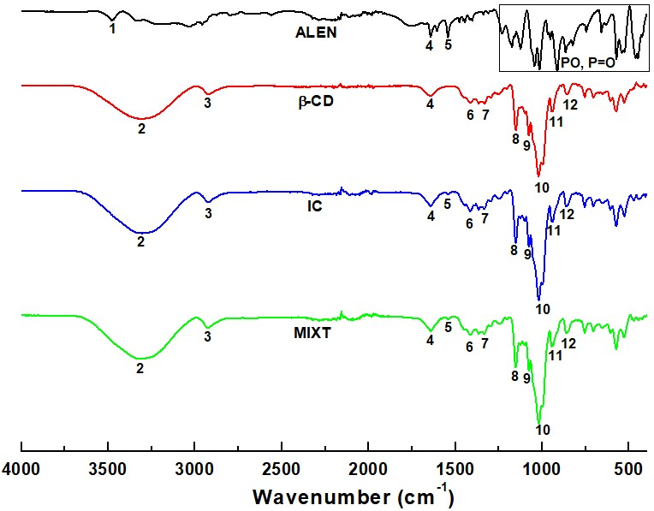

Fig S1. ATR-FTIR spectra acquired for the specimens: β-CD, ALEN, IC and MIXT.

Table S1 Band assignments for ATR-FTIR spectra for ALEN, β-CD, IC (ALEN–β-CD), and MIXT (ALEN/β-CD).
Band | ALEN  Wavenumber  (cm⁻¹) | β-CD Wavenumber  (cm⁻¹) | IC  ALEN–β-CD  Wavenumber  (cm⁻¹) | MIXT  ALEN/β-CD  Wavenumber  (cm⁻¹) | Ref.
1 | 3476  N-H stretch |  |  |  | [1], [2]
2 |  | 3294 stretching vibration O-H | 3290 stretching vibration O-H | 3291 stretching vibration O-H (H₂O y β-CD) | [4], [5]
3 |  | 2922  C-H stretch | 2922  C-H stretch | 2922  C-H stretch | [4], [6]
4 | 1641  O-H bending | 1641  O-H bending | 1641  O-H bending | 1641  O-H bending | [4]
5 | 1543  N-H bending,  C-N  stretching |  | 1543  N-H bending,  C-N  stretching | 1543  N-H bending,  C-N  stretching | [3]
6 |  | 1413 O-H plane bending vibration | 1413 OH plane bending vibration | 1413 OH plane bending vibration | [5]
7 |  | 1335 C-H  vibration | 1335 C-H  vibration | 1335 C-H  vibration | [7]
8 | 1250 – 800 PO, P=O stretching | 1152  C-O-C stretching | 1152 C-O-C  stretching | 1152 C-O-C  stretching | [4], [8]
9 |  | 1077 C-C stretching | 1077 C-C stretching | 1077 C-C stretching | [9]
10 |  | 1022 C-O  stretching | 1022 C-O  stretching | 1022 C-O  stretching | [9]
11 |  | 938 C-H  stretching | 938 C-H stretching | 938 C-H stretching | [7],  [11],  [12],
glucopyranose ring |  |  | glucopyranose ring | glucopyranose ring | [13],  [14]
12 854  1,4-bond skeleton vibration / Breath of glucopyranose ring |  |  | 854 1,4-bond skeleton vibration / Breath of glucopyranose ring | 854 1,4-bond skeleton vibration / Breath of glucopyranose ring | [6], [15]

References
- S. Choi et al., ‘Multifunctional Tannic Acid-Alendronate Nanocomplexes with Antioxidant, AntiInflammatory, and Osteogenic Potency’, Nanomaterials, vol. 11, no. 7, p. 1812, Jul. 2021, doi:
10.3390/nano11071812.
- N. Nafee, M. Zewail, and N. Boraie, ‘Alendronate-loaded, biodegradable smart hydrogel: a promising injectable depot formulation for osteoporosis’, J Drug Target, vol. 26, no. 7, pp. 563–575, Aug. 2018, doi: 10.1080/1061186X.2017.1390670.
- H. Piao, M. H. Kim, M. Cui, G. Choi, and J.-H. Choy, ‘Alendronate-Anionic Clay Nanohybrid for Enhanced Osteogenic Proliferation and Differentiation’, J Korean Med Sci, vol. 34, no. 5, 2019, doi:
10.3346/jkms.2019.34.e37.
- X. Wang, Z. Luo, and Z. Xiao, ‘Preparation, characterization, and thermal stability of βcyclodextrin/soybean lecithin inclusion complex’, Carbohydr Polym, vol. 101, pp. 1027–1032, Jan. 2014, doi: 10.1016/j.carbpol.2013.10.042.
- J. Wang et al., ‘Facile synthesis of chitosan-grafted beta-cyclodextrin for stimuli-responsive drug delivery’, Int J Biol Macromol, vol. 125, pp. 941–947, Mar. 2019, doi:
10.1016/j.ijbiomac.2018.12.150.
- Z. Jahanbakhsh, H. Hosseinzadeh, and B. Masoumi, ‘Synthesis of carboxymethyl β-cyclodextrin bonded Fe3O4@SiO2–NH2 core-shell magnetic nanocomposite adsorbent for effective removal of Pb(II) from wastewater’, J Solgel Sci Technol, vol. 99, no. 1, pp. 230–242, Jul. 2021, doi:
10.1007/s10971-021-05569-z.
- S. Salgın, U. Salgın, and Ö. Vatansever, ‘Synthesis and Characterization of β-Cyclodextrin
Nanosponge and Its Application for the Removal of p- Nitrophenol from Water’, Clean (Weinh), vol. 45, no. 10, Oct. 2017, doi: 10.1002/clen.201500837.
- C. Koulouktsi, S. Nanaki, P. Barmpalexis, M. Kostoglou, and D. Bikiaris, ‘Preparation and characterization of Alendronate depot microspheres based on novel poly(-ε-caprolactone)/Vitamin E TPGS copolymers’, Int J Pharm X, vol. 1, p. 100014, Dec. 2019, doi: 10.1016/j.ijpx.2019.100014.
- M. Paczkowska et al., ‘Complex of Rutin with β-Cyclodextrin as Potential Delivery System’, PLoS One, vol. 10, no. 3, p. e0120858, Mar. 2015, doi: 10.1371/journal.pone.0120858.
- T. Goulart da Silva et al., ‘Polycaprolactone/alendronate systems intended for production of biomaterials’, J Appl Polym Sci, vol. 138, no. 28, Jul. 2021, doi: 10.1002/app.50678.
- M. P. Kapoor, M. Moriwaki, M. Ozeki, and D. Timm, ‘Structural elucidation of novel isoquercitrinγ-cyclodextrin (IQC-γCD) molecular inclusion complexes of potential health benefits’, Carbohydrate Polymer Technologies and Applications, vol. 2, p. 100046, Dec. 2021, doi:
10.1016/j.carpta.2021.100046.
- K. Majewska, A. Skwierawska, B. Kamińska, and M. Prześniak-Welenc, ‘Improvement of opipramol base solubility by complexation with β-cyclodextrin’, Supramol Chem, vol. 30, no. 1, pp. 20–31, Jan. 2018, doi: 10.1080/10610278.2017.1350677.
- T. Simsek, S. Simsek, C. Mayer, and B. Rasulev, ‘Combined computational and experimental study on the inclusion complexes of β-cyclodextrin with selected food phenolic compounds’, Struct Chem, vol. 30, no. 4, pp. 1395–1406, Aug. 2019, doi: 10.1007/s11224-019-01347-4.
- C. A. B. Nava-Ortiz, G. Burillo, E. Bucio, and C. Alvarez-Lorenzo, ‘Modification of polyethylene films by radiation grafting of glycidyl methacrylate and immobilization of β-cyclodextrin’, Radiation Physics and Chemistry, vol. 78, no. 1, pp. 19–24, Jan. 2009, doi:
10.1016/j.radphyschem.2008.07.005.
- A. Obaid, A. K. M. Jamil, S. Prabu, S. M. Saharin, and S. Mohamad, ‘Spectroscopic studies for the inclusion complexation of ketoprofen enantiomers with β-cyclodextrin’, Spectrochim Acta A Mol Biomol Spectrosc, vol. 241, p. 118674, Nov. 2020, doi: 10.1016/j.saa.2020.118674.
- P. Albu, S. C. Doca, A. Anghel, G. Vlase, and T. Vlase, ‘Thermal behavior of sodium alendronate’, J Therm Anal Calorim, vol. 127, no. 1, pp. 571–576, Jan. 2017, doi: 10.1007/s10973-016-5745-7.

