Supplementary information

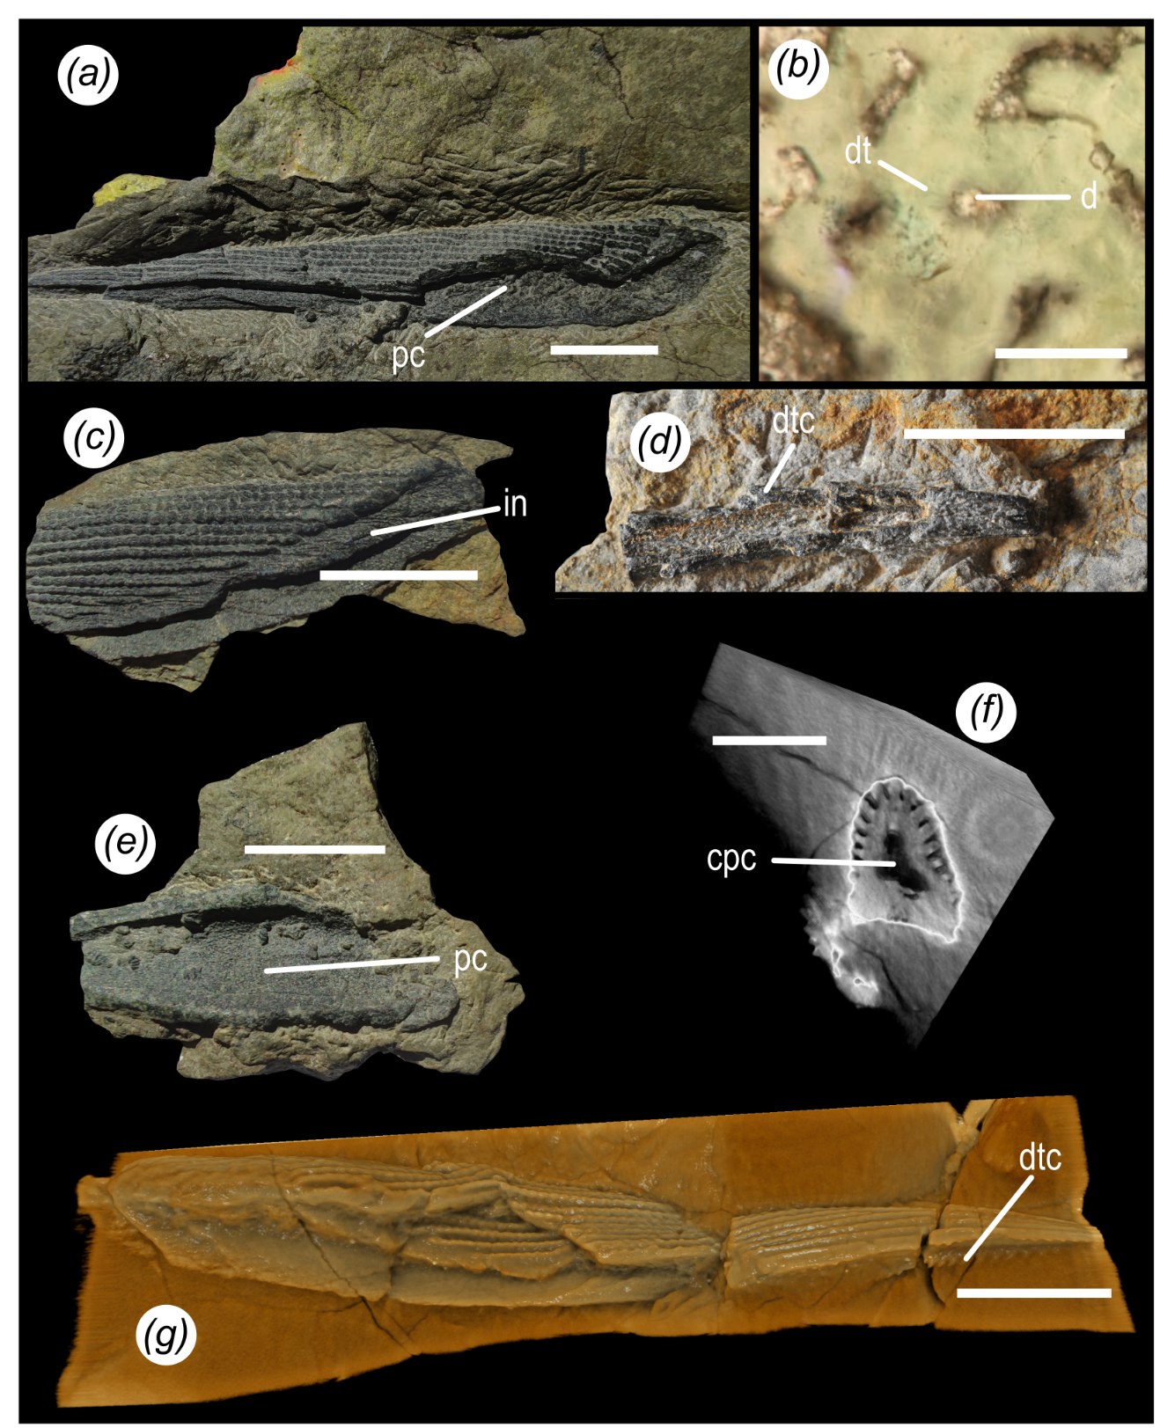
G
F
E
D
C
B
A

Supplementary figure: Middle Devonian shark, Wellerodus priscus, fin spines remains; (A) Dorsal fin spine NYSM 19051-2 in lateral view, exposing central pulp cavity and external ornamentation; (B) Histological view of specimen NYSM 19057, showing a denteon with dentine tubules; (C) insertion zone of spine NYSM 19056 showing striation; (D) Ventral surface of pectoral fin spine NYSM 19060 showing thorn-like denticles; (E) Ventral surface exposing central pulp cavity in fin spine NYSM 19051-3; (F) CT-Scan middle section of fin pectoral fin spine NYSM 19057 exposing asymmetrical profil; (G) Complete fin spine NYSM 19057 before histological cuts. Abbreviations: pc = pulp cavity, dt = dentine tubule, d = denteon, in= insertion zone, dtc = denticles, cpc = central pulp cavity. Scale bar = 1 cm for (A), (C), (D), (E), (F), (G) and 100 µm for (B).

