Automated Radiosynthesis and Biodistribution of [¹⁸F]Fluoroflutamide
Gina Kaup,¹ Jason Anthony Witek,¹ Shelbie Jaylene Cingoranelli,¹ Jenelle Stauff,¹ David Raffel,¹ Allen Frederick Brooks,¹ Peter James Henry Scott,^{1,2*} Jay Samuel Wright^{3*}
¹Division of Nuclear Medicine, Department of Radiology, University of Michigan Medical School, Ann Arbor, MI 48109, United States.
²The Interdepartmental Program in Medicinal Chemistry, University of Michigan, Ann Arbor, MI 48109, United States.
³Department of Radiology, Perelman School of Medicine, University of Pennsylvania, Philadelphia, PA 19104, United States. JSW Email: jswright@upenn.edu
*Correspondence: PJHS (pjhscott@umich.edu), JSW (jswright@upenn.edu)
Table of Contents
1. Chemistry and Characterization 2
1.1 General Considerations 2
1.2. Synthetic Procedures 2
- Synthesis of Bromide Precursor 2
- Synthesis of Fluorine Standard 3
2. Radiochemistry 3
2.1. General Considerations 3
2.2 General Procedure for Radiochemical Synthesis 4
2.3 Radiochemical Syntheses Data and HPLC Traces 7
3. References 16

1. Chemistry and Characterization
1.1. General Considerations
All the chemicals were purchased from commercially available suppliers and used without purification. Automated flash chromatography was performed with Biotage Isolera Prime system. High-performance liquid chromatography (HPLC) was performed using a Shimadzu LC-2010A HT system equipped with a Bioscan B-FC-1000 radiation detector. ¹H and ¹³C NMR spectra: Varian 500 apparatus (400 MHz for ¹H NMR and 100 MHz for 13C NMR), in CDCl₃ unless otherwise indicated, δ in ppm relative to tetramethylsilane (δ = 0), J in Hz. Mass spectrometry (HRMS) was performed using an Agilent 6520 Accurate-Mass Q-TOF LC/MS spectrometer using ESI ionization with less than 5-ppm error for all HRMS analyses. 2-Bromo-2-methylpropanoyl bromide, triethylamine, anhydrous bottles of acetonitrile (MeCN, ≥99.9%) and dichloromethane (DCM, 99.9%) fitted with an AcroSeal™ septum, and silver (II) fluoride were purchased from Thermo Fisher Scientific. 3-Nitro-3-(trifluoromethyl)aniline was purchased from Oakwood Chemical. Deuterated chloroform (CDCl₃) for NMR analysis was purchased from Cambridge Isotope Laboratories. Compounds 1 and 2 were previously reported by Mizuta and the reported methods were followed with slight variation.¹
1.2. Synthetic Procedures
Synthesis of Bromide Precursor
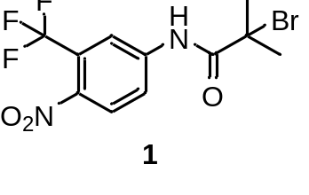2-bromo-2-methyl-N-(4-nitro-3-(trifluoromethyl)phenyl)propenamide 1. Triethylamine (1.00 mL, 7.20 mmol) and 2-bromo-2-methylpropanoyl bromide (758.55 µL, 6.14 mmol) were added to a solution of 4-nitro-3-(trifluoromethyl)aniline (1.10 g, 5.34 mmol) and dichloromethane (15 mL) at 0°C and allowed to stir at room temperature for 23 hours. The reaction mixture was washed with saturated NaHCO₃ (2 x 15 mL), brine (1 x 20 mL), and dried over anhydrous Na₂SO₄. The resulting organic layers were concentrated in vacuo and purified using flash column chromatography (0-50% EtOAc/HEX) to afford 2-bromo-2-methyl-N-(4-nitro-3-(trifluoromethyl)phenyl)propenamide as a white crystalline powder (1.11g, 58.39% yield). Data for 1 matched a report by Mizuta.¹

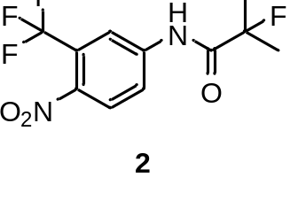Synthesis of Flutamide Standard
2-fluoro-2-methyl-N-(4-nitro-3-(trifluoromethyl)phenyl)propenamide 2. A 20 mL scintillation vial equipped with a magnetic stir bar was charged with compound 1 (2-bromo-2-methyl-N-(4-nitro-3-(trifluoromethyl)phenyl)propenamide (44 mg, 0.15 mmol), AgF (38 mg, 0.3 mmol), and MeCN (0.1M) and allowed to stir at room temperature for 12 h. The resulting mixture was diluted with EtOAc and filtered through a celite plug. The plug was then washed with EtOAc (10 mL), and the filtrate was concentrated in vacuo. Purification via flash column chromatography in a EtOAc/hexanes system afforded the desired compound, 2, as an off-white solid ( 32 mg, 71% yield). Data for 2 matched a report by Mizuta.¹
2. Radiochemistry
2.1. General Considerations
Reagents and solvents were commercially available unless otherwise stated. QMA-light (WAT023525), Alumina N Plus Light (WAT023561), and Oasis HLB 1 cc Vac (WAT094225) cartridges were purchased from Waters Corporation. QMA-light Sep-Paks were flushed with 10 mL of ethanol, 10 mL of aqueous 0.5 M KOTf, and 10 mL of Milli-Q® water before use. Alumina N Plus Light Sep-Pak cartridges and Oasis HLB 1 cc Vac cartridges were flushed with 10 mL of ethanol and 10 mL of water before use. Triazabicyclodecene, flutamide, apalutamide, Millex™-FG sterile filters, Millex™-GV sterile filters, and anhydrous bottles of dimethylsulfoxide (DMSO, ≥99.9%) fitted with a Sure/SealTM septum were purchased from Millipore Sigma. Zinc triflate and anhydrous bottles of acetonitrile (MeCN, ≥99.9%) fitted with an AcroSeal™ septum were purchased from Thermo Fisher Scientific. Sodium chloride, 0.9% USP and sterile water for injection, USP were purchased from Pfizer. ASCOR® ascorbic acid injection (500 mg/mL), USP was purchased from McGuff Pharmaceuticals. Sterile dose vials were purchased from ALK Life Science Solutions™.
Tetramethylammonium triflate (Me₄NOTf) was synthesized by the slow addition of Me₄NOH pentahydrate (10 g, 55.2 mmol, 1 equiv.) in 20 mL H₂O to a 0 °C solution of Tf₂O (4.6 mL, 27.6 mmol, 0.5 equiv.), in H₂O (20 mL), over 20 min. The reaction was allowed to warm to room temperature over 1 h before azeotropic removal of the volatiles with MeCN (3 × 75 mL) and recrystallization from anhydrous isopropanol (iPrOH) to obtain a solid residue that was dried under high vacuum (0.1 Pa) at 150 °C for 3 d. Me₄NOTf was obtained as a free-flowing white powder (11.1 g, 49.7 mmol, 90%), with characterization data matching previous reports.^{2–4}

2.2. General Procedure for Radiochemical Syntheses
The GE TRACERlab FX N Pro in standard configuration was loaded as follows: Sep-PakTM Plus Light QMA prepped with 10 mL of EtOH, 10 mL of 0.5 M KOTf, 10 mL of Milli-Q water, Sep-PakTM Plus Light Alumina N cartridge prepped with 10 mL EtOH, 10 mL of Milli-Q water, Waters Oasis® HLB 1 cc/30 mg prepped with 10 mL EtOH, 10 mL of Milli-Q water, Vial #1: TMAOTf (5.9 mg, 26.5 micromol) in 0.5 mL H₂O, Vial #2: K₂₂₂ in 1 mL MeCN (0.14 mg, 0.36 micromol), Vial #3: Zn(OTf)₂ (20 mol%, 0.36 mg) and triazabicyclodecene (TBD, 0.9 equiv., 0.63 mg) in 400 µL MeCN + 100 µL MeCN, Vial #4: Precursor (1 equiv., 1.8 mg, 5 micromol) in 500 µL MeCN, Vial #5: 3.5 mL semi-prep HPLC eluent, Vial #12: 4.5 mL of USP saline, Vial #13: 500 µL USP EtOH, Vial #14: 10 mL MQ H₂O, Product vial: 5.0 mL USP saline, 0.1 mL USP ascorbic acid solution, Dilution flask: 60 mL H₂O, 0.1 mL USP ascorbic acid solution.
Figure S1: Standard configuration of GE TRACERlab FX_{N-Pro}.
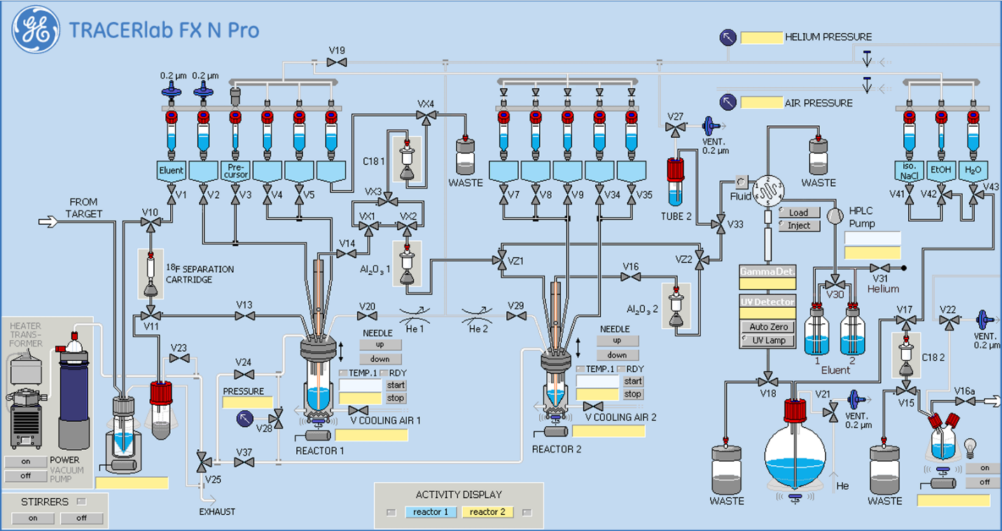

Figure S2: Time list for the production of [¹⁸F]fluoroflutamide using a GE TRACERlab FX_{N-Pro}.
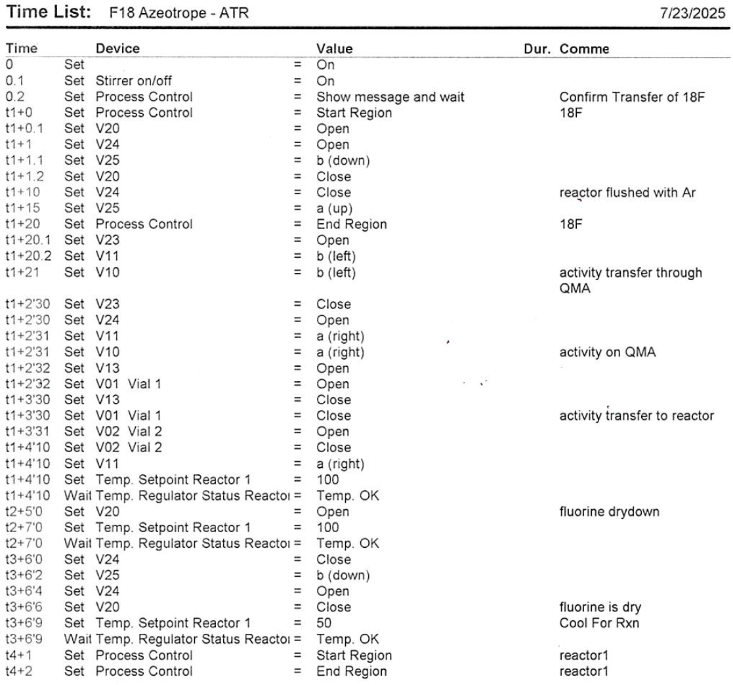

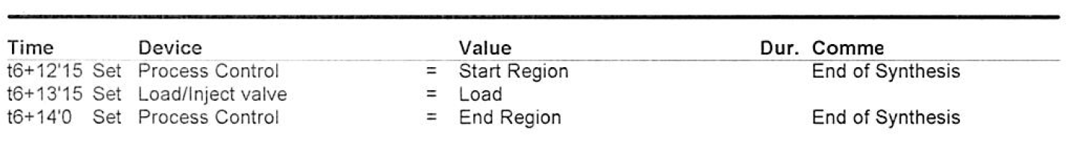
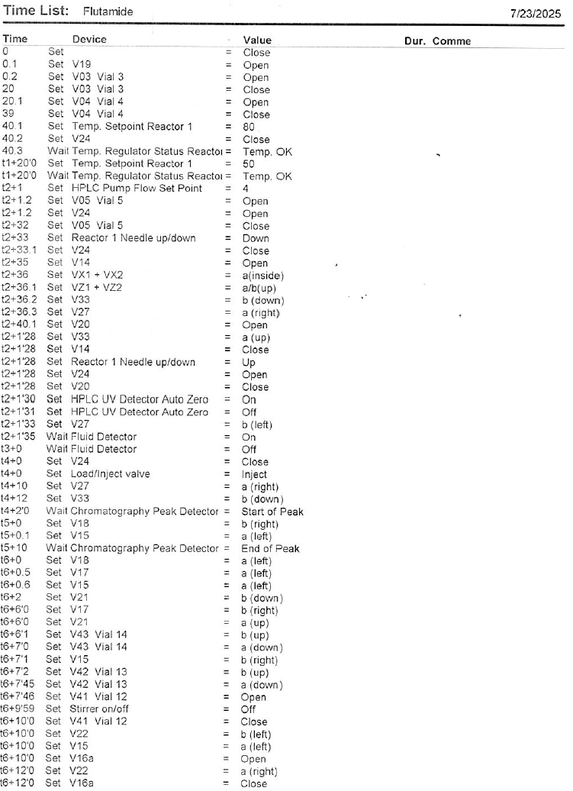
2.3. Radiochemical Syntheses Data and HPLC Traces
Run 1
Activity Yield | 81.0 mCi
¹⁸F Activity at EOB | 1.87 Ci
Radiochemical Yield | 4.34%
Radiochemical Purity | 99.9%
Molar Activity | 2,336.43 Ci/mmol
2 h Stability RCP | 45.25%

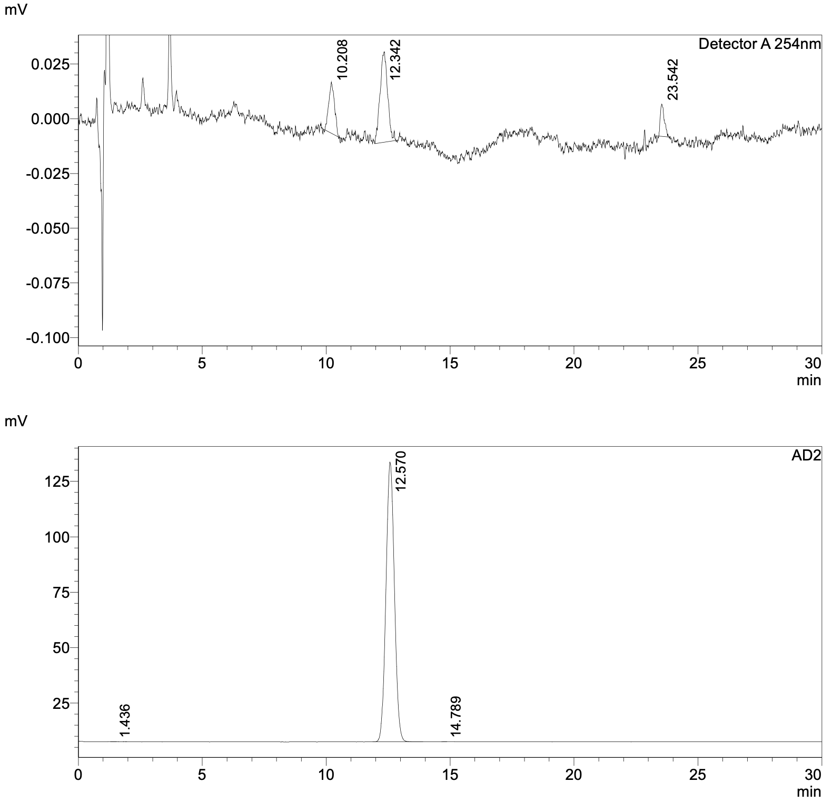
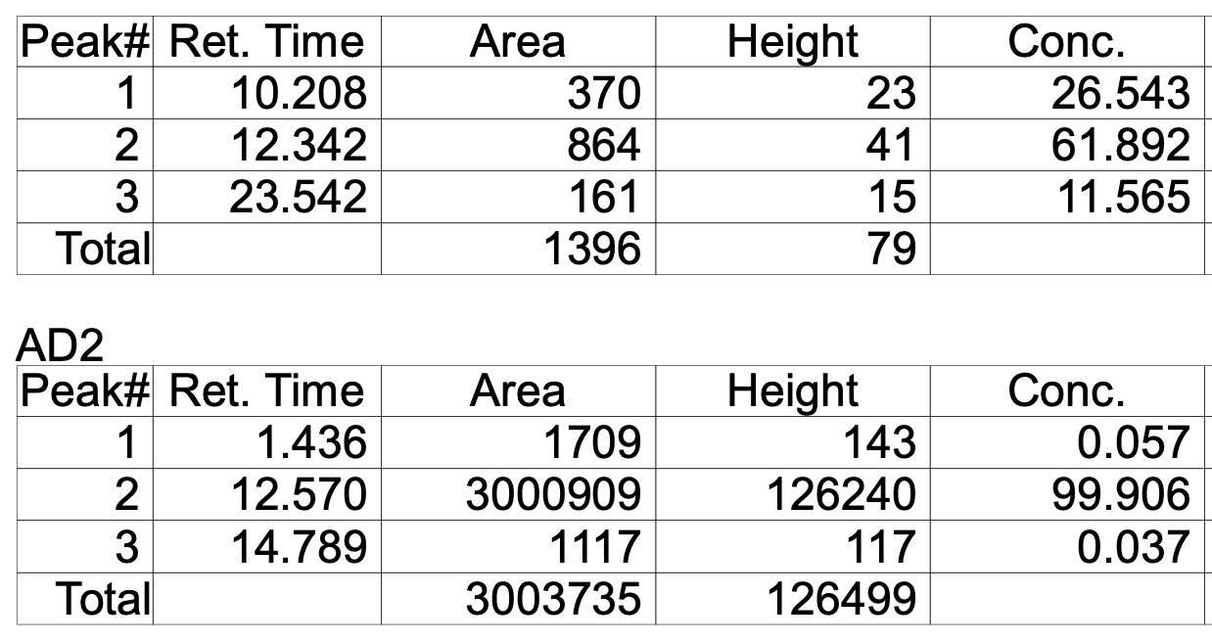

Figure S3: Analytical HPLC trace of [¹⁸F]fluoroflutamide dose from run 1.
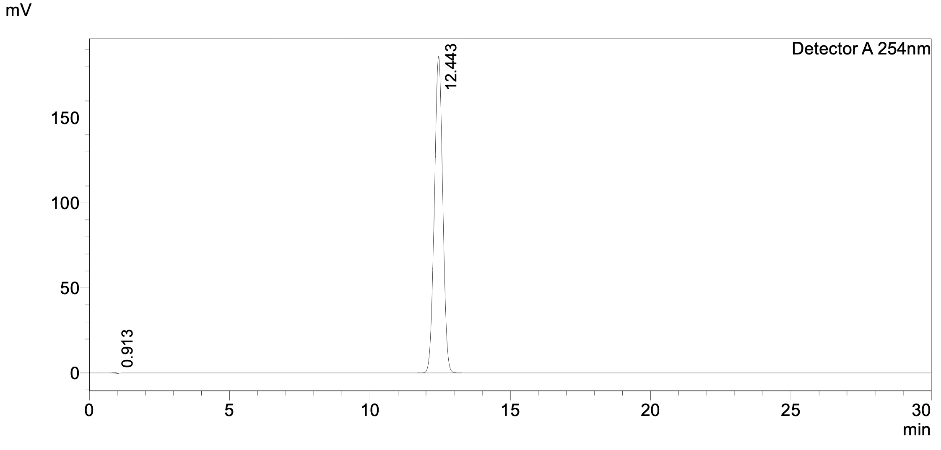
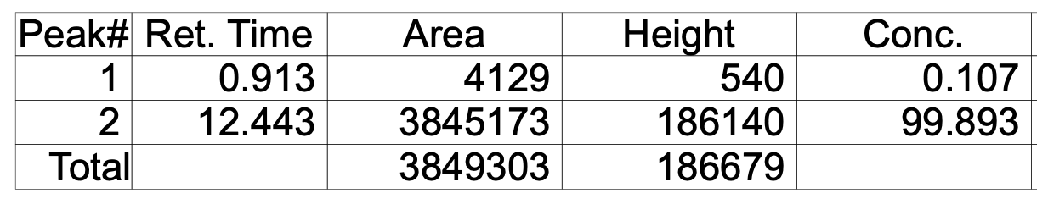
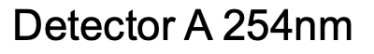
Figure S4: Analytical HPLC trace of ¹⁹F-fluoroflutamide standard from run 1.
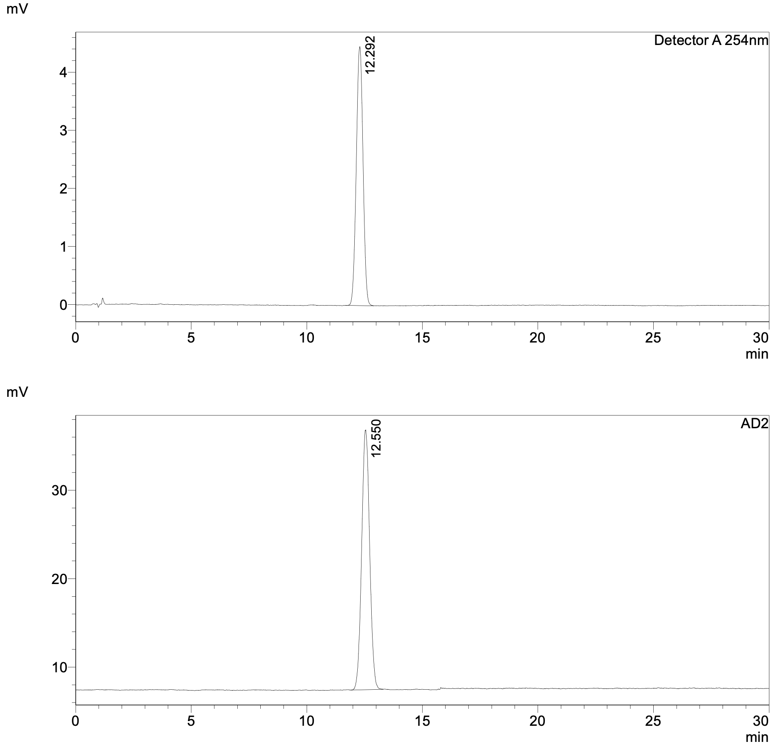
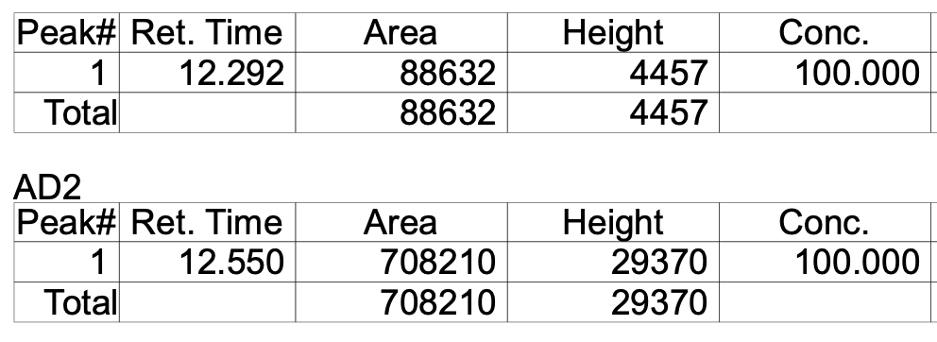
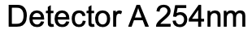
Figure S5: Analytical HPLC trace of [¹⁸F]fluoroflutamide dose from run 1 coinjected with ¹⁹F-fluoroflutamide standard.
Figure S6: Semi-preparative HPLC trace of the automated synthesis of [¹⁸F]fluoroflutamide from run 1.
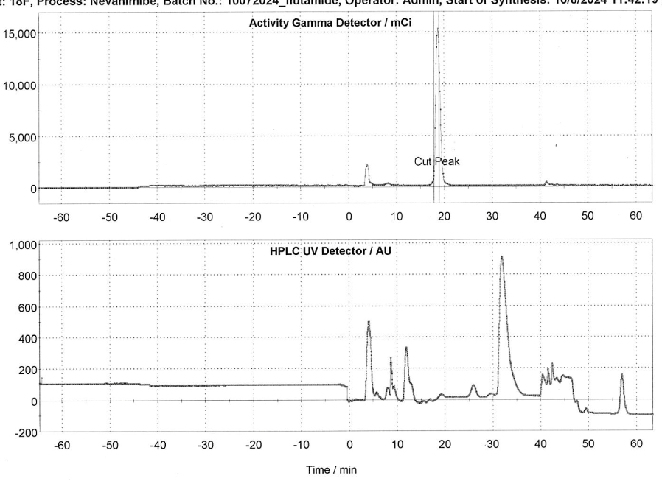

Figure S7: Standard curve for the molar activity calculation from run 1.

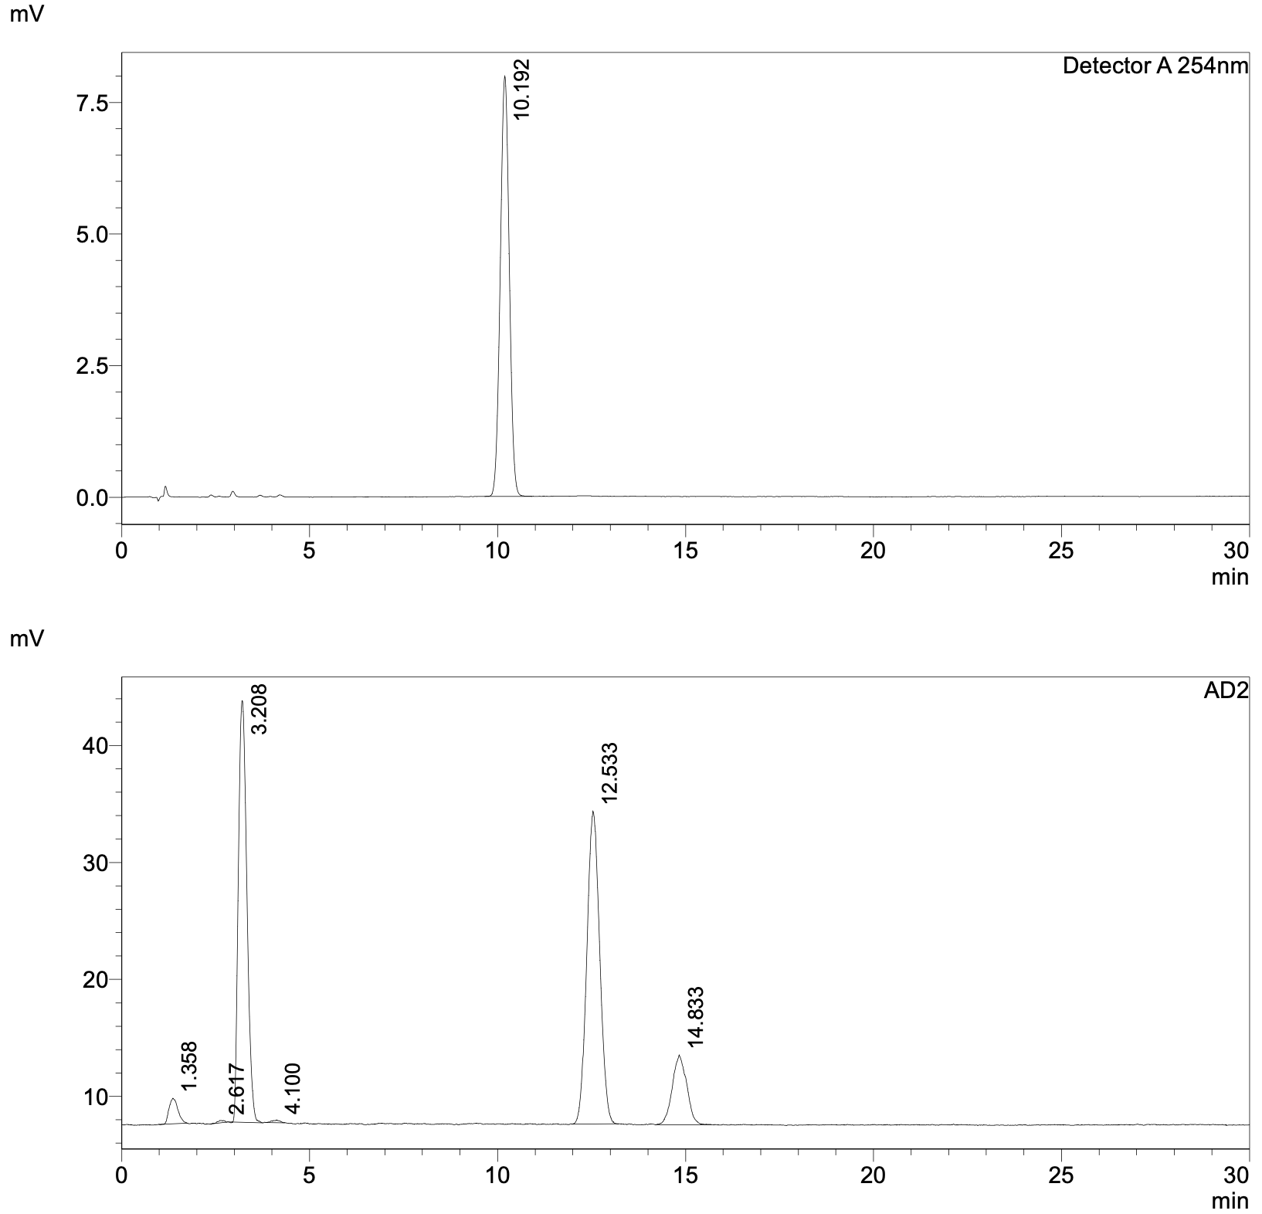

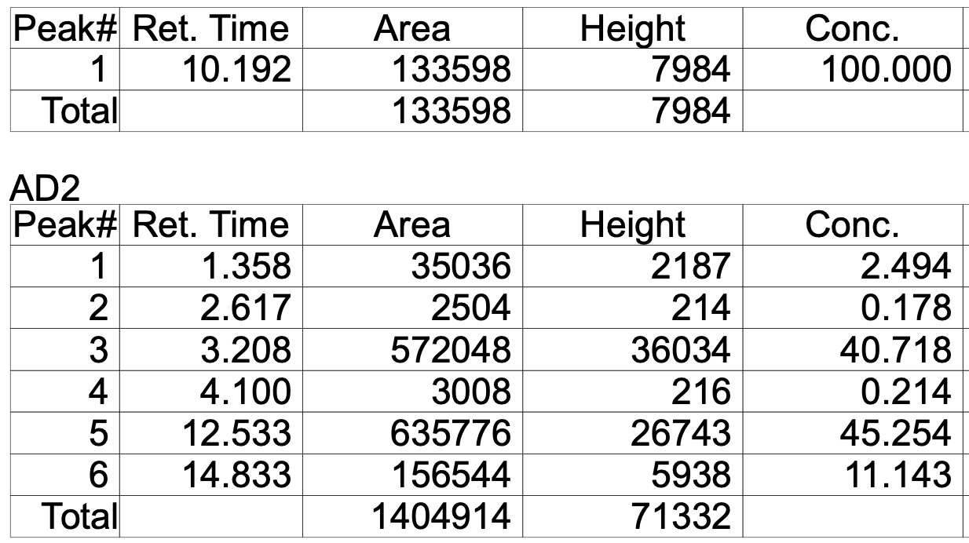
Figure S8: Analytical HPLC trace of [¹⁸F]fluoroflutamide dose from run 1 coinjected with flutamide at 2 h post EOS. Radiolysis observed.

Run 2
Activity Yield | 87.7 mCi
¹⁸F Activity at EOB | 1.87 Ci
Radiochemical Yield | 4.70%
Radiochemical Purity | 99.9%
1 h Stability RCP | 99.54%
4 h Stability RCP | 97.80%

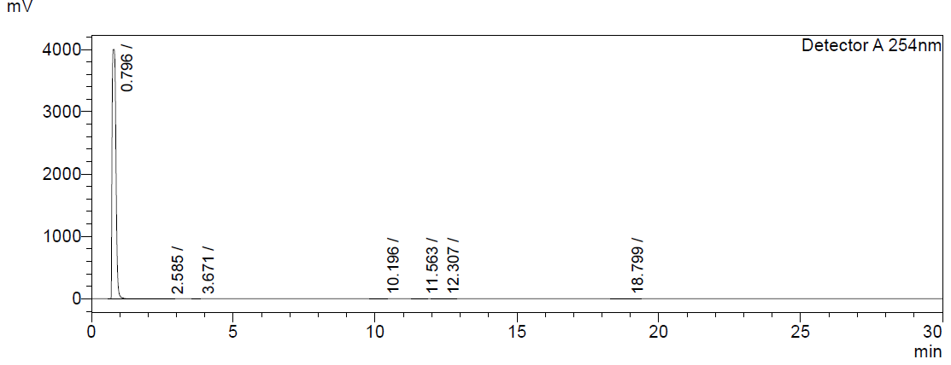
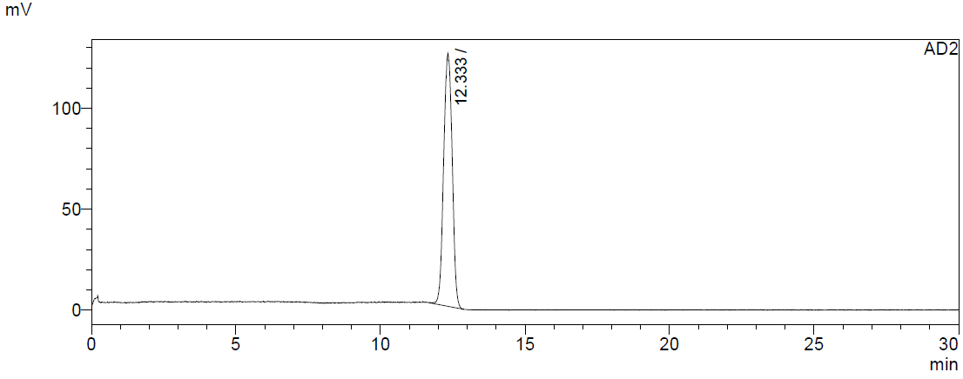
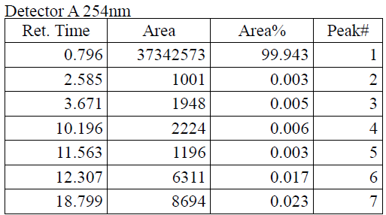
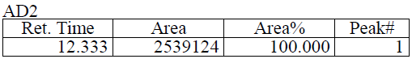
Figure S9: Analytical HPLC trace of [¹⁸F]-fluoroflutamide dose from run 2.
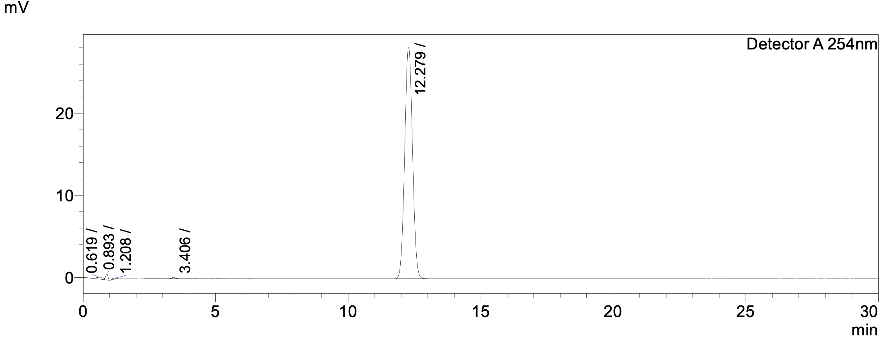
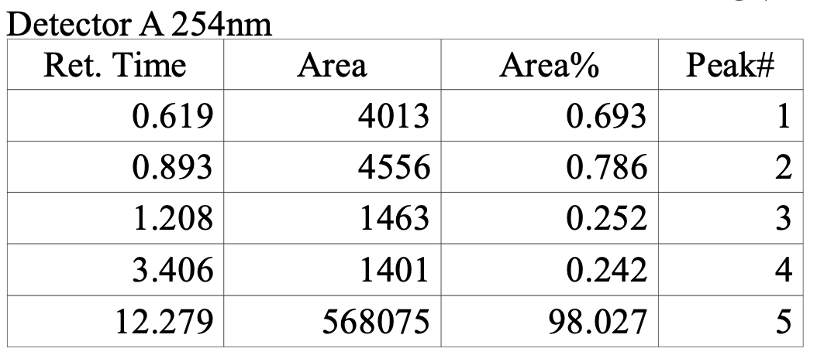
Figure S10: Analytical HPLC trace of ¹⁹F-fluoroflutamide standard from run 2.

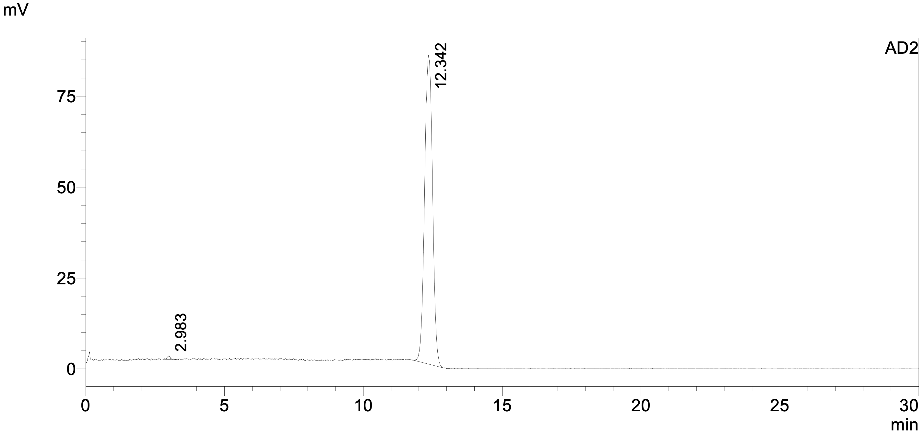
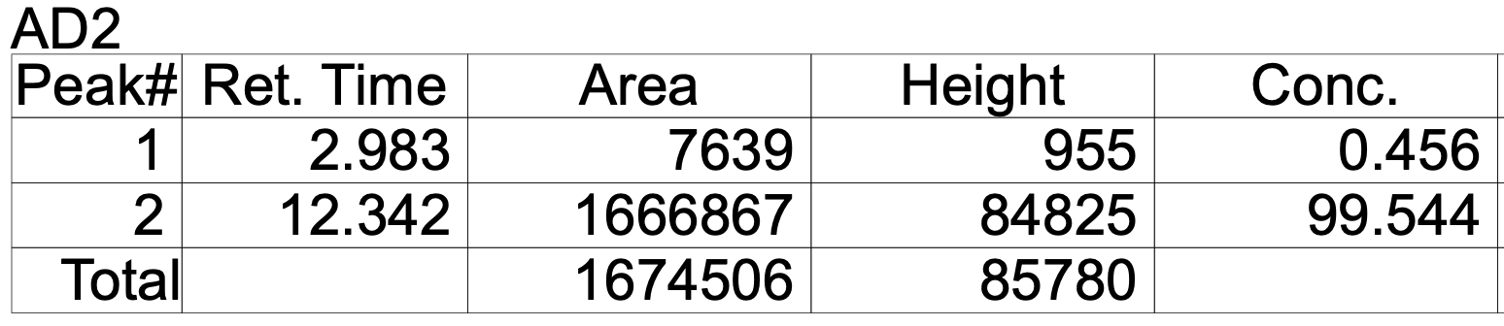
Figure S11: Analytical HPLC trace of [¹⁸F]-fluoroflutamide dose 1-hour post-EOS from run 2.

Figure S12: Analytical HPLC trace of [¹⁸F]-fluoroflutamide dose 4-hours post-EOS from run 2.
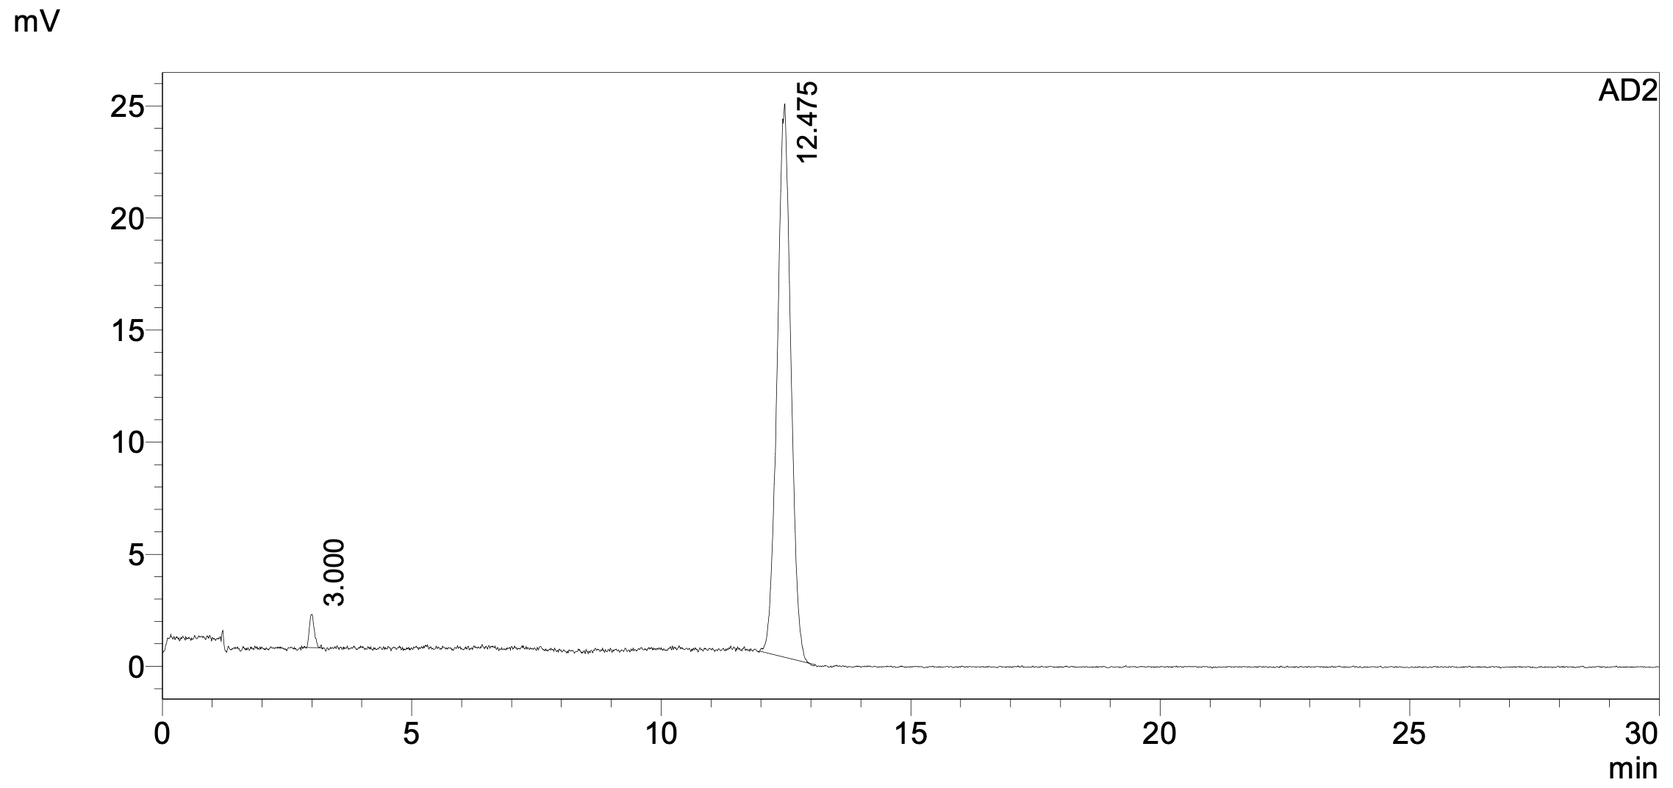
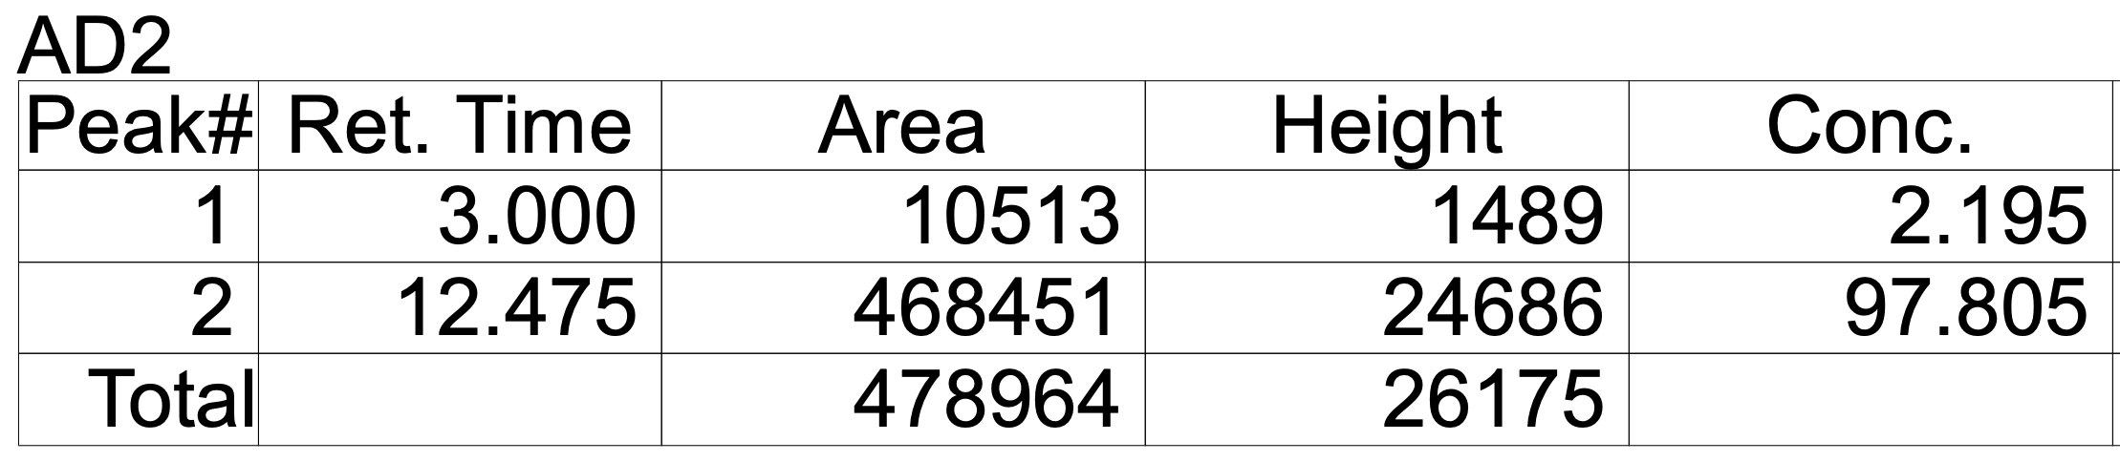
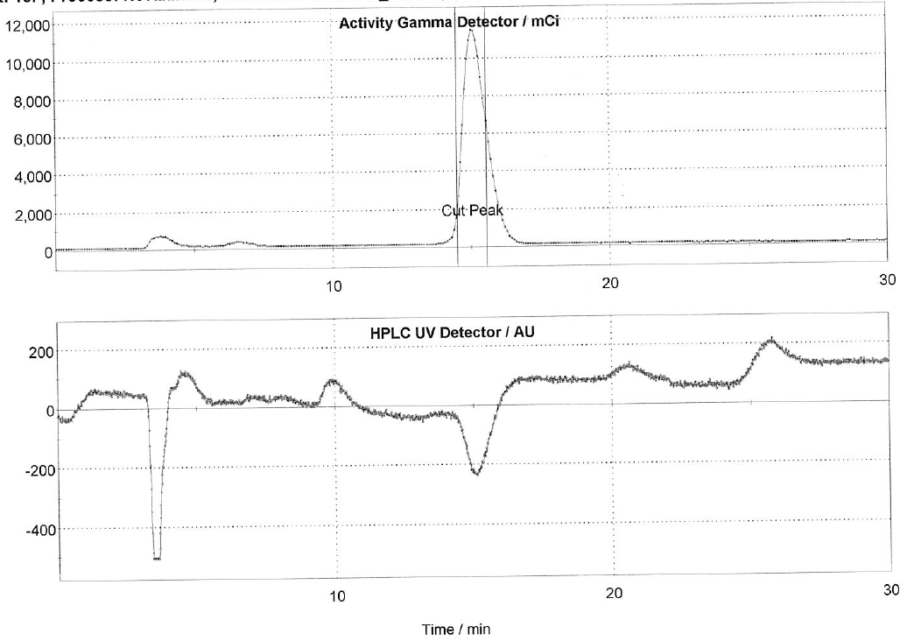
Figure S13: Semi-preparative HPLC trace of the automated synthesis of [¹⁸F]fluoroflutamide from run 2.

Run 3
Activity Yield | 54.2 mCi
¹⁸F Activity at EOB | 1.87 Ci
Radiochemical Yield | 2.90%
Radiochemical Purity | 99.81%

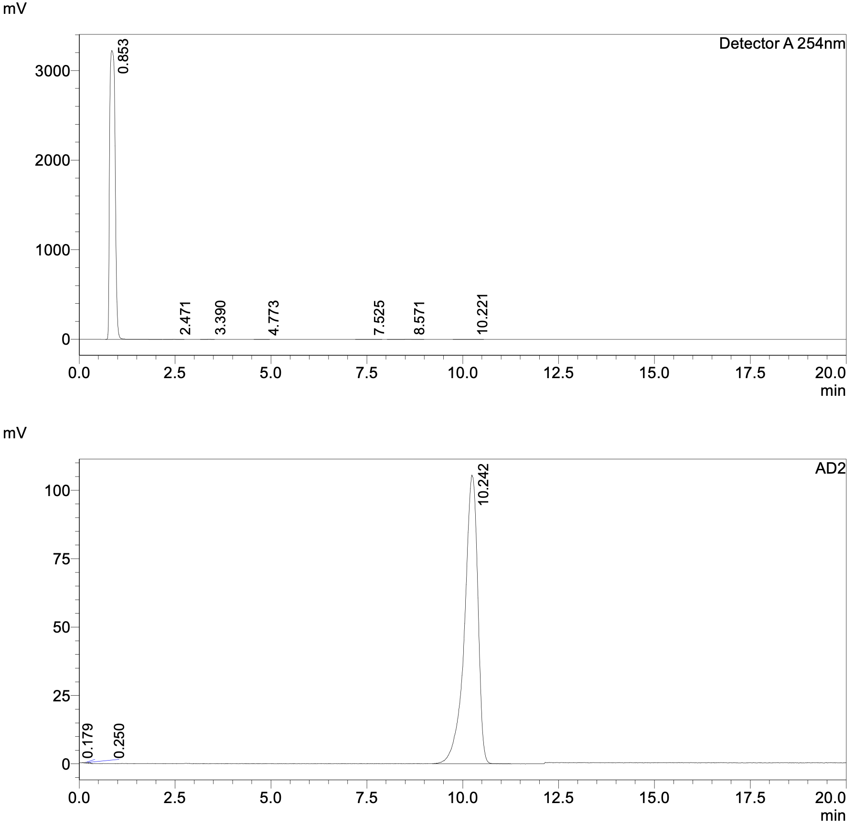

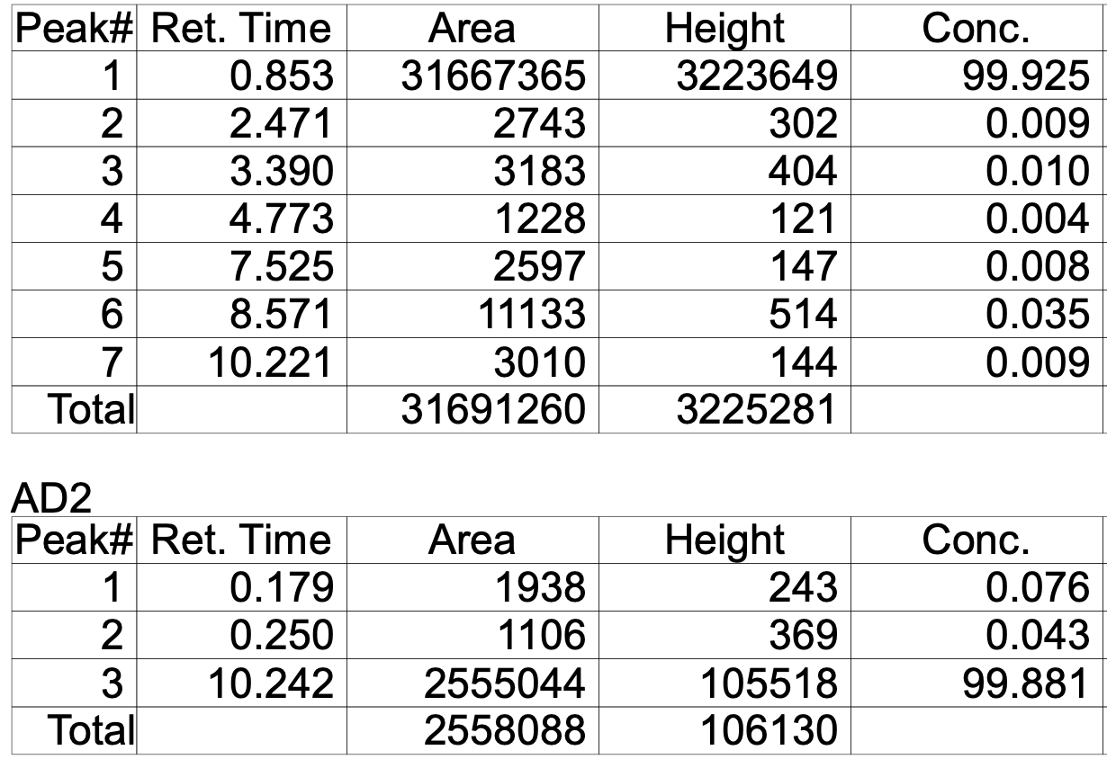
Figure S14: Analytical HPLC trace of [¹⁸F]-fluoroflutamide dose from run 3.

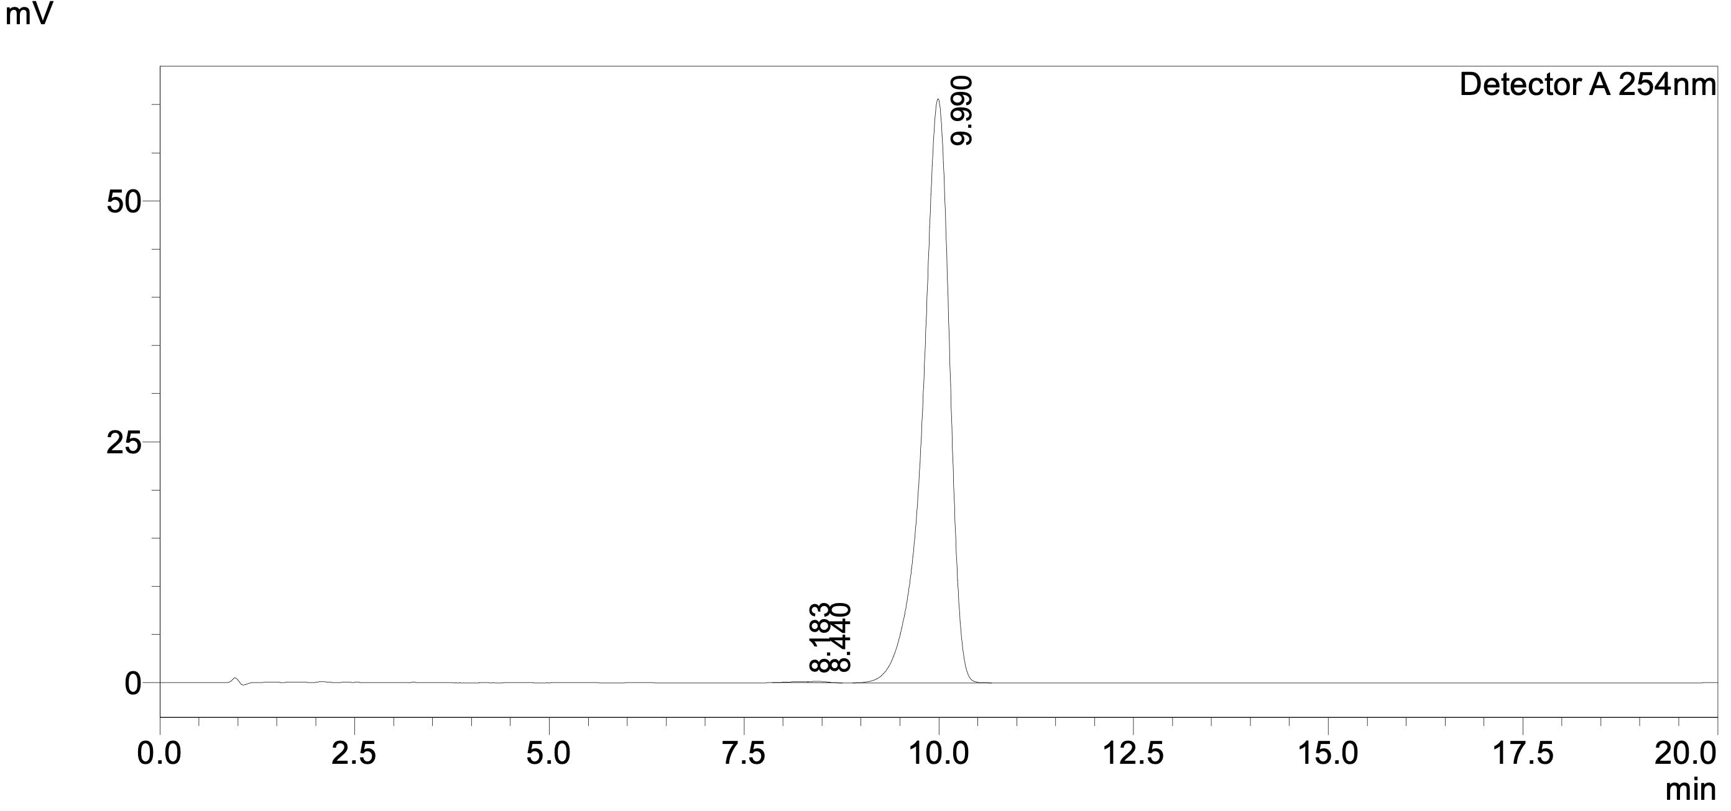
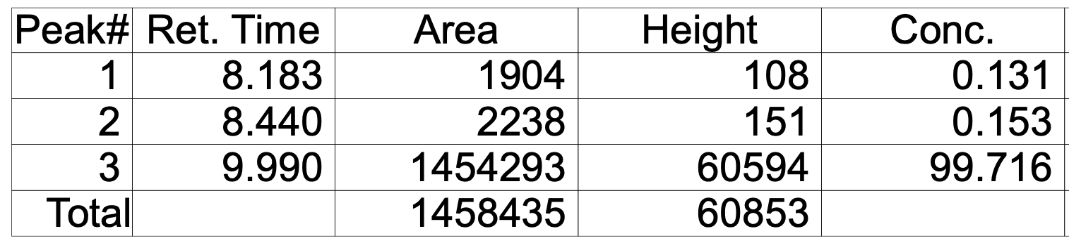

Figure S15: Analytical HPLC trace of ¹⁹F-fluoroflutamide standard from run 3.
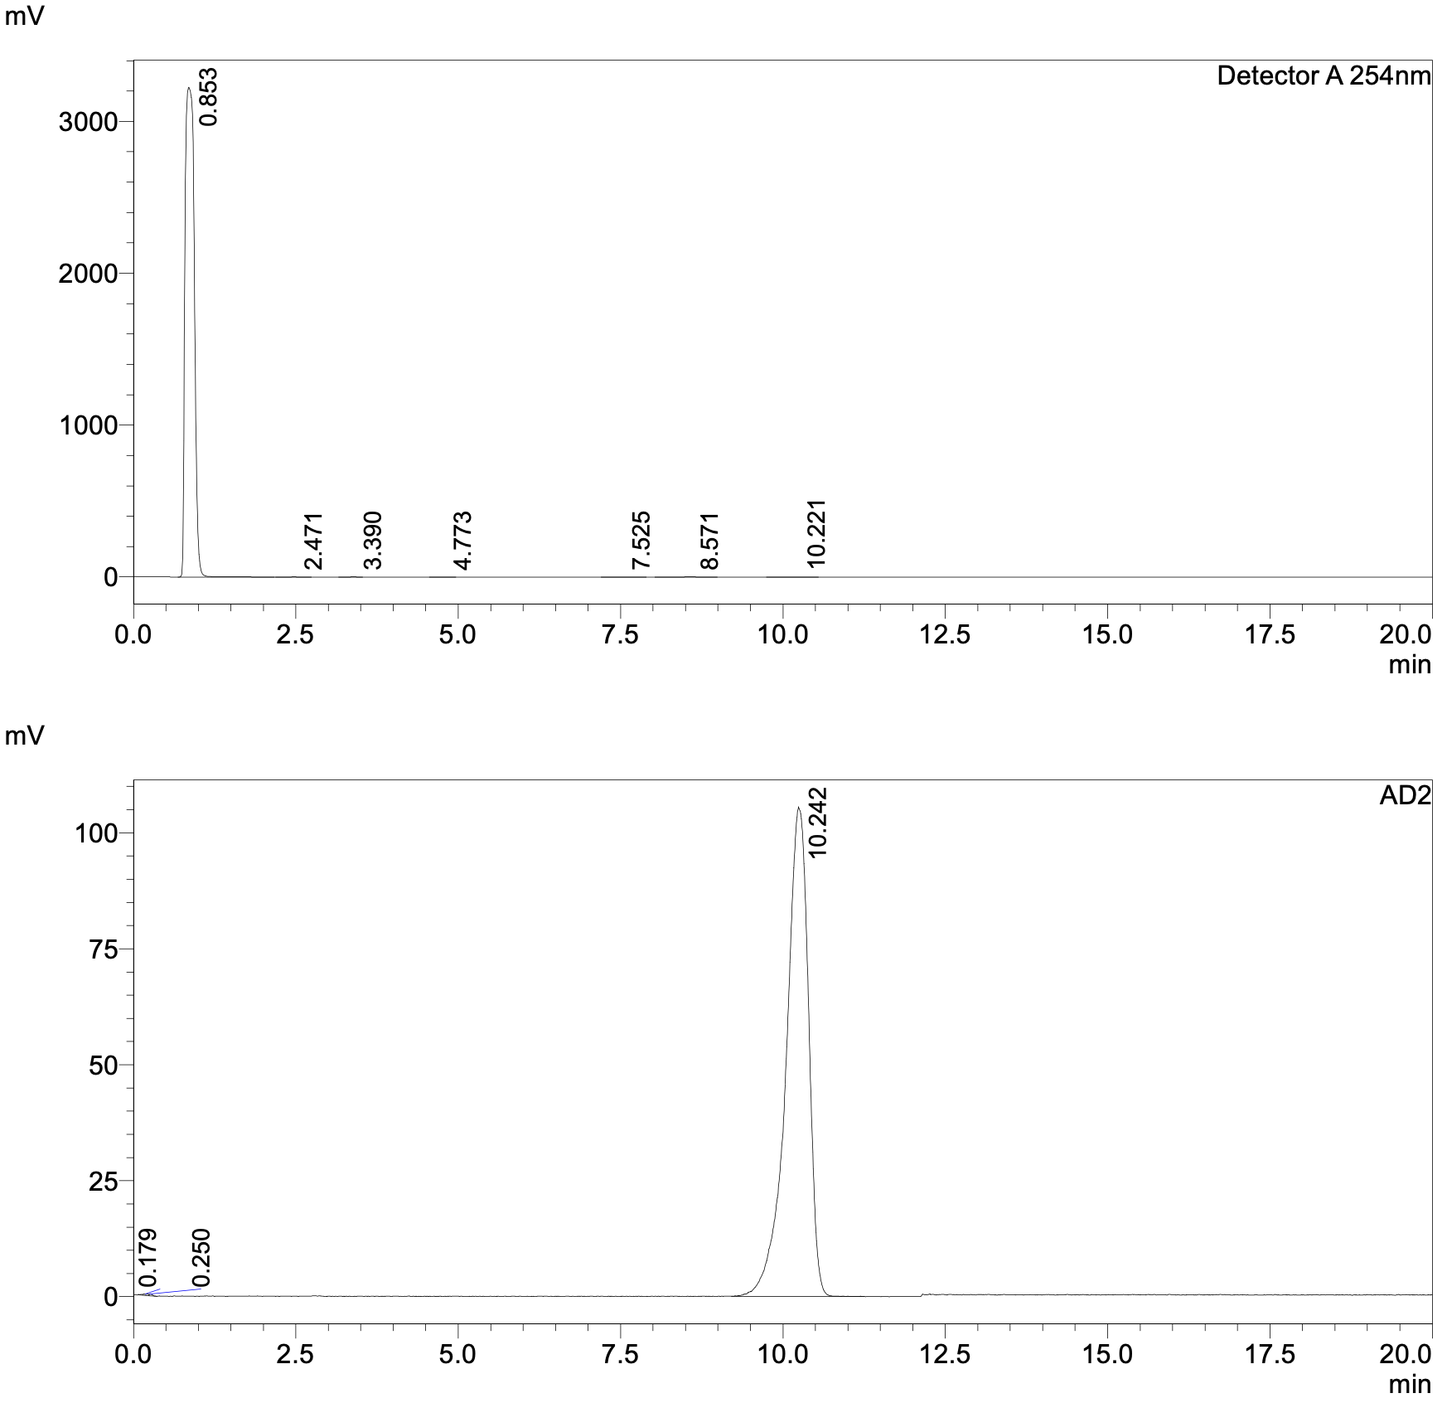
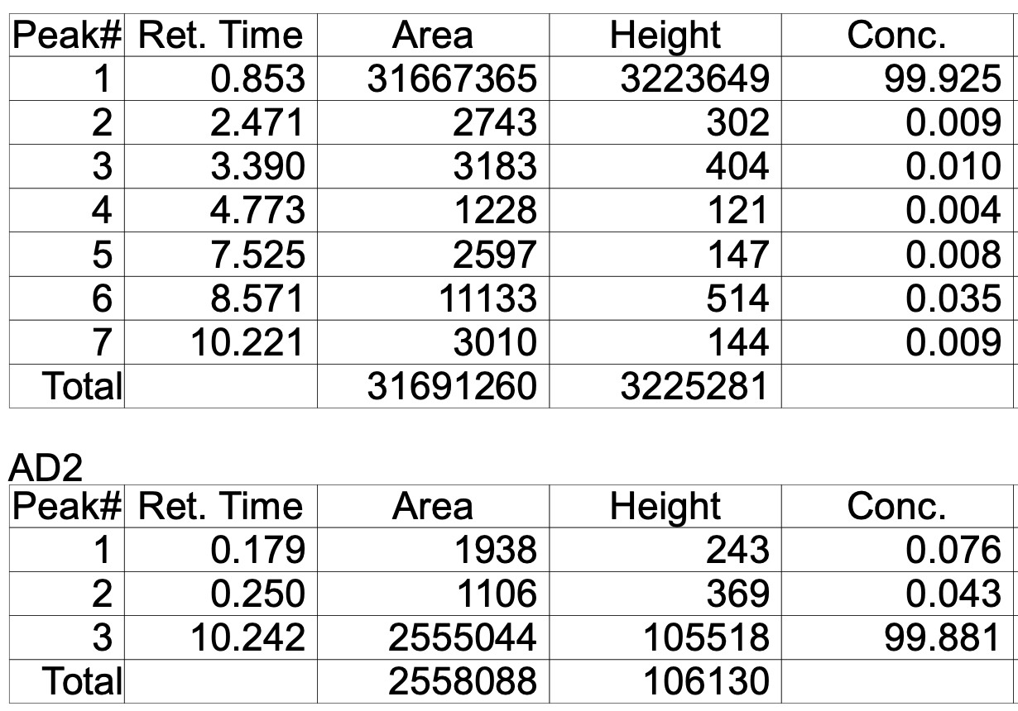
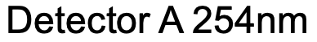
Figure S16: Analytical HPLC trace of [¹⁸F]fluoroflutamide dose from run 3 coinjected with ¹⁹F-fluoroflutamide standard.

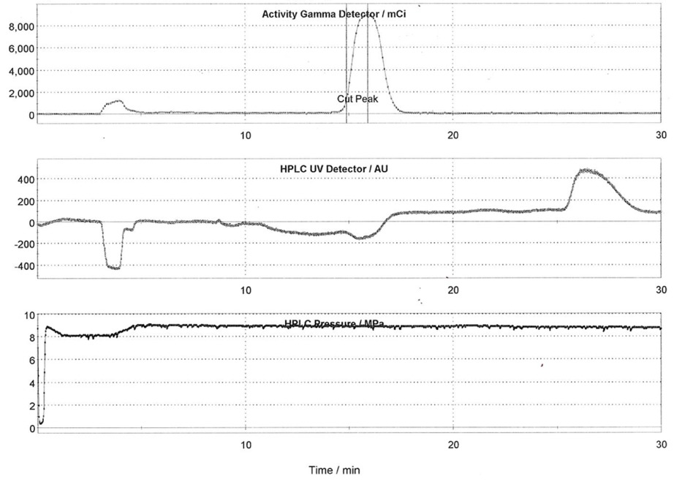
Figure S17: Semi-preparative HPLC trace of the automated synthesis of [¹⁸F]fluoroflutamide from run 3.

Run 4
Activity Yield | 35.3 mCi
¹⁸F Activity at EOB | 1.87 Ci
Radiochemical Yield | 1.89%
Radiochemical Purity | 99.9%
Molar Activity | 811.34 Ci/mmol

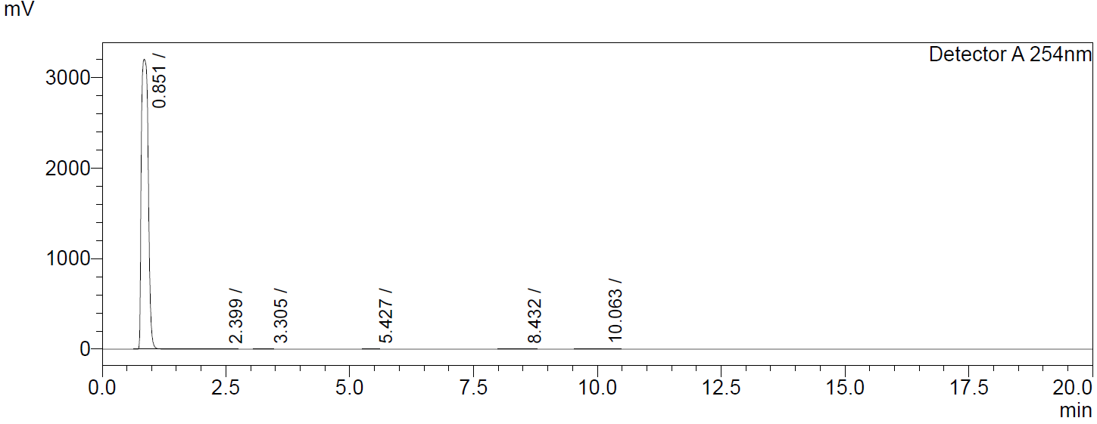
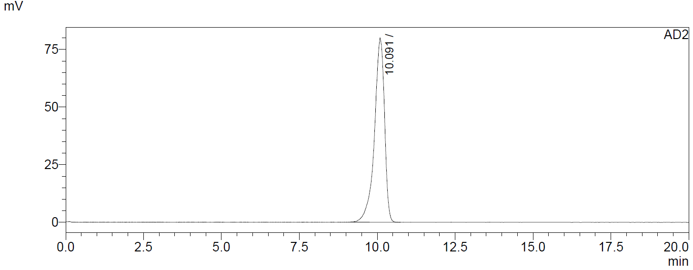
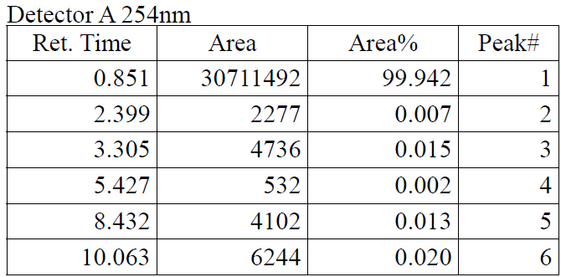
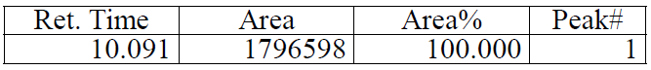
Figure S18: Analytical HPLC trace of [¹⁸F]-fluoroflutamide dose from run 4.

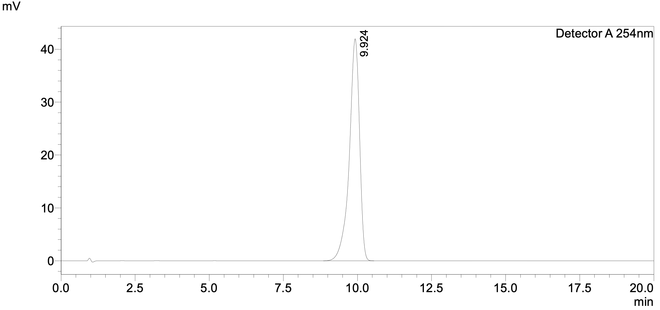
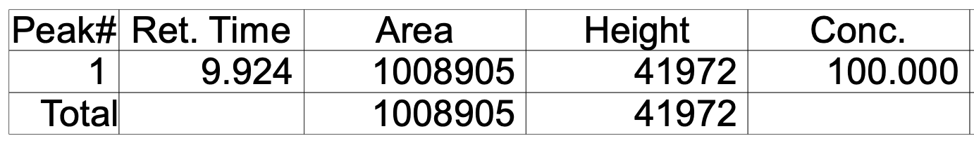

Figure S19: Analytical HPLC trace of ¹⁹F-fluoroflutamide standard from run 4.
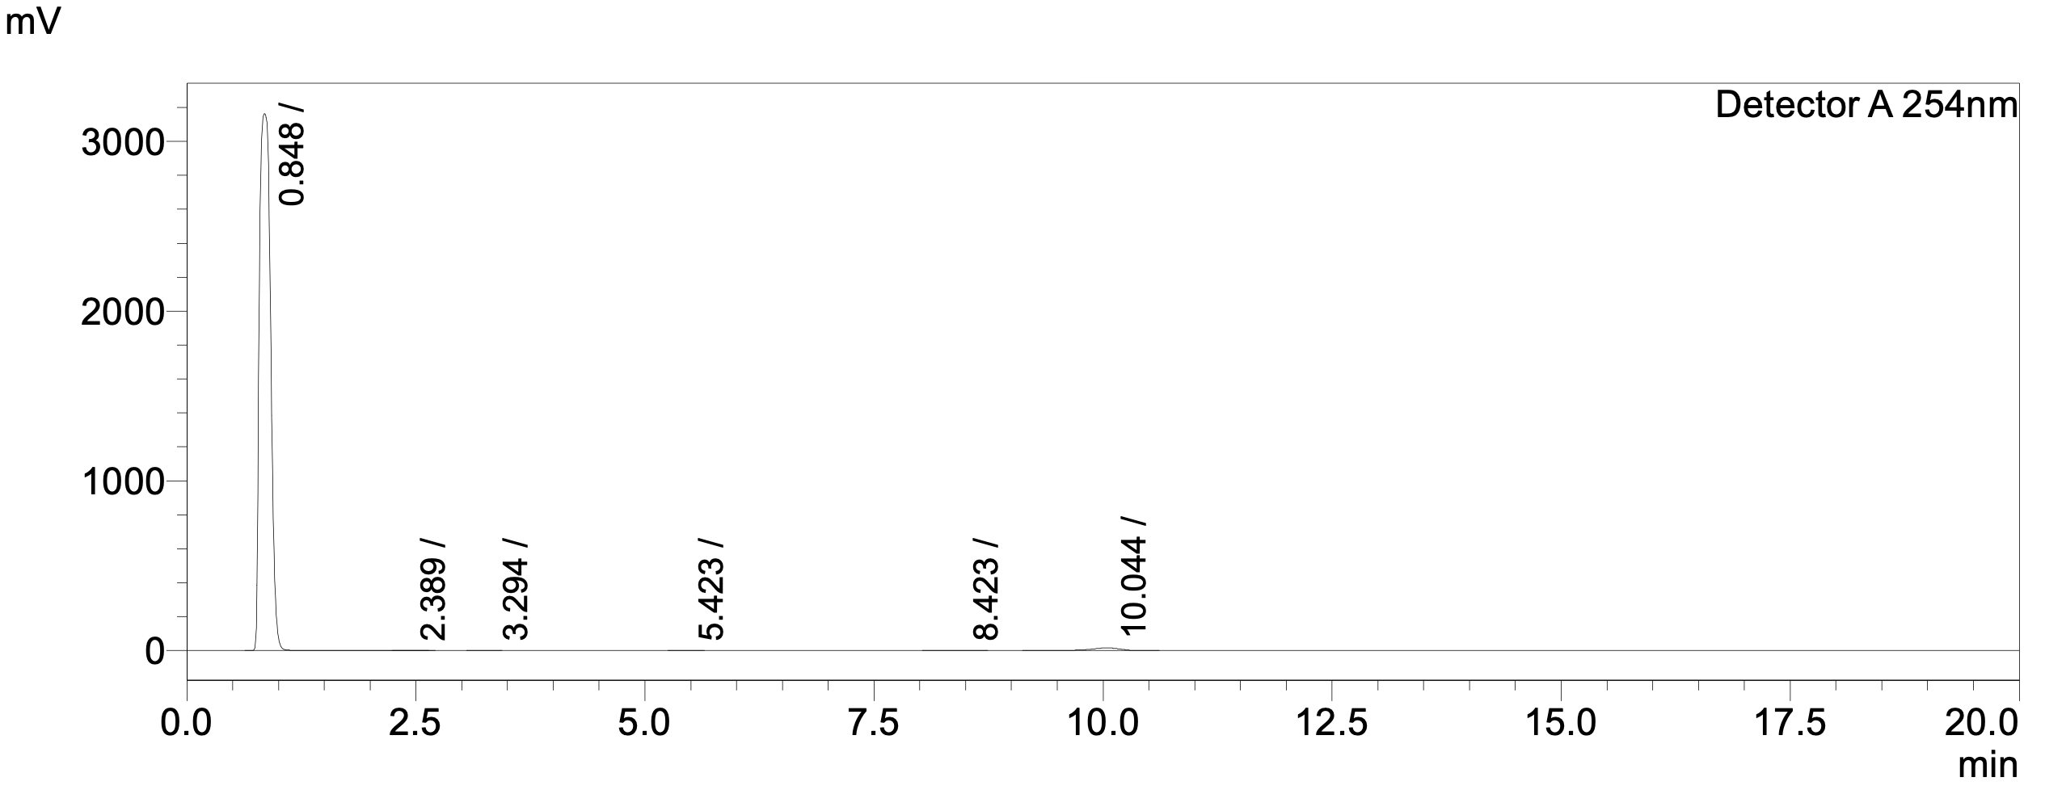
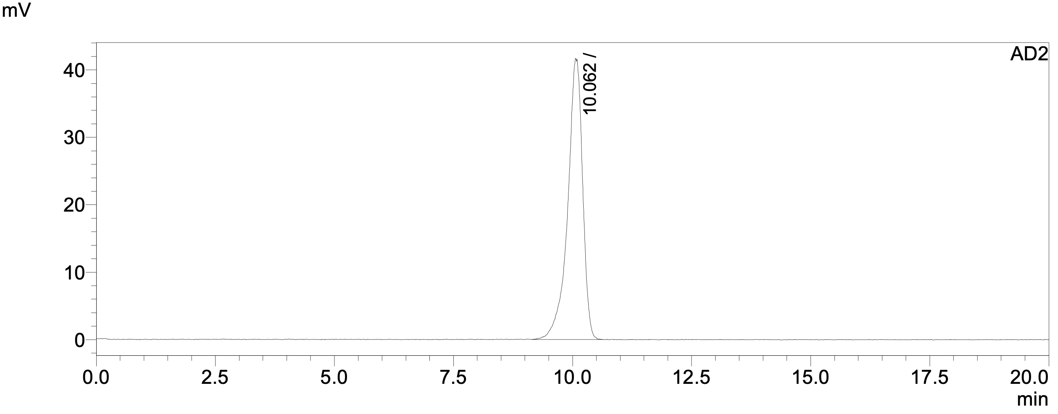
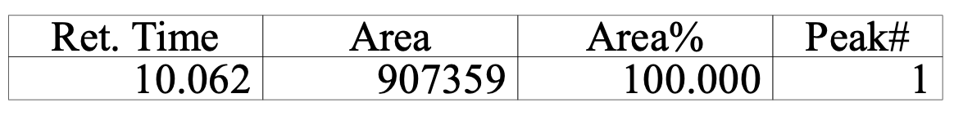
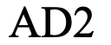
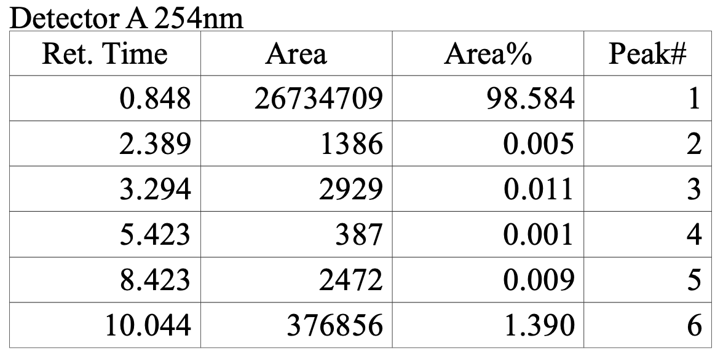
Figure S20: Analytical HPLC trace of [¹⁸F]fluoroflutamide dose from run 4 coinjected with ¹⁹F-fluoroflutamide standard.

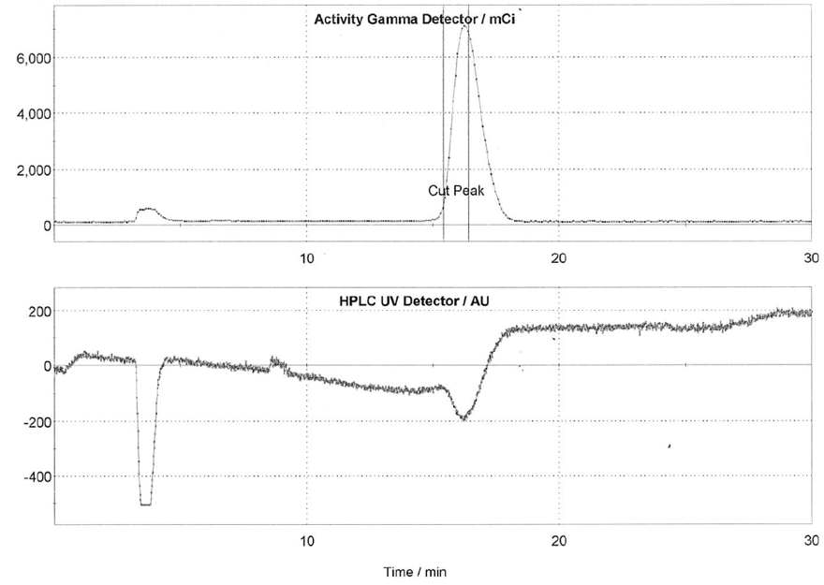
Figure S21: Semi-preparative HPLC trace of the automated synthesis of [¹⁸F]fluoroflutamide from run 4.

Figure S22: Standard curve for the molar activity calculation from run 4.

4. References
(1) Mizuta, S.; Kitamura, K.; Kitagawa, A.; Yamaguchi, T.; Ishikawa, T. Silver-Promoted Fluorination Reactions of α-Bromoamides. Chem. Eur. J. 2021, 27 (19), 5930–5935. https://doi.org/10.1002/chem.202004769.
(2) Wright, J. S.; Ma, R.; Webb, E. W.; Winton, W. P.; Stauff, J.; Cheng, K.; Brooks, A. F.; Sanford, M. S.; Scott, P. J. H. Zinc-Mediated Radiosynthesis of Unprotected Fluorine-18 Labelled α-Tertiary Amides. Angew. Chem. Int. Ed. 2024, 63 (2), e202316365. https://doi.org/10.1002/anie.202316365.
(3) Sagl, D. J.; Martin, J. C. The Stable Singlet Ground State Dication of Hexaiodobenzene: Possibly a .Sigma.-Delocalized Dication. J. Am. Chem. Soc. 1988, 110 (17), 5827–5833. https://doi.org/10.1021/ja00225a038.
(4) Toro, J. M. S.; Hartog, T. den; Chen, P. Cyclopropanation of Styrenes and Stilbenes Using Lithiomethyl Trimethylammonium Triflate as Methylene Donor. Chem. Commun. 2014, 50 (73), 10608–10610. https://doi.org/10.1039/C4CC04929B.

