Supporting Information (SI)
Dual functions of MDP monomer with de- and re- mineralizing ability
Haiyan Zheng^{1‡}, Ying Shi^{1‡}, Ling Bi^{2‡}, Zhixin Zhang¹, Zihuai Zhou¹, Changyu Shao³, Dezhi Cui⁴, Xiamin Cheng⁴, Ruikang Tang⁵, Haihua Pan⁶, Zhifang Wu¹* and Baiping Fu¹*
1Stomatology Hospital, School of Stomatology, Zhejiang University School of Medicine, Clinical Research Center for Oral Diseases of Zhejiang Province, Key Laboratory of Oral Biomedical Research of Zhejiang Province, Cancer Center of Zhejiang University, Hangzhou 310006, Zhejiang Province, China
2 The First Affiliated Hospital, Zhejiang University School of Medicine, Hangzhou 310003, Zhejiang Province, China
3 Center for Craniofacial Molecular Biology, University of Southern California, Los Angeles, CA 90033, USA
4 Institute of Advanced Synthesis, School of Chemistry and Molecular Engineering, Jiangsu National Synergetic Innovation Center for Advanced Materials, Nanjing Tech University (Nanjing Tech), Nanjing 211816, Jiangsu Province, China
5 Center for Biomaterials and Biopathways, Department of Chemistry, Zhejiang University Hangzhou 310027, Zhejiang Province, China
6 Qiushi Academy for Advanced Studies, Zhejiang University, Hangzhou 310027, Zhejiang Province, China
* Corresponding Author:
Email address: fbp@zju.edu.cn (Baiping Fu)
Email address: 11418288@zju.edu.cn (Zhifang Wu)
S1. Experimental Section
Preparation and characterization of MDP solution
A solution containing 10 wt % of MDP was prepared by dissolving MDP in 50% (v/v %) ethanol-aqueous solution. The solution was characterized by matrix-assisted laser desorption ionization time-of-flight (MALDI-TOF) spectra (Bruker MALDI-TOF Ultraflex, Munchen, Germany) for mass analysis.
Synthetic procedure of compound 1-6
In short, decane-1,10-diol was monoprotected with a tert-butyldimethylsilyl (TBS) group to obtain Compound 1 in a yield of 49%. Then, Compound 1 was coupled with Compound 2, which was synthesized in two steps to obtain Compound 3 in a yield of 70%. After deprotection of Compound 3 with tetra-n-butylammonium fluoride (TBAF), the resulting intermediate (Compound 4) was reacted with dibenzyl chlorophosphate in the presence of anhydrous pyridine to access Compound 5, which was then deprotected by catalytic hydrogenation to afford target Compound 6 in a yield of 92%.
The synthesis of compound 1


TBSCl (0.301 g, 2.0 mmol) was added into the solution of decane-1,10-diol (0.348 g, 2.0 mmol) in N, N-dimethylforamide (DMF, 6 mL) at room temperature. The reaction mixture was cooled at 0℃ before triethylamine (Et₃N , 0.73 mL, 2 mmol) was slowly added. The reaction mixture was warmed to room temperature and stirred for 12 h before it was quenched with NH₄Cl (ammonium chloride, 10 mL, sat. aq.). Firstly, the layers were separated. Then, the combined organic layer was washed with water (20 mL), dried over anhydrous sodium sulfate (Na₂SO₄) and concentrated in vacuo to afford the crude product, which was chromatographed on silica gel (petroleum ether - ethyl acetate = 10:1) to give the corresponding mono-protected diol compound 1 (0.285 g, 49 %) as a colorless oil.
The synthesis of compound 3
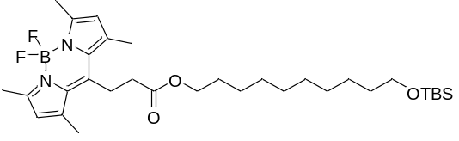
DMAP (N, N-dimethylpridine, 0.02 mmol, 2.5 mg) was added into the solution of compound 1 (0.22 mmol, 70.43 mg) in DCC (N, N’-Dicyclohexylcarbodiimide, 0.25 mmol, 51.54 mg), and compound 2 (0.2 mmol, 57.71 mg) in DCM (Dichloromethane, 5 mL) , in a 25 mL round bottom flash at room temperature. Thent they were stirred for 12 h under nitrogen atmosphere. The solvent was removed in vacuo and the residue was purified by column chromatography on silica gel (petroleum ether - ethyl acetate = 20:1) to give the compound 3 (0.097 g, 70 %) as a red oil.
The synthesis of compound 4
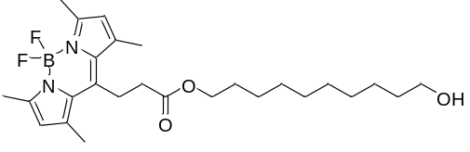
Tetra-n-butylammonium fluoride (TBAF, 0.16 mL, 1.0 M in tetrahydronfuran (THF)) was added to a solution of compound 3 (0.091 g, 0.15 mmol) in THF (5 mL) with stirring at room temperature for overnight. After the volatiles was evaporated, the residue was taken up in DCM and washed with water and brine. The organic phase was dried over anhydrous Na₂SO₄, filtered and concentrated in vacuo. The crude product was chromatographed on silica gel (petroleum ether - ethyl acetate = 6:1) to give the compound 4 (0.043 g, 61 %) as a red oil.
The synthesis of compound 5
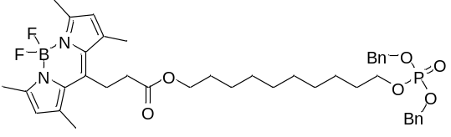
Freshly prepared dibenzyl chlorophosphate (0.213 g, 0.72 mmol) was added into the solution of compound 4 (0.216 g, 0.45 mmol) in anhydrous pyridine (5 mL) at 0 °C. The reaction mixture was brought to room temperature and stirred overnight for 18 h. Excess pyridine was evaporated off and the crude mixture was purified by column chromatography over silica gel (petroleum ether - ethyl acetate = 9:1) to give the compound 5 (0.228 g, 69 %) as a red oil.
The synthesis of compound 6
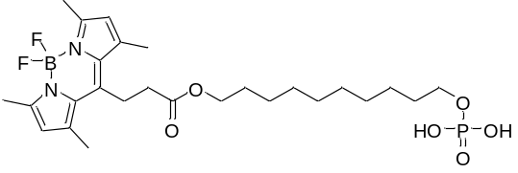
Pd/C (10%, 20 mg) was added into a solution of compound 5 (118.2 mg 0.16 mmol) in MeOH (methanol, 5 mL). The mixture was stirred at room temperature for 2 h under H₂ atmosphere (balloon, 1 atm). Then the mixture was filtrated over Celite and concentrated in vacuo to afford the desired product 6 (0.081 g, 92%).
Elemental analysis of the collagen fibrils
A total of 12 collagen-coated TEM grids were prepared and treated with or without MDP. Then, 8 TEM grids were incubated in 1.5 mM CaCl₂ solution and in AS solution for 24 h. Two TEM grids were floated on 60 µl of solution. Thereafter, all the grids were analyzed by STEM (Nova Nano SEM 450, FEI, CA, USA) with energy-dispersive X-ray spectroscopy (EDAX Leap detector attached to a Nova NanoSEM).
S2. Sectional Results and Figures
The spectra of compound 1-6
The spectra of compound 1
¹H NMR (400 MHz, CDCl₃) δ 0.01 (s, 6 H), 0.83 (s, 9 H), 1.20-1.29 (m, 12 H), 1.43-1.50 (m, 4 H), 3.51-3.55 (m, 4 H); ¹³C NMR (101 MHz, CDCl₃) δ -5.24, 18.38, 25.84, 26.01, 29.49, 29.52, 29.64, 32.74, 32.88, 62.65, 63.37.
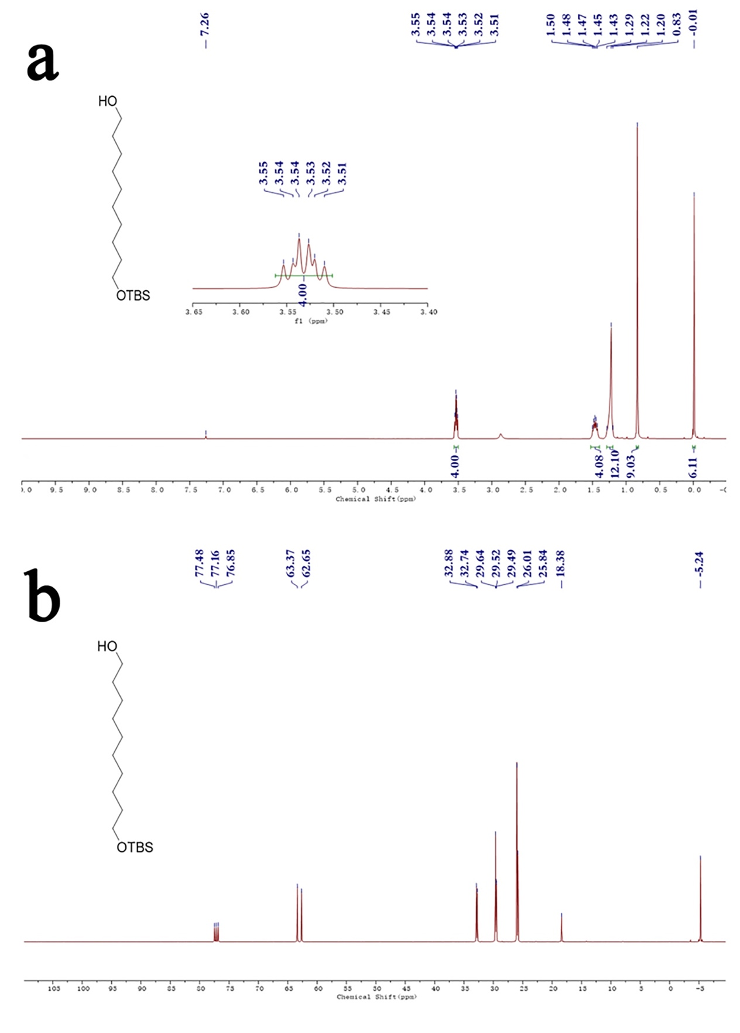
Fig. S1 The ¹H NMR and ¹³C NMR spectra of compound 1.
The spectra of compound 3
¹H NMR (400 MHz, CDCl₃) δ 0.04 (s, 6 H), 0.89 (s, 9 H), 1.28 (s, 12 H), 1.48-1.52 (t, 2 H), 1.61-1.65 (t, 2 H), 2.43 (s, 6 H), 2.51 (s, 6 H), 2.56-2.60 (m, 2 H), 3.27-3.31 (m, 2 H), 3.59 (t, J = 6.6 Hz, 1H), 4.12 (t, J = 6.7 Hz, 1H), 6.06 (s, 2 H); ¹³C NMR (101 MHz, CDCl₃) δ -5.14, 14.60, 16.50, 18.49, 23.81, 25.89, 25.99, 26.09, 28.64, 29.32, 29.52. 29.58, 29.64, 32.97, 35.60, 63.41, 65.30, 122.02, 131.29, 140.51, 143.45, 154.69, 171.87.
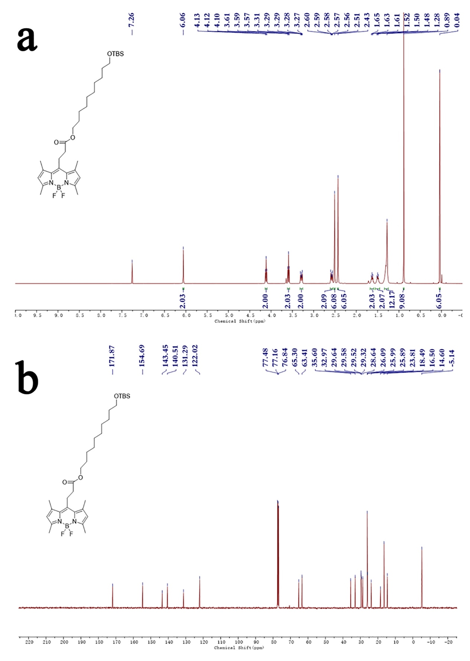
Fig. S2 The ¹H NMR and ¹³C NMR spectra of compound 3.
The spectra of compound 4
¹H NMR (400 MHz, CDCl₃) δ 1.29-1.31 (m, 12 H), 1.54-1.65 (m, 4 H), 2.43 (s, 6 H), 2.51 (s, 6 H), 2.56-2.61 (m, 2 H), 3.27-3.32 (m, 2 H), 3.63 (t, J = 6.6 Hz, 1H), 4.12 (t, J = 6.7 Hz, 1H), 6.06 (s, 2 H); ¹³C NMR (101 MHz, CDCl₃) δ 14.62, 16.52, 23.82, 25.84, 25.98, 28.61, 29.29, 29.50, 29.54, 29.61, 32.88, 35.62, 63.14, 65.31, 122.05, 131.31, 140.53, 143.46, 154.74, 171.91.
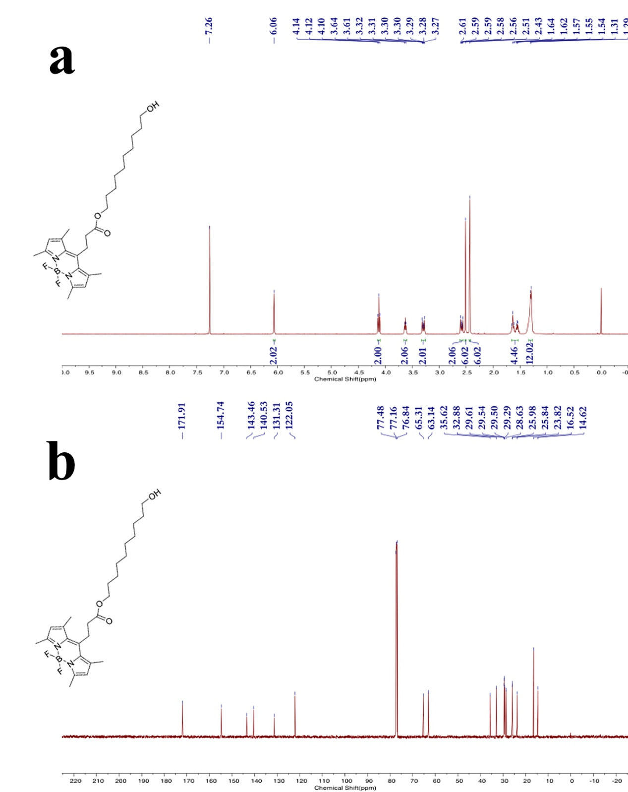
Fig. S3 The ¹H NMR and ¹³C NMR spectra of compound 4.
The spectra of compound 5
¹H NMR (400 MHz, CDCl₃) δ 1.25-1.30 (m, 12 H), 1.57-1.67 (m, 4 H), 2.43 (s, 6 H), 2.51 (s, 6 H), 2.56-2.60 (m, 2H), 3.27-3.31 (m, 2 H), 3.98 (q, J = 6.7 Hz, 2H), 4.12 (t, J = 6.7 Hz, 2H), 5.02-5.05 (m, 4 H), 6.06 (s, 2 H), 7.31-7.36 (m, 10 H); ¹³C NMR (101 MHz, CDCl₃) δ 14.57, 16.47, 23.78, 25.44, 25.96, 28.62, 29.15, 29.27, 29.47, 29.49, 30.20, 30.27, 35.57, 65.25, 68.04, 68.10, 69.17, 69.23, 122.00, 127.97, 128.55, 128.63, 131.28, 135.98, 136.05, 140.48, 143.43, 154.68.

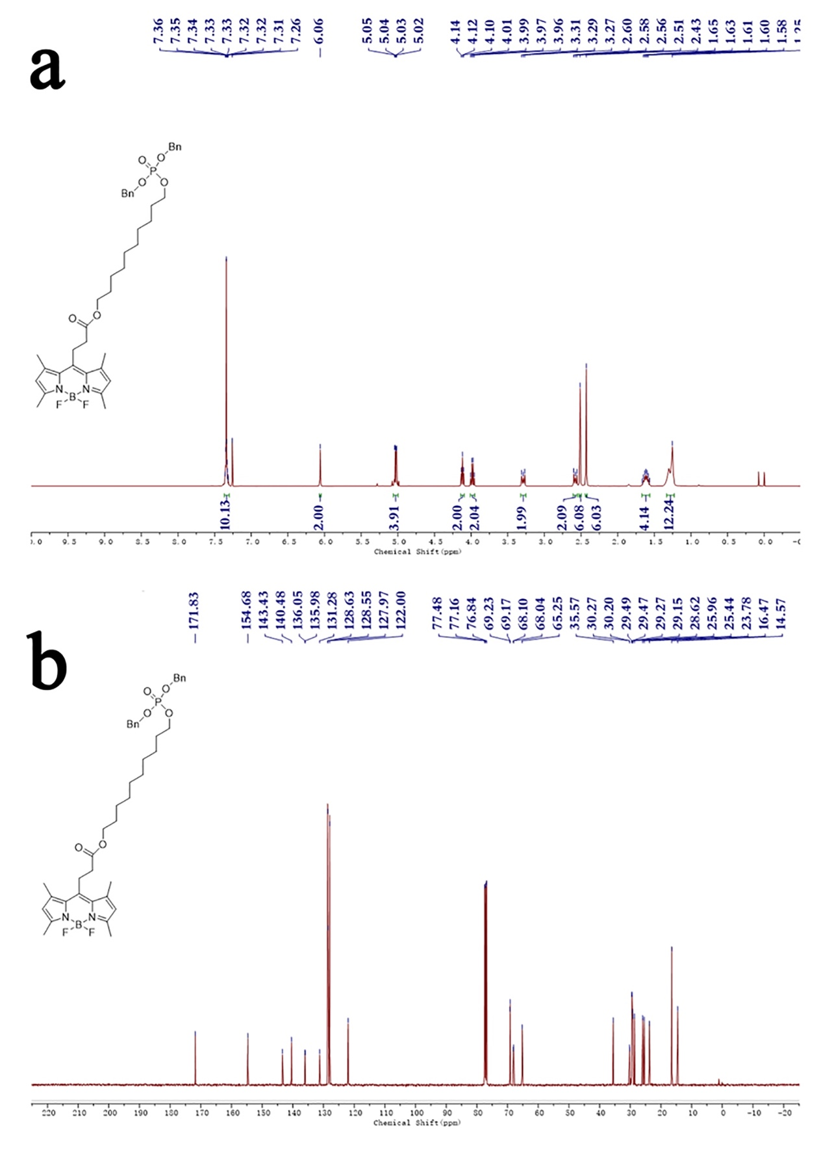
Fig. S4 The ¹HNMR and ¹³C NMR spectra of compound 5.
The spectra of compound 6
¹H NMR (400 MHz, CDCl₃) δ 1.19-1.38 (m, 12 H), 1.56-1.71 (m, 4 H), 2.41 (s, 6 H), 2.49 (s, 6 H), 2.54-2.58 (t, 2 H), 3.25-3.29 (m, 2H), 4.08-4.12 (m, 2 H), 6.05 (s, 2 H); ¹³C NMR (101 MHz, CDCl₃) δ 14.54, 16.42, 23.73, 25.93, 28.58, 29.27, 29.51, 29.53, 35.53, 65.26, 122.01, 131.25, 140.47, 143.36, 154.66, 171.91.
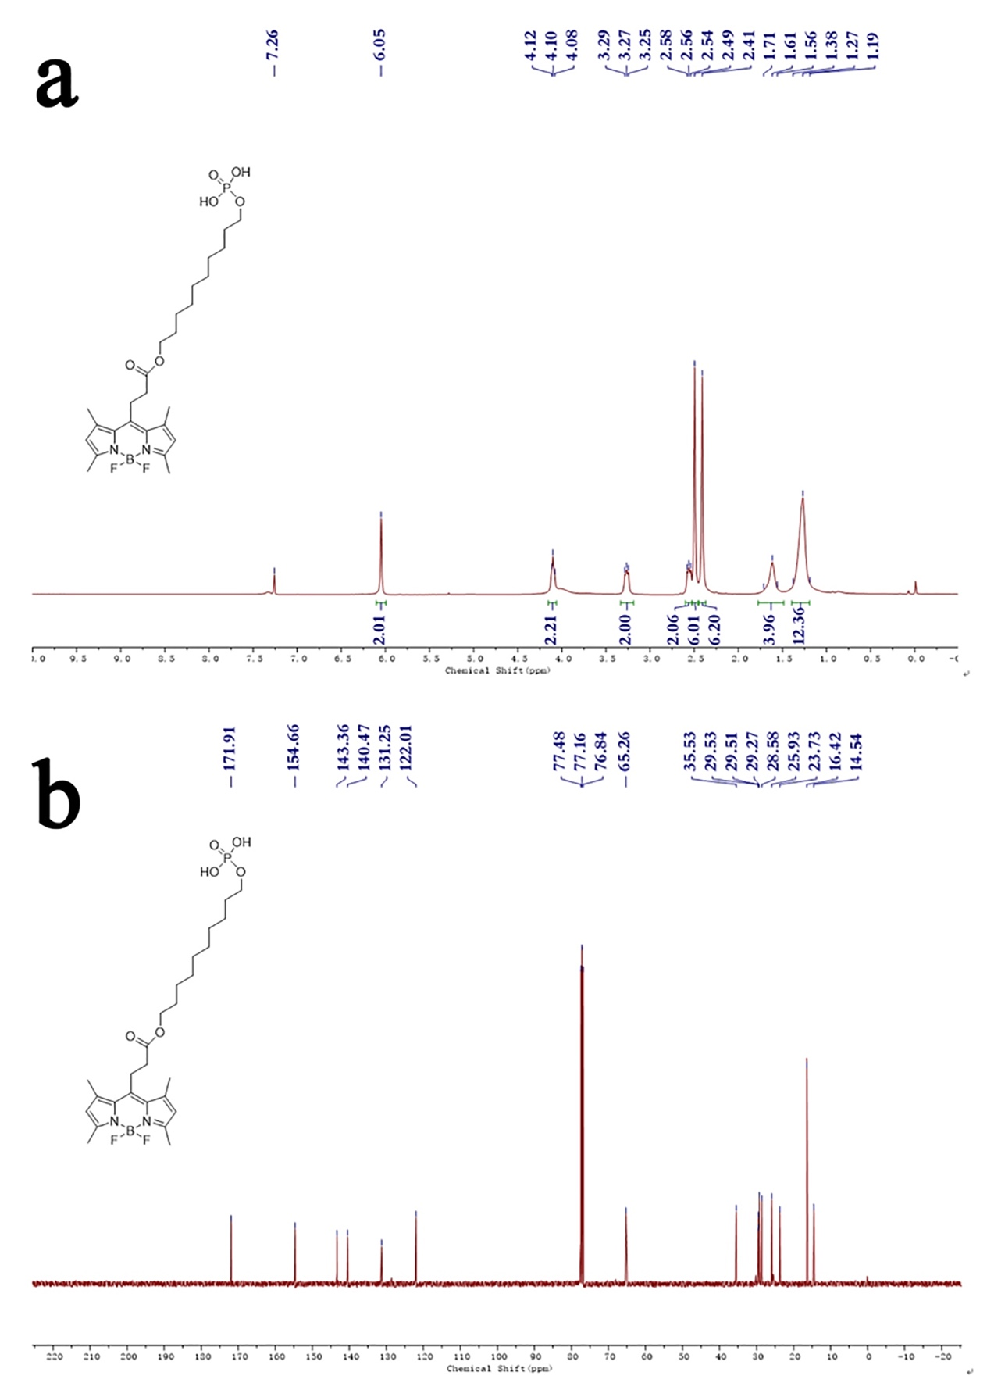
Fig. S5 The ¹HNMR and ¹³C NMR spectra of compound 6.
Mineralization of collagen
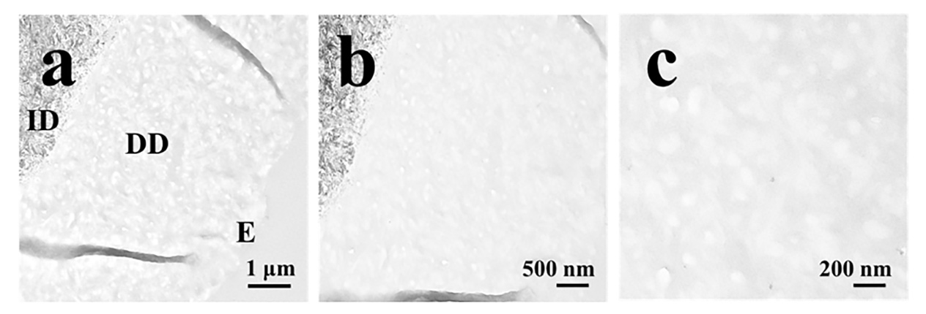
Fig. S6 TEM images of the demineralized dentin. Panels b and c are the higher magnifications of the dentin in panels a. D: intact dentin. DD: demineralized dentin. E: epoxy resin.
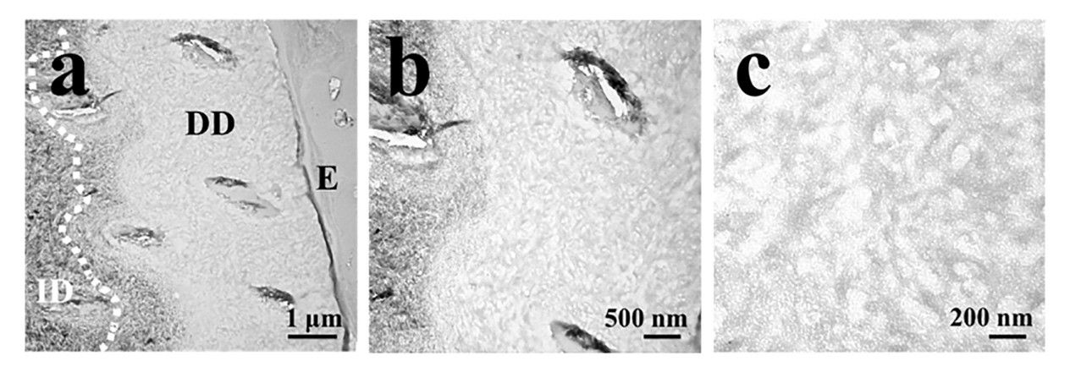
Fig. S7 TEM images of the demineralized dentin with the pretreatment of MDP. Panels b and c are the higher magnifications of the dentin in panels a. Dotted lines for the boundary between partly demineralized dentin and intact natural dentin (ID). ID: intact dentin. DD: demineralized dentin. E: epoxy resin.
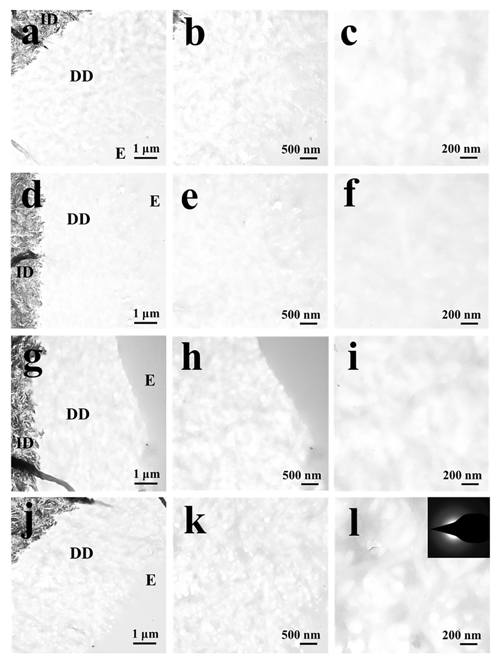
Fig. S8 TEM images of the demineralized dentin in control group after 4 days (a-c), 7 days (d-f), 14 days (g-i) and 30 days (j-l) of incubation in AS. Panels b and c, e and f, h and i, k and l are the higher magnifications of the dentin in panels a, d, g and j, respectively. DD: demineralized dentin. E: epoxy resin.
Characterization of MDP solution
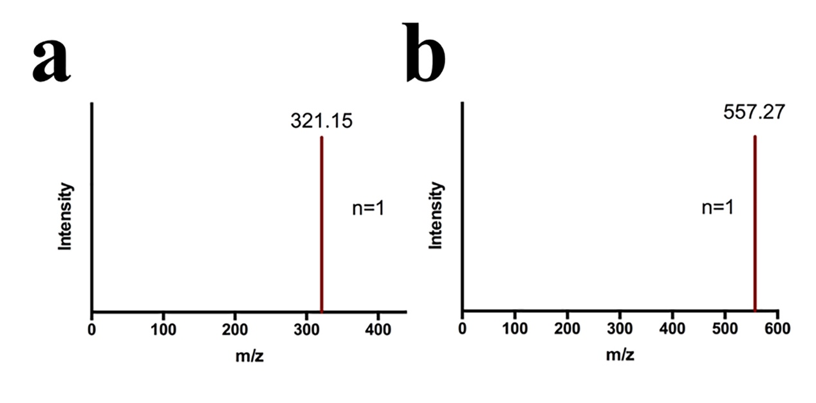
Fig. S9 The mass spectrum of MDP (a) and MDP-BODIPY (b) in ethanol-aqueous solution reveals a single peak at 321.15and 557.27, respectively.

Elemental analysis of the collagen fibrils
The elemental mapping results of the collagen fibrils are shown in Fig. S10. After MDP pretreatment, P element was detected on the collagen fibrils, suggesting that MDP was immobilized in the collagen fibrils (Fig. S10a). After incubation in CaCl₂ for 24 h, MDP-collagen possessed an affinity for Ca²⁺ ions (Fig. S10b). After incubation in AS for 24 h, MDP-collagen could attract calcium ions or CaP precursors from the AS to promote nucleation (Fig. S10c). Unlike MDP-collagen, elemental mapping analysis demonstrated that bare collagen could not absorb calcium ions or amorphous CaP precursors (Fig. S01d-f).

Fig. S10 STEM images with elemental mapping analysis of MDP-collagen (a-c) and bare collagen (d-f). a, d: Collagen pretreated with or without MDP; b, e: Collagen after immersion in CaCl₂ solution; c, f: Collagen after immersion in AS solution.
Supporting Movie Caption
Movie S1and S2 show the 3D representation of MDP-collagen fibril and bare collagen fibril, with the viewing angle rotated to show different perspectives.

