Supplementary Material
Second near-infrared photothermal-amplified immunotherapy using photoactivatable composite nanostimulators

Haitao Sun^{1†}, Tianzhu Yu^{1†}, Xin Li^{3†}, Yanyang Lei¹, Jianke Li¹, Xiuhui Wang^{4*}, Peike Peng^{5*}, Dalong Ni⁶, Xiaolin Wang^{1*}, Yu Luo^{2*}

¹Department of Interventional Radiology, Zhongshan Hospital, Fudan University, Shanghai Institute of Medical Imaging, No. 180 Fenglin Road, Xuhui District, Shanghai 200032, China
²Frontier Institute of Medical & Pharmaceutical Science and Technology, School of Chemistry and Chemical Engineering, Shanghai University of Engineering Science, No. 333 Longteng Road, Shanghai 201620, P. R. China
³Institute for Technical and Macromolecular Chemistry, RWTH Aachen University, Worringerweg 2, 52074 Aachen, Germany
⁴Institute of Translational Medicine, Shanghai University, Shanghai 200011, P. R. China
⁵ School of Basic Medical Sciences, Shanghai University of Traditional Chinese Medicine, Shanghai, P. R. China
⁶ Department of Orthopaedics, Shanghai Key Laboratory for Prevention and Treatment of Bone and Joint Diseases, Shanghai Institute of Traumatology and Orthopaedics, Ruijin Hospital, Shanghai Jiao Tong University School of Medicine, 197 Ruijin 2nd Road, Shanghai 200025, P. R. China.

*Correspondence: fduwangxiaolin@hotmail.com (Xiaolin Wang), blackrabbit@shu.edu.cn (Xiuhui Wang), pengpeike@shutcm.edu.cn (Peike Peng), and yuluo@sues.edu.cn (Yu Luo)
†Haitao Sun, Tianzhu Yu and Xin Li contributed equally to this work.

Material and methods
Materials. Bovine serum albumin (BSA), copper (II) chloride dihydrate (CuCl₂·2H₂O), sodium sulfide nonahydrate (Na₂S·9H₂O), and sodium hydroxide (NaOH) were obtained from Sigma–Aldrich Co. (Shanghai, China). DPPC and DSPE–PEG_{2k} were purchased from Ananti Polar Lipids, Inc. (Alabaster, AL, USA). ICG was obtained from Shanghai Aicheng Biological Technology Co., Ltd (Shanghai, China). JQ1 was purchased from MedChemExpress (Monmouth Junction, NJ, USA). CpG 1826 (5′-TCC ATG ACG TTC CTG ACG TT-3′) and Cy5.5-CpG 1826 (5′-TCC ATG ACG TTC CTG ACG TT-3′-Cy5.5) were synthesized at Sangon Biotechnology Co., Ltd (Shanghai, China). Antibodies, including CD45-BV605 (Biolegend, Clone: 30-F11, Catalog No. 103140), CD3-APC/Cyanine7 (Biolegend, Clone: 17A2, Catalog No. 100222), CD4-FITC (Biolegend, Clone: GK1.5, Catalog No. 100406), CD8-PE (Biolegend, Clone: 53-5.8, Catalog No. 140408), CD11c-FITC (Biolegend, Clone: N418, Catalog No. 117306), CD80-PE (Biolegend, Clone: 16-10A1, Catalog No. 104708), and CD86-APC (Biolegend, Clone: GL-1, Catalog No. 105012) were purchased from Biolegend, Inc. Anti-calreticulin antibody (Catalog No. ab227444), recombinant anti-HMGB1 antibody (Catalog No. ab79823), and recombinant anti-PD-L1 antibody (Catalog No. ab213480) were all purchased from AbCam. Fetal bovine serum (FBS), Dulbecco’s Modified Eagle’s Medium (DMEM), RPMI 1640, penicillin, streptomycin, and 0.25% trypsin-EDTA were purchased from Gibco (New York, USA). 2-Mercaptoethanol and granulocyte-macrophage colony-stimulating factor were purchased from Shanghai Aladdin Biochemical Technology Co., Ltd. Cell counting kit-8 (CCK-8) was purchased from 7Sea Pharmatech, Co., Ltd (Shanghai, China). Mouse IFN-γ, TNF-α, and IL-6 ELISA kits were purchased from Shanghai Suran Biotechnology Co., Ltd (Shanghai, China).
Characterization. Transmission electron microscope (TEM) images were obtained using a JEM 2100F transmission electron microscope (JEOL, Japan). Zetasizer Nano series (Nano ZS90, Malvern) was used to analyze hydrodynamic diameters and zeta potentials. A 3600 spectrometer (Shimadzu, Japan) was used to record the absorption spectra of various nanoparticles. High-performance liquid chromatography (HPLC) was using the LC-20A Prominence UFLC system (Shimadzu, Japan). A FLIR 225s IR thermal camera was used to obtain the thermal images. An IVIS imaging system (IVIS-CT machine, PerkinElmer, MA, USA) was used to obtain fluorescence images in vivo. A CytoFLEX LX flow cytometer (Beckman Coulter, Inc) was used for flow cytometric analysis.
Evaluation of CNS photothermal properties. Aqueous solutions of various CNS (0.2 mL) at CuS concentrations of 100 μg/mL were exposed to an NIR laser (1 W cm⁻²) to evaluate the photothermal performance of CNS nanoparticles. First, CNS aqueous solutions were irradiated with an NIR-II laser to increase to the maximum temperature and the laser was then artificially turned off so the temperature of the solution naturally dropped to near room temperature. All processes were recorded using a FLIR 225s IR thermal camera. Next, the photothermal stability of CNS nanoparticles was assessed. Five cycles of heating and cooling for CNS solutions were recorded using a FLIR 225s IR thermal camera. The corresponding photothermal conversion efficiency of four CNS nanoparticles was calculated as previously described.[1]
Photothermally activated release of JQ1 from CNS. CNS_{D} (2 mL) in 1 × PBS buffer was irradiated for 5 min (1 W cm⁻²) and placed into a dialysis bag (MW = 3,500) to determine the photothermally activated release of JQ1. The dialysis bag was stored in a 50-mL centrifuge tube containing 20 mL of 1 × PBS (pH = 7.4, 0.5% Tween-20) and placed in a constant-temperature shaker (37°C, 120 rpm). Next, 2 mL of external liquid was removed at different time points (0, 5, 10, 20, 40, and 60 min) and an equal volume of new PBS solution (pH = 7.4, 0.5% Tween-20) was added. CNS_{D} without photoirradiation was considered the control group. The JQ1 content in the collected PBS solutions was then measured using HPLC. All assays were conducted three times.
Cell culture. Panc02 murine pancreatic cancer cells and 4T1 murine breast tumor cells were used in the present study. Panc02 cells and 4T1 cells were cultured in complete DMEM and RMPI-1640, respectively, containing 10% FBS, 100 U mL⁻¹ penicillin, and 0.1 mg mL⁻¹ streptomycin. Both cell lines were cultured at 37 ℃ under humidified conditions with a 5% CO₂ supply.
In vitro DC maturation. BMDCs were extracted from eight-week-old C57BL/6 mice as described previously.[2, 3] Following different treatments, Panc02 cancer cells were implanted in the upper compartment of a transwell system and then co-cultured with BMDCs implanted in the lower compartment for 24 h. The obtained DCs were then stained with anti-CD11c FITC, anti-CD80 PE, and anti-CD86 APC and examined using FCM (Beckman Coulter). After treatment, the obtained DC suspensions were collected and examined using ELISA kits to examine the content of proinflammatory cytokines, including IL-6 and TNF-α.
CNS-induced ICD in vitro. CRT expression, which is a representative biomarker of ICD, was measured using flow cytometric assay to determine CNS-induced ICD in vitro as follows. Panc02 cells were cultured in 12-well plates at a density of 2 × 10⁶/well for 24 h. The cells were then treated with PBS or 50 μg/mL CNS₀, CNS_{C}, CNS_{J}, and CNS_{D} for 24 h. The cells were then washed three times with PBS and new medium was added. Next, cells treated with four types of CNS nanoparticles were respectively exposed under the NIR-II laser (1064 nm, 1.0 W cm⁻², 5 min) and subsequently cultured for 24 h. PBS and CNS_{D}-treated cells, which served as the no laser-treatment groups, were simultaneously cultured for 24 h without photoirradiation. The cells were collected after different treatments and stained with anti-calreticulin antibody (ab227444) and analyzed using flow cytometry (Beckman Coulter).
Evaluation of intratumoral ICD in vivo. Intratumoral ATP levels were investigated. Panc02 tumor-bearing C57BL/6 mice were randomly divided into six groups: control (PBS); CNS₀ + L; CNS_{C} + L; CNS_{J} + L; CNS_{D}; and CNS_{D} + L (n = 3). The mice in each group were intravenously administered with 0.2 mL of PBS or 300 μg/mL CNS₀, CNS_{C}, CNS_{J}, and CNS_{D}. Each primary tumor was then photoirradiated using a 1064-nm laser (1 W cm⁻²) for 5 min at 24 h post-injection. At day 2 post-treatment, the mice were sacrificed and the tumors were collected. The tumors were ground to determine the ATP levels using an ATP kit according to the manufacturer’s protocol. At day 2 post-treatment, the primary tumors in each group were collected and stained with anti-calreticulin antibody (Catalog No. ab227444) and recombinant anti-HMGB1 antibody (Catalog No. ab79823) for immunohistochemical and immunofluorescent analysis, respectively, to assess the intratumoral levels of CRT and HMGB1.
In vivo evaluation of DC maturation. Panc02 tumor-bearing C57BL/6 mice were randomly divided into six groups: control (PBS); CNS₀ + L; CNS_{C} + L; CNS_{J} + L; CNS_{D}; CNS_{D} + L (n = 3). The mice in each group were intravenously administered with 0.2 mL of PBS or 300 μg/mL CNS₀, CNS_{C}, CNS_{J}, and CNS_{D}. Each primary tumor was photoirradiated using a 1064-nm laser (1 W cm⁻²) for 5 min at 24 h post-injection. At day 3 post-treatment, the inguinal tumor-draining lymph nodes were collected from each mouse and homogenized into single-cell suspension (1 × PBS), followed by staining for CD45-BV605 (Biolegend, Clone: 30-F11, Catalog No. 103140), CD11c-FITC (Biolegend, Clone: N418, Catalog No. 117306), CD80-PE (Biolegend, Clone: 16-10A1, Catalog No. 104708), and CD86-APC (Biolegend, Clone: GL-1, Catalog No. 105012) according to the manufacture’s protocol. The stained cells were then examined using A CytoFLEX LX flow cytometer (Beckman Coulter, Inc).
Evaluation of serum cytokine levels in vivo. Panc02 tumor-bearing C57BL/6 mice were randomly divided into six groups: control (PBS); CNS₀ + L; CNS_{C} + L; CNS_{J} + L; CNS_{D}; and CNS_{D} + L (n = 3). The mice in each group were intravenously administered with 0.2 mL of PBS or 300 μg/mL CNS₀, CNS_{C}, CNS_{J}, and CNS_{D}. Each primary tumor was photoirradiated using a 1064 nm laser (1 W cm⁻²) for 5 min at 24 h post-injection. At day 3 post-treatment, serum was collected from each mouse. The levels of TNF-α, IFN-γ, and IL-6 in the serum samples were determined using ELISA kits according to the manufacturers’ protocols.
In vivo assessment of intratumoral infiltration of T lymphocytes. Panc02 tumor-bearing C57BL/6 mice were randomly divided into six groups: Control (PBS); CNS₀ + L; CNS_{C} + L; CNS_{J} + L; CNS_{D}; and CNS_{D} + L (n = 3) to examine the intratumoral infiltration of T lymphocytes. The mice in each group were intravenously administered with 0.2 mL of PBS or 300 μg/mL CNS₀, CNS_{C}, CNS_{J}, and CNS_{D.} Each primary tumor was photoirradiated using a 1064-nm laser (1 W cm⁻²) for 5 min at 24 h post-injection. At 10 days post-treatment, distant tumors (n = 3) were collected and homogenized into single-cell suspension (1 × PBS). The cells were stained for CD45-BV605 (Biolegend, Clone: 30-F11, Catalog No. 103140), CD3-APC/Cyanine7 (Biolegend, Clone: 17A2, Catalog No. 100222), CD4-FITC (Biolegend, Clone: GK1.5, Catalog No. 100406), and CD8-PE (Biolegend, Clone: 53-5.8, Catalog No. 140408) and examined using an A CytoFLEX LX flow cytometer (Beckman Coulter, Inc).

References
1. Zhou J, Jiang Y, Hou S, Upputuri PK, Wu D, Li J, et al. Compact Plasmonic Blackbody for Cancer Theranosis in the Near-Infrared II Window. ACS Nano. 2018;12:2643-2651.
2. Xu L, Liu Y, Chen Z, Li W, Liu Y, Wang L, et al. Morphologically Virus-Like Fullerenol Nanoparticles Act as the Dual-Functional Nanoadjuvant for HIV-1 Vaccine. Adv Mater. 2013;25:5928-5936.
3. Lutz MB, Kukutsch N, Ogilvie AL, Rossner S, Koch F, Romani N, et al. An advanced culture method for generating large quantities of highly pure dendritic cells from mouse bone marrow. J Immunol Methods. 1999;223:77-92.

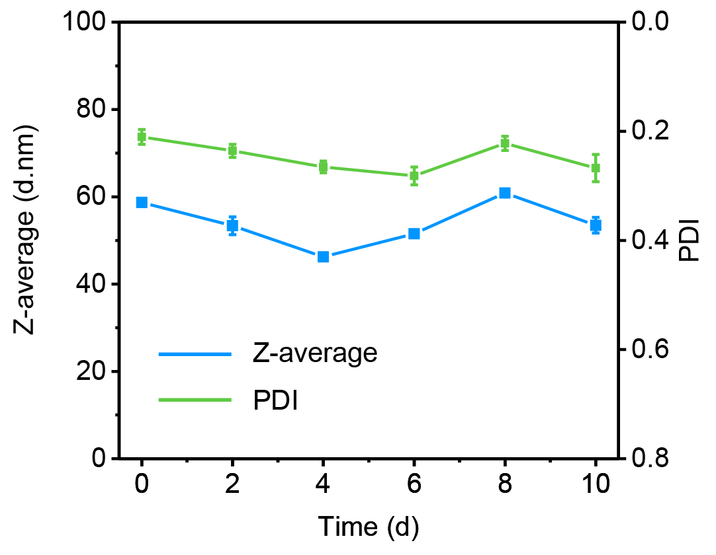
Figure S1. Hydrodynamic diameters and PDI of CNS_{D} after storage in 1× PBS buffer (pH = 7.4) during 10 days (n = 3).

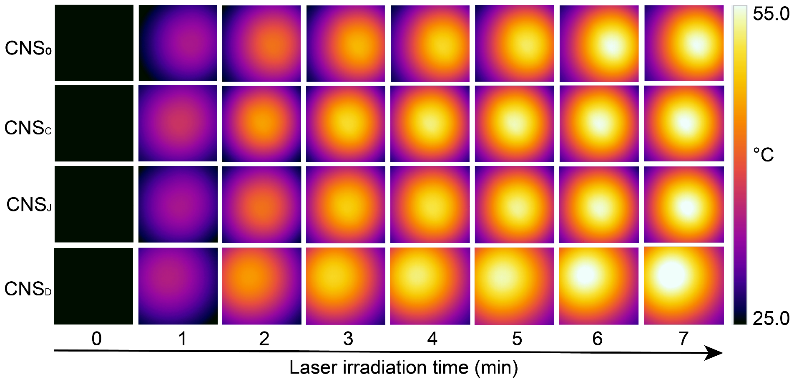
Figure S2. NIR images of CNS₀, CNS_{C}, CNS_{J,} and CNS_{D} ([CuS] = 100 µg mL⁻¹) under the NIR-II laser irradiation (1064 nm, 1.0 W cm⁻²) for 5 min.

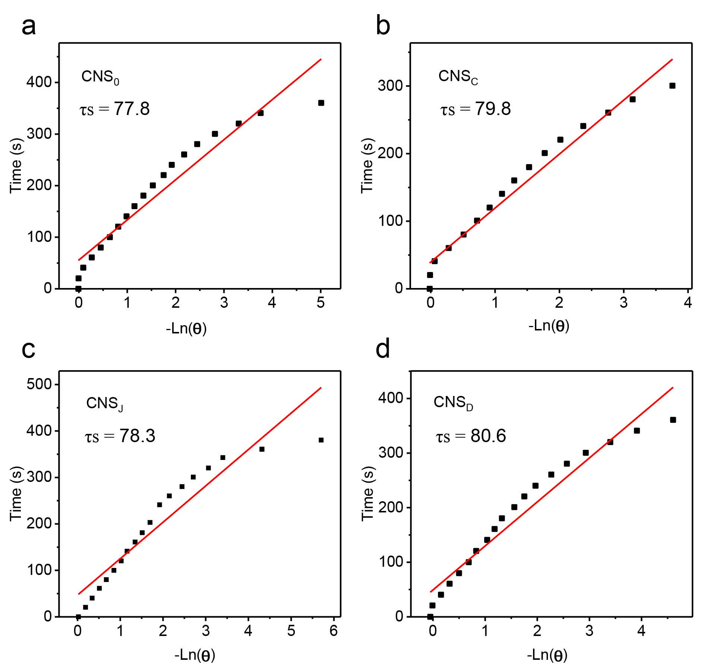

Figure S3. Time constant for heat transfer from the system determined by applying the linear time data from the cooling period of (a) versus negative natural logarithm of driving force temperature.

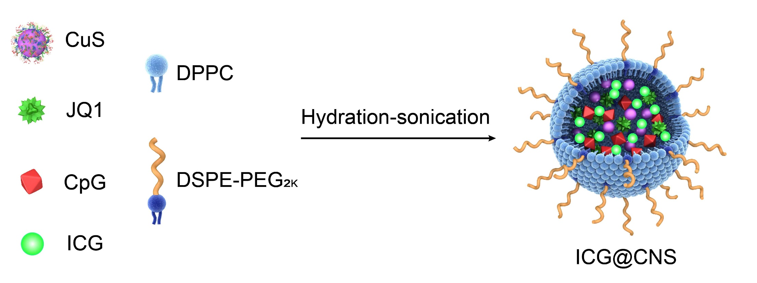

Figure S4. Schematic illustration of synthesis of ICG-loaded CNS nanoparticle (CNS₀@ICG, CNS_{C}@ICG, CNS_{J}@ICG, CNS_{D}@ICG) for tracing the nanoparticle trajectory.

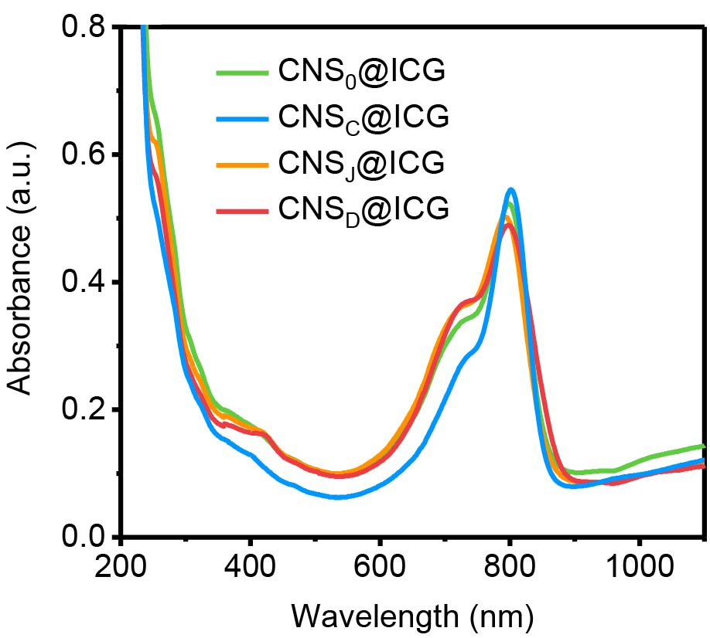

Figure S5. UV-vis absorption spectrums of CNS₀@ICG, CNS_{C}@ICG, CNS_{J}@ICG and CNS_{D}@ICG.

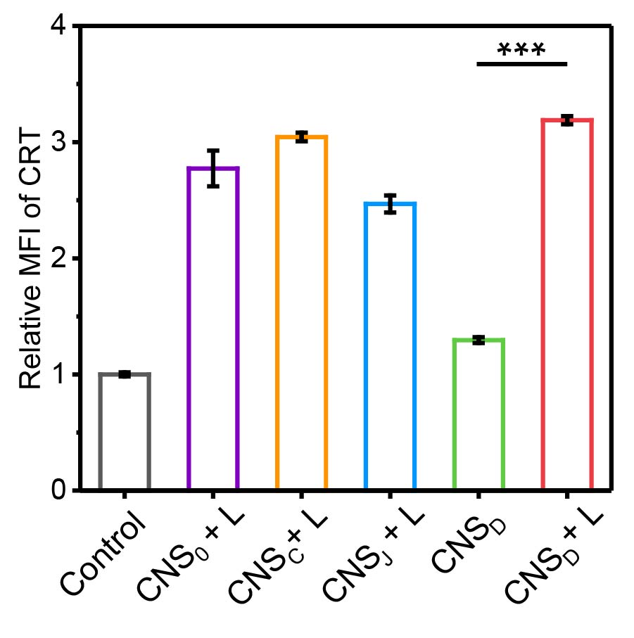

Figure S6. Relative mean fluorescence intensity (MFI) of CRT in Panc02 cells after different treatments.

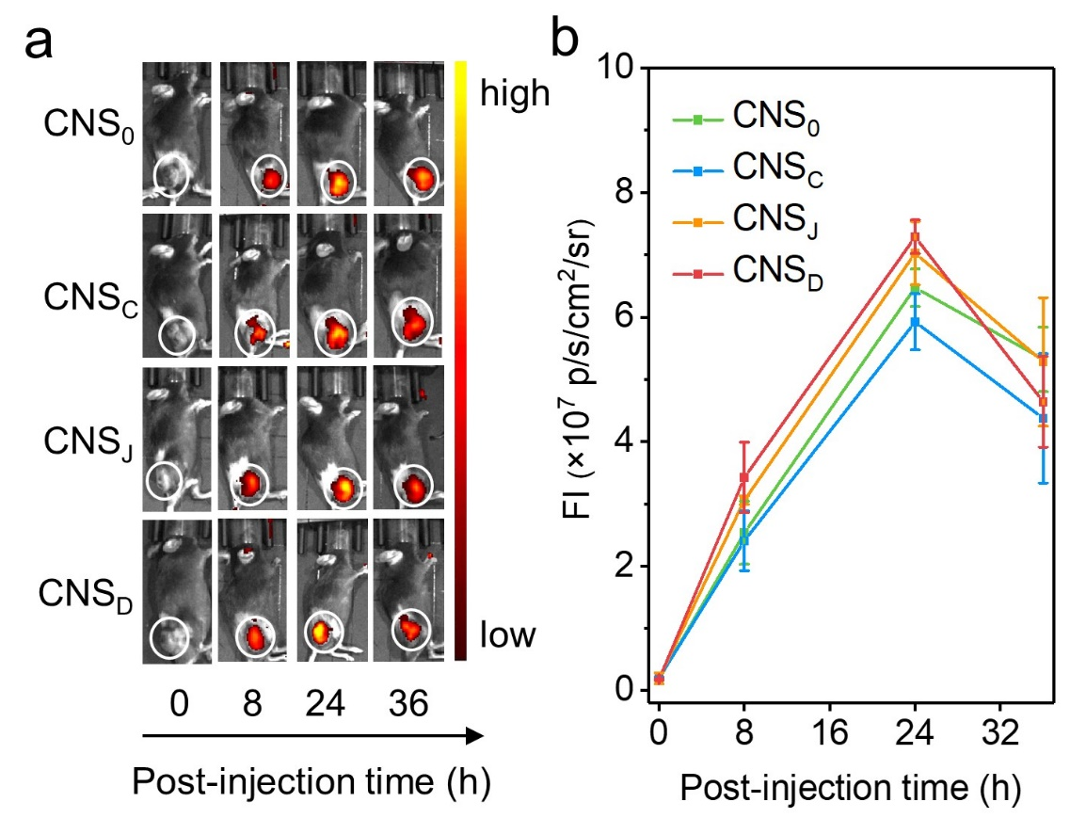
Figure S7. The NIR fluorescence imaging of xenograft Panc02-tumor-bearing C57BL/6 living mice at 0, 8, 24 and 36 h after systemic administration of CNS@ICG through tail-vein administration (0.2 mL, [ICG] = 2 mg kg⁻¹). The fluorescence images were collected with excitation at 710 nm and emission at 790 nm, and the tumors were marked by white circles. (b) The fluorescence intensity of tumor regions of mice at different post-injection times of (n = 3).

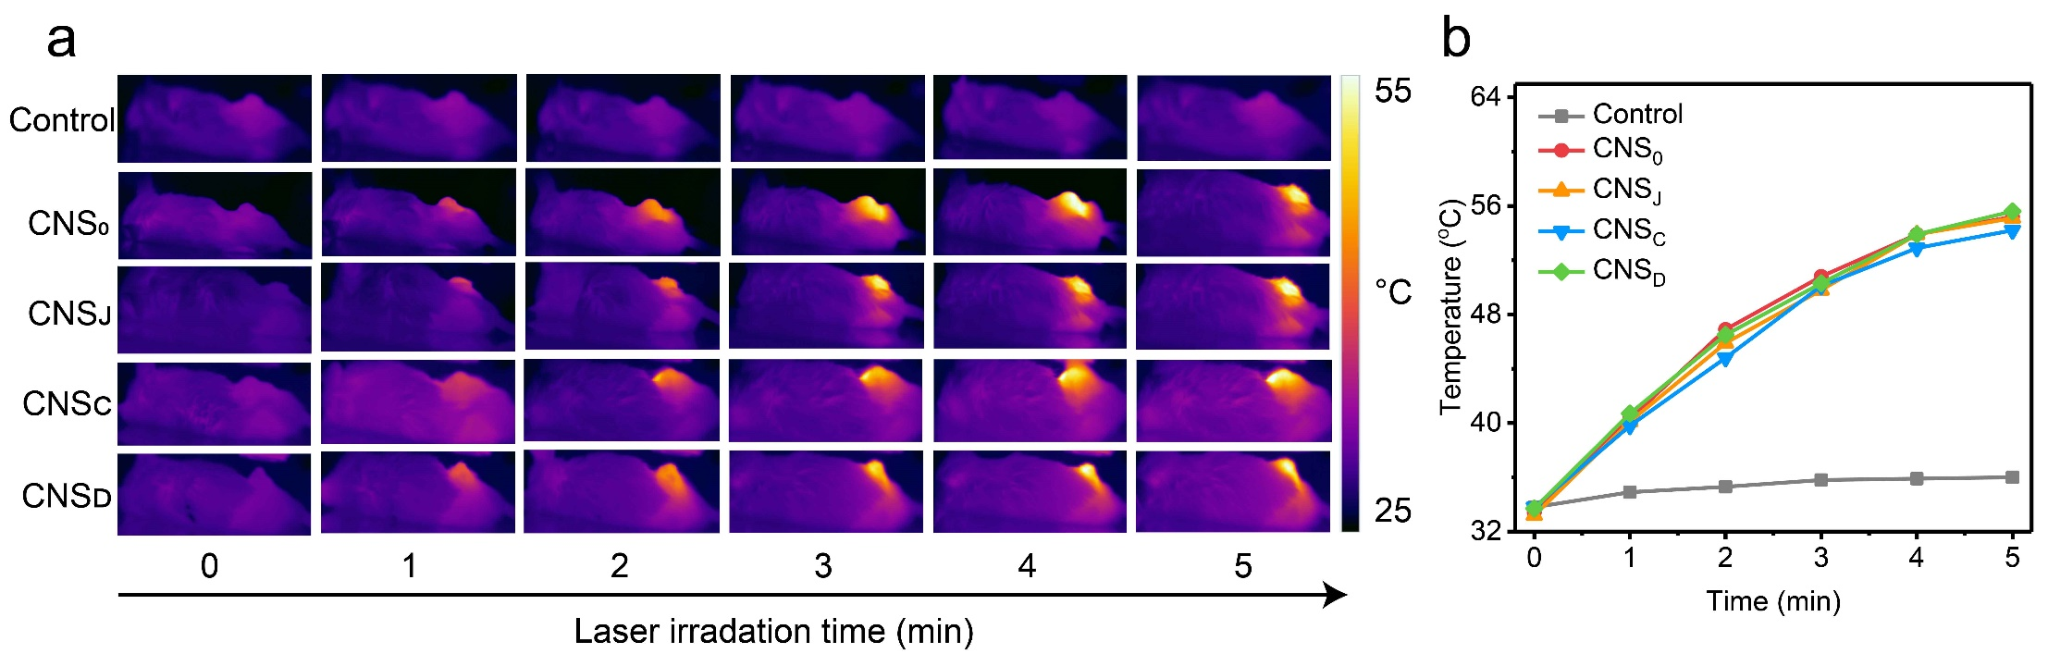
Figure S8. (a) NIR thermal photos of 4T1 tumor-bearing mice under laser irradiation at 24 h post-injection of PBS, CNS₀, CNS_{C}, CNS_{J} and CNS_{D} through tail-vein injection (0.2 mL, the concentration of CuS = 300 µg/mL for CNS₀, CNS_{C}, CNS_{J} and CNS_{D}); (b) Temperature elevation curves of tumors in 4T1 tumor-bearing mice after administration of Control (PBS), CNS₀, CNS_{C}, CNS_{J} and CNS_{D} under NIR-II laser illumination (1064 nm, 1W cm⁻², 5 min).

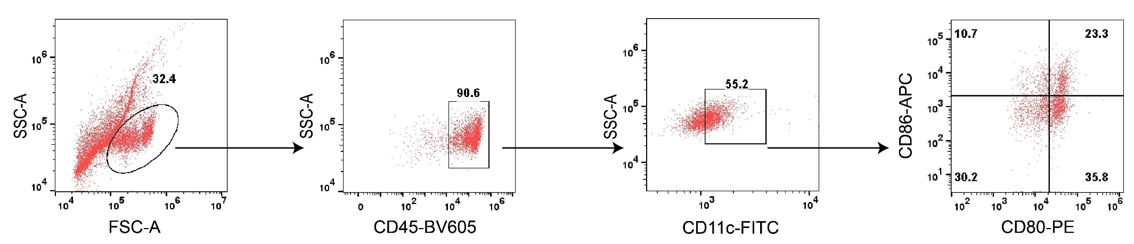
Figure S9. Gating strategies for flow cytometry assay of matured CD80⁺CD86⁺ DCs in tumor-draining lymph nodes of Panc02-tumor bearing C57BL/6 mice.

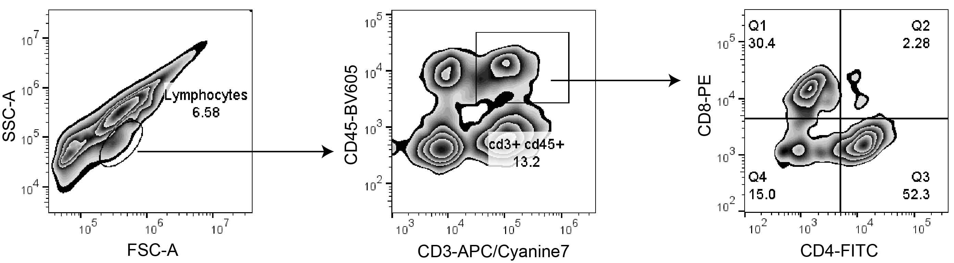
Figure S10. Gating strategy for flow cytometry assay of CD4⁺ T cells and CD8⁺ T cells in distant tumors of Panc02-tumor bearing C57BL/6 mice.

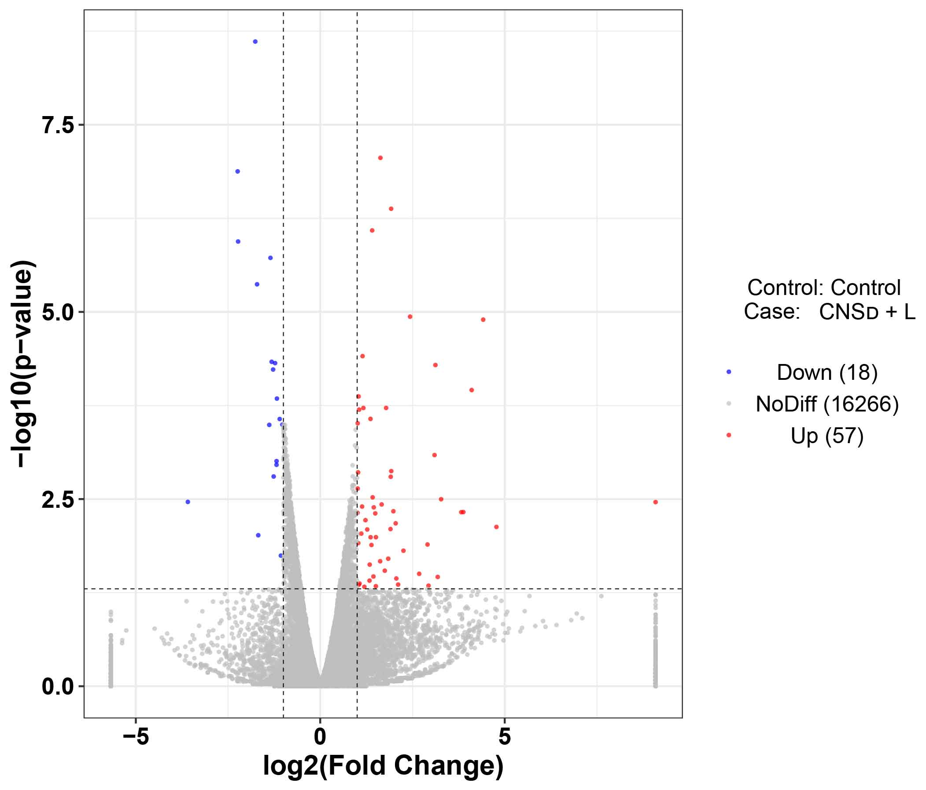
Figure S11. A volcano plot showing the up-regulated or insignificantly expressed or down-regulated genes when comparing the CNS_{D}-treated group with the Control (PBS) group.

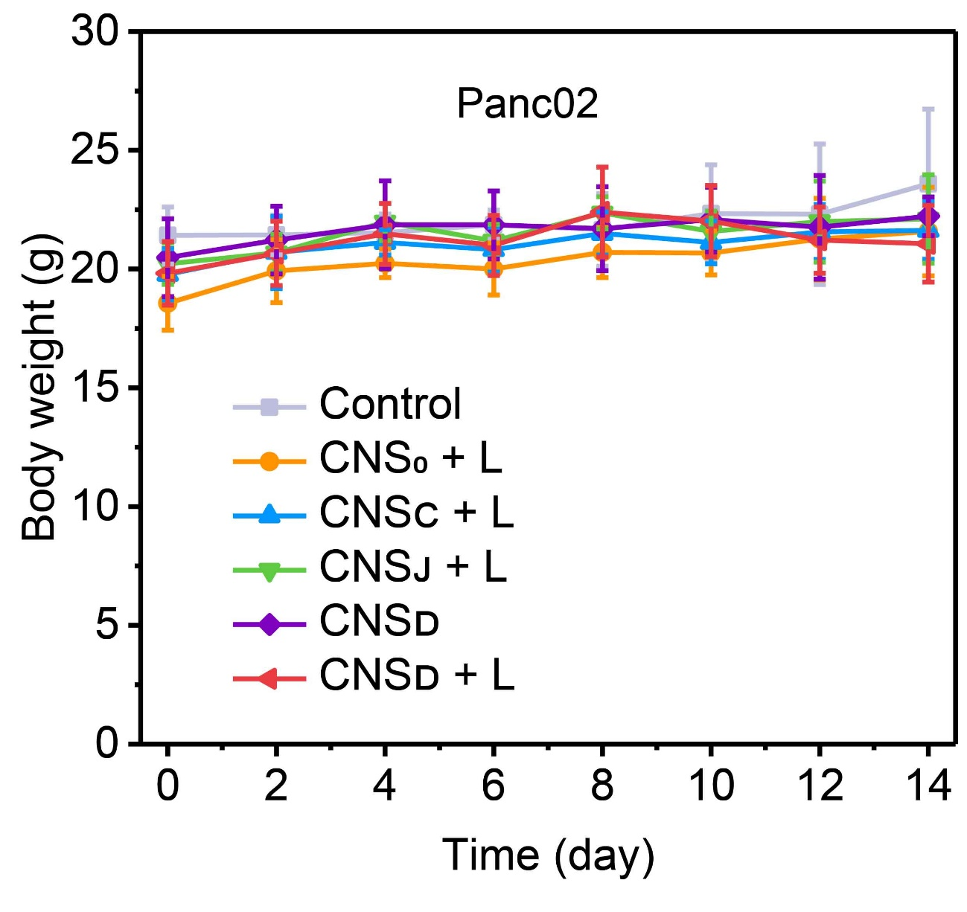
Figure S12. Body weights of Panc02 tumor-bearing C57BL/6 mice in different groups within 14 days of treatment (Control (PBS), CNS₀, CNS_{C}, CNS_{J} and CNS_{D}, 0.2 mL, [CuS] = 300 μg/mL, n = 5).

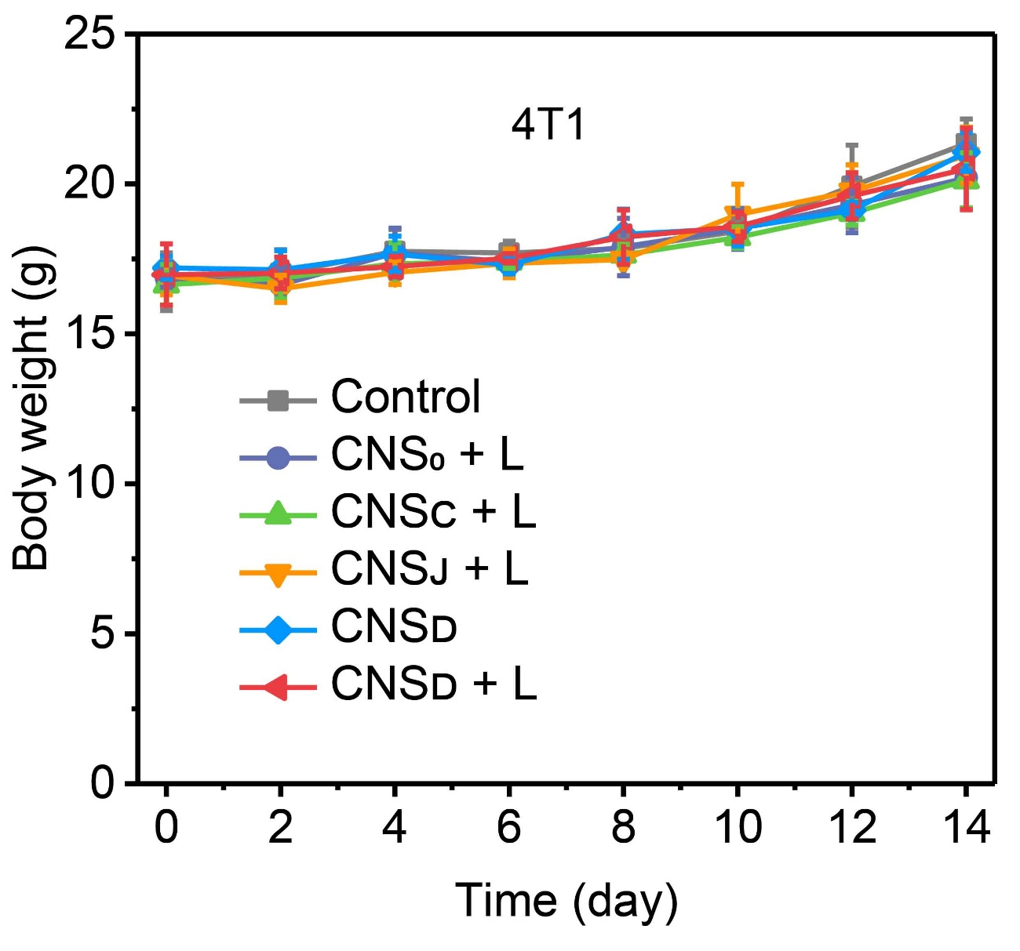
Figure S13. Body weights of 4T1 tumor-bearing Balb/c mice in different groups within 14 days of treatment (Control (PBS), CNS₀, CNS_{C}, CNS_{J} and CNS_{D}, 0.2 mL, [CuS] = 300 μg/mL, n = 5).

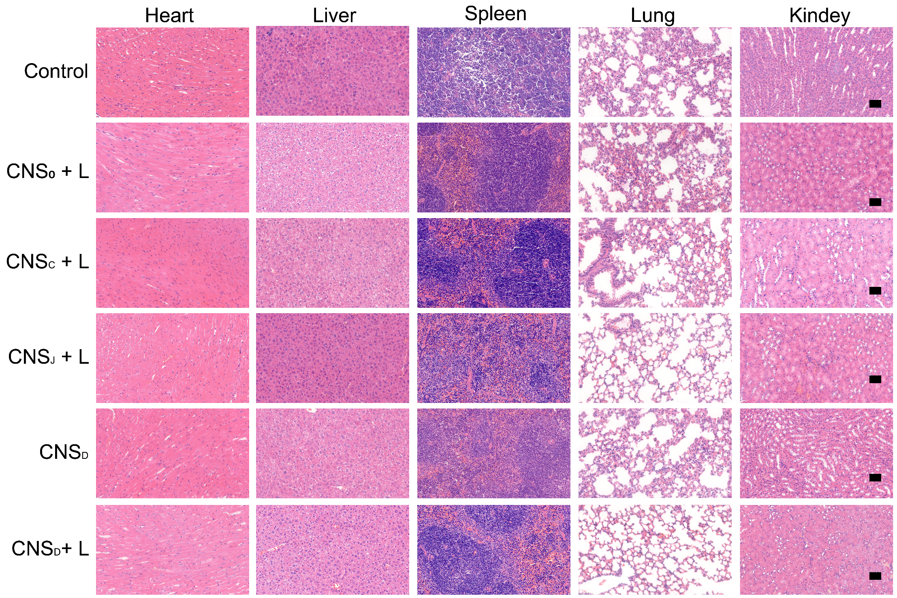
Figure S14. Representative histological H&E staining images of major organs (heart, liver, spleen, lung and kidney) collected from Panc02-tumor bearing C57BL/6 mice in different treatment groups at the end of treatment (Control (PBS), CNS₀, CNS_{C}, CNS_{J} and CNS_{D}, 0.2 mL, [CuS] = 300 μg/mL). The scale bar represents 50 μm.

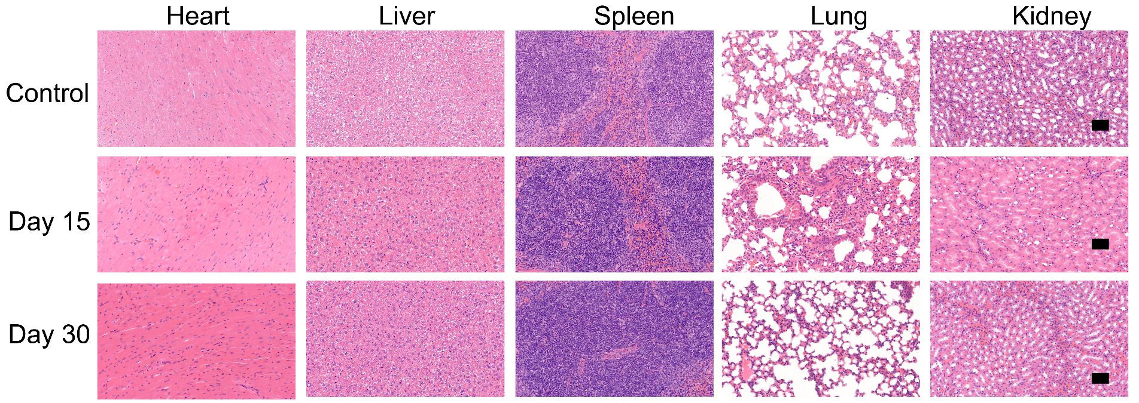
Figure S15. Representative histological H&E staining photos of major organs (heart, liver, spleen, lung, and kidney) in healthy C57BL/6 mice before treatment (Control) and after tail-intravenous injection of CNS_{D} (0.2 mL, [CuS] = 00 μg/mL) for 15 (Day 15) and 30 days (Day 30). The scale bar represents 50 μm.

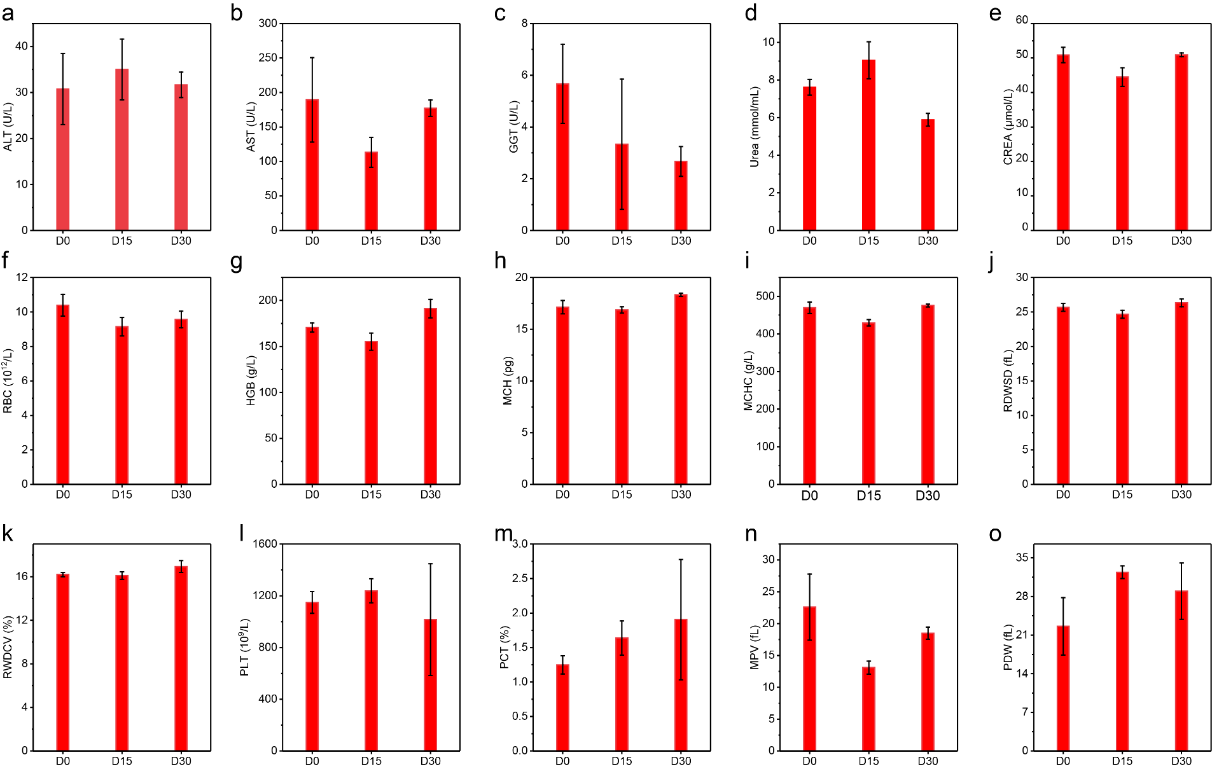
Figure S16. The levels of (a) alanine aminotransferase (ALT), (b) aspartate aminotransferase (AST), (c) γ-glutamyl transpeptidase (GGT), (d) urea, (e) creatinine (CREA), (f) red blood cells (RBC), (g) hemoglobin (HGB), (h) mean corpuscular hemoglobin (MCH), (i) hemoglobin concentration (MCHC), (j) red cell distribution width (RDW-SD), (k) red cell volume distribution width (RDW-CV), (l) platelet (PLT), (m) plateletcrit (PCT), (n) mean platelet volume (MPV), and (o) platelet distribution width (PDW) in the blood of healthy C57BL/6 mice before treatment (D0) and after tail-intravenous administration of CNS_{D} (0.2 mL, [CuS] = 300 μg/mL) for 15 (D15), and 30 days (D30) (n = 3).

