Supplementary Information

Preparation and characterization of QP12
QP12 was prepared following a three-step procedure as depicted in Scheme S1. Diethanolamine (0.1 mol) and potassium carbonate (0.3 mol) were dissolved in acetone. After heating and stirring under reflux for 1 h, suction filtration was performed to obtain a filtrate. 1-Bromododecane was dissolved in a small amount of acetone and added slowly dropwise to the subsequent filtrate. The reaction was continued by heating and stirring for 24 h. The end of the reaction was detected using thin-layer chromatography. The solvent diethanolamine was separated via a separatory funnel, yielding a yellow liquid, and the mixture was separated via column chromatography to obtain N, N-dihydroxyethyl-N-dodecyl-tertiary amine (LA12). Next, 6-bromo-1-hexene (0.8 g) and anhydrous toluene (5 mL) were added to PMHS (245 μL) in sequence under the protection of argon and stirred for 5 min to fully mix. Next, Karstedt catalyst (50 μL) was added and the mixture was allowed to react at 65 °C for 48 h. The product was precipitated and washed with cold methanol three times and dried in an oven at 55 °C for 12 h. The obtained solid was dissolved in chloroform, filtered using a 0.22-μm filter membrane, and rotary-evaporated to obtain light yellow PMHS grafted with bromohexane (MHSB). Finally, the synthesized MHSB (1-time equivalent) and LA12 (1.37 g, 0.005 mol) were mixed by adding a mixture (5 mL) of DMF and CHCl₃ at a ratio of 1:1. The mixture was heated and stirred under reflux for 24 h. The product was then washed with ether, precipitated overnight, and dried to obtain QP12. QP12 structures were determined using Fourier transform infrared (FT-IR, Frontier, PerkinElmer) spectroscopy and proton nuclear magnetic resonance (¹H NMR), and the grafting rate of QP12 was determined through elemental analysis (Vario EL, Elementar).

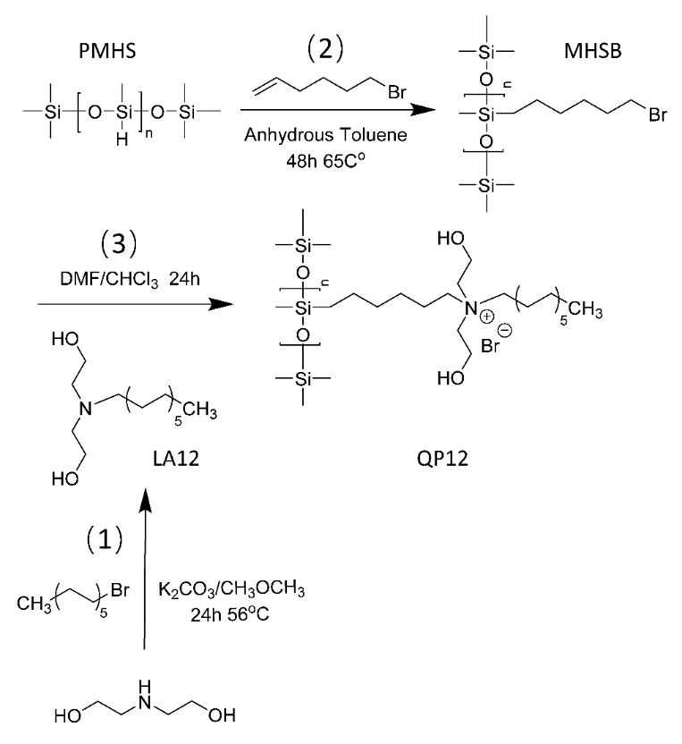
Figure S1. Synthetic routes employed for the preparation of QP12.

In vitro antibacterial effect of QP12
Gram-positive bacteria (S. aureus, α-H. tococcus), gram-negative bacteria (E. coli, P. aeruginosa, P. vulgaris), and fungi (C. albicans) were used to evaluate the ability of QP12 to resist bacterial invasion. Bacterial cultures were diluted to an appropriate amount (1 × 10⁶ CFU mL⁻¹) and then incubated with different formulations at varied concentrations according to the two-fold dilution method for 18 h at 37 °C. The minimum inhibitory concentration (MIC) was obtained by comparing the turbidity of bacteria in each experimental group. The clarified bacterial suspension (100 μL) was incubated with different formulations seeded in a solid medium and cultured for 24 h at 37 °C. The minimum bactericidal concentration (MBC) of different formulations was calculated as the minimum concentration of the drug solution corresponding to a plate count of fewer than five colonies.

In vitro cytotoxicity and proliferation
The cytotoxicity of different treatments was investigated using the MTT assay. Human immortalized epidermal (HaCaT) and normal human liver (LO2) cells were seeded onto 96-well plates (5000 cells per well). When the cells reached 80% confluence, the indicated concentrations of different membrane formulations were administered. The cells were further cultured for 24, 48, or 72 h, and MTT (20 μL, 5 mg mL⁻¹) was added to the cell cultures. After 4 h of incubation, media were removed, replaced with DMSO (150 μL), and shaken for 10 min. Cell viability was assessed by recording the absorbance at 570 nm using a microplate reader and cell proliferation was analyzed.

In vitro cell adhesion
The nanomembrane was cut into disks at a diameter of 1.5 cm and placed in a 24-well plate after sterilization. After washing three times with PBS and DMEM for 15 min each, each well was inoculated with the cell suspension (1 mL) at a concentration of 5 × 10⁴ cells/mL and placed in an incubator in a humidified atmosphere containing 5% CO₂ at 37 °C for 24, 36, or 72 h. The cultured nanomembrane was taken out and washed with PBS to remove unadhered cells. For SEM, the nanomembranes were fixed overnight with 2.5% glutaraldehyde at 4 °C. After washing three times with PBS, the nanomembranes were dehydrated through sequential treatments of 50, 75, 85, 95, and 100% ethanol. The final samples were dried in a vacuum freezing/drying oven before being inspected via SEM.

In vivo skin irritation
Nanomembranes were cut into rectangles (1.5 × 2 cm) and added to saline (polar reagent, 1 mL) or cottonseed oil (non-polar reagent, 1 mL) for 72 h at 37 °C to obtain extracts. After sterilization, the nanomembrane extract in two solvents (0.2 mL) was injected into the left side of the rabbit spine. Five parallel experimental groups were set up bearing a 2 cm wound. Next, the right side was injected with an equal dose of the solvent. The redness and swelling of the skin were observed and recorded 24, 36, and 72 h after injection and scored according to the degree of skin erythema and edema at each injection site. The skin irritation of the nanomembrane was determined based on the resulting scores.

In vitro blood coagulation
To verify the blood coagulation effect of the nanomembranes, they were cut into small square pieces (1 × 1 cm). After preheating at 37 °C for 5 min, rabbit blood (200 μL, containing 20 μL of 0.2 M CaCl₂) was added dropwise to the surface of the nanomembrane and incubated for 5 min. Distilled water (25 mL) was added to dissolve the uncoagulated rabbit blood and shaken for 20 min at 37 °C and 40 rpm. The optical density (OD) of the supernatant at 545 nm was measured using a microplate reader, and the blood-clotting index was calculated through the ratio of the corresponding OD in different groups to the OD of the control group.

In vivo hemostasis
A longitudinal incision (1 cm) was made at the distal end of the rabbit ear artery or liver, and the indicated membranes were then used to cover the wounds to stop bleeding with pressure. The bleeding around the wound was observed every 20 s. When there was no bleeding within 1 min, hemostasis was regarded as completed. The hemostatic time was recorded as the time required from the application of the membranes until hemostasis. After hemostasis was completed, the membranes were weighed, and the amount of bleeding was calculated.

Blood compatibility
Nanomembranes cut into small squares (1 × 1 cm) were added to saline (10 mL) and placed in a water bath for 30 min preheating. Fresh anticoagulated rabbit blood (20 mL) was collected in potassium oxalate anticoagulant (1 mL). Fresh anticoagulated rabbit blood (8 mL) was added to normal saline (10 mL) to dilute for later use. Next, diluted fresh anticoagulated rabbit blood (0.2 mL) was mixed with the membranes and incubated at 37 °C for 60 min. The OD of the supernatant at 545 nm was measured using a microplate reader.

Table S1. Elemental analysis of QP12.
 | N | C | H | DS_{N/S} | DS_{C/H}
MHSB | 0 | 38.92 | 6.89 | / | /
QP12-1 | 0.78 | 45.45 | 8.5 | 22.99% | 20.23%
QP12-2 | 0.96 | 42.22 | 7.04 | 14.98% | 17.85%
MHSB, polymethyl hydrogen siloxane grafted with bromohexane; QP12, quaternized silicone.

Table S2. Classification of toxicity grade based on relative growth rate.
Relative growth rate | Toxicity grade | Result evaluation
> 100 | 0 | Qualified
75–99 | 1 | Qualified
50–74 | 2 | Qualified
25–49 | 3 | Qualified
1–24 | 4 | Qualified
0 | 5 | Qualified

Table S3. The degree of skin erythema and edema with clinical scores of 0–4.
Score | Erythema | Score | Edema (ED)
0 | No erythema | 0 | No Edema
1 | Slight erythema (barely visible) | 1 | Slight Edema (barely visible)
2 | Clear erythema | 2 | Clear Edema (swelling, not beyond the contact area)
3 | Moderate erythema | 3 | Moderate Edema (swelling about 1 mm)
4 | Severe erythema (purple-red to eschar formation) | 4 | Severe Edema (swelling more than 1 mm and beyond the contact area)

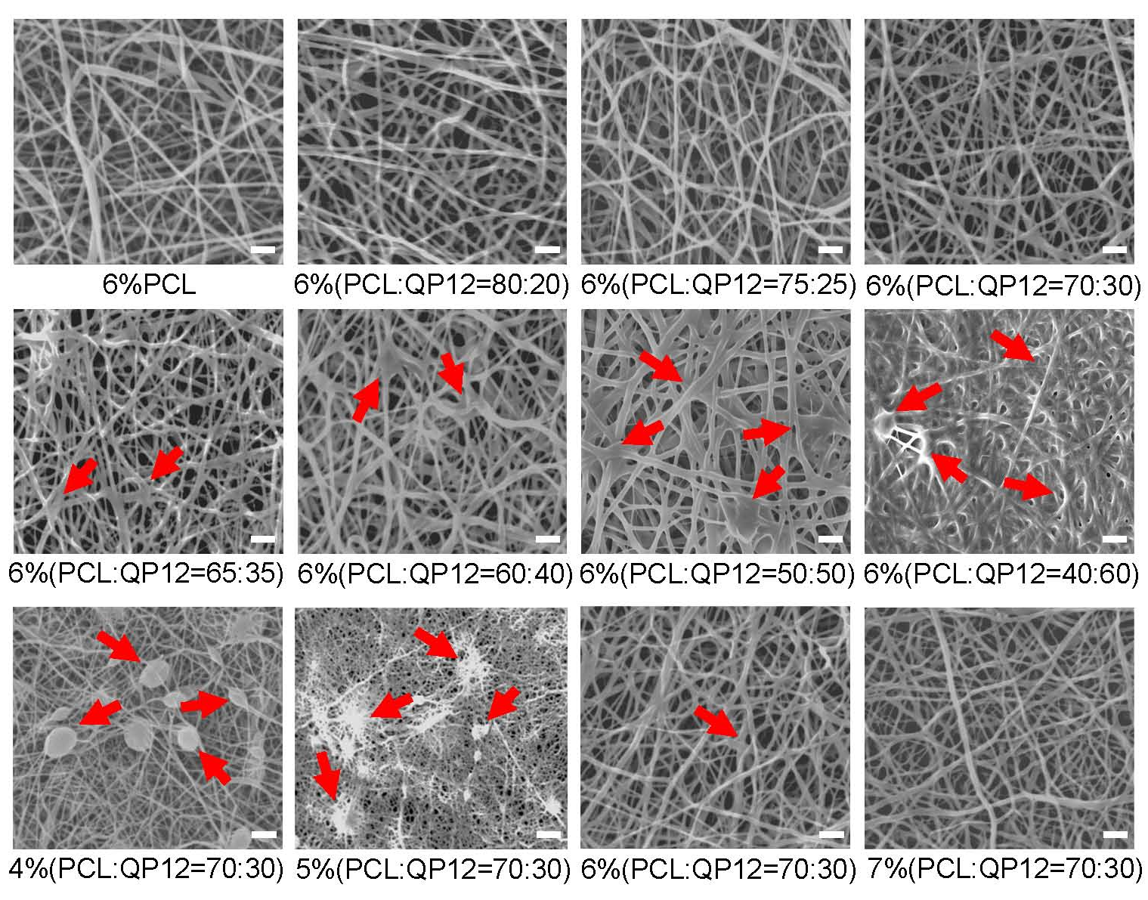
Figure S2. SEM images of MQP12 prepared under different blending ratios and different concentrations. The red arrows indicate the formation of beads (Scale bar = 1 μm).

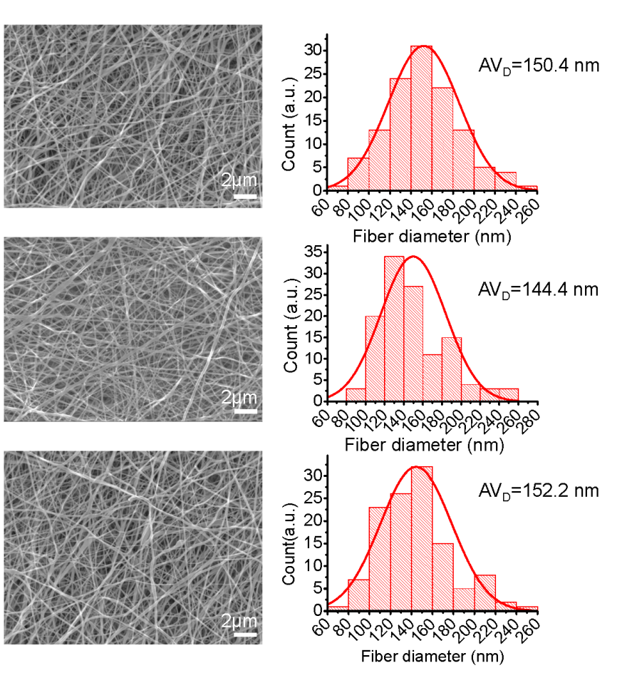
Figure S3. SEM images and fiber diameter distribution of MQP12 prepared three times.

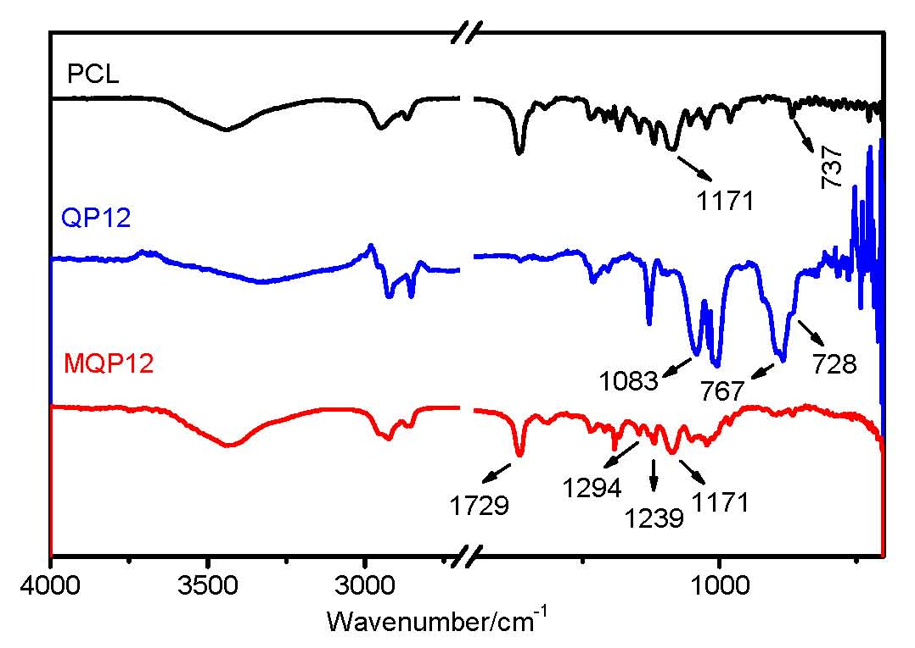
Figure S4. FT-IR spectra of PCL, QP12, and MQP12.

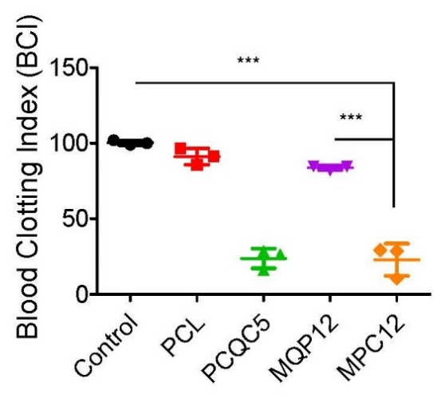
Figure S5. BCI of control, PCL, PCQC5, MQP12, and MPC12. Data are presented as the mean ± SD, ***p < 0.001 (t-test).

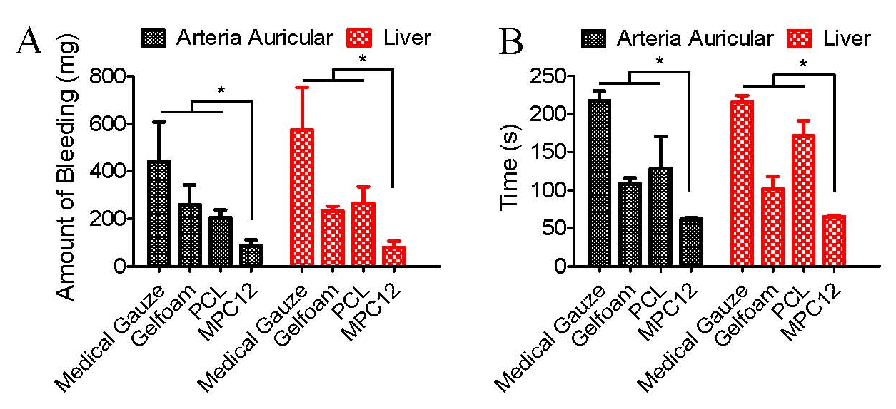
Figure S6. Amount of bleeding and hemostasis duration of ear artery bleeding (a) and liver bleeding (b) treated with different materials. Data are presented as mean ± SD, *p < 0.05 (t-test).

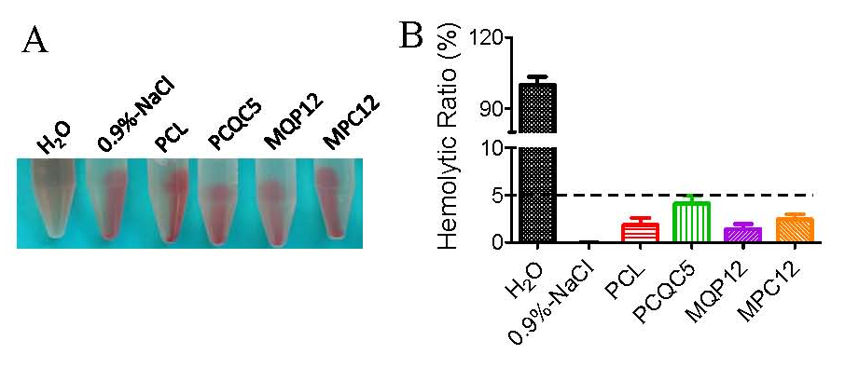
Figure S7. Evaluation of hemolysis performance of different nanofiber membranes. (a) Images of the hemolytic properties of different nanofiber membranes. (b) Hemolytic ratio of different nanofiber membranes.

