Summary of neurons recorded in the lesioned hemisphere in the animals
Monkey A (L-Dopa)
Channel | Location | Cell count | # Sessions
10 | STN | 1 | 1
13 | VPL | 2 | 2
17 | preM | 1 | 1
19 | preM | 2 | 2
20 | preM | 1 | 1
21 | preM | 4 | 4

Monkey B (L-Dopa)
Channel | Location | Cell count | # Sessions
2 | S1 | 2 | 2
3 | S1 | 1 | 1
4 | S1 | 23 | 12
5 | MGN | 7 | 7
6 | MGN | 9 | 7
8 | MGN | 1 | 1
9 | MGN | 16 | 15
10 | MGN | 5 | 5
11 | MGN | 4 | 4
12 | MGN | 3 | 3
13 | Pulv | 1 | 1
14 | Pulv | 2 | 2
15 | Pulv | 2 | 2
16 | Pulv | 3 | 3
18 | Str | 2 | 2
19 | Str | 3 | 3
20 | Str | 10 | 9
21 | Str | 11 | 9
22 | Str | 4 | 2
23 | Str | 2 | 2
24 | ZI | 10 | 9
25 | ZI | 4 | 4
26 | ZI | 2 | 2
27 | ZI | 3 | 3
28 | STN | 16 | 12
29 | STN | 8 | 6
30 | STN | 4 | 4
31 | STN | 18 | 14
32 | STN | 15 | 13

Monkey B (Apomorphine)
Channel | Location | Cell count | # Sessions
1 | S1 | 3 | 3
9 | MGN | 1 | 1
10 | MGN | 2 | 2
11 | MGN | 3 | 3
12 | MGN | 2 | 2
13 | Pulv | 5 | 4
17 | S1 | 11 | 8
18 | Str | 2 | 2
21 | Str | 2 | 2
22 | Str | 3 | 3
25 | ZI | 4 | 4
27 | ZI | 2 | 2

STN = subthalamic nucleus
VPL = ventral posterolateral nucleus of the thalamus
preM = premotor cortex
S1= primary somatosensory cortex
MGN = medial geniculate nucleus of the thalamus
Pulv = pulvinar nucleus of the thalamus
Str = striatum (caudate-putamen)
ZI = zona incerta

Supplementary Table 1
Overview of recording locations in the two animals, as confirmed by histological verification, as well as the total number of isolated single units in each channel, and the number of recording sessions with units present.

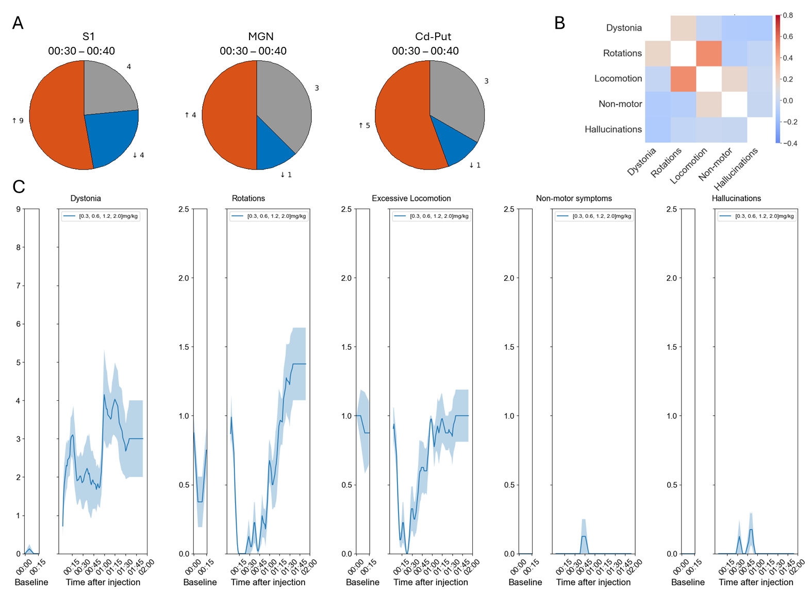
Supplementary Figure 1 – Behavioral and neurophysiological changes induced by apomorphine
Apomorphine induced excessive motor behaviors and increases in neuronal firing rates resembling the effects of L-DOPA. A) Fractions of cells showing significant changes in firing rates 30-40 minutes after apomorphine compared to their baseline firing rates (-15 to -5 minutes prior to injection). B) Temporal correlation matrix of abnormal behaviors (warm colors denote behaviors that tended to co-occur during the same 1-minute observation period and blue colors denote behaviors that tended to be mutually exclusive). C) Average frequency/severity scores of the five main categories of abnormal behaviors observed as a function of time after apomorphine treatment, throughout the 2 h observation period. Note the biphasic responses in the behavioral plots, which represent suppression of motor activity at initial lower plasma levels, followed by increased motor activity in the latter part of the session (as previously described; Ek et al., 2016).

