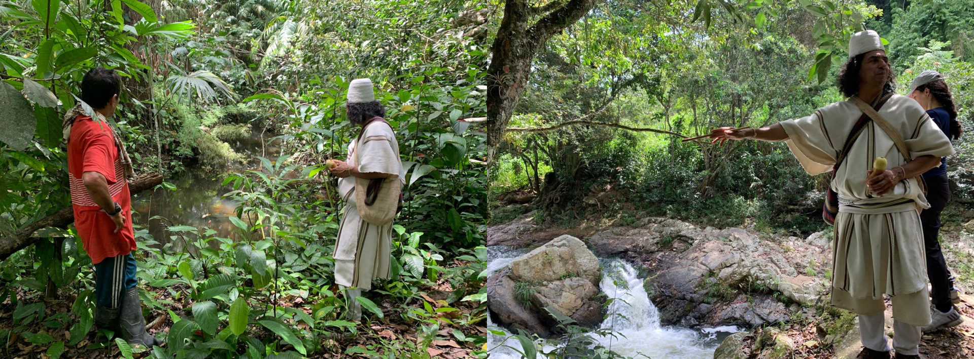
Figure. 1 Sacred water site (left) and ritual pagamento practice for water (right) documented during field visits with community authorities

