European Marine Protected Areas are well-placed and climate-resilient, but weakly protected - Supplementary material
Patrick A. Eskuche-Keith^{1,2}, Anna M. Addamo³, Peter M. Almond¹, Barbara Horta e Costa^{2,4}, Silas C. Principe⁵, Jorge Assis^{3,4}, Inês Sousa⁴, Even Moland^{6,7}, Alf R. Kleiven⁶, Johanna M. Aarflot⁶, Pippa J. Moore⁸, Daniel Skerritt^{1,9}, Elsa Sim³, Mark John Costello³, Fabrice Stephenson^{1,2}.
Affiliations
¹ School of Natural and Environmental Sciences, Newcastle University, UK
² IUCN World Commission on Protected Areas, Gland, Switzerland
³ Faculty of Biosciences and Aquaculture, Nord University, Bodø, Norway
⁴ Centre of Marine Sciences (CCMAR/CIMAR LA), Universidade do Algarve, Campus de Gambelas, Faro, Portugal
⁵ Ocean Biodiversity Information System, International Oceanographic Data and Information Exchange, Intergovernmental Oceanographic Commission, UNESCO, Oostende, 8400, Belgium
⁶ Institute of Marine Research, P.O. Box 1870, Nordnes 5817 Bergen, Norway
⁷ Centre for Coastal Research, University of Agder, P.O. Box 422, Kristiansand 4604, Norway
⁸ The Dove Marine Laboratory, School of Natural and Environmental Sciences, Newcastle University, Newcastle, UK
⁹ Transparent Oceans Initiative, Oceana, Washington, DC, USA.

Table S1: Percent cover of pan-European national Exclusive Economic Zones (EEZs) by marine protected area (MPA) protection levels. Values are presented for across all MPAs, by grouped protection level (Strong = Fully and Highly, Weak = Lightly, Minimally and Incompatible), and for each protection level individually.
Nation | All MPAs | Strong | Weak | Fully | Highly | Lightly | Minimally | Incompatible | Unclassified
Belgium | 37.4 | 0.0 | 37.3 | 0.0 | 0.0 | 0.1 | 17.1 | 20.2 | 0.0
Bulgaria | 8.1 | 0.0 | 8.1 | 0.0 | 0.0 | 0.0 | 8.1 | 0.0 | 0.0
Croatia | 9.2 | 0.1 | 9.0 | 0.1 | 0.0 | 0.0 | 7.6 | 1.4 | 0.1
Cyprus | 8.6 | 0.0 | 0.0 | 0.0 | 0.0 | 0.0 | 0.0 | 0.0 | 8.6
Estonia | 17.9 | 0.8 | 16.3 | 0.0 | 0.8 | 11.7 | 4.6 | 0.0 | 0.7
Finland | 10.9 | 0.3 | 10.4 | 0.2 | 0.1 | 5.5 | 4.8 | 0.0 | 0.2
France | 47.7 | 0.5 | 44.4 | 0.0 | 0.5 | 3.6 | 38.5 | 2.4 | 2.8
Germany | 44.8 | 0.6 | 44.2 | 0.0 | 0.6 | 4.5 | 5.0 | 34.7 | 0.0
Greece | 4.6 | 0.0 | 4.6 | 0.0 | 0.0 | 2.2 | 2.1 | 0.3 | 0.0
Iceland | 0.4 | 0.0 | 0.0 | 0.0 | 0.0 | 0.0 | 0.0 | 0.0 | 0.4
Ireland | 2.3 | 0.2 | 1.9 | 0.0 | 0.2 | 0.3 | 1.1 | 0.5 | 0.3
Italy | 10.6 | 0.4 | 9.9 | 0.1 | 0.3 | 1.7 | 8.1 | 0.1 | 0.3
Kingdom of Denmark | 5.3 | 0.0 | 5.2 | 0.0 | 0.0 | 2.2 | 1.5 | 1.5 | 0.1
Latvia | 15.8 | 0.0 | 15.8 | 0.0 | 0.0 | 1.4 | 14.3 | 0.0 | 0.0
Lithuania | 22.4 | 0.0 | 22.4 | 0.0 | 0.0 | 13.4 | 9.0 | 0.0 | 0.0
Malta | 7.8 | 0.0 | 7.2 | 0.0 | 0.0 | 0.0 | 6.8 | 0.4 | 0.6
Netherlands | 25.4 | 0.0 | 25.3 | 0.0 | 0.0 | 0.5 | 0.0 | 24.8 | 0.1
Norway | 4.3 | 0.0 | 4.3 | 0.0 | 0.0 | 0.9 | 0.6 | 2.8 | 0.0
Poland | 23.6 | 0.4 | 20.6 | 0.0 | 0.4 | 7.6 | 1.3 | 11.6 | 2.6
Portugal | 4.4 | 0.1 | 2.4 | 0.0 | 0.1 | 0.4 | 1.9 | 0.0 | 2.0
Romania | 20.9 | 0.0 | 20.9 | 0.0 | 0.0 | 9.1 | 4.7 | 7.2 | 0.0
Slovenia | 4.7 | 0.7 | 4.0 | 0.7 | 0.0 | 0.7 | 3.3 | 0.0 | 0.0
Spain | 13.1 | 0.0 | 11.3 | 0.0 | 0.0 | 1.6 | 3.9 | 5.7 | 1.8
Sweden | 15.6 | 0.8 | 13.5 | 0.1 | 0.7 | 2.0 | 4.0 | 7.5 | 1.3
United Kingdom | 43.5 | 0.1 | 43.4 | 0.0 | 0.1 | 0.9 | 21.4 | 21.1 | 0.0

Table S2: Summary statistics for the distribution of values of the overlap between species and marine protected areas (MPAs). Values represent the proportion of species distributions covered by MPAs as a percentage of the total area of their distribution across pan-European seas. Values are presented for all species across all MPAs, by grouped protection level (Strong = Fully and Highly, Weak = Lightly, Minimally and Incompatible), and also by biotic group and MPA protection level. Q95 = 95th percentiles, Min = minimum, Max = maximum.
Biotic group | Statistic | All MPAs | Strong | Weak | Fully | Highly | Lightly | Minimally | Incompatible | Unclassified
All | Median | 25.1 | 0.2 | 22.0 | 0.0 | 0.2 | 2.5 | 9.5 | 5.3 | 1.5
All | Q95 | 44.8 | 1.3 | 41.6 | 0.2 | 1.1 | 9.8 | 19.9 | 25.4 | 7.3
All | Min | 0.0 | 0.0 | 0.0 | 0.0 | 0.0 | 0.0 | 0.0 | 0.0 | 0.0
All | Max | 92.4 | 5.8 | 92.4 | 1.9 | 5.8 | 46.4 | 90.0 | 92.4 | 84.4
Benthic invertebrates | Median | 28.5 | 0.2 | 25.0 | 0.0 | 0.2 | 2.6 | 10.1 | 7.6 | 1.3
Benthic invertebrates | Q95 | 45.7 | 1.3 | 42.6 | 0.2 | 1.2 | 10.0 | 20.2 | 26.7 | 6.7
Benthic invertebrates | Min | 0.1 | 0.0 | 0.0 | 0.0 | 0.0 | 0.0 | 0.0 | 0.0 | 0.0
Benthic invertebrates | Max | 92.4 | 3.9 | 92.4 | 1.9 | 3.6 | 33.1 | 47.0 | 92.4 | 46.0
Pelagic invertebrates | Median | 13.8 | 0.1 | 11.8 | 0.0 | 0.1 | 1.6 | 6.8 | 2.3 | 1.6
Pelagic invertebrates | Q95 | 34.5 | 0.6 | 31.1 | 0.1 | 0.6 | 6.8 | 15.3 | 15.4 | 6.4
Pelagic invertebrates | Min | 0.0 | 0.0 | 0.0 | 0.0 | 0.0 | 0.0 | 0.0 | 0.0 | 0.0
Pelagic invertebrates | Max | 62.7 | 1.4 | 60.9 | 0.7 | 1.2 | 19.9 | 33.5 | 58.7 | 27.4
Demersal fish | Median | 29.8 | 0.5 | 24.2 | 0.0 | 0.4 | 4.1 | 13.3 | 3.1 | 2.9
Demersal fish | Q95 | 45.3 | 1.6 | 37.9 | 0.2 | 1.4 | 11.2 | 22.8 | 19.9 | 13.8
Demersal fish | Min | 0.9 | 0.0 | 0.0 | 0.0 | 0.0 | 0.0 | 0.0 | 0.0 | 0.0
Demersal fish | Max | 84.4 | 4.3 | 69.5 | 1.3 | 4.3 | 46.4 | 51.4 | 62.4 | 84.4
Pelagic fish | Median | 14.8 | 0.1 | 12.2 | 0.0 | 0.1 | 1.1 | 8.0 | 1.5 | 1.8
Pelagic fish | Q95 | 39.0 | 1.0 | 34.2 | 0.2 | 0.9 | 8.0 | 19.7 | 15.5 | 9.4
Pelagic fish | Min | 0.0 | 0.0 | 0.0 | 0.0 | 0.0 | 0.0 | 0.0 | 0.0 | 0.0
Pelagic fish | Max | 90.8 | 2.8 | 90.8 | 1.5 | 2.3 | 13.2 | 90.0 | 59.1 | 31.2
Elasmobranchs | Median | 26.5 | 0.4 | 23.2 | 0.0 | 0.3 | 2.3 | 13.2 | 3.6 | 2.3
Elasmobranchs | Q95 | 46.7 | 1.0 | 40.1 | 0.2 | 0.9 | 11.7 | 27.1 | 15.8 | 12.9
Elasmobranchs | Min | 3.5 | 0.0 | 3.5 | 0.0 | 0.0 | 0.0 | 0.5 | 0.0 | 0.0
Elasmobranchs | Max | 76.7 | 1.6 | 68.4 | 0.5 | 1.5 | 19.4 | 53.9 | 22.8 | 18.3
Mammals | Median | 21.8 | 0.2 | 19.6 | 0.0 | 0.2 | 2.0 | 8.3 | 6.5 | 1.5
Mammals | Q95 | 48.9 | 0.6 | 45.5 | 0.1 | 0.5 | 6.0 | 22.3 | 25.2 | 7.2
Mammals | Min | 7.2 | 0.0 | 2.6 | 0.0 | 0.0 | 0.3 | 0.4 | 0.0 | 0.0
Mammals | Max | 58.1 | 1.0 | 58.1 | 0.3 | 0.9 | 14.0 | 31.2 | 57.4 | 11.8
Primary producers | Median | 22.1 | 0.3 | 19.8 | 0.0 | 0.2 | 3.1 | 8.5 | 7.4 | 1.4
Primary producers | Q95 | 42.5 | 1.0 | 40.3 | 0.1 | 0.9 | 8.3 | 16.6 | 23.1 | 5.1
Primary producers | Min | 0.6 | 0.0 | 0.0 | 0.0 | 0.0 | 0.0 | 0.0 | 0.0 | 0.0
Primary producers | Max | 76.6 | 5.8 | 74.7 | 0.6 | 5.8 | 21.7 | 42.8 | 61.0 | 18.6

Table S3: Summary statistics for the distribution of values for the overlap between threatened and habitat-forming species and each marine protected area (MPA) protection level. Values represent the area of species distributions covered by each MPA protection level as a percentage of their total distribution area across pan-European seas. Values are presented across all MPAs, by grouped protection level (Strong = Fully and Highly, Weak = Lightly, Minimally and Incompatible), and also by individual MPA protection level. Q95 = 95th percentiles, Min = minimum, Max = maximum.
Group | Statistic | All MPAs | Strong | Weak | Fully | Highly | Lightly | Minimally | Incompatible | Unclassified
Threatened | Median | 29.4 | 0.4 | 25.0 | 0.0 | 0.4 | 3.9 | 12.5 | 5.5 | 2.2
Threatened | Q95 | 44.8 | 1.6 | 41.7 | 0.2 | 1.6 | 10.5 | 24.3 | 20.5 | 9.4
Threatened | Min | 1.4 | 0.0 | 1.4 | 0.0 | 0.0 | 0.0 | 0.5 | 0.0 | 0.1
Threatened | Max | 76.7 | 2.5 | 69.5 | 0.4 | 2.3 | 16.7 | 53.9 | 50.7 | 18.3
Habitat-formers | Median | 25.0 | 0.4 | 21.2 | 0.0 | 0.3 | 2.3 | 12.9 | 3.0 | 2.5
Habitat-formers | Q95 | 43.9 | 1.5 | 37.4 | 0.1 | 1.3 | 9.8 | 20.4 | 19.1 | 10.2
Habitat-formers | Min | 1.1 | 0.0 | 0.9 | 0.0 | 0.0 | 0.1 | 0.0 | 0.0 | 0.0
Habitat-formers | Max | 64.9 | 2.7 | 63.6 | 1.9 | 2.7 | 14.5 | 29.1 | 31.5 | 21.5

Table S4: Summary statistics for percentage changes in overlap area between biotic groups and marine protected areas (MPAs) under the intermediate Shared Socioeconomic Pathway emissions scenario (SSP2-4.5) for all taxa. Values are presented across all MPAs, by grouped protection level (Strong = Fully and Highly, Weak = Lightly, Minimally and Incompatible), and by biotic group and MPA protection level. Q2.5 = 2.5th percentiles, Q97.5 = 97.5th percentiles, Min = minimum, Max = maximum.
Biotic group | Statistic | All MPAs | Strong | Weak | Fully | Highly | Lightly | Minimally | Incompatible | Unclassified
All | Median | -0.5 | 0.0 | -0.5 | 0.0 | 0.0 | -0.1 | 0.0 | -0.2 | 0.0
All | Q2.5 | -11.7 | -0.4 | -11.5 | -0.1 | -0.4 | -3.5 | -8.4 | -8.6 | -2.7
All | Q97.5 | 14.0 | 0.6 | 12.2 | 0.1 | 0.5 | 4.4 | 7.9 | 7.3 | 3.7
All | Min | -75.6 | -5.4 | -76.3 | -1.9 | -5.3 | -33.1 | -75.6 | -38.0 | -74.7
All | Max | 95.6 | 56.4 | 95.6 | 38.1 | 56.4 | 45.7 | 82.9 | 95.9 | 48.9
Benthic invertebrates | Median | -0.7 | 0.0 | -0.7 | 0.0 | 0.0 | -0.1 | 0.0 | -0.3 | 0.0
Benthic invertebrates | Q2.5 | -11.0 | -0.4 | -11.4 | -0.1 | -0.4 | -3.4 | -8.2 | -9.3 | -1.9
Benthic invertebrates | Q97.5 | 11.7 | 0.6 | 10.4 | 0.1 | 0.5 | 4.0 | 7.0 | 6.8 | 2.9
Benthic invertebrates | Min | -61.6 | -2.7 | -44.1 | -1.9 | -2.4 | -33.1 | -36.3 | -38.0 | -37.2
Benthic invertebrates | Max | 91.3 | 37.1 | 91.3 | 3.9 | 37.2 | 43.2 | 78.9 | 91.7 | 42.3
Pelagic invertebrates | Median | 0.1 | 0.0 | 0.1 | 0.0 | 0.0 | 0.0 | 0.1 | 0.0 | 0.0
Pelagic invertebrates | Q2.5 | -11.1 | -0.3 | -9.0 | 0.0 | -0.3 | -3.5 | -6.6 | -4.8 | -4.9
Pelagic invertebrates | Q97.5 | 18.7 | 0.4 | 18.5 | 0.0 | 0.4 | 5.9 | 10.9 | 6.3 | 6.3
Pelagic invertebrates | Min | -56.4 | -1.3 | -28.3 | -0.4 | -1.1 | -16.3 | -24.7 | -29.6 | -27.4
Pelagic invertebrates | Max | 95.6 | 7.3 | 95.6 | 0.3 | 7.3 | 45.7 | 82.9 | 95.9 | 18.4
Demersal fish | Median | -0.4 | 0.0 | -0.3 | 0.0 | 0.0 | -0.1 | -0.3 | -0.1 | -0.1
Demersal fish | Q2.5 | -15.9 | -0.7 | -11.5 | -0.1 | -0.6 | -6.2 | -11.1 | -5.6 | -6.0
Demersal fish | Q97.5 | 12.3 | 1.0 | 10.6 | 0.1 | 0.9 | 5.5 | 7.2 | 9.1 | 6.1
Demersal fish | Min | -66.7 | -3.5 | -48.9 | -0.5 | -3.6 | -30.4 | -28.7 | -30.3 | -74.7
Demersal fish | Max | 74.5 | 37.0 | 52.9 | 38.1 | 6.4 | 27.4 | 43.0 | 21.7 | 45.1
Pelagic fish | Median | 0.2 | 0.0 | 0.2 | 0.0 | 0.0 | -0.1 | 0.0 | 0.0 | -0.1
Pelagic fish | Q2.5 | -22.7 | -0.6 | -17.3 | -0.1 | -0.5 | -3.6 | -15.1 | -4.0 | -7.6
Pelagic fish | Q97.5 | 14.9 | 1.0 | 12.2 | 0.1 | 1.0 | 3.6 | 8.8 | 6.0 | 4.9
Pelagic fish | Min | -75.6 | -1.8 | -76.3 | -1.5 | -1.8 | -10.1 | -75.6 | -26.9 | -24.1
Pelagic fish | Max | 40.7 | 56.4 | 39.0 | 0.7 | 56.4 | 21.3 | 38.7 | 22.3 | 33.2
Elasmobranchs | Median | -0.9 | 0.0 | -0.5 | 0.0 | 0.0 | -0.1 | -0.4 | -0.3 | -0.2
Elasmobranchs | Q2.5 | -14.4 | -0.6 | -9.7 | -0.1 | -0.5 | -5.8 | -10.4 | -8.4 | -5.7
Elasmobranchs | Q97.5 | 17.7 | 0.4 | 15.8 | 0.1 | 0.5 | 7.6 | 11.4 | 5.3 | 3.6
Elasmobranchs | Min | -29.2 | -1.5 | -36.1 | -0.4 | -1.5 | -13.3 | -26.3 | -14.6 | -9.3
Elasmobranchs | Max | 39.3 | 1.2 | 32.8 | 0.2 | 1.2 | 19.5 | 46.1 | 9.2 | 7.3
Mammals | Median | 1.2 | 0.0 | 1.8 | 0.0 | 0.0 | 0.0 | -0.3 | 1.4 | -0.2
Mammals | Q2.5 | -9.1 | -0.3 | -7.9 | 0.0 | -0.3 | -1.9 | -6.3 | -3.3 | -3.9
Mammals | Q97.5 | 21.4 | 0.1 | 20.4 | 0.0 | 0.1 | 2.3 | 8.1 | 13.2 | 3.8
Mammals | Min | -9.9 | -0.5 | -10.7 | -0.3 | -0.4 | -2.5 | -13.8 | -6.5 | -4.0
Mammals | Max | 25.8 | 0.8 | 21.4 | 0.2 | 0.6 | 3.2 | 14.6 | 18.9 | 12.3
Primary producers | Median | -0.2 | 0.0 | -0.2 | 0.0 | 0.0 | -0.2 | 0.0 | -0.1 | -0.1
Primary producers | Q2.5 | -11.5 | -0.4 | -10.6 | -0.1 | -0.4 | -2.9 | -6.3 | -5.7 | -2.1
Primary producers | Q97.5 | 17.8 | 0.3 | 17.0 | 0.1 | 0.3 | 3.6 | 8.9 | 8.9 | 2.6
Primary producers | Min | -37.1 | -5.4 | -37.4 | -0.3 | -5.3 | -13.0 | -25.3 | -23.3 | -14.9
Primary producers | Max | 64.1 | 2.0 | 41.6 | 0.4 | 2.0 | 35.7 | 46.6 | 36.6 | 48.9

Table S5: Summary statistics for percentage changes in overlap area between biotic groups and marine protected areas (MPAs) under the intermediate Shared Socioeconomic Pathway (SSP2-4.5) emissions scenario for taxa classed as ‘High climate-risk’. Values are presented across all MPAs, by grouped protection level (Strong = Fully and Highly, Weak = Lightly, Minimally and Incompatible), and by biotic group and MPA protection level. Q2.5 = 2.5th percentiles, Q97.5 = 97.5th percentiles, Min = minimum, Max = maximum.
Biotic group | Statistic | All MPAs | Strong | Weak | Fully | Highly | Lightly | Minimally | Incompatible | Unclassified
All | Median | 1.8 | 0.0 | 1.1 | 0.0 | 0.0 | 0.1 | 0.4 | -0.6 | 0.0
All | Q2.5 | -16.3 | -0.8 | -18.2 | -0.2 | -0.7 | -5.2 | -17.4 | -9.3 | -3.6
All | Q97.5 | 31.5 | 2.9 | 27.3 | 0.2 | 2.9 | 13.1 | 14.6 | 15.4 | 11.5
All | Min | -61.6 | -5.4 | -44.1 | -1.5 | -5.3 | -33.1 | -36.3 | -35.9 | -19.2
All | Max | 95.6 | 56.4 | 95.6 | 38.1 | 56.4 | 45.7 | 82.9 | 95.9 | 48.9
Benthic invertebrates | Median | 0.9 | 0.0 | 0.1 | 0.0 | 0.0 | 0.0 | 0.3 | -0.8 | 0.0
Benthic invertebrates | Q2.5 | -18.7 | -0.9 | -22.1 | -0.3 | -0.8 | -5.6 | -21.6 | -10.5 | -3.1
Benthic invertebrates | Q97.5 | 29.5 | 4.0 | 26.2 | 0.3 | 4.1 | 12.2 | 14.9 | 19.3 | 11.4
Benthic invertebrates | Min | -61.6 | -2.7 | -44.1 | -0.8 | -2.3 | -33.1 | -36.3 | -35.9 | -19.2
Benthic invertebrates | Max | 91.3 | 37.1 | 91.3 | 3.9 | 37.2 | 43.2 | 78.9 | 91.7 | 42.3
Pelagic invertebrates | Median | 4.0 | 0.0 | 2.9 | 0.0 | 0.0 | 0.1 | 0.1 | -0.3 | 0.1
Pelagic invertebrates | Q2.5 | -14.2 | -0.3 | -13.4 | 0.0 | -0.3 | -4.8 | -8.5 | -6.3 | -5.5
Pelagic invertebrates | Q97.5 | 34.7 | 1.2 | 33.4 | 0.1 | 1.2 | 22.5 | 17.2 | 21.7 | 14.4
Pelagic invertebrates | Min | -28.1 | -1.3 | -28.1 | -0.2 | -1.1 | -16.3 | -16.4 | -29.6 | -6.7
Pelagic invertebrates | Max | 95.6 | 7.3 | 95.6 | 0.1 | 7.3 | 45.7 | 82.9 | 95.9 | 18.4
Demersal fish | Median | 0.5 | 0.0 | -0.2 | 0.0 | 0.0 | 0.6 | -1.7 | -0.7 | 0.0
Demersal fish | Q2.5 | -18.4 | -1.0 | -20.6 | -0.2 | -1.0 | -6.9 | -16.8 | -6.1 | -3.3
Demersal fish | Q97.5 | 22.4 | 4.7 | 17.1 | 0.4 | 4.2 | 15.2 | 7.8 | 14.5 | 9.0
Demersal fish | Min | -41.5 | -1.3 | -36.7 | -0.2 | -1.1 | -29.3 | -21.9 | -30.3 | -12.8
Demersal fish | Max | 74.5 | 37.0 | 52.9 | 38.1 | 6.4 | 27.4 | 43.0 | 21.7 | 45.1
Pelagic fish | Median | 3.1 | 0.1 | 1.8 | 0.0 | 0.1 | 0.3 | 1.3 | 0.0 | 0.6
Pelagic fish | Q2.5 | -10.5 | -0.5 | -17.0 | -0.2 | -0.5 | -3.7 | -16.9 | -4.9 | -4.2
Pelagic fish | Q97.5 | 23.5 | 7.8 | 17.4 | 0.2 | 7.8 | 9.3 | 15.3 | 4.1 | 18.2
Pelagic fish | Min | -25.0 | -1.4 | -41.1 | -1.5 | -1.2 | -8.3 | -31.1 | -22.6 | -7.3
Pelagic fish | Max | 40.7 | 56.4 | 39.0 | 0.7 | 56.4 | 21.3 | 38.7 | 7.3 | 33.2
Elasmobranchs | Median | 1.5 | 0.0 | 1.0 | 0.0 | 0.0 | 0.3 | 0.0 | 0.0 | 0.0
Elasmobranchs | Q2.5 | -10.0 | -0.5 | -9.0 | 0.0 | -0.5 | -8.2 | -13.6 | -5.2 | -6.6
Elasmobranchs | Q97.5 | 33.0 | 0.7 | 32.6 | 0.1 | 0.7 | 14.7 | 35.0 | 4.5 | 6.3
Elasmobranchs | Min | -10.4 | -0.6 | -9.8 | -0.1 | -0.6 | -13.3 | -15.5 | -5.4 | -9.3
Elasmobranchs | Max | 39.3 | 0.9 | 32.8 | 0.1 | 0.9 | 19.5 | 46.1 | 5.0 | 7.3
Mammals | Median | 11.6 | 0.1 | 11.0 | 0.0 | 0.1 | 0.7 | 5.2 | 5.6 | 0.5
Mammals | Q2.5 | 5.0 | 0.0 | 5.0 | 0.0 | 0.0 | -0.6 | 0.8 | 1.1 | 0.0
Mammals | Q97.5 | 25.5 | 0.7 | 20.5 | 0.2 | 0.6 | 3.1 | 8.5 | 11.6 | 11.2
Mammals | Min | 4.5 | 0.0 | 4.4 | 0.0 | 0.0 | -0.7 | 0.4 | 0.8 | 0.0
Mammals | Max | 25.8 | 0.8 | 21.4 | 0.2 | 0.6 | 3.2 | 8.7 | 12.1 | 12.3
Primary producers | Median | 2.1 | 0.0 | 2.0 | 0.0 | 0.0 | 0.0 | 1.4 | -0.6 | -0.1
Primary producers | Q2.5 | -13.3 | -0.6 | -11.9 | -0.1 | -0.6 | -4.1 | -9.2 | -6.4 | -2.8
Primary producers | Q97.5 | 31.5 | 1.0 | 24.2 | 0.1 | 0.9 | 8.1 | 12.4 | 13.8 | 7.2
Primary producers | Min | -37.1 | -5.4 | -37.4 | -0.3 | -5.3 | -13.0 | -25.3 | -15.4 | -14.9
Primary producers | Max | 64.1 | 2.0 | 41.6 | 0.4 | 2.0 | 35.7 | 46.6 | 36.6 | 48.9

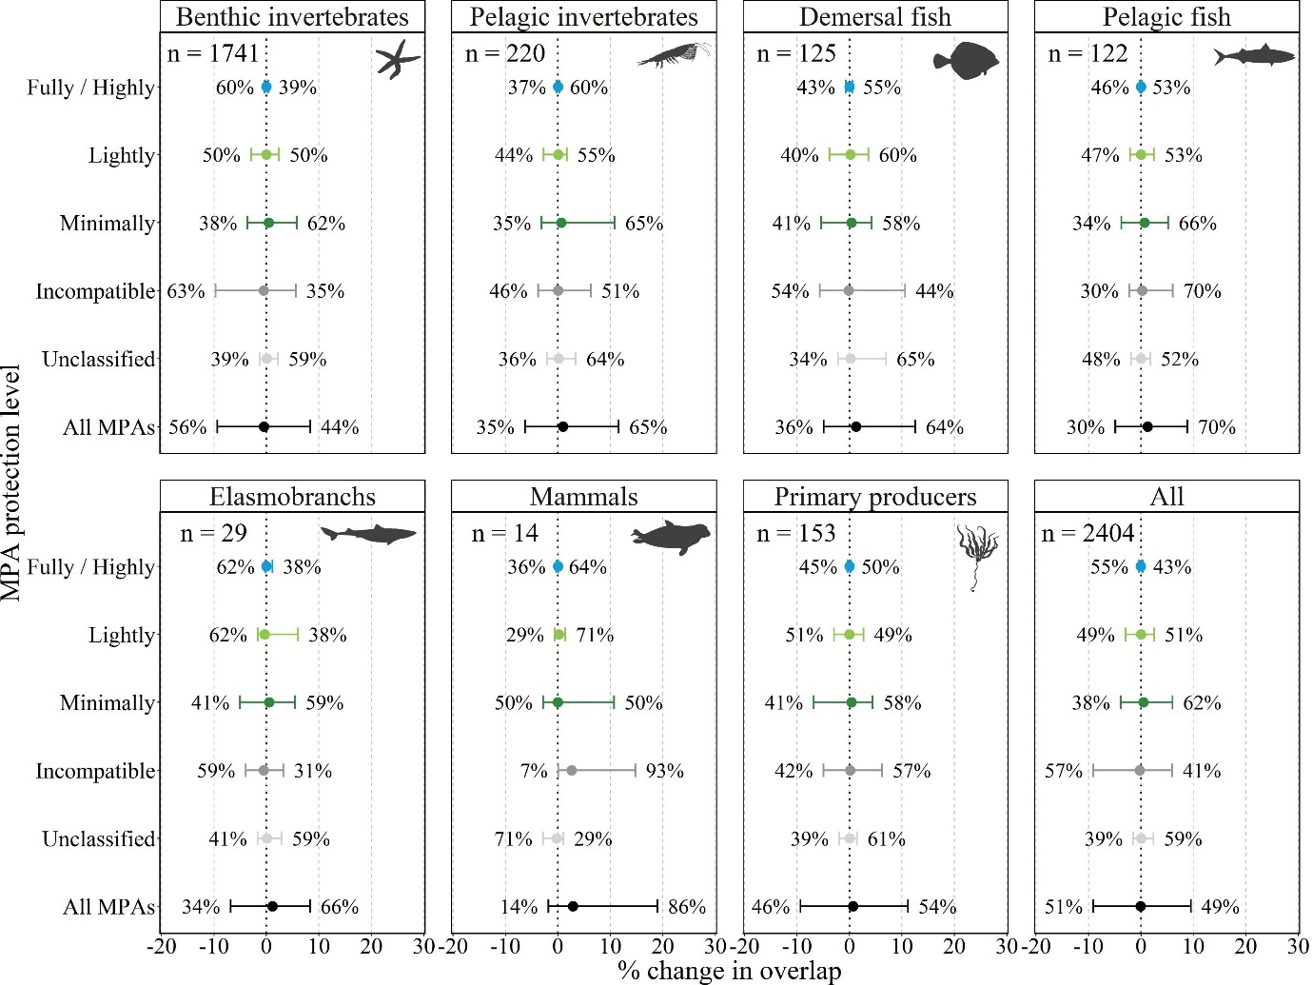
Figure S1: Relative change in overlap between species ranges and marine protected areas (MPAs) by biotic group under the intermediate Shared Socio-economic Pathway emissions scenario (SSP2-4.5), for taxa classed as ‘Medium climate-risk’. Values beyond the range of the 2.5 % and 97.5 % quantiles of the data are omitted for clarity. Circles indicate the median value across the full data range. Values on either side of the whiskers identify the proportion of species for each combination of biotic group and MPA protection level which are projected to experience either increases or decreases in overlap (note that these values do not always sum to 100 % as they do not consider species with zero change in coverage). n values indicate the total number of species included in each panel.

Table S6: Summary statistics for percentage change in overlap area between biotic groups and marine protected areas (MPAs) under the intermediate Shared Socioeconomic Pathway emissions scenario (SSP2-4.5) for taxa classed as ‘Medium climate-risk’. Values are presented across all MPAs, by grouped protection level (Strong = Fully and Highly, Weak = Lightly, Minimally and Incompatible), and by biotic group and MPA protection level. Q2.5 = 2.5th percentiles, Q97.5 = 97.5th percentiles, Min = minimum, Max = maximum.
Biotic group | Statistic | All MPAs | Strong | Weak | Fully | Highly | Lightly | Minimally | Incompatible | Unclassified
All | Median | -0.1 | 0.0 | -0.1 | 0.0 | 0.0 | 0.0 | 0.5 | -0.3 | 0.1
All | Q2.5 | -9.1 | -0.4 | -8.8 | -0.1 | -0.3 | -2.9 | -3.9 | -9.1 | -1.4
All | Q97.5 | 9.5 | 0.3 | 8.5 | 0.1 | 0.3 | 2.5 | 6.0 | 6.0 | 2.4
All | Min | -18.6 | -1.2 | -19.5 | -1.1 | -1.3 | -11.8 | -15.8 | -24.7 | -9.9
All | Max | 38.2 | 1.4 | 38.2 | 0.3 | 1.4 | 13.5 | 24.3 | 38.3 | 16.2
Benthic invertebrates | Median | -0.5 | 0.0 | -0.6 | 0.0 | 0.0 | 0.0 | 0.5 | -0.5 | 0.1
Benthic invertebrates | Q2.5 | -9.4 | -0.4 | -9.3 | -0.1 | -0.3 | -2.9 | -3.6 | -9.7 | -1.3
Benthic invertebrates | Q97.5 | 8.4 | 0.3 | 7.6 | 0.1 | 0.3 | 2.4 | 5.8 | 5.6 | 2.2
Benthic invertebrates | Min | -18.6 | -1.2 | -19.5 | -1.1 | -1.3 | -11.8 | -15.8 | -24.7 | -7.4
Benthic invertebrates | Max | 38.2 | 1.1 | 38.2 | 0.3 | 1.0 | 13.5 | 19.7 | 38.3 | 9.7
Pelagic invertebrates | Median | 1.0 | 0.0 | 0.9 | 0.0 | 0.0 | 0.1 | 0.6 | 0.0 | 0.2
Pelagic invertebrates | Q2.5 | -6.3 | -0.2 | -6.3 | 0.0 | -0.2 | -2.7 | -3.1 | -3.8 | -2.1
Pelagic invertebrates | Q97.5 | 11.6 | 0.3 | 11.6 | 0.0 | 0.3 | 1.7 | 10.8 | 6.3 | 3.4
Pelagic invertebrates | Min | -11.4 | -0.6 | -12.7 | -0.4 | -0.3 | -7.4 | -6.3 | -13.2 | -5.9
Pelagic invertebrates | Max | 34.9 | 0.6 | 24.1 | 0.1 | 0.6 | 3.1 | 24.3 | 12.6 | 16.2
Demersal fish | Median | 1.3 | 0.0 | 0.9 | 0.0 | 0.0 | 0.2 | 0.4 | -0.2 | 0.2
Demersal fish | Q2.5 | -4.9 | -0.7 | -5.7 | -0.1 | -0.7 | -3.8 | -5.4 | -5.6 | -2.2
Demersal fish | Q97.5 | 12.5 | 0.6 | 8.7 | 0.2 | 0.6 | 3.6 | 4.3 | 10.6 | 7.0
Demersal fish | Min | -8.4 | -0.9 | -9.1 | -0.1 | -1.1 | -7.7 | -6.2 | -12.0 | -4.5
Demersal fish | Max | 26.2 | 1.4 | 18.8 | 0.3 | 1.4 | 10.0 | 17.6 | 17.5 | 8.0
Pelagic fish | Median | 1.3 | 0.0 | 1.4 | 0.0 | 0.0 | 0.0 | 0.7 | 0.2 | 0.0
Pelagic fish | Q2.5 | -4.9 | -0.2 | -4.9 | -0.1 | -0.2 | -2.1 | -3.7 | -2.2 | -1.9
Pelagic fish | Q97.5 | 8.8 | 0.2 | 8.5 | 0.0 | 0.2 | 2.5 | 5.2 | 6.1 | 1.8
Pelagic fish | Min | -10.7 | -0.8 | -8.9 | -0.2 | -0.6 | -4.4 | -9.2 | -3.5 | -9.8
Pelagic fish | Max | 12.3 | 0.3 | 12.2 | 0.1 | 0.3 | 8.5 | 16.8 | 9.5 | 3.1
Elasmobranchs | Median | 1.2 | 0.0 | 1.1 | 0.0 | 0.0 | -0.3 | 0.5 | -0.5 | 0.1
Elasmobranchs | Q2.5 | -6.8 | -0.2 | -5.7 | 0.0 | -0.2 | -1.6 | -5.0 | -3.9 | -1.7
Elasmobranchs | Q97.5 | 8.3 | 1.1 | 7.9 | 0.1 | 1.1 | 6.0 | 5.5 | 3.2 | 2.9
Elasmobranchs | Min | -7.4 | -0.4 | -6.0 | -0.1 | -0.4 | -2.3 | -7.8 | -6.9 | -2.6
Elasmobranchs | Max | 9.0 | 1.2 | 8.4 | 0.1 | 1.2 | 6.5 | 5.6 | 3.8 | 3.4
Mammals | Median | 2.9 | 0.0 | 3.2 | 0.0 | 0.0 | 0.2 | 0.0 | 2.6 | -0.2
Mammals | Q2.5 | -1.8 | -0.3 | -1.5 | -0.2 | -0.1 | -0.6 | -2.8 | 0.1 | -2.9
Mammals | Q97.5 | 19.0 | 0.1 | 20.5 | 0.0 | 0.1 | 1.4 | 10.7 | 14.7 | 1.1
Mammals | Min | -2.3 | -0.5 | -1.9 | -0.3 | -0.1 | -0.7 | -3.0 | -0.1 | -4.0
Mammals | Max | 19.9 | 0.1 | 21.4 | 0.0 | 0.1 | 1.5 | 14.6 | 18.9 | 1.5
Primary producers | Median | 0.7 | 0.0 | 0.4 | 0.0 | 0.0 | 0.0 | 0.4 | 0.2 | 0.1
Primary producers | Q2.5 | -9.3 | -0.3 | -7.7 | -0.1 | -0.3 | -3.0 | -6.8 | -5.0 | -1.9
Primary producers | Q97.5 | 11.2 | 0.3 | 10.1 | 0.0 | 0.2 | 2.7 | 4.4 | 6.3 | 1.4
Primary producers | Min | -15.7 | -0.6 | -14.5 | -0.1 | -0.6 | -4.7 | -12.2 | -8.1 | -9.9
Primary producers | Max | 15.0 | 0.4 | 13.4 | 0.1 | 0.4 | 6.5 | 9.9 | 13.4 | 2.9

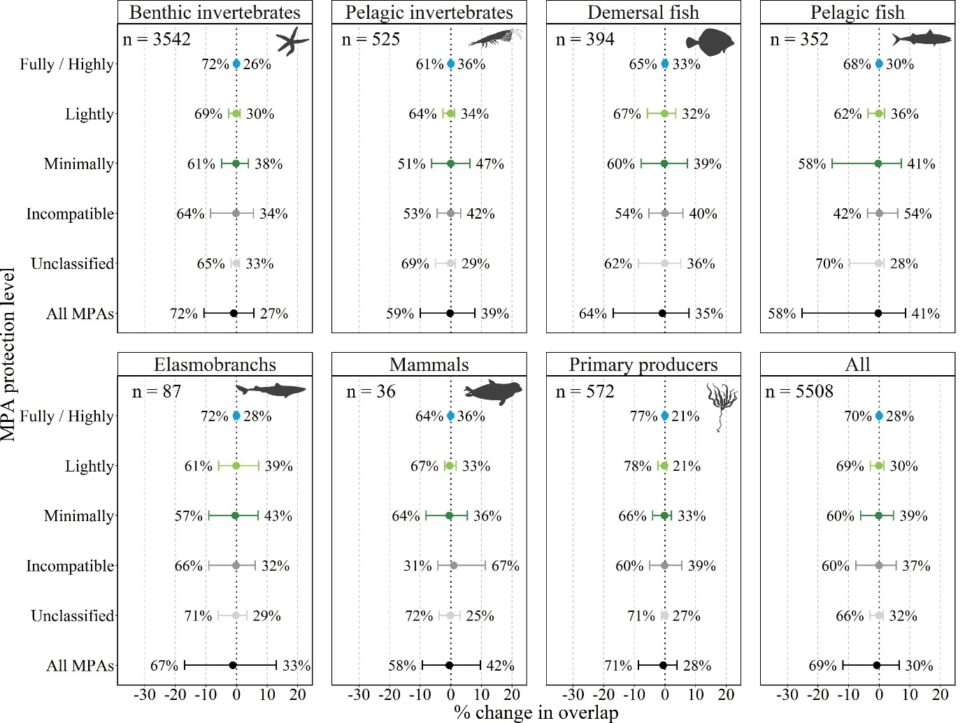
Figure S2: Relative change in overlap between species ranges and marine protected areas (MPAs) by biotic group under the intermediate Shared Socio-economic Pathway emissions scenario (SSP2-4.5), for taxa classed as ‘Low climate-risk’. Horizontal bars indicate the range of the central 95 % of the data (values beyond the range of the 2.5 % and 97.5 % quantiles of the data are omitted for clarity). Circles indicate the median value across the full data range. Values on either side of the whiskers identify the proportion of species for each combination of biotic group and MPA protection level which are projected to experience either increases or decreases in overlap (note that these values do not always sum to 100 % as they do not consider species with zero change in coverage). n values indicate the total number of species included in each panel.

Table S7: Summary statistics for percentage changes in overlap area between biotic groups and marine protected areas (MPAs) under the intermediate Shared Socio-economic Pathway emissions scenario (SSP2-4.5) for taxa classed as ‘Low climate-risk’. Values are presented across all MPAs, by grouped protection level (Strong = Fully and Highly, Weak = Lightly, Minimally and Incompatible), and by biotic group and MPA protection level. Q2.5 = 2.5th percentiles, Q97.5 = 97.5th percentiles, Min = minimum, Max = maximum.
Biotic group | Statistic | All MPAs | Strong | Weak | Fully | Highly | Lightly | Minimally | Incompatible | Unclassified
All | Median | -0.8 | 0.0 | -0.7 | 0.0 | 0.0 | -0.1 | -0.2 | -0.1 | -0.1
All | Q2.5 | -11.9 | -0.4 | -11.1 | -0.1 | -0.3 | -2.9 | -6.1 | -7.6 | -3.0
All | Q97.5 | 6.5 | 0.2 | 6.4 | 0.0 | 0.2 | 1.5 | 4.7 | 5.5 | 1.3
All | Min | -75.6 | -3.5 | -76.3 | -1.9 | -3.6 | -30.4 | -75.6 | -38.0 | -74.7
All | Max | 43.0 | 1.5 | 41.0 | 1.2 | 1.2 | 16.2 | 40.7 | 40.8 | 19.1
Benthic invertebrates | Median | -0.9 | 0.0 | -0.8 | 0.0 | 0.0 | -0.1 | -0.2 | -0.2 | -0.1
Benthic invertebrates | Q2.5 | -10.7 | -0.3 | -10.6 | -0.1 | -0.3 | -2.6 | -4.9 | -8.4 | -1.8
Benthic invertebrates | Q97.5 | 5.7 | 0.2 | 5.6 | 0.0 | 0.2 | 1.2 | 3.9 | 5.5 | 0.9
Benthic invertebrates | Min | -31.9 | -2.6 | -39.4 | -1.9 | -2.4 | -15.6 | -25.2 | -38.0 | -37.2
Benthic invertebrates | Max | 31.2 | 1.5 | 31.2 | 1.2 | 1.2 | 12.8 | 36.1 | 40.8 | 19.1
Pelagic invertebrates | Median | -0.3 | 0.0 | -0.2 | 0.0 | 0.0 | -0.1 | 0.0 | 0.0 | -0.1
Pelagic invertebrates | Q2.5 | -10.0 | -0.3 | -8.6 | -0.1 | -0.2 | -2.6 | -6.2 | -4.4 | -5.0
Pelagic invertebrates | Q97.5 | 7.9 | 0.2 | 9.5 | 0.0 | 0.1 | 1.3 | 6.3 | 3.2 | 1.5
Pelagic invertebrates | Min | -56.4 | -1.0 | -28.3 | -0.3 | -0.8 | -11.6 | -24.7 | -11.3 | -27.4
Pelagic invertebrates | Max | 43.0 | 0.5 | 41.0 | 0.3 | 0.5 | 16.2 | 40.7 | 13.4 | 7.9
Demersal fish | Median | -0.9 | 0.0 | -0.5 | 0.0 | 0.0 | -0.1 | -0.3 | -0.1 | -0.1
Demersal fish | Q2.5 | -16.9 | -0.6 | -11.9 | -0.1 | -0.5 | -5.8 | -7.8 | -5.2 | -8.7
Demersal fish | Q97.5 | 7.9 | 0.4 | 7.9 | 0.1 | 0.4 | 3.5 | 7.3 | 5.9 | 5.2
Demersal fish | Min | -66.7 | -3.5 | -48.9 | -0.5 | -3.6 | -30.4 | -28.7 | -30.1 | -74.7
Demersal fish | Max | 14.3 | 0.8 | 25.1 | 0.4 | 0.8 | 8.0 | 21.0 | 10.3 | 8.8
Pelagic fish | Median | -0.4 | 0.0 | -0.3 | 0.0 | 0.0 | -0.1 | -0.3 | 0.0 | -0.2
Pelagic fish | Q2.5 | -25.2 | -0.6 | -18.5 | -0.1 | -0.5 | -3.7 | -15.4 | -3.8 | -9.7
Pelagic fish | Q97.5 | 8.7 | 0.2 | 8.5 | 0.0 | 0.2 | 1.8 | 7.1 | 6.0 | 1.6
Pelagic fish | Min | -75.6 | -1.8 | -76.3 | -0.3 | -1.8 | -10.1 | -75.6 | -26.9 | -24.1
Pelagic fish | Max | 29.4 | 1.1 | 29.4 | 0.1 | 1.1 | 9.3 | 16.8 | 22.3 | 7.4
Elasmobranchs | Median | -1.2 | 0.0 | -1.0 | 0.0 | 0.0 | -0.1 | -0.4 | -0.2 | -0.3
Elasmobranchs | Q2.5 | -17.0 | -0.6 | -12.5 | -0.1 | -0.5 | -5.9 | -9.1 | -9.1 | -6.0
Elasmobranchs | Q97.5 | 13.0 | 0.3 | 13.4 | 0.1 | 0.3 | 7.2 | 7.1 | 6.1 | 3.3
Elasmobranchs | Min | -29.2 | -1.5 | -36.1 | -0.4 | -1.5 | -11.9 | -26.3 | -14.6 | -7.0
Elasmobranchs | Max | 18.2 | 0.4 | 22.7 | 0.2 | 0.6 | 9.6 | 35.0 | 9.2 | 6.8
Mammals | Median | -0.5 | 0.0 | -0.4 | 0.0 | 0.0 | -0.4 | -0.5 | 1.0 | -0.1
Mammals | Q2.5 | -9.3 | -0.3 | -8.6 | 0.0 | -0.3 | -2.0 | -8.1 | -4.2 | -3.8
Mammals | Q97.5 | 9.7 | 0.1 | 9.2 | 0.0 | 0.1 | 1.8 | 5.5 | 11.3 | 3.0
Mammals | Min | -9.9 | -0.4 | -10.7 | 0.0 | -0.4 | -2.5 | -13.8 | -6.5 | -4.0
Mammals | Max | 14.3 | 0.1 | 14.3 | 0.0 | 0.2 | 2.2 | 5.6 | 13.8 | 4.4
Primary producers | Median | -0.6 | 0.0 | -0.5 | 0.0 | 0.0 | -0.2 | -0.2 | -0.1 | -0.1
Primary producers | Q2.5 | -8.7 | -0.3 | -7.9 | 0.0 | -0.3 | -2.4 | -4.1 | -5.0 | -1.2
Primary producers | Q97.5 | 3.9 | 0.1 | 3.9 | 0.0 | 0.1 | 0.5 | 2.1 | 5.5 | 0.4
Primary producers | Min | -27.6 | -1.1 | -26.9 | -0.2 | -1.0 | -7.7 | -13.2 | -23.3 | -5.3
Primary producers | Max | 19.9 | 0.6 | 22.0 | 0.2 | 0.5 | 10.6 | 11.6 | 14.2 | 8.5

