Supplementary Information

Sub-picomolar Dopamine Sensing in Aqueous Electrolyte with Surface-Engineered MXene-Gated Organic Transistors
Matteo Genitoni^{a,b}, Ioan-Alexandru Baragau^{c,*}, Matteo Sensi^{d}, Dana Georgeta Popescu^{c}, George E. Stan^{c}, Petru Palade^{c}, Outman El Khouja^{c}, Sabina Alexandra Nicolae^{c}, Alice Lunghi^{e}, Pierpaolo Greco^{b}, Michele Bianchi^{d,*}, Fabio Biscarini^{a,d}
ª Center for Translational Neurophysiology of Speech and Communication, Istituto Italiano di Tecnologia, Ferrara, 44121, Italy.
^{b} Department of Neuroscience and Rehabilitation, Università di Ferrara, Ferrara, 44121, Italy.
^{c} National Institute of Materials Physics, Măgurele, Ilfov, 077125, Romania.
^{d} Life Science Department, Università degli Studi di Modena e Reggio Emilia, Modena, 41125, Italy.
^{e} Department of Physics, Informatics and Mathematics, University of Modena and Reggio Emilia, Modena, 41125, Italy.
* correspondence to ioan.baragau@infim.ro and michele.bianchi@unimore.it

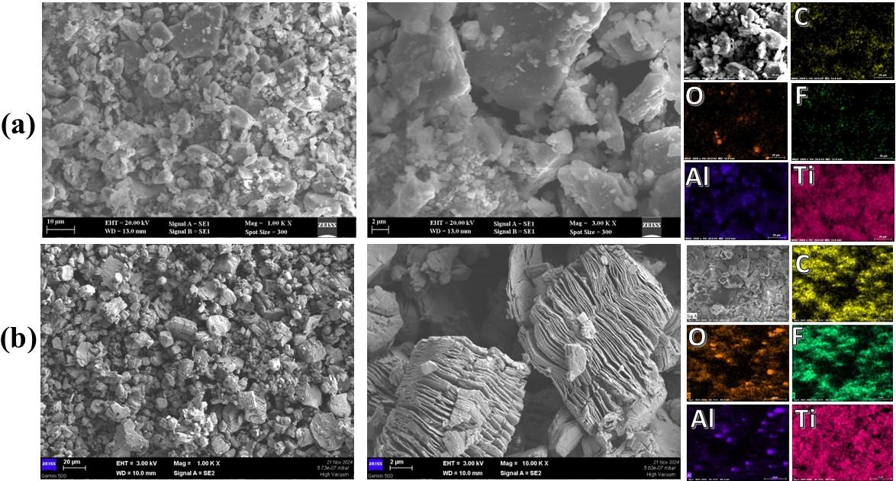
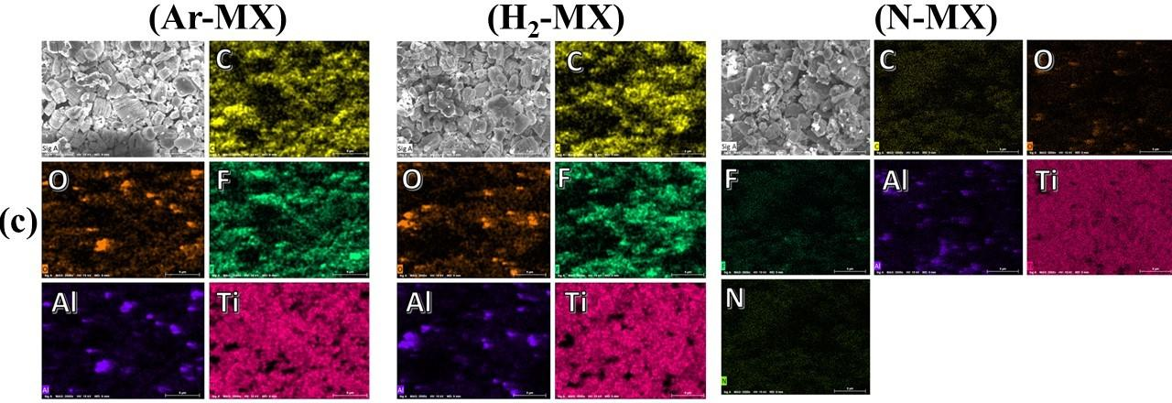
Figure S1: The SEM and EDS mapping images of (A) MAX phase and (B) HF-MX sample, and (C) the EDS mapping images of Ar-MX, H₂-MX and N-MX samples.

Table S1: The EDS elemental composition of MAX phase, HF-MX, Ar-MX, H₂-MX, and N-MX samples.
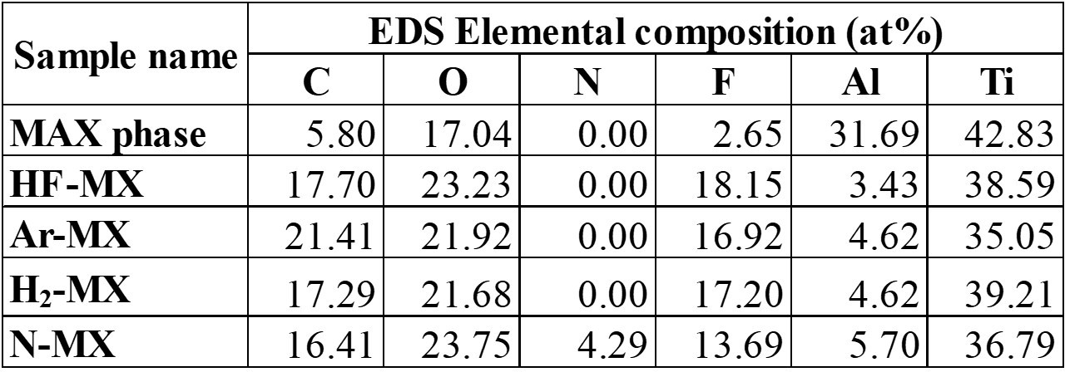

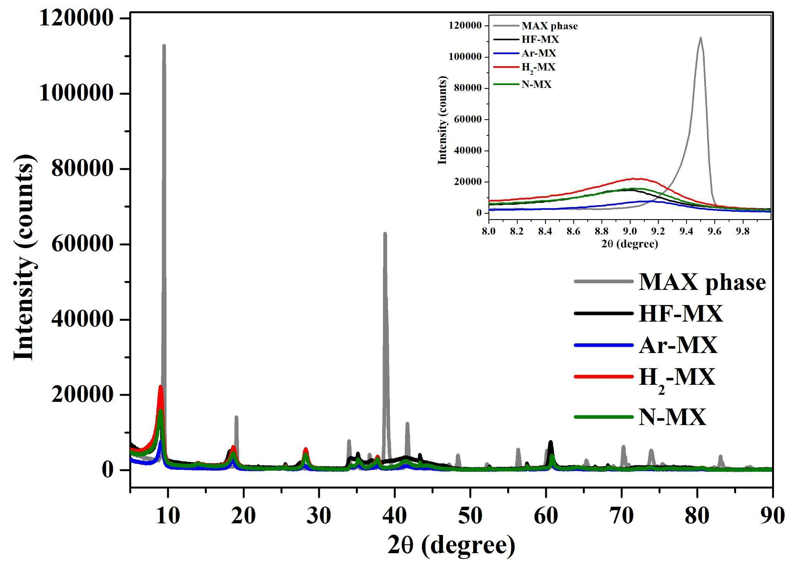
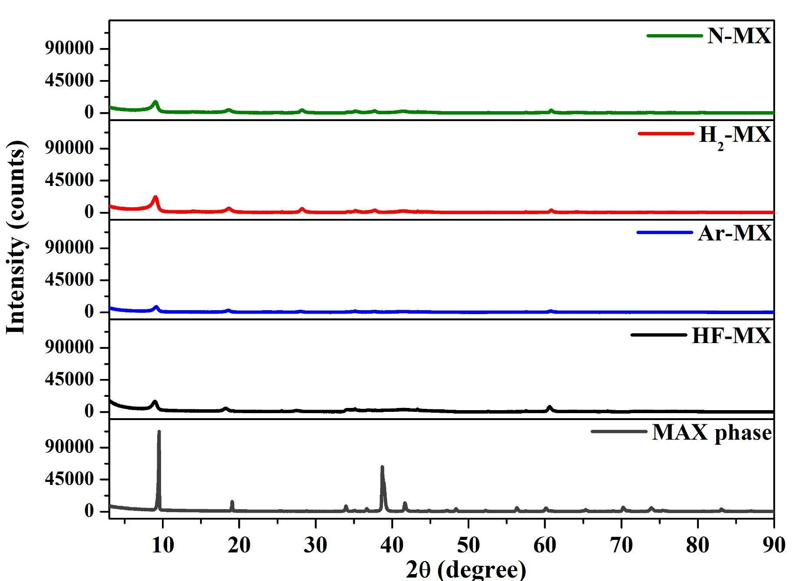
Figure S2: The X-ray diffraction patterns of MAX phase, HF-MX, Ar-MX, H₂-MX, and N-MX samples.
The XRD patterns show (Figure S2) an intense 002 peak at 9.5° and a second order reflection (006) at 19.07° for MAX phase, while in the HF-MX sample these peaks suffer a broadening, a major decrease in intensity and a slight shift toward smaller angle 9.02° (002) and 18.22° (006) indicating a structural disorder due to the extraction and replacement of bulk Al atoms with -F and -OH terminations, while the 004 peak at 38.72° characteristic of MAX phase was almost flattened in intensity for HF-MX sample, (004) suffering a shift to a smaller angle, to 37.75° for HF-MX, confirming an increase in the distance in between the Ti₃C₂ layers¹. Another indication that HF etching occurred is the appearance of a 008 diffraction peak at ~27°, characteristic of the formation of Ti₃C₂(OH)₂².
Table S2: XRD peak positions and intensities of MAX phase, HF-MX, Ar-MX, H₂-MX, and N-MX samples.
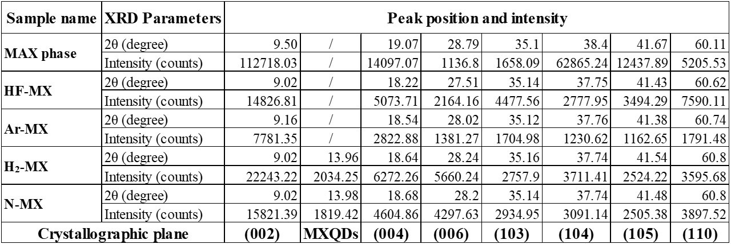
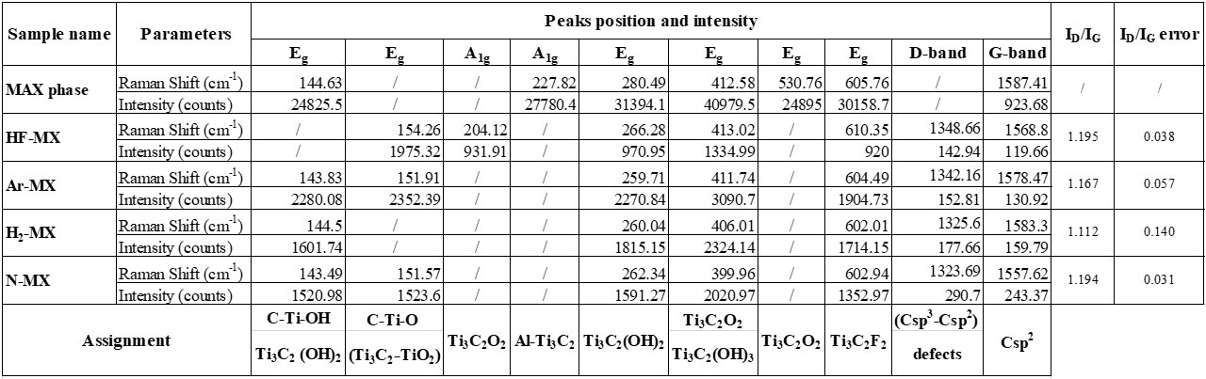
Table S3: Raman spectroscopy peak positions and intensities of MAX phase, HF-MX, Ar-MX, H₂-MX, and N-MX samples.

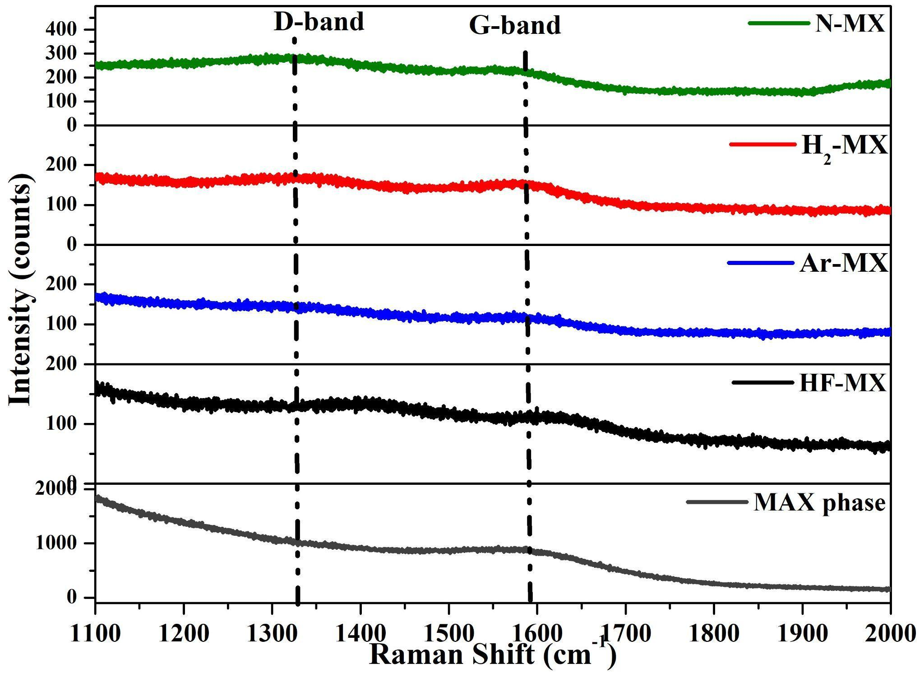
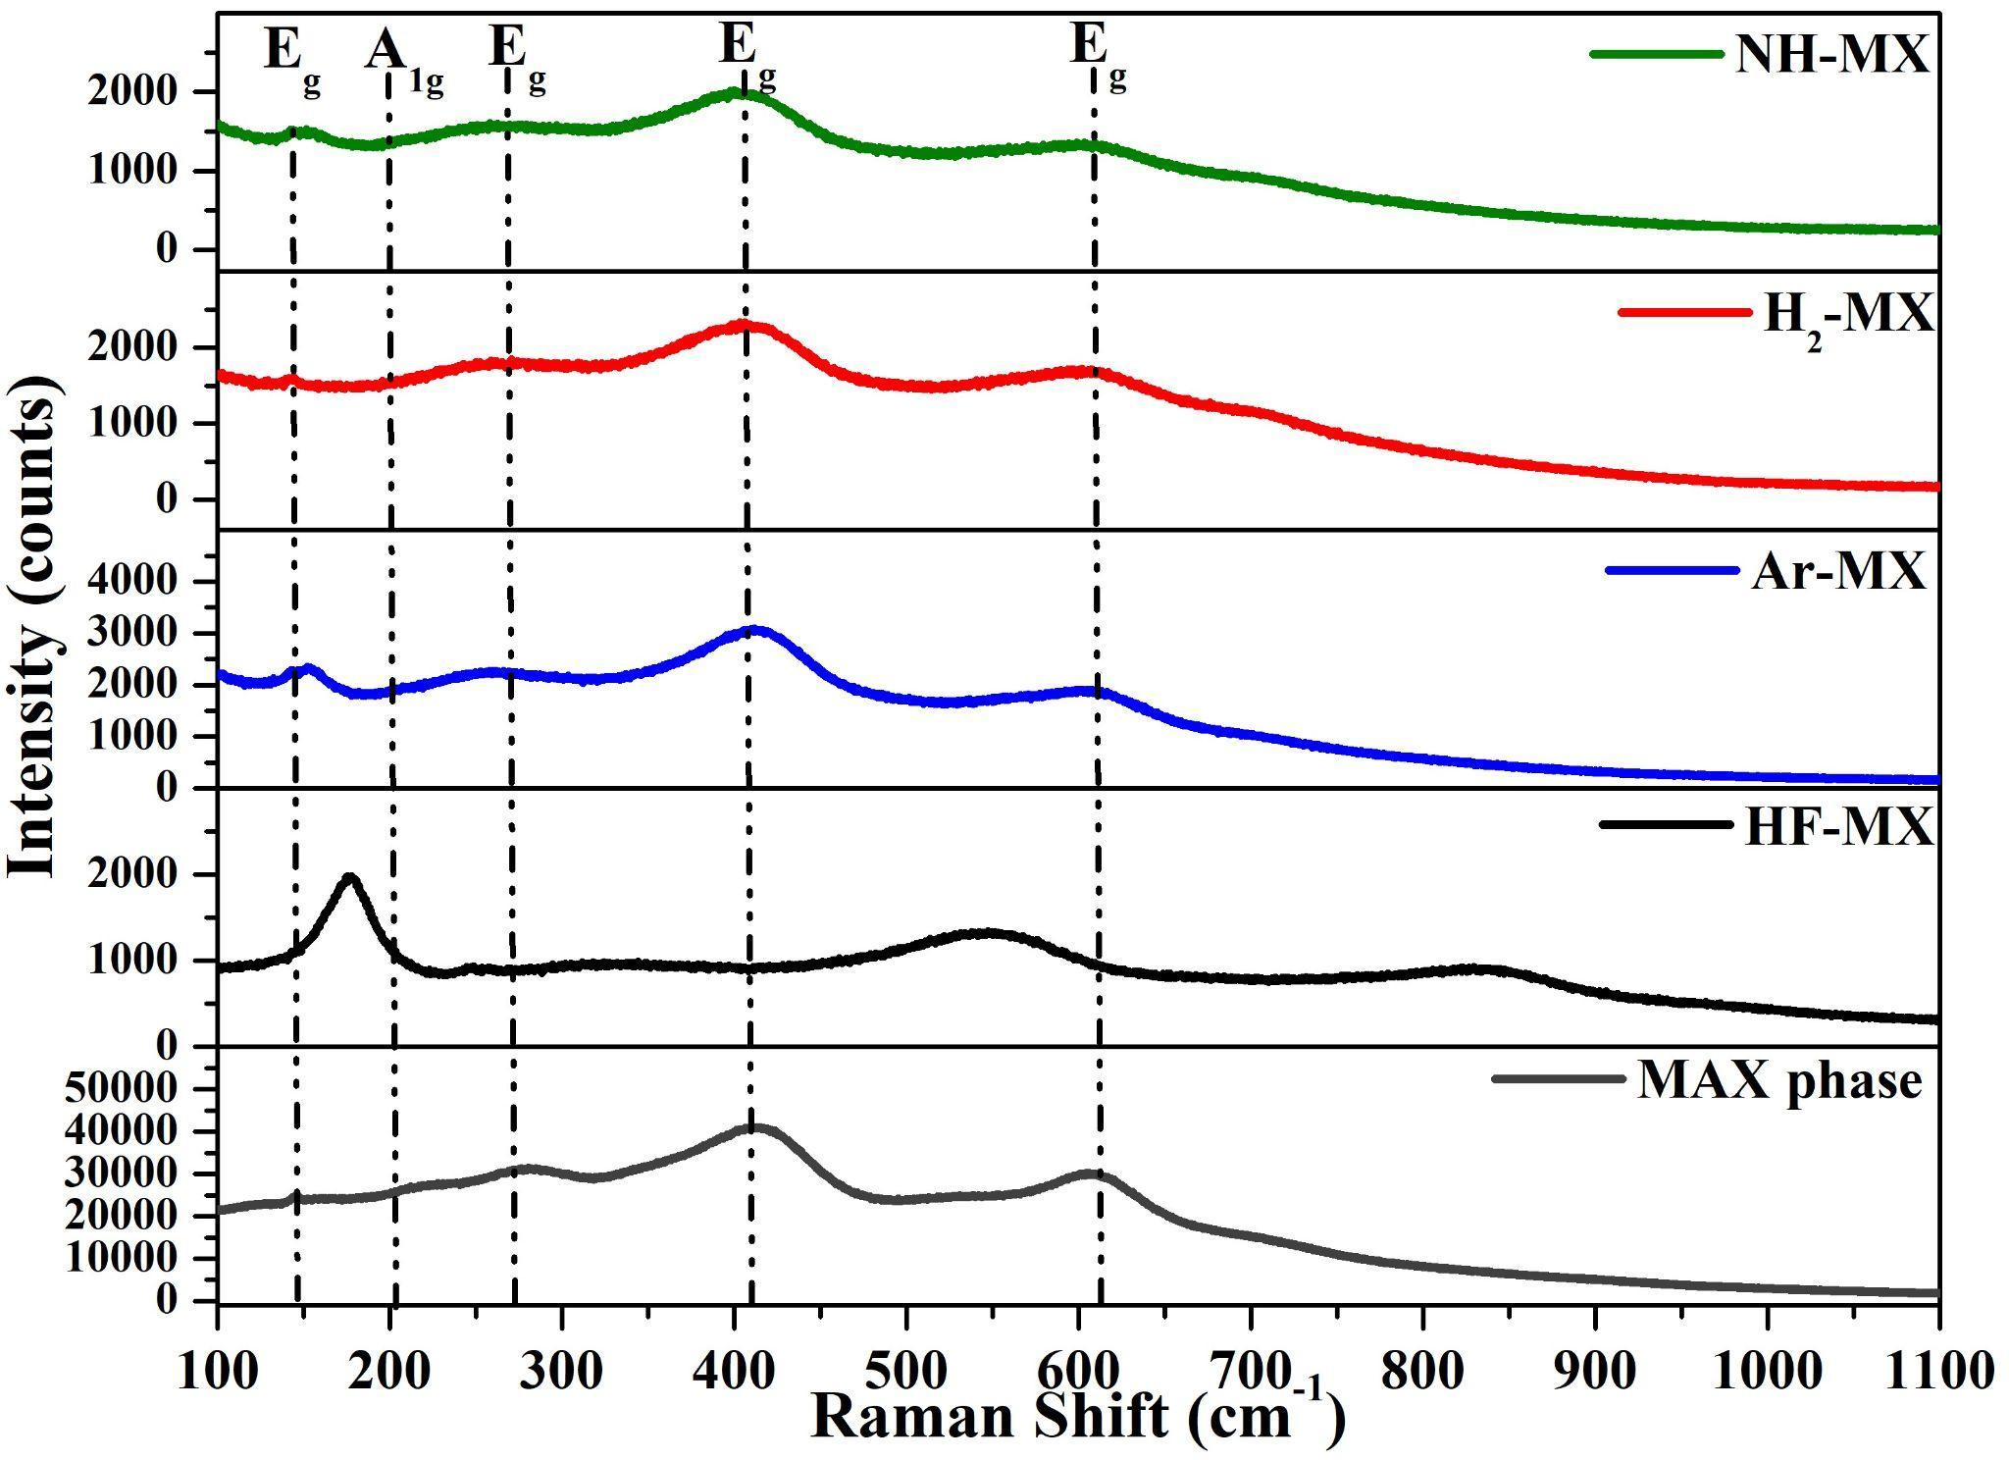
Figure S3: Raman spectra of MAX phase, HF-MX, Ar-MX, H₂-MX, and N-MX samples.
The characteristic A_{1g} vibrational modes of the MAX phase at 227 cm⁻¹ (corresponding to the out-of-plane vibration of Ti atoms within the C₂Ti₃-Al-Ti₃C₂ structure) is missing from the HF-MX sample spectrum, at 204 cm⁻¹ appears the A1g vibrational mode characteristic for out-of-plane vibration of Ti atoms in Ti₃C₂T_{x} MXene³ (see Figure S3 and Table S3), proving that Ti-Al bonds reacted with hydrofluoric acid. Also, Raman spectroscopy shows the appearance of the D-band (a vibrational mode absent in the MAX phase sample), demonstrating the formation of defects in the carbon structure of the HF-MX sample as a consequence of the etching process and side oxidation/degradation processes facilitated by the etching environment⁴. The elemental compositional evolution between the MAX phase and HF-MX sample was observed in the XPS and EDS elemental composition (see Table S1 and Table S5), while the remaining Al atoms are present in the HF-MX, Ar-MX, H₂-MX and N-MX samples as AlF₃ and Al₂O₃ (see Al 2p in Table S6).

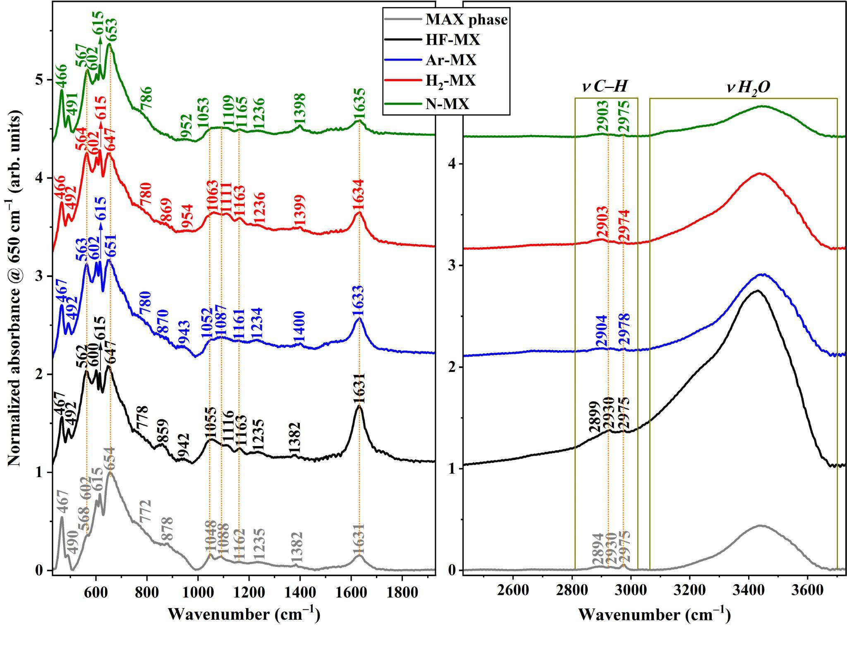
Figure S4: The FTIR spectra of MAX phase, HF-MX, Ar-MX, H₂-MX, and N-MX samples (with zoom in at different wavenumber ranges for a better visualization of FTIR spectra).

Table S4: IR absorption band positions and their assignments for MAX phase, HF-MX, Ar-MX, H₂-MX, and N-MX samples.
IR band assignment | IR band position |  |  |  |  | Refs.
IR band assignment | MAX phase | HF-MX | Ar-MX | H₂-MX | N-MX
• Ti–C stretching | 467 | 467 | 467 | 466 | 466 | ⁵
• C–C stretching
• Ti–C stretching | 490 | 492 | 492 | 492 | 491 | ⁵
• Ti–O and C–Ti–O vibrations | --- | 562 | 563 | 564 | 567 | ⁵
• Ti–O and C–Ti–O vibrations | 602 | 600 | 602 | 602 | 602 | ⁵
• Ti–O and C–Ti–O vibrations | 615 | 615 | 615 | 615 | 615 | ⁶
• Ti–O and C–Ti–O vibrations | 654 | 647 | 651 | 647 | 653 | ⁵
• Ti–F vibrations | 772 | 778 | 780 | 780 | 786 | ⁵
• Al–O bending vibrations | 878 | 859 | 870 | 869 | --- | ⁷
• Ti–OH bending | --- | 942 | 943 | 964 | 952 | ⁵
• C–O stretching | 1048 | 1055 | 1052 | 1063 | 1053 | ⁵
• C–F stretching | 1088 | 1116 | 1087 | 1111 | 1109 | ⁶
• C–O stretching | 1162 | 1163 | 1161 | 1163 | 1165 | ⁵
• C–O–C stretching | 1235 | 1235 | 1234 | 1236 | 1236 | ⁵
• Ti–O–C bridging
• O–H stretching | 1382 | 1382 | 1400 | 1399 | 1398 | ⁵
• bending of adsorbed water molecules | 1631 | 1631 | 1633 | 1634 | 1635 | ⁶
• C=O vibrations
• Ti–OH stretching
• symmetric stretch of – CH₂– and –CH₃ | 2894 | 2899 | 2904 | 2903 | 2903 | ⁶
• asymmetric stretching of –CH₂– | 2930 | 2930 | --- | --- | --- | ⁶
• asymmetric stretching of –CH₃ | 2972 | 2975 | 2978 | 2974 | 2975 | ⁸
• stretching of adsorbed water molecules | 3700–3100 | 3700–3100 | 3700–3100 | 3700–3100 | 3700–3100 | ⁶

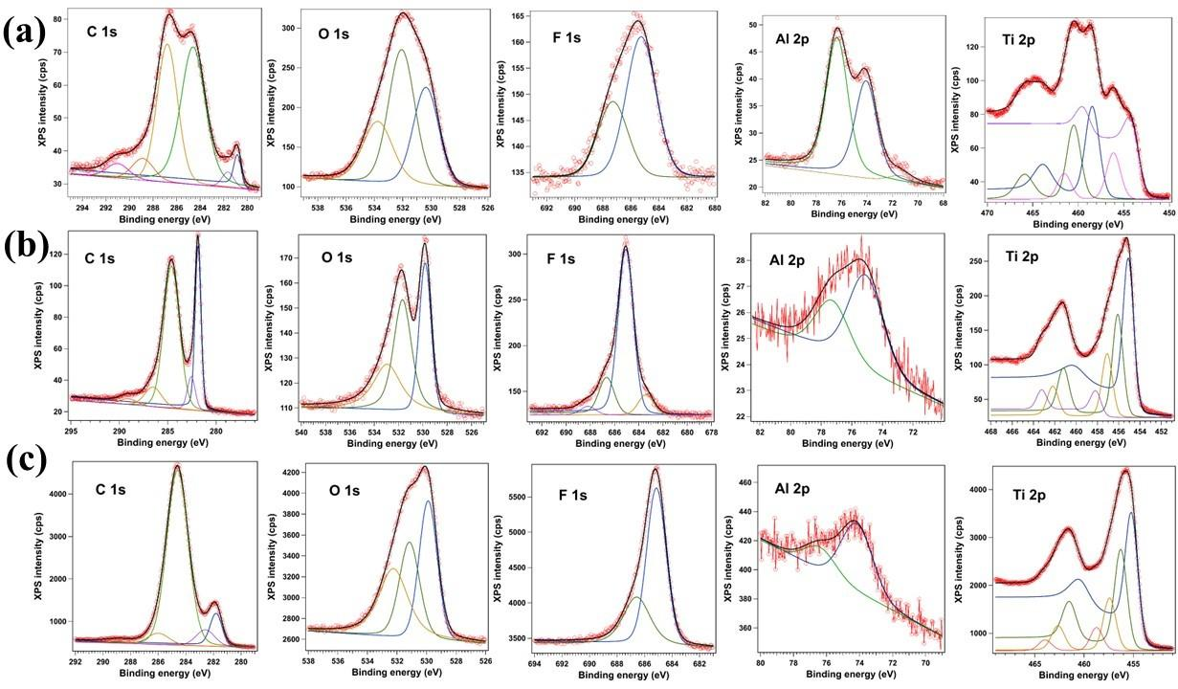
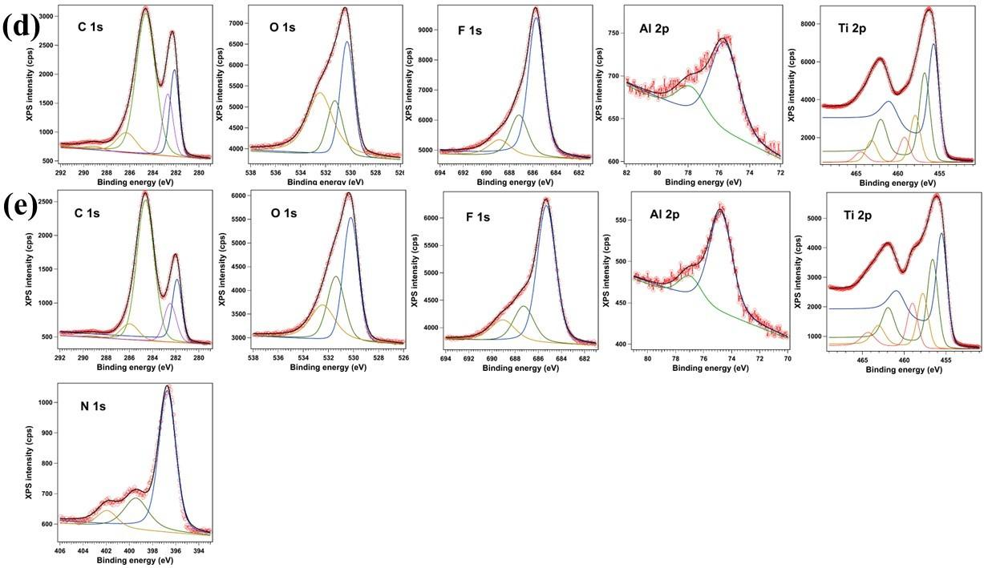
Figure S5: The high-resolution C1s, O1s, N1s, F1s, Al2p, Ti2p XPS spectra of (A) MAX phase, (B) HF-MX, (C) Ar-MX, (D) H₂-MX, (E) N-MX samples.

Table S5: The XPS elemental composition of MAX phase, HF-MX, Ar-MX, H₂-MX, and N-MX samples.
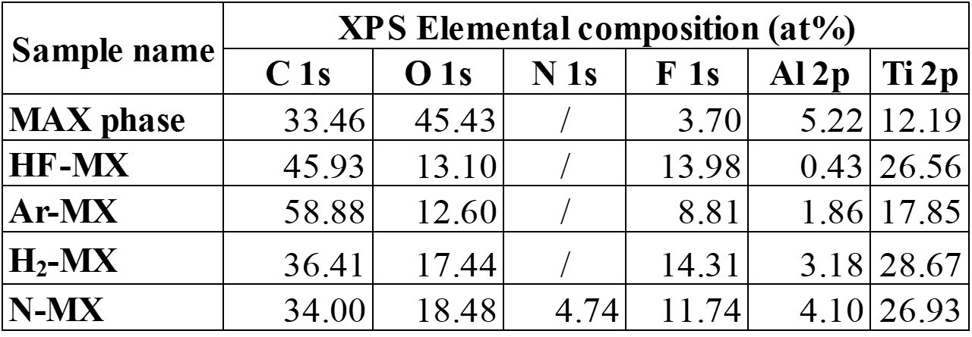

Table S6: HR-XPS components and chemical assignment of C1s, O1s, N1s, F1s, Al2p, Ti2p spectra of MAX phase, HF-MX, Ar-MX, H₂-MX, and N-MX samples.
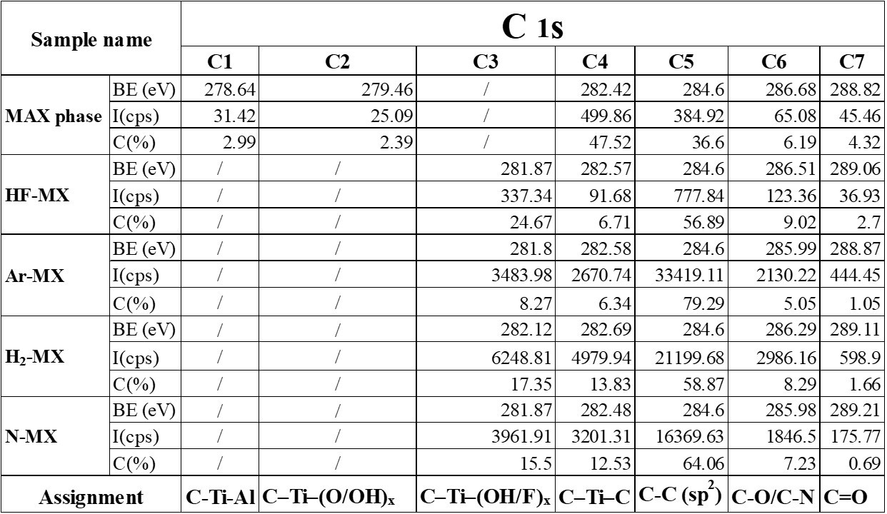
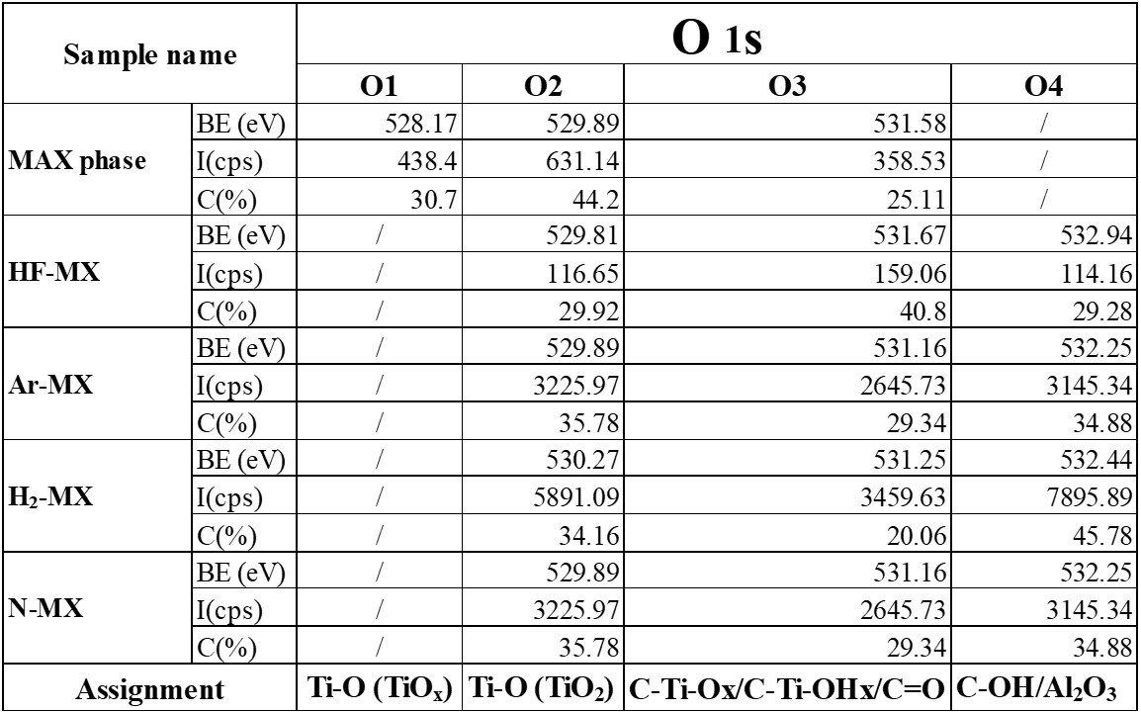
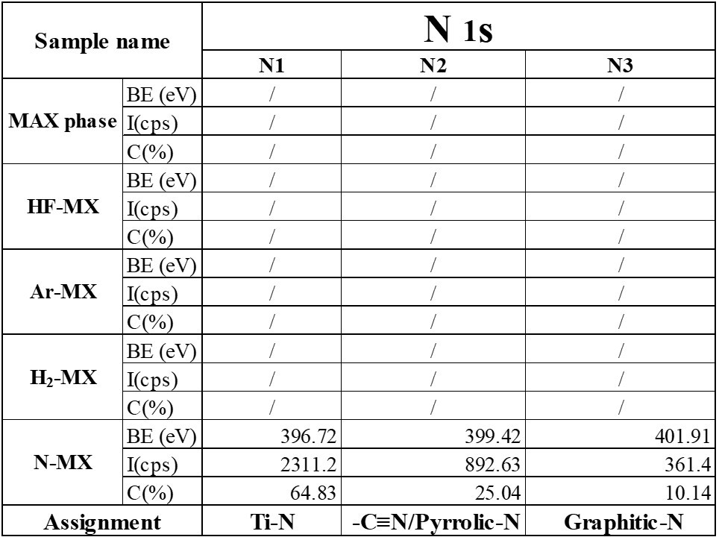
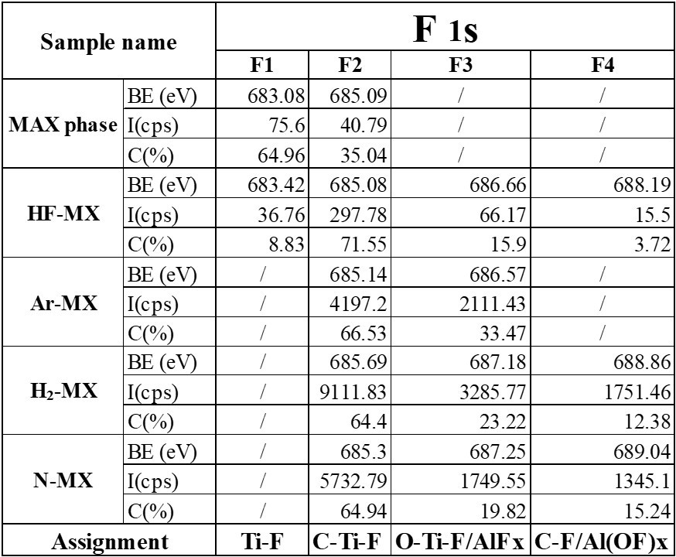
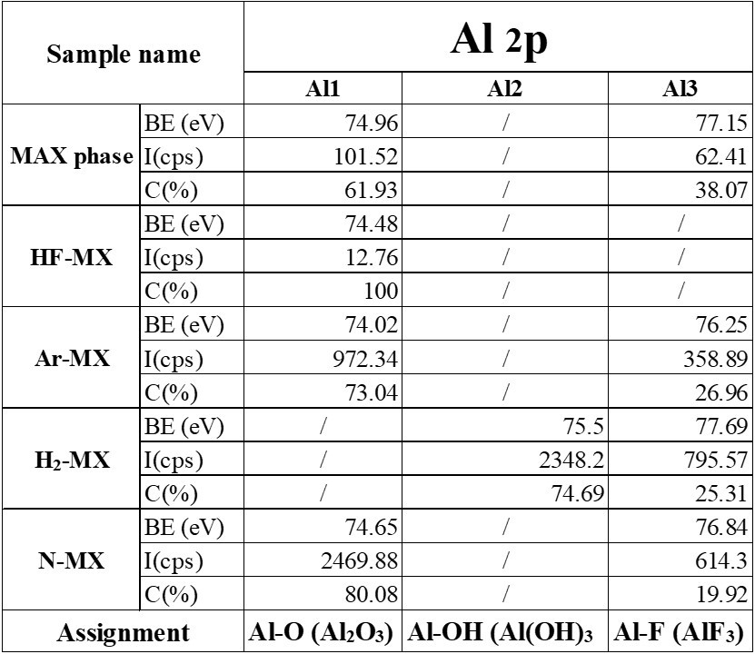
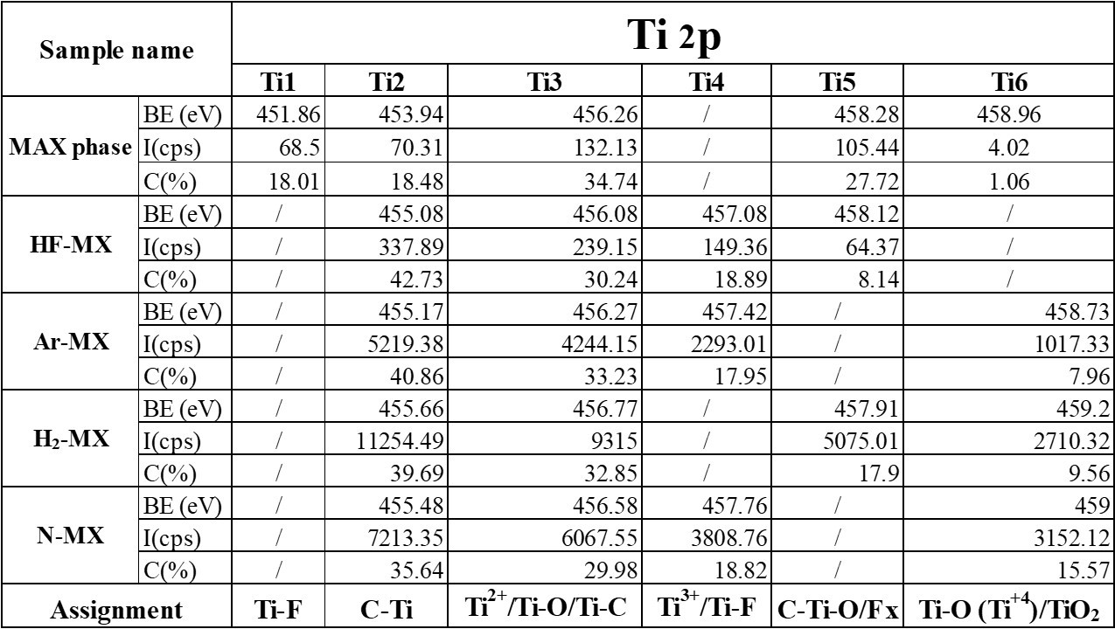
The XPS survey spectrum of the MAX phase confirms the expected elemental composition, dominated by Ti, C and Al, with oxygen arising mainly from surface oxidation (Figure S5). After HF etching, the Al signal is strongly suppressed, confirming the successful removal of the A-layer and the formation of Ti₃C₂T_{x} MXene, in agreement with well-established MAX etching mechanisms^{9,10}. Concomitantly, the appearance of an intense F 1s signal and the redistribution of the O 1s spectral components in HF-MX indicate the formation of fluorine- and oxygen-based surface terminations, such as Ti–F, C–Ti–O and C–Ti–(OH)ₓ species¹¹. Notably, while the overall oxygen content does not increase relative to the MAX phase, the chemical nature of oxygen changes markedly upon HF etching, shifting from oxide species present in the MAX phase to surface termination groups bound to Ti atoms in the MXene. High-resolution C 1s spectra reveal that HF etching substantially modifies the surface bonding environment of Ti₃C₂. Compared to the MAX phase, HF-MX exhibits a strong increase of low-binding-energy components associated with C–Ti–(O/OH/F)x species, indicating the replacement of Al–C bonds by surface terminations bound to Ti atoms⁹. At the same time, the C 1s spectra show a marked increase of the C–C (sp²) contribution and a strong suppression of C–O and C=O components compared to the MAX phase, indicating an effective removal of oxidised carbon species from the surface¹¹. Post-treatments under Ar, H₂ and NH₃ atmospheres induce distinct surface chemistries while preserving the Ti₃C₂ backbone, as confirmed by the persistence of the Ti–C component in both C 1s and Ti 2p spectra (Figure 2). The Ar-treated MXene (Ar-MX) exhibits moderate changes compared to HF-MX, mainly consisting of a relative increase in surface carbon content and a partial decrease in oxygen- and fluorine-based terminations. These variations are attributed primarily to thermally induced surface rearrangements and desorption of weakly bound species, without evidence of significant chemical reduction, in line with previous reports on annealed MXenes. Consistently, Ar-MX exhibits the most pronounced decrease in fluorine content among the investigated samples, which can be attributed to thermally induced desorption of weakly bound Ti–F species¹². In contrast, H₂ treatment induces pronounced surface reorganisation effects that primarily affect the chemical nature of oxygen-containing species rather than their overall abundance. While the total O 1s content increases compared to HF-MX (Table S5), high-resolution O 1s and Ti 2p spectra indicate a redistribution of Ti–O- and Ti–C-related environments at the MXene surface. Consistently, the C 1s spectra show a decrease of terminated C–Ti species (C–Ti–(O/OH/F)x) and a concomitant increase of the Ti–C contribution, indicating partial restoration of the carbide-like surface configuration. Notably, H₂-MX exhibits the highest fraction of polar C–OH surface groups among the investigated MXenes (Table S6), consistent with a highly hydrophilic and electrostatically active interface^{12,13}. The NH₃-treated MXene (N-MX) shares several reductive features with H₂-MX and exhibits clear evidence of nitrogen incorporation. The N 1s spectra reveal a dominant Ti–N component, accompanied by contributions from pyrrolic- or cyano-type nitrogen and graphitic-N species, with a total nitrogen content of approximately 4–5 at%. In parallel, the reduced abundance of C–Ti–(OH/F)ₓ species and the increased Ti–C contribution indicate efficient removal of electronegative surface terminations and reorganisation of the surface toward a more electronically structured configuration. Nitrogen doping of MXenes has been shown to modify the density of electronic states and introduce chemically active sites, thereby influencing both interfacial capacitance and charge-transfer processes^{14–16}.
Overall, XPS demonstrates that all post-treated MXenes retain the Ti₃C₂ structural backbone, while their surface chemistries are strongly dependent on the treatment atmosphere. Ar treatment primarily induces thermally driven desorption of weakly bound species, most notably Ti–F terminations, without substantial modification of the carbide framework. In contrast, H₂ and NH₃ treatments promote a redistribution of oxygen- and fluorine-containing surface species and a partial restoration of Ti–C bonding environments. In the case of NH₃ treatment, this process is accompanied by controlled nitrogen incorporation within the MXene lattice.

Table S7: List of the parameters extracted from fitting faradaic EIS with the equivalent circuit reported in the inset of Figure 3d.
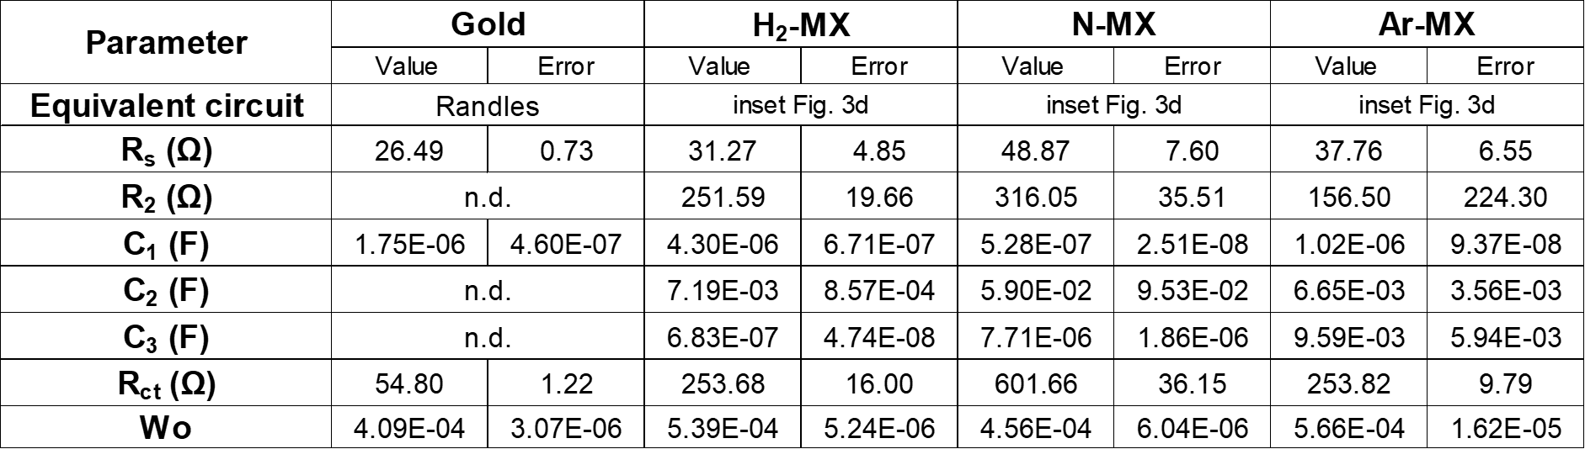

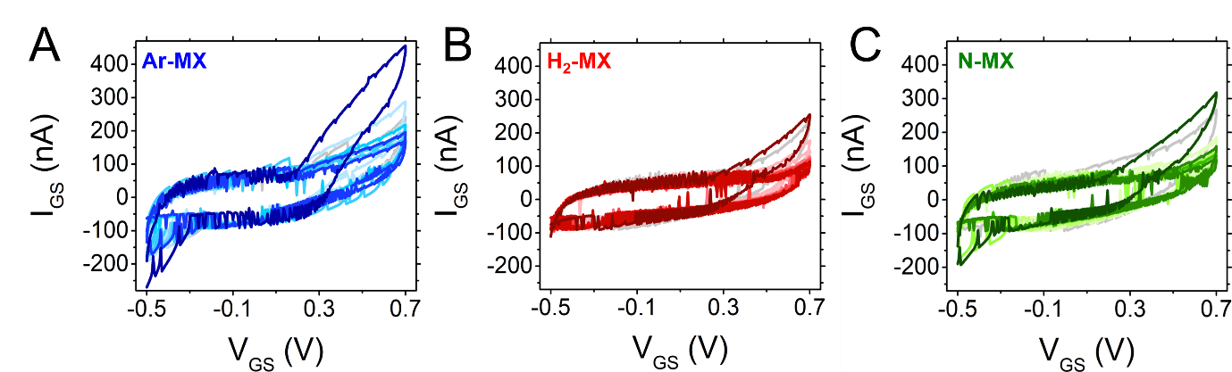
Figure S6: Gate electrode current during dopamine sensing. I_{GS} measured during the sensing experiments (Figure 5) for (A) Ar-MX electrode (blue curves), (B) H₂-MX electrode (red curves) and (C) N-MX electrode (green curves). Grey profiles represent 50 mM PB in the absence of DA. The increasing color intensity of the curves corresponds to increasing DA concentrations (from 100 fM to 10 µM).
References
1. Allen-Perry, K. et al. Tuning the magnetic properties of two-dimensional mxenes by chemical etching. Materials (Basel). 14, 1–9 (2021).
2. Wang, H. et al. Enhancement of the electrical properties of MXene Ti3C2 nanosheets by post-treatments of alkalization and calcination. Mater. Lett. 160, 537–540 (2015).
3. Hu, T. et al. Vibrational properties of Ti3C2 and Ti3C2T2 (T = O, F, OH) monosheets by first-principles calculations: A comparative study. Phys. Chem. Chem. Phys. 17, 9997–10003 (2015).
4. Adomaviciute-Grabusove, S. et al. Monitoring Ti3C2Tx MXene Degradation Pathways Using Raman Spectroscopy. ACS Nano 18, 13184–13195 (2024).
5. Parker, T. et al. Fourier-Transform Infrared Spectral Library of MXenes. Chem. Mater. 36, 8437–8446 (2024).
6. Li, Y. et al. Facile preparation of in situ coated Ti3C2Tx/Ni0.5Zn0.5Fe2O4 composites and their electromagnetic performance. RSC Adv. 7, 24698–24708 (2017).
7. Al-Amin, K., Kawsar, M., Mamun, M. T. R. B. & Sahadat Hossain, M. Fourier transform infrared spectroscopic technique for analysis of inorganic materials: a review. Nanoscale Adv. 6677–6702 (2025) doi:10.1039/d5na00522a.
8. Solangi, M. Y. et al. Ti3C2Tx MXene coupled Co(OH)2: a stable electrocatalyst for the hydrogen evolution reaction in alkaline media. RSC Sustain. 2, 3424–3435 (2024).
9. Naguib, M. et al. Two-dimensional nanocrystals produced by exfoliation of Ti 3AlC 2. Adv. Mater. 23, 4248–4253 (2011).
10. Anasori, B., Lukatskaya, M. R. & Gogotsi, Y. 2D metal carbides and nitrides (MXenes) for energy storage. Nat. Rev. Mater. 2, (2017).
11. Hope, M. A. et al. NMR reveals the surface functionalisation of Ti3C2 MXene. Phys. Chem. Chem. Phys. 18, 5099–5102 (2016).
12. Mashtalir, O. et al. Intercalation and delamination of layered carbides and carbonitrides. Nat. Commun. 4, 1–7 (2013).
13. Persson, I. et al. On the organization and thermal behavior of functional groups on Ti3C2 MXene surfaces in vacuum. 2D Mater. 5, (2018).
14. Wen, Y. et al. Nitrogen-doped Ti3C2Tx MXene electrodes for high-performance supercapacitors. Nano Energy 38, 368–376 (2017).
15. Lu, C. et al. Nitrogen-Doped Ti3C2 MXene: Mechanism Investigation and Electrochemical Analysis. Adv. Funct. Mater. 30, (2020).
16. Yang, F. et al. A nitrogenous pre-intercalation strategy for the synthesis of nitrogen-doped Ti3C2TxMXene with enhanced electrochemical capacitance. J. Mater. Chem. A 9, 6393–6401 (2021).

